System Services Test Report

Fast Frequency Response (FFR), Primary, Secondary and Tertiary Reserve (POR, SOR, TOR1, TOR2)

Aggregators

Unit Name

DISCLAIMER:
This Document contains information (and/or attachments) which may be privileged or confidential. All content is intended solely for the use of the individual or entity to whom it is addressed. If you are not the intended recipient please be aware that any disclosure, copying, distribution or use of the contents of this message is prohibited. If you suspect that you have received this Document in error please notify EirGrid or its subsidiaries immediately. EirGrid and its subsidiaries do not accept liability for any loss or damage arising from the use of this document or any reliance on the information it contains or the accuracy or up to date nature thereof. Use of this document and the information it contains is at the user’s sole risk. In addition, EirGrid and its subsidiaries strongly recommend that any party wishing to make a decision based on the content of this document should not rely solely upon data and information contained herein and should consult EirGrid or its subsidiaries in advance.
Further information can be found at: http://www.eirgridgroup.com/legal/

Document Version History
Template Version 4.0, published 21 March 2020
Version | Date | Comment | Name | Company
0.1 | Insert Date | Minor version (v0.1) - First submission for review and approval | Insert Name | Unit Company Name
1.0 | Insert Date | Revised to version 1.0 following approval by EirGrid, SONI. | Insert Name | Unit Company Name

Introduction
The Unit shall submit the latest version of this test report template as published on the EirGrid, SONI websites.
The report shall be developed for technical and non-technical readers and shall follow the agreed test programme. The report is submitted to DSU@eirgrid.com or generator_testing@soni.ltd.uk no more than 10 business days after the test date.
Submission of this document is required if a Unit does not have and existing FFR, POR, SOR, TOR1 or TOR2 Contract or is making changes or updates to any of the affected parameters.
To complete the report, the Unit shall have either:
- Recorded frequency response data as per the test procedure agreed with EirGrid, SONI; or
- Performance Data showing frequency response capability.
Any issue with meeting any requirements or completing this report, please contact DSU@eirgrid.com or generator_testing@soni.ltd.uk as appropriate.

Abbreviations
Unit Demand Side Unit
EDIL Electronic Dispatch Instruction Logger
IS Individual Site
MEC Maximum Export Capacity
MIC Maximum Import Capacity
MPRN Metering Point Registration Number
MRSO Meter Registration Service Operator
MVAr Mega VAR
MW Mega watt
NCC National Control Centre
CHCC Castlereagh House Control Centre
TSO Transmission System Operator
FFR Fast Frequency Response
POR Primary Operating reserve
SOR Secondary Operating Reserve
TOR Tertiary Operating Reserve
PMU Phasor Monitoring Unit

Unit Data

Aggregator data
Aggregator Type | DSU / AGU to specify.
Aggregator Name | Unit to specify
Aggregator Point of contact and contact number | Unit to specify
Aggregator Control Centre Location and main contact Number | Unit to specify
Aggregator Notice Time (min) | Unit to specify
Aggregator MW Response Time (min) | Unit to specify
Aggregator Response Type (Static, Dynamic) | Unit to Specify

Individual site details
Copy and paste this table depending of number of IS being tested and complete accordingly

Descriptor | Site No.1 | Site No. 2 | Site No. 3 | Site No. 4
Individual Demand Site Name/Number | Unit to specify | Unit to specify | Unit to specify | Unit to specify
MPRN | Unit to specify | Unit to specify | Unit to specify | Unit to specify
Bulk Supply Point or Connection Point | Unit to specify | Unit to specify | Unit to specify | Unit to specify
Irish Grid Co-ordinates | Eastings | Eastings | Eastings | Eastings
 | Northing | Northing | Northing | Northing
Site Address | Unit to specify | Unit to specify | Unit to specify | Unit to specify
Special Operating Limits or Network Limitations | Unit to specify | Unit to specify | Unit to specify | Unit to specify
MW Capacity | ________MW | ________MW | ________MW | ________MW
Demand Reduction Capability - Avoided Consumption | ________MW | ________MW | ________MW | ________MW
Demand Reduction Capability - On Site Generation (Continuous Parallel Mode or Shaving Mode) | ________MW | ________MW | ________MW | ________MW
Maximum Import Capacity | ________MW | ________MW | ________MW | ________MW
Maximum Export Capacity | ________MW | ________MW | ________MW | ________MW
Performance Measurement Device Standards for Fast Acting Services installed in agreement with TSO. | Unit to specify | Unit to specify | Unit to specify | Unit to specify
The Trigger Point that the IDS starts responding at (F Trigger On)  Or the trigger point range if using a dynamic system to issue trigger points | ________Hz or  ________Hz to ________Hz | ________Hz or  ________Hz to ________Hz | ________Hz or  ________Hz to ________Hz | ________Hz or  ________Hz to ________Hz
The frequency range over which the IDS went from minimum to maximum declared response. (F Trigger Range) | ________Hz to ________Hz | ________Hz to ________Hz | ________Hz to ________Hz | ________Hz to ________Hz
The frequency at which the IDS ceased responding at. (F Trigger Off) | ________Hz | ________Hz | ________Hz | ________Hz
Time delay to the F Trigger Off characteristic that the IDS continued to respond for thereafter. (T loiter) | _____sec | _____sec | _____sec | _____sec
Minimum time duration following a response before the IDS will become available to respond again. (T Min Interval) | _____sec | _____sec | _____sec | _____sec
FFR Capacity (MW) (achieved) | ________MW | ________MW | ________MW | ________MW
POR Capacity (MW) (achieved) | ________MW | ________MW | ________MW | ________MW
SOR Capacity (MW) (achieved) | ________MW | ________MW | ________MW | ________MW
TOR1 Capacity (MW) (achieved) | ________MW | ________MW | ________MW | ________MW
TOR2 Capacity (MW) (achieved) | ________MW | ________MW | ________MW | ________MW
Currently aggregated or alternatively date of effectiveness | Yes or dd:mm:yy | Yes or dd:mm:yy | Yes or dd:mm:yy | Yes or dd:mm:yy

System Services definitions
The definitions referenced in this document are for indicative purposes only. In the event of inconsistency between the definitions in this document and those in the DS3 System Services Agreement, the definitions in the DS3 System Services Agreement shall prevail.

Fast Frequency Response
FFR is defined as the additional increase in MW output from a unit or a reduction in demand following a frequency event that is available within two seconds of the start of the event and sustainable for at least eight seconds afterwards.
The extra energy provided by the MW increase, in the timeframe from T0 + the FFR response time to 10 seconds shall be greater than any loss of energy in the ten-to-twenty second timeframe afterwards due to a reduction in MW output. The energy provided and drawn should be compared to the pre-event output.

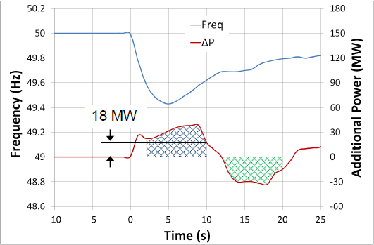
Figure 1: FFR being delivered after a frequency event

As shown in the diagram above, in order to be eligible for FFR the amount indicated by the blue hatched area (Power provided) must be greater than the green hatched area (Power drawn).

Please note there are performance monitoring standards that apply for DS3 System Services and specific requirements for FFR. Further detail is available in the DS3 Performance Measurement Device Standards for Fast Acting Services document.

POR, SOR & TOR1

Operating Reserve
Operating Reserve is defined as the additional MW output provided from Generation plant, reduction of Active power transfer to an external system or increase of Active power transfer to the Transmission system by interconnectors, or reduction in Customer demand, which must be realisable in real time operation to contain and correct any potential Transmission system deviation to an acceptable level.

Primary Operating Reserve (POR)
Primary Operating Reserve (POR) is the additional MW output (and/or reduction in Demand) required at the frequency nadir (minimum), compared to the pre-incident output (or Demand) where the nadir occurs between 5 and 15 seconds after an Event.

Secondary Operating Reserve (SOR)
Secondary Operating Reserve (SOR) is the additional MW output (and/or reduction in Demand) required at the frequency nadir (minimum), compared to the pre-incident output (or Demand) which is fully available and sustainable over the period from 15 to 90 seconds following an event.

Tertiary Operating Reserve band 1 (TOR1)
Tertiary Operating Reserve (TOR1) is the additional MW output (and/or reduction in Demand) required at the frequency nadir (minimum), compared to the pre-incident output (or Demand) which is fully available and sustainable over the period from 90 seconds to 5 minutes following an event.

Tertiary Operating Reserve band 1 (TOR2)
Tertiary Operating Reserve (TOR2) is the additional MW output (and/or reduction in Demand) required at the frequency nadir (minimum), compared to the pre-incident output (or Demand) which is fully available and sustainable over the period from 5 minutes to 20 minutes following an event.
Note: While it is envisaged that aggregators will provide TOR2 as a dispatch based service and test accordingly, the TSO acknowledge that some providers may wish to demonstrate and provide the TOR2 service as an extension of the other reserve services provided automatically in response to frequency events. The TSO will therefore facilitate TOR2 testing for such units through extended duration of reserve testing; however the TSO reserve the right to assess the appropriateness of this provision on a case by case basis.

Dynamic & Static Response

FFR Dynamic Capability requirements
Dynamic response is when a Unit tracks the system frequency and adjust its response accordingly. A Unit providing a dynamic response shall meet the following criteria:
- The unit shall track changes in frequency dynamically and respond in a continuously controlled manner proportional to the system frequency.
- Contain at least 10 discrete steps or sources which can dynamically adjust load contributions in response to frequency. No individual step shall be larger than 5MW and the response shall be provided in a linear, monotonically increasing manner. All step sizes shall be no more than +/- 1MW of the average step size.
- For each step as the frequency recovers the withdrawal of the provision of the service must be identical in both MW volume and response time to that provided at the corresponding Reserve Step Trigger when providing the service. Otherwise, the provision of the FFR service is deemed as Static.
- The unit shall have the capability to commit to a frequency trigger set point greater than or equal to 49.8 Hz and less than or equal to 49.985 Hz.
- Have frequency measurement installed locally.
- The unit shall be able to operate with a minimum trajectory of 2Hz in response to a Reserve Trigger.
- While the basic energy recovery requirement of the FFR product is to apply, to qualify as a dynamic provider, the unit shall be able to operate without recovering its resource until the system frequency has recovered to within 5% of the pre-event frequency in steady-state for a period of up to 5 mins (the exact timeframe will be instructed by the TSOs);
- The unit’s provision of POR, SOR and TOR1, if contracted for any of these Services, shall mirror its FFR response characteristics, i.e. the unit shall have the capability of continuing along the trajectory of the applicable frequency response curve for the extended timeframes obligated of POR, SOR and TOR1, as required of the TSOs in response to a Reserve Trigger.
- The unit shall have a PMU in situ. PMU shall meet the current metering standards.

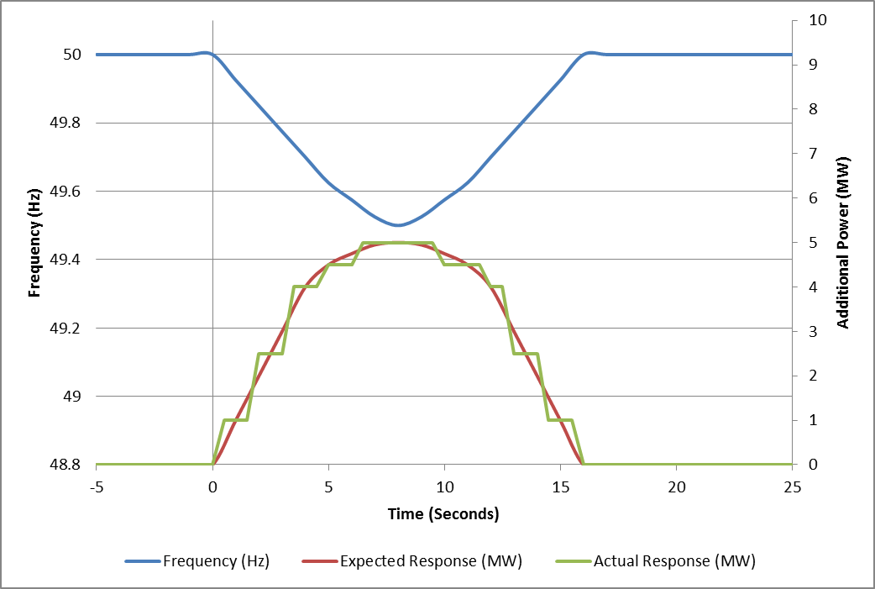
Figure 2: Example of a Dynamic unit response
As shown in figure 2, above, as the frequency drops the unit does not respond until the trigger point is reached (in this example the trigger point is set at 50 Hz). When this point is reached the unit output begins ramping up in discrete steps (steps in accordance with the requirements stated in section 5.3.1), staying as close as possible to the expected output. The output steps down also as the frequency returns to nominal (50Hz). This is what is expected of a dynamic response.

FFR Static Capability with multiple steps requirements
An FFR Static Response with multiple steps does not track the system frequency during frequency recovery. It responds proportionally to a drop in frequency and does not subsequently alter its response capability proportionally as the frequency recovers. In order to be classed as stepped-static response the Unit shall contain greater than one discrete step and have frequency measurement installed locally.
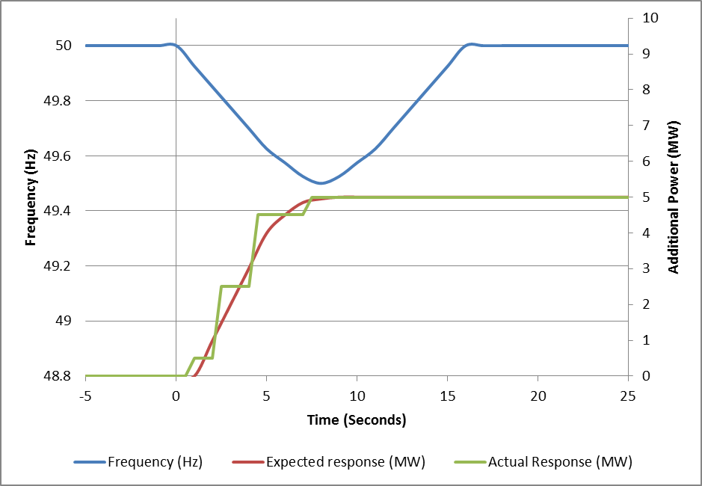
Figure 3: Example of a Stepped-Static Unit Response
As shown in figure 3, above, the unit responds to the event by stepping up its’ output as the frequency drops. When the unit hits its’ maximum capability it maintains this output as with a static response.

FFR Static Capability with a single step requirements
A Static response is where the Unit provides its entire response at one single trigger point.
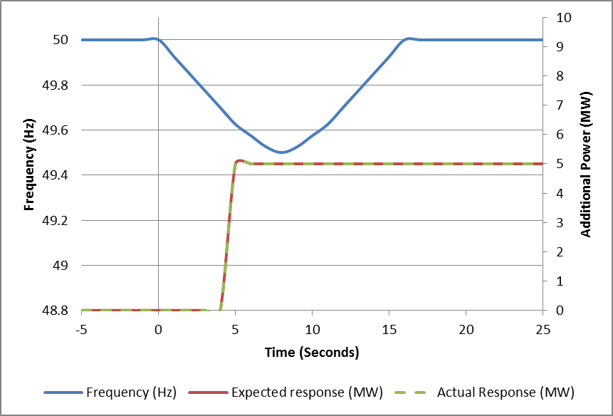
Figure 4: Example of a Static Unit response
As shown in figure 3, above, as the frequency drops the unit does not respond until the trigger point is reached (in this example the trigger point is set at 49.8Hz). When this point is reached the unit output begins ramping up in discrete step(s) (steps in accordance with the requirements stated in section 5.3.1), staying as close as possible to the expected output. The output steps down also as the frequency returns to nominal (50Hz). This is what is expected of a dynamic response.

Hysteresis
FFR Hysteresis Control is defined in the DS3 System Services Agreement and means: the capability of a Providing Unit to deliver a response at a particular Reserve Trigger as the frequency falls and not to withdraw its initial provided response as the frequency recovers through the Reserve Trigger.
For each static step: as the frequency recovers, the provision of the service shall be withdrawn at a frequency specified by the TSO for that step that is greater, i.e. closer to nominal, than the corresponding Reserve Step Trigger.
For each static step: as the frequency recovers, the withdrawal of the provision of the service must be identical in both MW volume and response time to that provided at the corresponding Reserve Step Trigger when providing the service.

Assessment
The MW amount is based on the absolute lowest sustainable value the unit is capable of delivering in the given timeframe for the service.

POR, SOR, TOR1 Assessment Examples
The following are a few examples of how the different operating reserve services could be graphed and how they can be assessed:
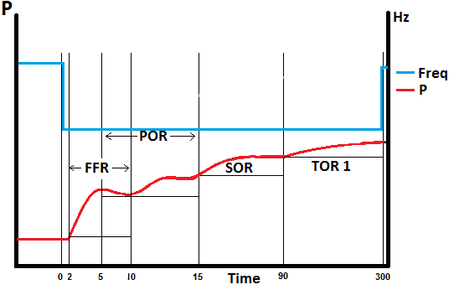
Figure 5: Example of how to measure the lowest MW value for each service
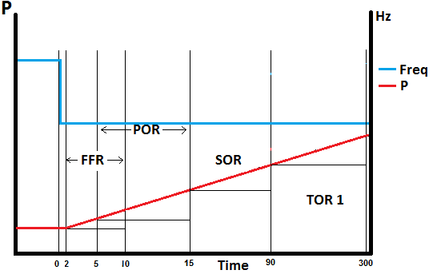
Figure 6: Levels shown with a linear response
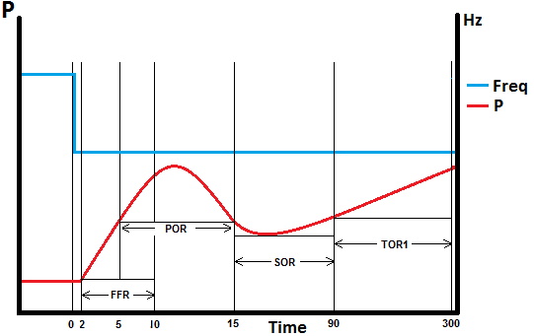
Figure 7: Levels shown with an overshoot response
The lines show where the lowest sustainable values are measured over the timeframe for each service.
The lines show where the lowest sustainable values are measured over the timeframe for each service.

FFR Assessment
The assessment of FFR is the lowest MW amount sustained over the 2 –10 second timeframe, compared to the pre-event output.
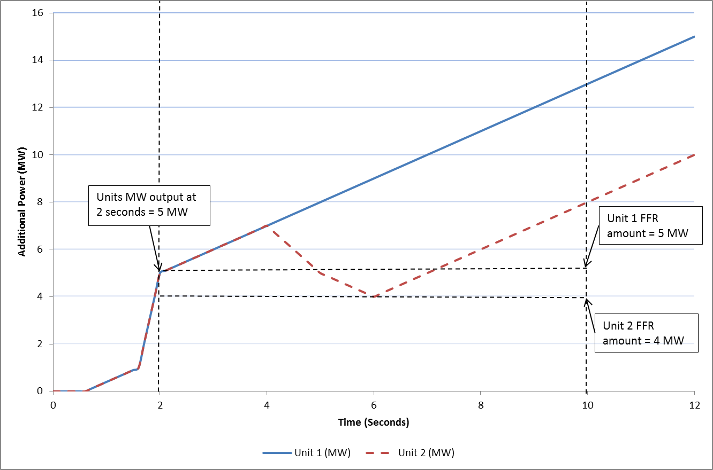
Figure 8: Example of how to measure the FFR MW amount

In figure 8, above, Unit 1 reaches 5 MW by the two second mark and continues ramping upwards over the course of the FFR timeframe. 5 MW is therefore the lowest sustainable MW amount provided over the timeframe by Unit 1.
Unit 2 also gets to 5 MW by two seconds, like Unit 1. Unlike Unit 1, it drops to 4 MW in the time frame. 4 MW is therefore the lowest sustainable MW amount provided over the timeframe by Unit 2.
The Pre-Event output is defined as the mean of the providing unit’s output between T-1.5 seconds and T-0.5 seconds from the time of the frequency passing through the reserve trigger for the providing unit (T=0). In the example above the pre-event output is 0MW.

FFR Response Time
A Providing Unit’s contracted FFR Response Time is the time from when the frequency falls through its contracted Reserve Trigger (T=0) to the time at which the Providing Unit must have achieved its contracted FFR volume, as dictated by its contracted FFR response curve.
The FFR response time provided in Section 7.4 shall be based on test data.
Please note that the FFR Response Time, as recorded on the Providing Unit’s installed performance measurement equipment, will be evaluated as part of the FFR performance monitoring process.
The product scalar for faster response of FFR will be based on the FFR response time of the Providing Unit.
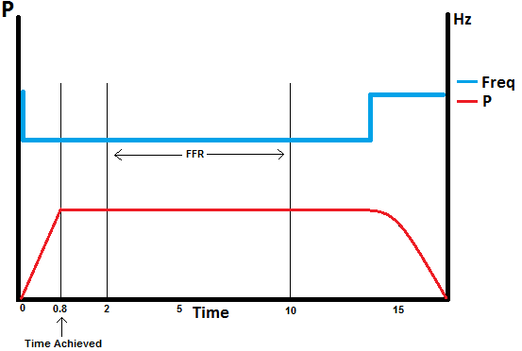
Figure 9: FFR volume achieved before the FFR time period

FFR Eligibility
Measure the energy provided (in MW seconds) in the timeframe from FFR response time to 10 seconds following an event, compared to the pre-event output. Measure the energy drawn (in MW seconds) during the 10-20 second timeframe following an event, compared to the pre-event output.
If a unit draws more energy from the grid in the 10 – 20 second period after this then it will not qualify for an FFR contract.
Figure 10: FFR Energy provided in blue and FFR Energy withdrawn in green

Results

Summary of testing
Testing was completed on [DATE].
[Insert comment on the results, highlighting any issues encountered in performing the test or in analysing the results].
[Insert Report summary]
[Include any relevant test notes here, relating to how the test was carried out or to any specific conditions encountered during the test.]
[If the response was provided by means of energy generation (on-site generation, energy storage), provide details of the site setup, especially when site has MEC=0.]
[Any abnormal behaviour during the test (spikes, dips, unusual vibrations, etc.) shall be noted and documented. The reasons behind these shall be detailed along with any corrective actions taken and what its effects are on the unit and/or the result. If possible a clear graph of the issue shall also be presented.]

FFR, POR, SOR, TOR1, TOR2 IDS Test Loads
(Times in this table are in seconds.)
IDS No. | Pre-Event Start | Pre-Event End | Average Site Pre-Event Load | T=0 | Max Site Load T+2* to T+10 | Max Site Load T+5 to T+15 | Max Site Load T+15 to T+90 | Max Site Load T+90 to T+300 | Max Site Load T+300 to T+1200
1 | hh:mm:ss | hh:mm:ss | 0.000 | hh:mm:ss | 0.000 | 0.000 | 0.000 | 0.000 | 0.000
2
3
4
5
6
(*If tested FFR response starts before T+2s, edit the column caption.)

FFR, POR, SOR, TOR1, TOR2 IDS Test Results
IDS No. | FFR (MW) | POR (MW) | SOR (MW) | TOR1 (MW) | TOR2 (MW)
1 | 0.000 | 0.000 | 0.000 | 0.000 | 0.000
2
3
4
5
6

Unit IDS specific Values
 | Existing Value (MW) |  |  |  |  | New Value (MW)
IDS No. | FFR | POR | SOR | TOR1 | TOR2 | FFR | POR | SOR | TOR1 | TOR2
1
2
3
4
5
6
DSU

FFR, POR, SOR, TOR1 Results
Unit load on the day; _________MW Level
 | Deadband Frequency
Frequency | _____________(Hz)

 | FFR Trajectory
Droop Response | ___________Hz

Unit Load | (a) FFR Energy Provided  (FFR Trigger – 10 Sec) | (b) FFR Energy drawn  (10 – 20 Sec) | FFR Eligibility: is (a) MW > (b) MW? | FFR | POR | SOR | TOR1
________MW | ______MWs | ______MWs | Yes/No | ____MW | ____MW | ____MW | ____MW

Graphs of results
[Insert full plots of the results demonstrating the frequency response of the unit. Graphs should be clear and highlight all relevant values and time periods, including levels. All Graphs should be clearly labelled and easy to read.]
[Graph should be a time series plot with Power and Frequency on the y axis and time on the x axis.]
[Include any relevant test notes here, relating to how the test was carried out or any specific conditions encountered during this test plus a full list of all IS’s in the Aggregator.]

[When a Dynamic response is reported, provide graphs for both ramp up and ramp down to demonstrate the response in a continuously controlled manner proportional to the system frequency.]

Report should include performance information both at aggregator level and also information relative to the performance of each IDS. Please ensure section 4.2 is updated accordingly with test results.

FFR Response Characteristics

No | Details | Value | Comment
1 | FFR Response Time | _____ms
2 | Is the response Static or Dynamic? |  | ___________________  Unit to fill in sections below as applicable
 | Dynamic Response Characteristics
3 | Reserve Trigger | ____Hz
4 | Trajectory Capability | ____Hz
 | Static Response Characteristics
5 | Reserve trigger | ____Hz
7 | Number of discrete steps
8 | Max discrete step value for static provision | MW
9 | Hysteresis capability |  | Y/N
10 | Hysteresis recovery trigger | Hz

Proposed Volumes
Please provide the proposed contract values for each service as per test results.
 |  | Total:  Services tested and available from date of System Service contract | Total:  Services tested and available including sites becoming available on date aligning with commencement of upcoming Capacity year (As per section J of I-SEM Capacity Market Code)
1 | Proposed Maximum FFR Available Volume | ____MW | ____MW
2 | Proposed Maximum POR Available Volume | ____MW | ____MW
3 | Proposed Maximum SOR Available Volume | ____MW | ____MW
4 | Proposed Maximum TOR1 Available Volume | ____MW | ____MW
4 | Proposed Maximum TOR2 Available Volume | ____MW | ____MW

Reserve Curve Characteristics
The Unit shall provide a proposed reserve curve for each service based on test data showing the levels of Operating Reserve at varying MW outputs.

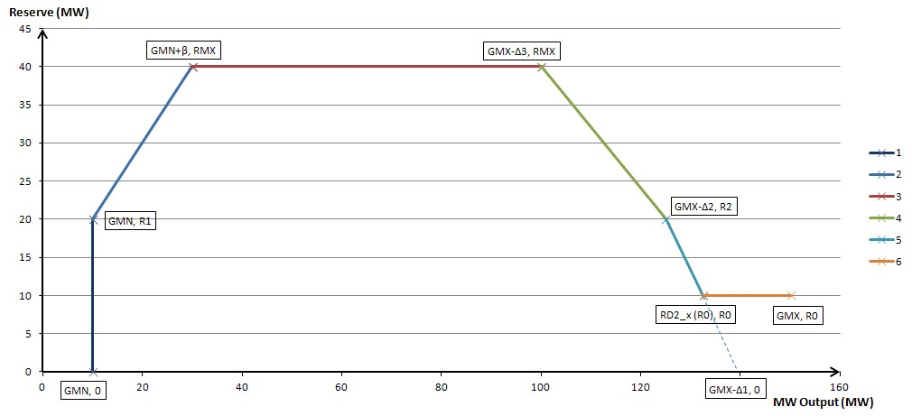

 | FFR | POR | SOR | TOR1 | TOR2
GMX (Reg Cap)
RMX (Max reserve volume)
GMN(Min Load)
R0
R1
R2
DELTA1
DELTA2
DELTA3
BETA

http://www.eirgridgroup.com/ or http://www.soni.ltd.uk/
Definitions form DS3 System Services Decision Paper SEM-13-098: https://www.semcommittee.com/sites/semcommittee.com/files/media-files/SEM-13-098%20%20DS3%20System%20Services%20Technical%20Definitions%20Decision%20Paper%20-%20FINAL_0.pdf
Where average step size = (Available FFR volume / number of discrete steps)
DS3 System Services Technical Definitions Decision Paper SEM-13-098 20/12/2013, page 10 https://www.semcommittee.com/sites/semcommittee.com/files/media-files/SEM-13-098%20%20DS3%20System%20Services%20Technical%20Definitions%20Decision%20Paper%20-%20FINAL_0.pdf
For example, a battery charging to its pre-event output

