Autoproducer
Customer Connection
Application Form for Connection to the Transmission System

March 2022

Introduction
This application form (version 1.2) outlines the information EirGrid requires to progress an application for connection of an Autoproducer facility to the Transmission System. EirGrid recommends that the applicant refers to the customers section of the website www.eirgridgroup.com for further information on the application process. The website has links to other relevant documents such as the Grid Code. It should be noted that it is the applicant’s responsibility to comply with the technical, design and operational standards detailed in the Grid Code.
Please note that this application form deals with HV connections only (≥ 110 kV) and that if an MV (≤ 110 kV) supply is required the applicant should first contact ESB Networks: Tel: +353 850 372 757, www.esb.ie.

EirGrid reserves the right to request additional data if necessary and the applicant should provide such information promptly during and post the offer process.

It is EirGrid’s responsibility to determine the transmission connection method. If the applicant has a specific request this will be considered and examined in the process. The selected method will be based on the overall least cost technically acceptable solution unless the Applicant requests otherwise or EirGrid requires an alternative method for system reasons.

Definitions of terms used in this form can be found in the Glossary of the Grid Code. Please note that if the application is not initially deemed complete, then the received complete date is recorded as the date that all necessary information has been provided to the system operator.

Please note that payment of application fees can only be made via electronic fund transfer into the following account. Cheques are not accepted.

Bank Details: Sort Code: 99-02-12
Barclays Bank Ireland Plc Account Name: EirGrid No 2 Account
2 Park Place, Account Number: 42890602
Hatch Street Swift Code: BARCIE2D
Dublin 2 IBAN: IE80BARC99021242890602

When the application form is completed please send the form to the below address, or email to OPMO@eirgrid.com

EirGrid Tel: +353 1 702 6642
OPMO Email: OPMO@eirgrid.com
The Oval,
160 Shelbourne Road, Ballsbridge,
Dublin 4,
Ireland.

If any queries arise please do not hesitate to contact our Offer Program Management Office Team at, OPMO@eirgrid.com

Details of Applicant

1. Full name of the applicant.

2. Please confirm if this application is an update on a previous application for a Facility?

Yes No

If Yes, please confirm the P or D reference supplied by the transmission system operator.

3. Address of the applicant or in the case of a corporate body, the registered address and company registration number.

Company Registration no. (if applicable)

4. Telephone Number

5. Contact Person(s)

6. Email Address

7. Contact Address (if different)

8. Please nominate a preferred name for this facility.

The TSO will take this preferred name into consideration when determining the facilities’ station name but reserves the right to change it in order to avoid any potential for confusion with other projects or stations. Please refer to Appendix A for EirGrid’s policy on User Site/Station Naming.

9. Please specify the address of this Facility

10. Please confirm that you have achieved planning permission for the facility.

Yes No

If yes, please confirm the planning authority reference.

11. It should be noted that it is the applicant’s responsibility to comply with the technical design and operational standards detailed in the Grid Code.

Noted

12. Please note that EirGrid may require an option from the applicant for additional land at the facility to facilitate future development of the Transmission System.

Noted

13. Has the Applicant signed a confidentiality agreement with EirGrid? If not, two copies must be submitted with this application form. Confidentiality agreement templates can be found on our website here.

Yes No

14. Has the Applicant previously had a pre-feasibility study regarding this facility completed by the TSO?

Yes No
If yes, please specify name and the date of issue of the Pre-feasibility study(s).
Study 1: (DD/MM/YYYY)
Study 2: (DD/MM/YYYY)

Customer Type

15. Please state which of the following applies to this application, then fill in the relevant sections/questions which apply to that type as specified below:

A. New transmission customer (fill in questions 19 – 48).

B. Existing transmission customer with transformer changes (fill in questions 17 – 48).

C: Existing transmission customers with no transformer changes fill in questions 17 – 33 and 42 – 48)

16: State if the applicant currently has a DSO connection

Yes No

If yes, please continue with question 17. If no, proceed to question 19.

Technical Information

17. What is your existing connection point? (Please specify substation/location)

18. What is your current Maximum Import Capacity (MIC)?

MVA

19. What is your requested new Maximum Import Capacity (MIC)?

MVA

20. What is your current MEC?

MW

21. What is your requested new MEC?

MW

22. Please fill in the table below

________________________________________________________________

 | Wind | Solar | Battery | CCGT | OCGT | Biomass | Other
22A. Please indicate the Generation Technology/ Type
22B. Number of generating units

22C. Rated power output of each generating unit (MW)

23. It should be noted that EirGrid will require a PSS/e dynamic model from the applicant for this generation facility 12 months in advance of connection to the network showing how the generator will respond to voltage dips, system faults, frequency changes etc.

Noted

24. Based on question 21 please state the following for your facility:

Active Power P MW
Reactive Power Q MVAr++

25. Please provide details of ramp schedule (power consumption over time) the facility intends to implement. Provide graph if necessary.

The ramping schedule will need to be compliant with the rule set included in EirGrid’s MIC Administration Paper. This is available to view here: https://www.eirgridgroup.com/site-files/library/EirGrid/MIC-administration-paper-v3-0-updated-Feb-2020.pdf

26. State the number of connecting circuits to the Transmission System (e.g. one, two etc.), the applicant requires for technical and/or security reasons.

27. Target Connection Date (this date will be used for connection assessment). (DD/MM/YYYY)

Please also state any specific connection method requests e.g. the use of underground cabling or connection to a specific station etc.

Please note that in certain areas of the country the use of underground cabling can have impacts on the Transmission System, for example amplification of background harmonic distortion, that would require additional equipment to be installed to mitigate their impact.

Where the possibility of harmonic amplification exists more detailed studies are required during the process leading to the issuance of a Connection Offer which may not be possible to complete within the standard 90 business day timeframe. Customer requested connection methods above and beyond the least cost connection method are fully chargeable to customers.
Further information on this aspect of charging policy is available here.

28. Confirm whether you wish the connection offer to issue on a contested or a non-contested basis and broadly outline the works the customer wishes to contest.
Further information on contestability is available here.

Type of Demand
The purpose of this section is to provide the TSO with a broad knowledge of the type of demand the customer will connect.

29. Is your facility a data centre?

Yes No

If yes, please indicate the square metres allocated for data centre usage allowed for in planning permission for the facility.

30. Please provide a graph of the facility’s Load Factor over 1 year.
Name of Attachment:

31. Please indicate if there are any items of plant which can contribute significant levels of harmonic distortion i.e. Large variable speed drives, large inverters etc.

Yes No
Name of Attachment:

32. Please indicate if your facility has any equipment that is designed to fluctuate by more than 5 MVA within a short period of time at the point of connection to the Transmission System.
If Yes, EirGrid may require further clarifications. However, these will not affect the completeness of your application.

Yes No

Grid Connected Transformer Data

There are many types of transformers. This application form specifies Two Winding Transformers. All impedances should be stated in % on transformer rated MVA base.
Please note that the connection voltage is determined by EirGrid in accordance with normal standards, as detailed in the Grid Code, taking into account the particulars of each development. If the connection voltage differs from that specified in the Application, EirGrid will request new data corresponding to the new voltage level. An appropriate connection voltage will initially be examined as part of the application check.

Please note the Grid Connected Transformer specified must be compliant with the relevant sections of the the Grid Code, in particular section WFPS1.6.5.

If the full details are not available at the time of application EirGrid can assume values based on the expected transformer size in MVA provided by the applicant and EirGrid would make assumptions. Please note any issues with the assumptions would be at the applicant’s risk and the applicant will have to provide the information requested in this section and a full manufactures test report for the installed transformer prior to energisation.

Two Winding Transformers

Transformer 1 Transformer2
33. Rating of Transformer (MVA)
34. Transformer voltage ratio HV/ LV
(kV)
35. Transformer positive sequence
resistance (R1%)
36. Transformer positive sequence
reactance (X1%)
37. Transformer zero sequence
resistance (R0%)
38. Transformer zero sequence
reactance (X0%)
39. Transformer vector group

40. Please provide details of tap changer.
Nature of tap changer off load/on load/off circuit)
 | kV | + Steps | - Steps | % Step Size
Transfomer 1
Transformer 2
Transformer Tapped voltage winding

Note: For Three Winding Transformers, please complete Appendix B. ‘Additional Reactive Power Devices’

41. Does the site include reactive devices or power factor correction devices on the MV side of the grid connected transformer?

Yes No

If yes, please complete questions 42-44, otherwise skip to question 45.

42. Number of inductive devices.

Device # | MVAr | Steps

Indicate for each device the inductive MVAr capability.
If the device has more than one stage, please indicate the number of stages and the MVAr capability switched in each stage.

43. Number of capacitive devices.

Device # | MVAr | Steps

Indicate for each device the capacitive MVAr capability. If the device has more than one stage, please indicate the number of stages and the MVAr capability switched in each stage.

44. Is it intended to utilise shunt compensation as harmonic filters?
Yes No

Maps and Diagrams
45. Please provide a 1:50,000 “Discovery Series” Ordnance Survey map, with the location address of the facility clearly marked. The electrical connection point must be clearly marked with an “X”.

Name of OS map attachment:

Please provide grid co-ordinates of the electrical connection point of your site (In appendix C an example is shown of how to correctly specify the grid co-ordinates):

Easting

Northing

46. Please provide a site plan in an appropriate scale. This site plan should indicate:
- The proposed location of the connection point,
- generators,
- transformers and site buildings

Note that the connection point is normally at the HV bushings of the grid connected transformer. Space for the transmission compound will have to be clearly marked on the site plan. The exact size of the compound will depend on the connection method defined in the connection offer. Site plan is to be submitted in soft copy.
Site plan is to be submitted in soft copy. Name of site plan attachment:

47. Please provide an electrical Single Line Diagram (SLD) of the proposed facility detailing all significant items of plant and their values, such as
- Generator transformer(s),
- power factor correction devices,
- location of alternative connection for on-site generation (if applicable) and
- grid connected transformer(s).

Name of the SLD attachment (should be submitted in soft copy)

Appendices

Appendix A:
EirGrid’s policy on Station Naming

- Station name must be unique and pronounceable for all stations,
- Station name must be geographically accurate and descriptive,
- Station name should be as local as possible to provide for future proofing for other stations that may locate in the same area.
- station names should not be named after a company, any individual supplier or manufacturer as this is liable to change,
- station name must not start with the letter X as this is reserved for specific usage.

Station names should be identified in the following order:
- Town land it is situated in,
- Nearby town land,
- Adjacent landmark e.g. a mountain,

Note: Station name above applies to both the transmission station name and the user’s site name.

EirGrid will also assign a unique 3-character code to each generation unit which are used by various software for modelling purposes and dispatch purposes. This 3-character code is based on the user site name and the number of generators at that site.
Appendix B:

Transformer 1
 | HV winding | LV1 winding | LV2 winding
B1. Transformer rated MVA
B2. Transformer rated voltage (kV)
B3. Transformer vector group

Transformer 2
 | HV winding | LV1 winding | LV2 winding
B4. Transformer rated MVA
B5. Transformer rated voltage (kV)
B6. Transformer vector group

Clearly specify the MVA base (in space provided between brackets) which the measured impedances below are related to:

Transformer 1 Transformer 2 Transformer 3
B7. Transformer positive
sequence resistance (R1HL1%)
between HV/LV1:
B8. Transformer positive
sequence reactance (X1HL1%)
between HV/LV1:
B9. Transformer zero sequence
resistance (R0HL1%) between
HV/LV1:
B10.Transformer zero
sequence reactance (X0HL1%)
between HV/LV1:
B11.Transformer positive
sequence resistance (R1HL2%)
between HV/LV2:
B12.Transformer positive
sequence reactance (X1HL2%)
between HV/LV2:
B13.Transformer zero sequence resistance (R0HL2%) between HV/LV2:
B14.Transformer zero
sequence reactance (X0HL2%)
between HV/LV2:
B15.Transformer positive
sequence resistance (R1L1L2%)
between LV1/LV2:

B16. Transformer positive
sequence reactance (X1L1L2%)
between LV1/LV2:
B17. Transformer zero
sequence resistance (R0L1L2%)
between LV1/LV2:
B18. Transformer zero
sequence reactance (X0L1L2%)
between LV1/LV2:
B19. Transformer positive sequence resistance (R1HL1L2
%) between HV/(LV1+LV2):
B20. Transformer positive
sequence reactance (X1HL1L2%)
between HV/(LV1+LV2):

Grid co-ordinates - How to define the grid co-ordinates from “Discovery Series” ordinance survey map.

Easting and Northing co-ordinates should be stated to six places. Easting co-ordinates are the numbers on the horizontal axis. Northing co-ordinates are the numbers on the vertical axis.

Figure 1: Example OS Map with 'X' clearly marking location of a facility

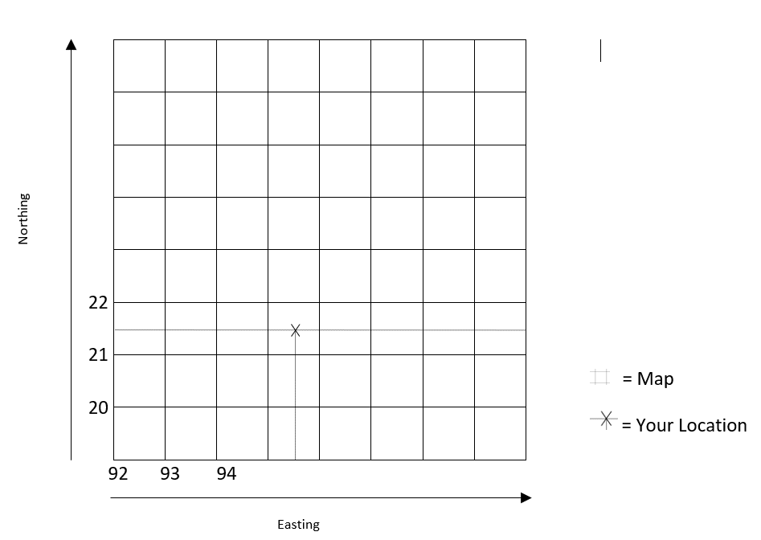

Appendix C:

Checklist for application submission

- Application form completed in full
- Application fee
- Two signed copies of confidentiality agreement (if applicable)
- OS map
- Single line diagram (SLD), soft copy
- Ramp schedule
- Load factor graph for 1 year
- Details provided of equipment that contributes significant levels of harmonic distortion (if applicable) and appendix relevant.

Further information on received complete dates can be found here
As per CRU/20/060, autoproducer applicants must be in receipt of valid planning permission to develop the project to which the connection application pertains.

