Fast Frequency Response (FFR), Primary, Secondary and Tertiary Reserve (POR, SOR, TOR1, TOR2)
System Services Test Procedure
Battery ESPS
Unit Name

DISCLAIMER:
This Document contains information (and/or attachments) which may be privileged or confidential. All content is intended solely for the use of the individual or entity to whom it is addressed. If you are not the intended recipient please be aware that any disclosure, copying, distribution or use of the contents of this message is prohibited. If you suspect that you have received this Document in error please notify EirGrid or its subsidiaries immediately. EirGrid and its subsidiaries do not accept liability for any loss or damage arising from the use of this document or any reliance on the information it contains or the accuracy or up to date nature thereof. Use of this document and the information it contains is at the user’s sole risk. In addition, EirGrid and its subsidiaries strongly recommend that any party wishing to make a decision based on the content of this document should not rely solely upon data and information contained herein and should consult EirGrid or its subsidiaries in advance.
Further information can be found at: http://www.eirgridgroup.com/legal/

Document Revision History
Operating reserve test procedure revision 3.0, published 30th July 2021
Version | Date | Comment | Name | Company
0.1 | Insert date | Minor version (v0.1) - First submission for review and approval | Insert name | Insert company
1.0 | Insert Date | Major version (V1.0) Approved Version by EirGrid / SONI | Insert Name | EirGrid / SONI

Introduction
The Unit must submit the latest version of this test procedure as published on the EirGrid or SONI website.
The order of this test can be rearranged only in agreement with EirGrid/SONI
The purpose of this document is to detail the data required to apply for a System Services Contract and to detail the necessary test procedures required to be performed should that data not be readily available.
If this data is already available then this document does not need to be completed. The Operating reserve test report should be completed and submitted to EirGrid/SONI.
All yellow sections must be filled in before the test procedure will be approved. All grey sections must be filled in during testing. If any test requirements or steps are unclear, or if there is an issue with meeting any requirements or carrying out any steps, please contact generator_testing@eirgrid.com or generator_testing@soni.ltd.uk.
On the day of testing, suitably qualified technical personnel are required on site to assist in undertaking the tests. The personnel shall have the ability to:
- Set up and disconnect the control system and instrumentation as required;
- Ability to fully understand the Unit’s function and its relationship to the System;
- Liaise with NCC/CHCC as required;
- Mitigate issues arising during the test and report on system incidents.
The availability of personnel at NCC/CHCC will be necessary in order to initiate the necessary instructions for the test. NCC/CHCC will determine:
- If network conditions allow the testing to proceed.
- Which tests will be carried out.
- When the tests will be carried out.
On completion of this test, the following shall be submitted to generator_testing@eirgrid.com or generator_testing@soni.ltd.uk.
Submission | Timeline
A scanned copy of the test procedure, as completed and signed on site on the day of testing | 1 working day
Test data in CSV or Excel format | 1 working day
Test report | 10 working days

Abbreviations
AAP Available Active Power
APC Active Power Control
CHCC Castlereagh House Control Centre (SONI)
DMOL Defined Minimum Operating Level
EA Emergency Action
EDIL Electronic Dispatch Instruction Logger
ESPS Energy Storage Power Station
FFR Fast Frequency Response
kV kilovolt
MEC Maximum Export Capacity
MIC Maximum Import Capacity
MVAr Mega Volt Ampere – reactive
MW Mega Watt
NCC National Control Centre (EirGrid)
PMU Phasor Measurement Unit
POR Primary Operating Reserve
RoCoF Rate-of-Change-of-Frequency
RPM Revolutions Per Minute
SOR Secondary Operating Reserve
TOR Tertiary Operating Reserve
TSO Transmission System Operator

Unit DATA
The data in the table below should be provided for the ESPS specific to the test.

ESPS Name | ESPS to Specify  (name per connection agreement)
ESPS Test Coordinator and contact number: | ESPS to Specify
Associated 110 kV Station | ESPS to Specify
ESPS connection point | ESPS to Specify  (i.e. T121 in XXX Distribution or Transmission Station)
ESPS connection voltage | ESPS to Specify
ESPS Connection Type | ESPS to Specify  (TSO, DSO Topology 1, DSO Topology 2 etc.)
Installed module type, MW size and quantity | ESPS to Specify
Contracted MEC | ESPS to Specify
Contracted MIC | ESPS to Specify
Registered Capacity | ESPS to Specify
Energy Storage Capacity | ESPS to Specify
% Charge maintained in normal operation | ESPS to Specify
Limiter applied to Exported MW | ESPS to Specify
Limiter applied to AAP | ESPS to Specify
DMOL | ESPS to Specify
RoCoF Capability | ESPS to Specify

System Services definitions

Fast frequency response
FFR is defined as the additional increase in MW output from a unit or a reduction in demand following a frequency event that is available within two seconds of the start of the event and sustainable for at least eight seconds afterwards

The extra energy provided by the MW increase, in the timeframe from the FFR response time to 10 seconds shall be greater than any loss of energy in the ten-to-twenty second timeframe afterwards due to a reduction in MW output. The energy provided and drawn should be compared to the pre-event output.

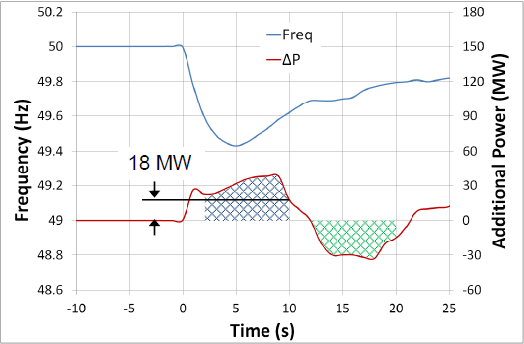
Figure 1: FFR being delivered after a frequency event

As shown in the diagram above, in order to be eligible for FFR the amount indicated by the blue hatched area (Power provided) must be greater than the green hatched area (Power drawn). If the amount of power drawn exceeds (or is equal to) the amount of power given (within the time frame) then the unit will not be eligible for an FFR contract.

POR, SOR & TOR1

Operating Reserve
Operating Reserve is defined as the additional MW output provided from Generation plant, reduction of Active power transfer to an external system or increase of Active power transfer to the Transmission system by interconnectors or storage plant, or reduction in Customer demand, which must be realisable in real time operation to contain and correct any potential Transmission system deviation to an acceptable level.

Primary Operating Reserve (POR)
Primary Operating Reserve (POR) is the additional MW output (and/or reduction in Demand) required at the frequency nadir (minimum), compared to the pre-incident output (or Demand) where the nadir occurs between 5 and 15 seconds after an Event.

Secondary Operating Reserve (SOR)

Secondary Operating Reserve (SOR) is the additional MW output (and/or reduction in Demand) required compared to the pre-incident output (or Demand), which is fully available and sustainable over the period from 15 to 90 seconds following an Event.

Tertiary Operating Reserve band 1 (TOR1)
Tertiary Operating Reserve band 1 (TOR1) is the additional MW output (and/or reduction in Demand) required compared to the pre-incident output (or Demand) which is fully available and sustainable over the period from 90 seconds to 5 minutes following an Event.

Tertiary Operating Reserve band 2 (TOR2)
Tertiary Operating Reserve band 2 (TOR2) is the additional MW output (and/or reduction in Demand) required compared to the pre-incident output (or Demand) which is fully available and sustainable over the period from 5 minutes to 20 minutes following an Event.

Dynamic & Static Response

FFR Dynamic Capability requirements
Dynamic response is when a Unit tracks the system frequency and adjust its response accordingly. A Unit providing a dynamic response shall meet the following criteria:
- The unit shall track changes in frequency dynamically.
- Contain at least 10 discrete steps or sources which can dynamically adjust load contributions in response to frequency. No individual step shall be larger than 5MW and the response shall be provided in a linear, monotonically increasing manner. All step sizes shall be no more than +/- 1MW of the average step size.
- The unit shall have the capability to commit to a frequency trigger set point greater than or equal to 49.8 Hz and less than or equal to 49.985 Hz.
- Have frequency measurement installed locally.
- The unit shall be able to operate with a minimum trajectory of 2Hz in response to a Reserve Trigger.
- While the basic energy recovery requirement of the FFR product is to apply, to qualify as a dynamic provider, the unit shall be able to operate without recovering its resource until the system frequency has recovered to within 5% of the pre-event frequency in steady-state for a period of up to 5 mins (the exact timeframe will be instructed by the TSOs);
- The unit’s provision of POR, SOR and TOR1, if contracted for any of these Services, shall mirror its FFR response characteristics, i.e. the unit shall have the capability of continuing along the trajectory of the applicable frequency response curve for the extended timeframes obligated of POR, SOR and TOR1, as required of the TSOs in response to a Reserve Trigger.
- The unit shall have a PMU in situ. PMU shall meet the current metering standards.

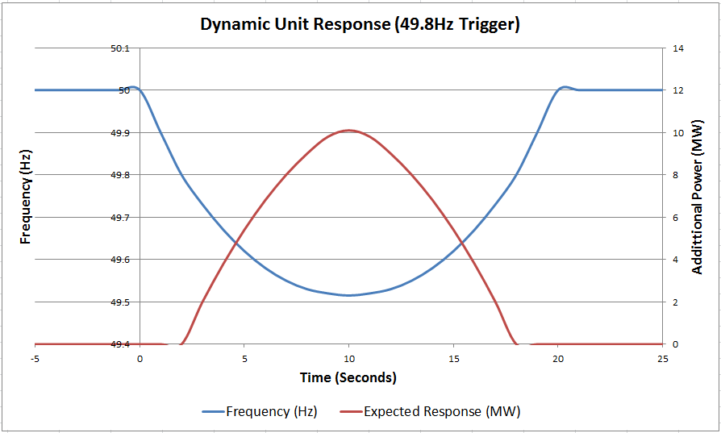
Figure 2: Example of a Dynamic unit response with a trigger point of 49.8Hz
As shown in figure 2, above, as the frequency drops the unit does not respond until the trigger point is reached (in this example the trigger point is set at 49.8Hz). When this point is reached the unit output begins ramping up in discrete steps (steps in accordance with the requirements stated in section 5.3.1), staying as close as possible to the expected output. The output steps down also as the frequency returns to nominal (50Hz). This is what is expected of a dynamic response.

Static response capability requirements
A Static response is where the Unit provides its entire response at one single trigger point.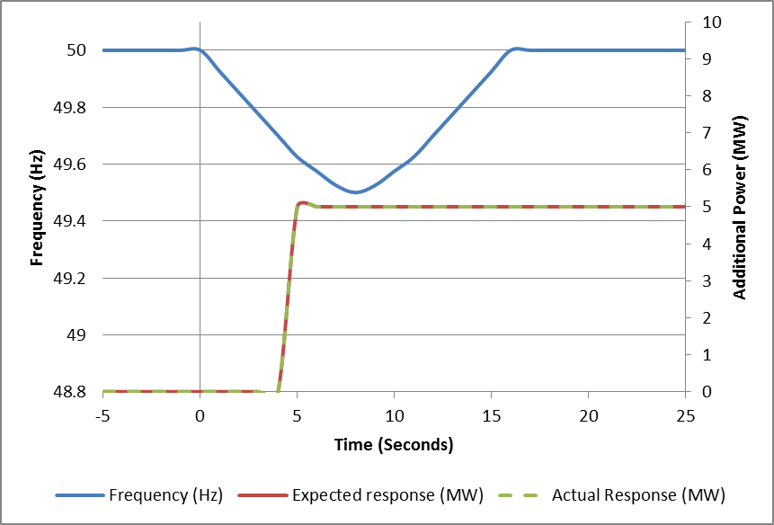
Figure 3: Example of a Static response from a unit with a trigger point of 49.8Hz

site Safety requirements
The following is required for the EirGrid/SONI witness to attend site:
Personal Protective Equipment Requirements  - Site Safety boots  - Hard Hat with chin strap  - Hi Vis  - Arc Resistive clothing  - Safety Glasses  - Gloves  - Safe Pass | - Yes / No  - Yes / No  - Yes / No  - Yes / No  - Yes / No  - Yes / No  - Yes / No
Site Induction requirements | Yes / No  (If Yes, Unit to specify how and when the induction must carried out)
Any further information | Unit to specify

Test Description and Pre Conditions

Purpose of the Test
The purpose of this test is to verify:
- The lowest sustainable amount of energy provided by the unit in the timeframe between the FFR Response Time and 10 seconds after a frequency event.
- The unit does not draw in more energy in the ten second timeframe after the event than it provided in the initial 10 seconds.
- The levels of Primary, Secondary and Tertiary Operating Reserves provided by the unit.
- Verify that the unit meets the conditions for dynamic response (For dynamic response only)
- Verify the trigger frequency(ies) of the Unit.
- Verify the response time of the Unit.
This is achieved by injecting simulated reference frequencies at different export and import levels and analysing the responses of the unit to those injections
Description | Comment
Is the frequency injected using software or external hardware? | Unit to specify
Can the frequency be injected as a ramp or as a step? | Unit to specify
Frequency injected as an offset to the system frequency or is the governor/control system isolated from the system frequency? | Unit to specify

Throughout the test procedure, for instances where APC/EA is OFF it is noted that the expected MW output is 0MW. It is understood that there may be small MW imports at the connection point to account for house load, unless otherwise instructed by the TSO.

Instrumentation and Onsite Data Trending
All of the following trends and screenshots must be recorded by the Unit during the test. Failure to provide any of these trends will result in test cancellation.

No. | Signal Name | Sample Rate | Source
1 | Available active power export (MW) | Unit to Specify (≥ 10 Hz) | Unit to Specify
2 | Available active power import (MW) | Unit to Specify (≥ 10 Hz) | Unit to Specify
3 | Actual active power (MW) | Unit to Specify (≥ 10 Hz) (20 ms for FFR Scalar Product) | Unit to Specify
4 | APC/EA (ON/OFF) | Unit to Specify (≥ 10 Hz) | Unit to Specify
5 | APC/EA set-point received from NCC/CHCC (MW) | Unit to Specify (≥ 10 Hz) | Unit to Specify
6 | ESPS Frequency Response (ON/OFF) | Unit to Specify (≥ 10 Hz) | Unit to Specify
7 | ESPS Reserve Response Mode (1 - 5) | Unit to Specify (≥ 10 Hz) | Unit to Specify
8 | Simulated Test Frequency (Hz) | Unit to Specify (≥ 10 Hz) (20 ms for FFR Scalar Product) | Unit to Specify
9 | Grid Frequency (Hz) | Unit to Specify (≥ 10 Hz) | Unit to Specify
10 | ESPS Useable Energy Remaining (MWh) | Unit to Specify (≥ 10 Hz) | Unit to Specify
11 | ESPS Total Useable Storage Capacity (MWh) | Unit to Specify (≥ 10 Hz) | Unit to Specify
12 | FFR Availability (MW) | Unit to Specify (≥ 10 Hz) | Unit to Specify
13 | POR Availability (MW) | Unit to Specify (≥ 10 Hz) | Unit to Specify
14 | SOR Availability (MW) | Unit to Specify (≥ 10 Hz) | Unit to Specify
15 | TOR1 Availability (MW) | Unit to Specify (≥ 10 Hz) | Unit to Specify
16 | TOR2 Availability (MW) | Unit to Specify (≥ 10 Hz) | Unit to Specify
17 | Other signals as required by the unit or by the TSO | Unit to Specify (≥ 10 Hz) (20 ms for FFR Scalar Product) | Unit to Specify
18 | Alarm/Event page | Screenshot of alarms / events for duration of the test.
19 | Generator Overview Screen | Screenshots may be required where test data/milestone/event is not available through the trends listed above.
20 | EDIL instructions | Screenshot as logged during the test.

Additional signals for system services
Please note that the list of signals required for this test, as stated above in Section 8, may be altered at any time to include any additional signals deemed necessary to demonstrate the provision of system services. If in any doubt please contact the generator testing team at: generator_testing@eirgrid.com or generator_testing@soni.ltd.uk.

Initial Conditions
Should “No” be answered to any of the following, contact the EirGrid/SONI test coordinator and agree next steps in advance of making any corrective actions.
No. | Conditions | Check on day of test
1 | Test Profiles have been submitted and approved by EirGrid/SONI | Yes/No
2 | The State of Charge of the Battery Unit is sufficient to complete the tests (XX%) | Yes/No
3 | Required signals, as described in section 8 are available | Yes / No

Frequency Mode Settings
 | Active under frequency trigger setting (Hz) | Active under frequency trajectory setting (Hz) | Active Maximum under frequency response setting (MW) | Active over frequency trigger setting (Hz) | Active over frequency trajectory setting (Hz) | Active Maximum over frequency response setting (MW)
Mode 2 | TBC | TBC | Operating range | TBC | TBC | Operating range
ESPS to update table below with Mode 2 settings implemented as per unit specific signal list.

Test Steps

Frequency Trigger Tests
The following test steps are to verify the high and low frequency deadbands as well as demonstrating proportional dynamic response in advance of full Dynamic Frequency Response testing (9.2).

FREQUENCY TRIGGER TEST
Step No. | Action | Time | Comments
1 | ESPS begins data recording for all trends noted in Section 8 above |  | Operator Name ___________  Date ____________
2 | ESPS requests permission from NCC/CHCC to proceed with the Frequency Response ON, Mode 2 test and confirms the following with NCC/CHCC:  - ESPS Useable Energy Remaining (MWhr)  - MW set-point is 0MW  - APC/EA is OFF  - MW output of the ESPS is 0MW  - Frequency Response is ON  - Frequency Response is in Mode 2  - Active Under frequency Trajectory setting  - Active Under frequency Trigger setting  - Active Maximum under frequency response setting  - Active Over frequency Trajectory setting  - Active Over frequency Trigger setting  - Active Maximum over frequency response setting  Note: The standard trigger test is an injection of 0.05Hz above and below the Mode 2 trigger setting. In the case that this would result in large MW step changes, for example for units with small trajectory settings, changes to these test steps should be discussed with Generator Testing.
3 | ESPS replaces the system frequency with a simulated frequency of 50 Hz and waits 1 minute.  Expected MW Output = [Insert Target MW] |  | AAP = ____ MW  MW Output = ____ MW
4 | ESPS requests permission from NCC/CHCC to inject a simulated frequency step injection of 0.05Hz inside active under frequency trigger [insert value of injection here __ Hz] and waits 1 minute  Expected MW Output = [Insert Target MW] |  | For frequency ≥ F1 and ≤ F3, no response shall be provided  MW Output = ____ MW
5 | ESPS requests permission from NCC/CHCC to inject a simulated frequency step injection of 0.05Hz outside active under frequency trigger [insert value of injection here __ Hz] and waits 1 minute  Expected MW Output = [Insert Target MW] |  | ESPS shall ramp at the Frequency response ramp rate  MW Output = ____ MW
6 | ESPS requests permission from NCC/CHCC to inject a simulated frequency step injection of 50Hz and waits 1 minute  Expected MW Output = [Insert Target MW] |  | MW Output = ____ MW
7 | ESPS requests permission from NCC/CHCC to inject a simulated frequency step injection of 0.05Hz inside active over frequency trigger [insert value of injection here __ Hz] and waits 1 minute  Expected MW Output = [Insert Target MW] |  | For frequency ≥ F1 and ≤ F3, no response shall be provided  MW Output = ____ MW
8 | ESPS requests permission from NCC/CHCC to inject a simulated frequency step injection of 0.05Hz outside active over frequency trigger [insert value of injection here __ Hz] and waits 1 minute  Expected MW Output = [Insert Target MW] |  | ESPS shall ramp at the Frequency response ramp rate  MW Output = ____ MW
9 | ESPS requests permission from NCC/CHCC to inject a simulated frequency step injection of 50Hz and waits 1 minute  Expected MW Output = [Insert Target MW] |  | MW Output = ____ MW
10 | ESPS requests NCC/CHCC to issue an APC/EA set-point of 0 MW and turn APC/EA OFF and waits 1 minute after set-point has been achieved
11 | ESPS to confirms simulated frequency of 50Hz is in place
12 | ESPS ends data recording
13 | ESPS informs NCC/CHCC that the Frequency Trigger test is complete. Return to standard settings
Note any issues or deviations from test procedure
For example changes in step size, duration, test operators, parameter changes on site.

Mark as “No Comment” if test proceeded as per procedure.

Dynamic Frequency Response
The following test steps are to verify the amount of FFR, POR, SOR, TOR1 & TOR2 available. The unit shall agree in advance with EirGrid / SONI which tests the unit shall be undertaking on the day.

Dynamic Frequency Response testing (9.2) will only commence upon successful completion of deadband testing (9.1)

DYNAMIC FREQUENCY RESPONSE TESTS
Step | Action | Time | Comment
1 | ESPS begins data recording for all trends noted in Section 8 above |  | Operator Name ____________  Date ____________
2 | ESPS requests permission from NCC/CHCC to proceed with the Frequency Response ON, Mode 2 test and confirms the following with NCC/CHCC:  - ESPS Useable Energy Remaining (MWhr)  - MW set-point is 0MW  - APC/EA is OFF  - MW output of the ESPS is 0MW  - Frequency Response is ON  - Frequency Response is in Mode 2  - Active Under frequency Trajectory setting  - Active Under frequency Trigger setting  - Active Maximum under frequency response setting  - Active Over frequency Trajectory setting  - Active Over frequency Trigger setting  - Active Maximum over frequency response setting |  | - ___MWhr  - MW set-point __MW  - APC status ___  - MW output ___ MW  - Frequency Response status _____  - Mode 2 status ___  - ___ Hz  - ___ Hz  - ___ MW  - ___ Hz  - ___ Hz  - ___ MW
3 | ESPS replaces the system frequency with a simulated frequency of 50 Hz and waits 1 minute.  Expected MW Output = [Insert Target MW] |  | AAP = ____ MW  MW Output = ____ MW
4 | ESPS requests NCC/CHCC to turn APC/EA ON and issue an APC/EA set-point of [insert 100% MIC] MW and waits 1 minute after set-point has been achieved
5 | ESPS requests permission from NCC/CHCC to inject a simulated frequency step injection of under frequency trigger-trajectory [insert value of injection here __ Hz] and waits 20 minutes*  Expected MW Output = [Insert Target MW]  Note 1: Unless capacity limited, the ESPS should remain at this output until the frequency is returned towards 50Hz in step 6.  Note 2: If the Battery ESPS has a greater capacity than 20 minutes, the timing for this step can be extended to demonstrate this.
6 | ESPS requests permission from NCC/CHCC to inject a simulated frequency ramp injection of 50Hz over 1 minute and waits 1 minute  Expected MW Output = [Insert Target MW]
7 | ESPS requests NCC/CHCC to turn APC/EA ON and issue an APC/EA set-point of [insert 100% MEC] MW and waits 1 minute after set-point has been achieved
8 | ESPS requests permission from NCC/CHCC to inject a simulated frequency step injection of over frequency trigger + trajectory [insert value of injection here __ Hz] and waits 1 minute*  Expected MW Output = [Insert Target MW]  * If the Battery ESPS unit has contracted for over-frequency services as part of the Volume Capped arrangements, the timing of this step should be extended. |  | ESPS shall ramp at the Frequency response ramp rate  MW Output = ____ MW
9 | ESPS requests permission from NCC/CHCC to inject a simulated frequency ramp injection of 50Hz over 1 second and waits 1 minute  Expected MW Output = [Insert Target MW] |  | MW Output = ____ MW
10 | ESPS requests NCC/CHCC to issue an APC/EA set-point of 0 MW and turn APC/EA OFF and waits 1 minute after set-point has been achieved
11 | ESPS ends data recording
12 | ESPS informs NCC/CHCC that the Frequency Response ON, Mode 2 test is complete. If further testing is not being completed, return to standard settings
Note any issues or deviations from test procedure
For example changes in step size, duration, test operators, parameter changes on site.

Mark as “No Comment” if test proceeded as per procedure.

Return to Standard Settings
The ESPS settings are returned to standard following completion of the Operating Reserve Test.
Step No. | Action | Time | Comments
1 | ESPS removes the simulated frequency, returning the ESPS reference to system frequency |  | Operator Name ____________  Date ____________
2 | ESPS confirms the following with NCC/CHCC:  - APC/EA Set-point = 0MW  - APC/EA is OFF  - MW output of the ESPS  - Frequency Response is ON  - Frequency Response is in Mode 1 (or as agreed with NCC/CHCC)  - ESPS Control System frequency reference is system frequency |  | - ____ MW  - Status ____  - ____ MW  - Status ____  - Mode ____  - Frequency Reference __________
3 | ESPS informs NCC/CHCC that Frequency Response testing is complete

Comments & Sign-off
Comments:

Unit Witness signoff that this test has been carried out according to the test procedure above.
Signature: __________________________________ Date / Time: ____________________
EirGrid/SONI Witness signoff that this test has been carried out according to the test procedure above.
Signature: __________________________________ Date / Time: ____________________

http://www.eirgrid.com/operations/gridcode/compliancetesting/cdgutestprocedures/#d.en.17699
Definitions form DS3 System Services Decision Paper SEM-13-098: https://www.semcommittee.com/sites/semcommittee.com/files/media-files/SEM-13-098%20%20DS3%20System%20Services%20Technical%20Definitions%20Decision%20Paper%20-%20FINAL_0.pdf
Where average step size = (Available FFR volume / number of discrete steps)
Trajectory is defined in the DS3 System services contract paper Pg.39: http://www.eirgridgroup.com/site-files/library/EirGrid/DS3-System-Services-Contracts-Recommendations_final.pdf
DS3 System Services Technical Definitions Decision Paper SEM-13-098 20/12/2013, page 10 https://www.semcommittee.com/sites/semcommittee.com/files/media-files/SEM-13-098%20%20DS3%20System%20Services%20Technical%20Definitions%20Decision%20Paper%20-%20FINAL_0.pdf
For example, a battery charging to its pre-event output

