Steady-State Reactive Power (SSRP)
System Services
Test Report
Battery
Unit Name

DISCLAIMER:
This Document contains information (and/or attachments) which may be privileged or confidential. All content is intended solely for the use of the individual or entity to whom it is addressed. If you are not the intended recipient please be aware that any disclosure, copying, distribution or use of the contents of this message is prohibited. If you suspect that you have received this Document in error please notify EirGrid or its subsidiaries immediately. EirGrid and its subsidiaries do not accept liability for any loss or damage arising from the use of this document or any reliance on the information it contains or the accuracy or up to date nature thereof. Use of this document and the information it contains is at the user’s sole risk. In addition, EirGrid and its subsidiaries strongly recommend that any party wishing to make a decision based on the content of this document should not rely solely upon data and information contained herein and should consult EirGrid or its subsidiaries in advance.
Further information can be found at: http://www.eirgridgroup.com/legal/

Document Version History
Revision 2.0, published 12th November 2019

Version | Date | Comment | Name | Company
0.1 | Insert date | Minor version (v0.1) - First submission for review and approval | Insert name | Insert company
1.0 | Insert Date | Revised to version 1.0 following approval by EirGrid, SONI. | Insert Name | Unit Company Name

Introduction
The Unit shall submit the latest version of this test report template as published on the EirGrid or SONI websites.
The report shall be developed for technical and non-technical readers and shall follow the agreed test programme. The report is submitted to generator_testing@eirgrid.com or generator_testing@soni.ltd.uk as appropriate.
Submission of this document is required if a Unit does not have and existing SSRP contract or is making changes or updates to any of the effected parameters.
To complete the report, the Unit shall have either:
- Recorded active and reactive power data as per the test procedure agreed with EirGrid, SONI; or
- Performance Data showing full reactive power capability.
Any issue with meeting any requirements or completing this report, please contact generator_testing@eirgrid.com or generator_testing@soni.ltd.uk as appropriate.

Abbreviations
SSRP Steady-State Reactive Power
MVAr Mega Volt Ampere – reactive
MW Mega Watt
TSO Transmission System Operator
MEC Maximum Export Capacity
RP Reactive Power
kV kilovolt
Hz Hertz – unit of frequency
AVR Automatic Voltage regulation
DMOL Defined Minimum Operating Level
Q_{range} Maximum MVAr range (from full lagging to full leading) that the unit can provide at the connection point.
P_{range} Maximum MW range that the unit can deliver while also being able to provide reactive power at the connection point.
P_{Max} Maximum MW amount the unit can deliver while also providing reactive power at the connection point.
P_{Min} Minimum MW amount the unit can deliver while also providing reactive power at the connection point.
Q_{Max} Maximum Lagging Mar that can be delivered over the full P_{range}.
Q_{Min} Minimum Leading MVAr that can be delivered over the full P_{range}.

Unit Data
Battery Name | Battery to Specify
Battery Test Coordinator and contact number: | Battery to Specify
Battery Location | Battery to Specify
Battery connection point | HV Bushings of T101 in XX 110kV station
Battery connection voltage | Battery to Specify
Installed Battery type, Module size and quantity | Battery to Specify
Contracted MEC | Battery to Specify
Registered Capacity | Battery to Specify
Limiter applied to Exported MW | Battery to Specify
Limiter applied to AAP | Battery to Specify
DMOL | Battery to Specify
Is the AVR fully commissioned and functional? | Yes/No
Voltage Regulation Slope Setting | _______%

System Services
The definitions referenced in this document are for indicative purposes only. In the event of inconsistency between the definitions in this document and those in the DS3 System Services Agreement, the definitions in the DS3 System Services Agreement shall prevail.

Steady-State Reactive Power
SSRP is defined as the dispatchable reactive power range (Q_{Range}) in MVAr that can be provided across the full range of active power output (P_{Range}). For Battery, P_{Range} may or may not be limited by DMOL.

Reactive Power Factor calculation
$$RP Factor= \frac{Active Power Range across which reactive power can be provided \left(P_{Range}\right)}{Registered Capacity}$$
$$SSRP Volume= Q_{Range} x RP Factor$$

Assessment
Q_{min} is the maximum leading MVAr that can be delivered over the full P_{range}. Q_{max} is the maximum lagging MVAr that can be delivered over the full P_{range}.
P_{range} is the MW range over which the Battery can deliver the Q_{range}.
Q_{min} and Q_{max} are based on reactive power measured at the connection point.
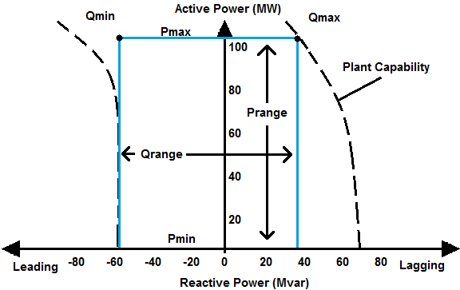
Figure 1: Example graph showing a unit with reactive capability down to 0 MW.
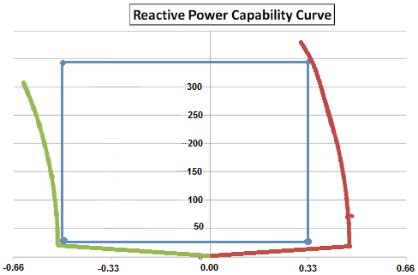
Figure 2: Example graph of a with no reactive power capability at 0 MW

Results

Summary
Testing was completed on [DATE].
[Comment on the results, highlighting any issues encountered in performing the test or in analysing the results.]
[Insert Report summary]
[Include any relevant test notes here, relating to how the test was carried out or to any specific conditions encountered during the test.]
[Abnormal behaviour in the data (spikes, dips, unusual vibrations, etc.) shall be noted and documented. The reasons behind these shall be detailed along with any corrective actions taken and what its effects are on the unit and/or the result. If possible a clear graph of the issue should also be presented].
[Data shall be presented as a full PQ chart with significant points highlighted and clearly labelled. A table of values and/or results shall accompany the graph.]

1MW resolution – Table of Results
The table will be list of the MVAr values at 1MW intervals both modelled and measured.
Reading | Importing/ Leading – Measured | Exporting/  Lagging - Measured | Importing/  Leading - Modelled | Exporting/  Lagging - Modelled
MVAr at 100% of Registered Capacity | ____ MVAr | ____ MVAr | ____ MVAr | ____ MVAr
[Unit shall amend this table and include 1MW intervals from Registered capacity] | ____ MVAr | ____ MVAr | ____ MVAr | ____ MVAr
 | ____ MVAr | ____ MVAr | ____ MVAr | ____ MVAr
 | ____ MVAr | ____ MVAr | ____ MVAr | ____ MVAr
 | ____ MVAr | ____ MVAr | ____ MVAr | ____ MVAr
MVAr at 5MW | ____ MVAr | ____ MVAr | ____ MVAr | ____ MVAr
MVAr at 4MW | ____ MVAr | ____ MVAr | ____ MVAr | ____ MVAr
MVAr at 3MW | ____ MVAr | ____ MVAr | ____ MVAr | ____ MVAr
MVAr at 2MW | ____ MVAr | ____ MVAr | ____ MVAr | ____ MVAr
MVAr at 1MW | ____ MVAr | ____ MVAr | ____ MVAr | ____ MVAr
MVAr at 0 MW | ____ MVAr | ____ MVAr | ____ MVAr | ____ MVAr

System Services Parameters – Table of results
Point | Value
Registered capacity (Pmax), full lagging | _________MW, _______MVAr
Registered capacity (Pmax), full leading | _________MW, _______MVAr
Minimum Load/ Minimum Generation (Pmin), full lagging | _________MW, _______MVAr
Minimum Load/ Minimum Generation (Pmin), full leading | _________MW, _______MVAr
Maximum leading MVAr that can be delivered over the full P_{range}. (Q_{min} )

Maximum lagging MVAr that can be delivered over the full P_{range} (Q_{max} )

System Services Values
Reading | Value | Comment
Registered Capacity | ______MW
P range | _______MW to _____MW
Q range | ______MVAr to _______MVAr | (Qmin to Qmax as identified above in Table 7.3)
RP factor |  | Insert Calculation and value per Section 6.2
SSRP volume |  | Insert Calculation and value as per Section 6.2
Q range at 0 MW | ______MVAr to _______MVAr
Cable Network Charging Capacitance including filters, etc. | 0 MW, _______MVAr | With Battery Modules disconnected

Graph of results
[Insert a full graph of the results showing the full reactive power capability of the unit, all relevant values shall be displayed, such as the full Q range (x-axis) and the full P range (y-axis). Each corner point must also have its value clearly labelled; the chart shall also have the theoretical values shown.]
[Include any relevant test notes here, relating to how the test was carried out or any specific conditions encountered during this test.]

http://www.eirgridgroup.com/ or http://www.soni.ltd.uk/

