Energy Identification Codes FAQ

What are Energy Identification Codes (EIC)?
The Energy Identification Coding scheme (EIC), standardized and maintained by ENTSO-E (European Network of Transmission System Operators for Electricity), provides a unique identification of the Market Participants and other entities active within the Energy Internal European Market (IEM). It is widely used in the Electronic Document Interchange.
An Energy Identification Code (EIC) is a 16 digit alphanumeric code issued upon a request from a Market Participant.

What do Energy Identification Codes (EIC) identify?
EIC Party X codes identify an organization or legal entity that actively trades within the Energy Internal European Market (IEM).
Over and above Market Participants (Parties - object type "X"), the EIC scheme also covers other entities by allocating a unique EIC code to the following object types:
- Areas – object type “Y”, Areas for inter System Operator data interchange
- Measuring Points – object type “Z”, Energy Metering points, interconnector units
- Resource objects – object type “W”, such as generation plants, demand side units, consumption units, etc.
- Tie-lines – object type “T”, International tie lines between areas
- Location – object type “V”, Physical or logical place where a Market Participant or IT system is located
- Substation – object type “A”, Substations for electrical nodes (stations, passive nodes, etc.).
- How can I obtain an EIC code?
To request an EIC code, please complete the EIC Request Form and send it to eic@EirGrid.com. A guide to completing the EIC Request Form can be found below after Question 18.
- Who should I request EIC codes from?
EIC codes should be requested from the Local Issuing Office (LIO) where the EIC Participant is VAT registered. LIO EirGrid acts as the LIO for the Island of Ireland (NI and ROI) and therefore, can issue EIC Party (X) codes for EIC Participants who are VAT registered in the Republic of Ireland and Northern Ireland. An object type EIC code (Y, Z, W, T, V, A) should be requested from the LIO in the jurisdiction of that asset.
Requests for Area “Y” codes, Tie-lines “T” and Location “V” codes should be requested from the CIO (ENTSOE).
- How do I update the attributes/ details attached to an EIC code?
Any updates to existing EIC code attributes can be requested by completing the “Update of information for existing code” section of the EIC Request Form and sending this to eic@EirGrid.com. Such updates will not change the EIC code itself as only the attributes attached to an EIC code can be updated.
- How do I deactivate an existing EIC code?
To request to deactivate an existing EIC code the “Deactivation of EIC code” section of the EIC Request Form must be completed and sent to eic@EirGrid.com. Upon receipt of this request, EirGrid will contact the requester regarding the deactivation of the EIC code.
- How long does it take, from receipt of the EIC Request Form; to issue an EIC code?
LIO EirGrid is not obliged to follow any external or internal timelines for the issue of EIC codes upon receipt of an EIC Request Form. However, EirGrid endeavor to issue EIC codes within 5 working days from receipt of completed EIC Request Form.
- What is an ‘international’ EIC code?
An ‘international’ EIC code is allocated for activities on one or several geographical area(s) which may cross borders with another country. These can be issued by LIO EirGrid; however they are published by the Central Issuing Office (CIO) (ENTSO-E).
- What is a ‘local’ EIC code?
A ‘local’ EIC code is allocated for activities limited to a single geographical area and is not used in another country. All local EIC codes are published on the EirGrid website.

What is the EIC parent and when should it be used?
The EIC Parent identifies the relationship between the parent and child objects. This allows the issuing office to define a hierarchy of units. EIC Parents define a relationship between two EIC codes of the same type (e.g. a Company with its Subsidiary, a Production Unit with its Generating Unit, an area with a sub-area etc.)
W Code (child object) X Code (parent object)

What is the EIC Responsible Party and when should it be used?
EIC Responsible Party identifies the party responsible for the management of A, T, V, Y, W or Z object types. For EIC codes of type W, the EIC Responsible Party should identify the owner of the Generator or Demand Side Unit. It shows the relationship between the EIC Party (X) code (which is issued based on legal entity or at organisational level) and the Resource Object (W) code (e.g. Generation Unit).
W Code X Code
Currently, the EIC Responsible Party attribute is not used as part of EMFIP Reporting or REMIT Reporting; however it is likely to be used in further stages of reporting.
- What is the company function and why is it required?
The company function is a mandatory attribute attached to each EIC code which is used to describe the activities of the organisations or object type. Up to four functions can be attached to each EIC code issued. Please consult the ‘list of allowed functions’ tab on the EIC Request Forms to see which functions are acceptable for each EIC code type.

What is the Display Name?
The Display Name is a short name to be used for display on screen and verbal communication. Within each category (Party, area, metering point, etc.) the Display Name will be unique. This is issued along with every EIC code at the time that the Local Issuing Office (LIO) issues the requested EIC code.
- Where can I find a list of EIC codes?
A list of all ‘local’ EIC codes can be found on the EIC section of the EirGrid website. Please access the below link to see the current EIC code List:
http://www.eirgridgroup.com/customer-and-industry/general-customer-information/eic-codes/
A list of all ‘international’ EIC codes can be found on the ENTSO-E website. Please access the below link to see the current International EIC code List:
https://www.entsoe.eu/data/energy-identification-codes-eic/eic-code-lists/Pages/default.aspx
Please note that both ‘local’ and ‘international’ EIC code lists are updated by close of business every Monday.
- What is the role of the EIC Central Issuing Office (CIO)?
ENTSO-E acts as the Central Issuing Office (CIO) for all EIC codes.
The CIO supplies and administers EIC codes for Local Issuing Offices, Areas, Interconnectors and System Operators. It is responsible for the collection, integration and publication of all the international EIC codes received from the LIOs. It also maintains the Central EIC repository (EIC codes used within the Internal European Market) and ensures that no duplicate entries exist.

What EIC code type should I request for my organisation/ legal entity?
The EIC code that must be requested for your organisation is an EIC X code. The EIC code of type X is used to identify a Party. It identifies Market Participants that can trade one or more energy commodities (electricity, gas, etc.). Each organization/legal entity can only have one EIC Party X code.
- What is the difference between a generation EIC code and a production unit EIC?
A Production Unit is understood to be a facility for generation of electricity made up of a single Generation Unit or of an aggregation of Generation Units. A Generation Unit is said to be a single electricity generator belonging to a Production Unit.
- I have EIC codes which my organisation did not request. Why were these EIC codes issued and where are they used?
In order to comply with fundamental data reporting under Electricity Market Fundamental Information Platform (EMFIP), Energy Identification Codes were issued automatically by LIO EirGrid, to all conventional generation plants and respective organisations registered in the Single Electricity Market, in August 2014. The ENTSO-E Transparency Platform does not allow for individual Generator Unit registration and must be associated with a Production Unit. In addition TSO EirGrid are required to send outages of Generation Units above 100 MW of their installed capacity should the Generator Unit (GU) members of Production Unit (PU) outages exceed 200 MW, the TSO is required to submit the PU and withdraw the GU outages. As a result, EIC Resource Object W codes were automatically issued for all Generation and Production Units. The relevant EIC Party X codes were issued for each organisation for the corresponding Generation and Production Units.

For more information on Energy Identification Codes, please refer to the ENTSO-E website:
https://www.entsoe.eu/data/energy-identification-codes-eic/Pages/default.aspx
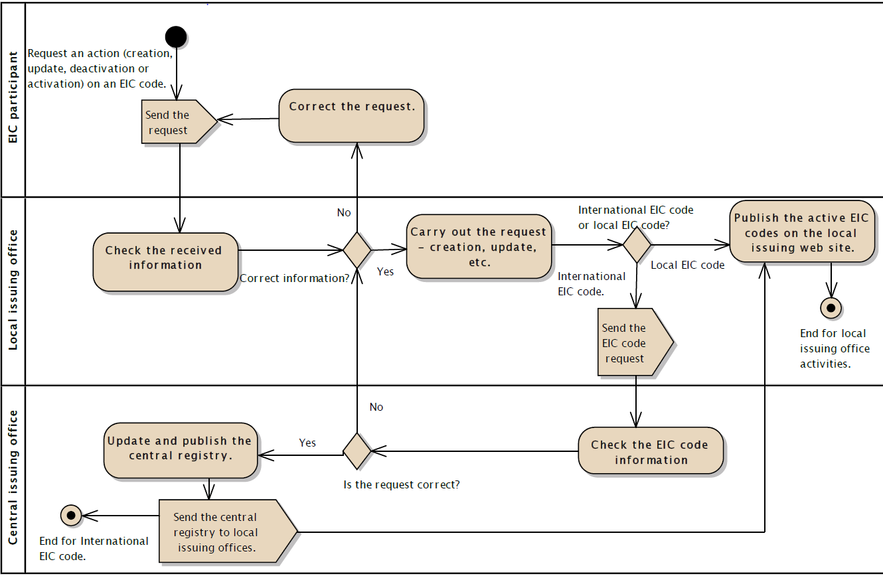
Figure 1: Process for issuing EIC code

Guide to completing EIC Request Form
The EIC Request Form can be found on the EIC section of the EirGrid website. Please use the below link to access the request form:
http://www.eirgridgroup.com/site-files/library/EirGrid/EIC-Request-Form.xlsx
All completed EIC Request Forms should be sent to eic@EirGrid.com
Step 1: Agree to accept the terms in the EIC Reference Manual by ticking the tick box on the “Introduction” tab of the EIC Request Form. Then hit Begin Request.

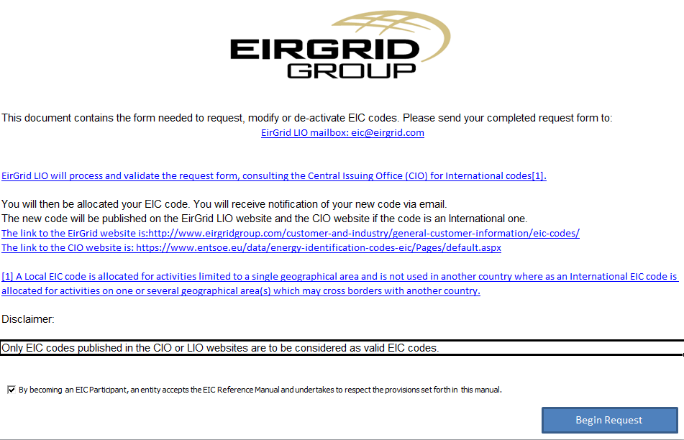
Step 2: Complete the company details. All fields in blue are mandatory. For definitions and guidance on how to complete Company function and EIC Locality fields, please refer to answers 13, 9 and 10 above.

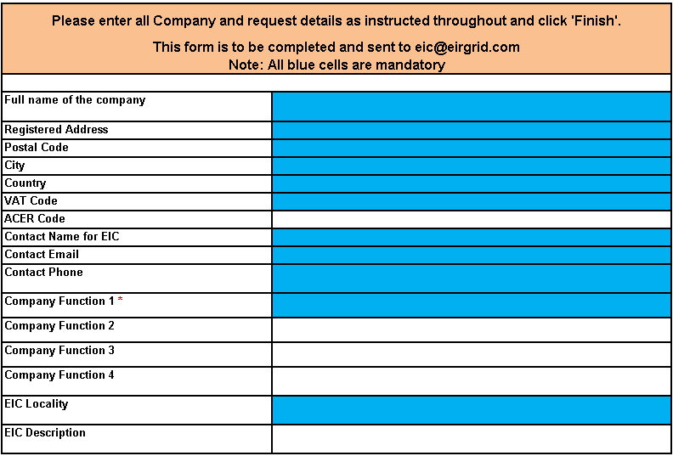
Step 3: Complete the relevant section below.
- Request new EIC code: Please complete the “creation of EIC code” section only
- Request update of attributes attached to existing EIC code: Please complete the “Update of information for existing code” section only
- Request deactivation of existing EIC code: Please complete the “Deactivation of EIC code” section only.
Please refer to answers 4, 6 and 7 above for guidance on the relevant section.
For new EIC code Requests, this form relates to new requests for all code types. Please refer to the comments detailed in each field when completing step 3.

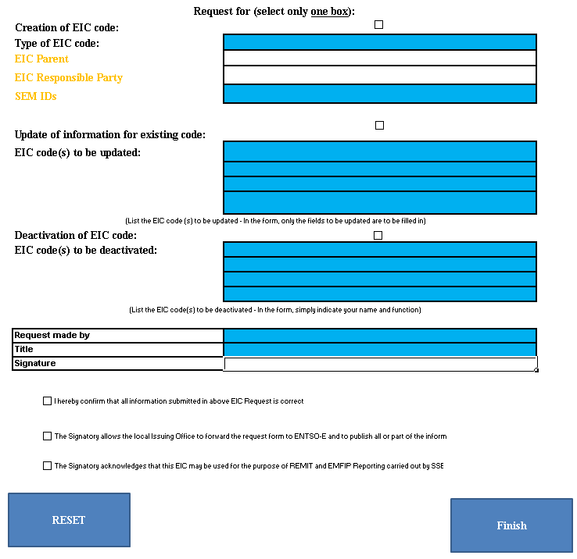
Step 4: Sign off and tick the three tick boxes to confirm agreement with these terms with respect to the EIC code being requested. These tick boxes are not applicable to requests to update or deactivate existing EIC code(s).
Example of new EIC ‘W’ code Request
The screen shot below shows an example of an EIC W code request form.
Step 1:
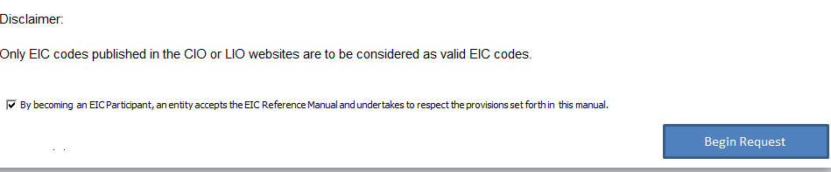
Step 2:
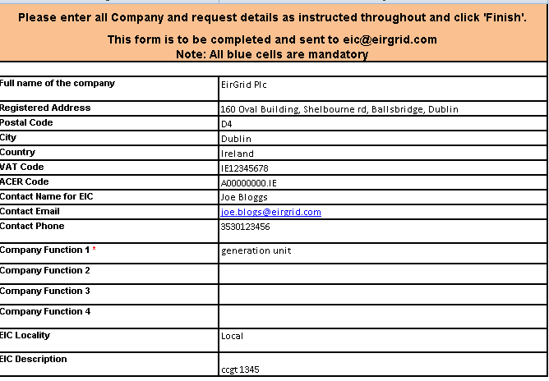
Step 3:
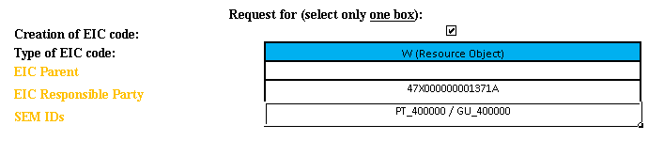
Step 4:
