DS3 System Services
Compliance and Testing Capability Management
Guidance Document

Tuesday, 12 December 2017
DISCLAIMER:
This Document contains information (and/or attachments) which may be privileged or confidential. All content is intended solely for the use of the individual or entity to whom it is addressed. If you are not the intended recipient please be aware that any disclosure, copying, distribution or use of the contents of this message is prohibited. If you suspect that you have received this Document in error please notify EirGrid or its subsidiaries immediately. EirGrid does not accept liability for any loss or damage arising from the use of this document or any reliance on the information it contains or the accuracy or up to date nature thereof. Use of this document and the information it contains is at the user’s sole risk. In addition, EirGrid strongly recommends that any party wishing to make a decision based on the content of this document should not rely solely upon data and information contained herein and should consult EirGrid in advance.
Further information can be found at: http://www.eirgridgroup.com/legal/
Contents
1 System Service Capability Management 3
2 DS3 System Services Prtocol 3
3 DS3 Performance Measurement Device Standards for Fast Acting Services 3
4 Compliance Documentation 4
5 DS3 System Service Product Overview 5
6 List of Proven Technologies 6
7 Compliance Evidence 7
7.1 New Units 7
7.2 Existing Units 7
7.3 Performance Scalars 7
8 characteristic changes 7
9 System Services Signals and controls 8
9.1 Signalling requirements 8
9.2 Signals Lists updates 8
10 Test Scheduling, execution and tariffs 8
10.1 Wind Farm Power Stations 8
10.1.1 WFPS Test Request Process 9
10.2 Conventional 9
10.2.1 Within Day Test 9
10.2.2 Full Day Test 9
10.2.3 Commissioning Unit 9
10.2.4 Testing tariffs 9
10.3 Execution and Post Test follow up 10
11 Product compliance information 10
11.1 Synchronous Inertial Response (SIR) 10
11.1.1 Minimum generation testing 10
11.1.2 Minimum Load Testing 11
11.2 FFR, POR, SOR & TOR1 11
11.2.1 Synchronous Machines, Interconnectors and WFPS 11
11.2.2 DSU Aggregators 12
11.3 TOR2, RM1, RM3, RM8 12
11.4 Steady State Reactive Power 12
11.5 Nodal Controller 12
12 Performance Scalar Testing 14
13 Imporatant Dates 15
14 Contact Details 15
14.1 Contracts and Settlement 15
14.2 Neartime 15
14.3 Compliance and Testing 15

System Service Capability Management
The compliance testing process builds on the learnings from qualification trials process, implements the protocol requirements and ensures unit evidence is gathered effectively in safe, secure manner
For a unit to receive a contract to provide System Services they are required to demonstrate evidence of their capabilities in line with TSO requirements. This can be achieved through the compliance and testing processes in advance of contracting.
Existing service providers who wish to contract for enhanced capabilities must engage in changing operating characteristics and demonstrate enhanced capabilities.
System Service requirements are in addition to the standard Grid Code and are outlined through the System Service Documentation.
Further information on System Services testing and compliance requirements is available online.

DS3 System Services Prtocol
This DS3 System Services Protocol document is supplementary to the DS3 System Services Agreement. It provides information on Operational Requirements and Performance Monitoring requirements that need to be satisfied by Service Providers and their respective Providing Units as part of the DS3 System Services contractual arrangements. It is one of two supplementary documents referenced in the main Agreement.

DS3 Performance Measurement Device Standards for Fast Acting Services
This document sets out the minimum standards and compliance requirements for performance monitoring of DS3 System Services through the use of third party measurement devices i.e. devices not owned and operated by the TSOs. The minimum standards vary depending on both the nature and characteristics of each system service and additional requirements may apply to certain technology classes.
If the TSO has Monitoring Equipment that meets the minimum standards installed at the Service Provider’s location then data from this may be used for the purpose of performance assessment of Fast Acting Services for a maximum period of 24 months from contract execution. After this time the Service Provider must have installed its own Monitoring Equipment, unless otherwise agreed by the TSO.
The DS3 System Services Protocol details the process to be followed in relation to submission of data by the Service Provider for the purposes of Performance Monitoring.

Compliance Documentation
The table below shows what compliance testing documents are available or being developed for which of the DS3 System Services.
Service  Technology | SIR | FFR, POR, SOR, TOR1 | Ramping Services (TOR2, RRD/RRS RM1, RM3, RM8) | SSRP
Large scale centrally dispatched generating units (Coal, Gas turbine, Pumped Hydro, etc.) | Test Procedure  Test Report | Test Procedure  Test Report | Test Report | Test Procedure  Test Report
Wind Farm (Full converter, Emulated Inertia, etc.) | Not Qualified | Test Procedure  Test Report | Not Qualified | Test Procedure  Test Report
Interconnectors | Not Qualified | Test Procedure  Test Report | Test Report | Test Procedure  Test Report
Aggregators  (Demand Side Units, Aggregated Generation Units, etc.) | Not Qualified | Test Procedure  Test Report | Test Report | Not Qualified
Energy Storage Units (Batteries, etc.) | Not Qualified | Test Procedure  Test Report | Under Development | Under Development
Hybrid Synchronous Compensator & Flywheel | Test Procedure  Test Report | Test Procedure  Test Report | Not Qualified | Under Development

DS3 System Service Product Overview
Below is a table of all DS3 System Services and a brief description.
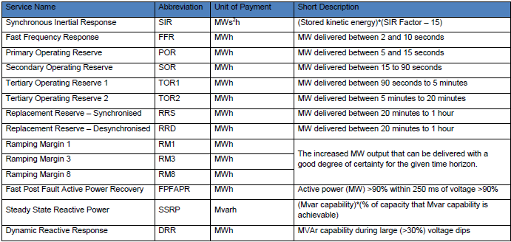
Figure 1: Table of DS3 System Services

List of Proven Technologies
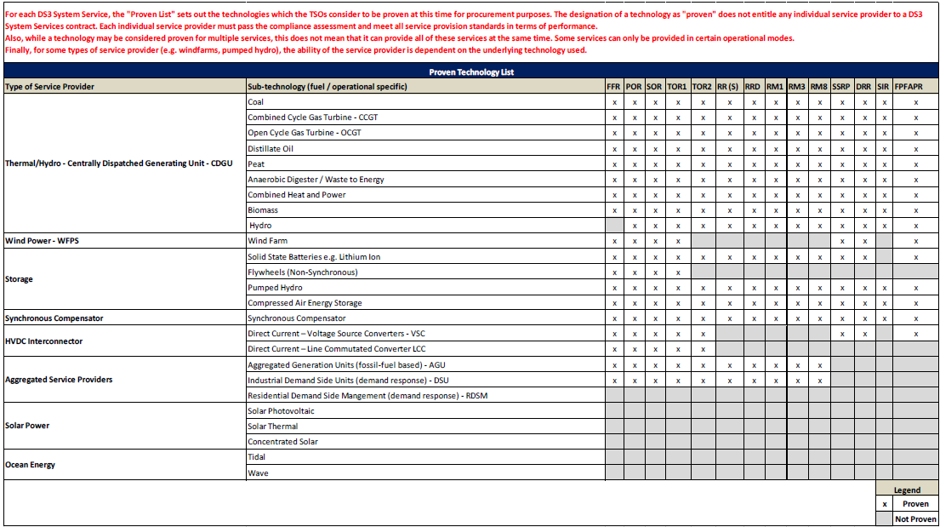

Compliance Evidence

New Units
The Unit shall complete the compliance testing process for the applicable technology and DS3 System Service product. Use the appropriate contact details to initiate the process.

Existing Units
Compliance and Performance Data already compiled from Grid Code and Distribution Code Operation and testing shall be used for the development of the appropriate system service test report. In cases where existing compliance and performance data is used, the requirements of the test report shall be met.

Performance Scalars
Upon completion of the Performance Test process a Providing Unit’s Performance Scalar may be reset to 1. This award will only be allocated once all the necessary work has been completed and any subsequent reports provided and approved by the testing teams within EirGrid and SONI.
The Providing Unit can apply for a Performance Test. Upon submission of an application the Providing Unit will be assessed in line with the High Level Data Poor Performance Scalar business process illustrated in Figure 8 of the Protocol. Depending on the TSO assessment, a Performance Test may be required to reset the Performance Scalar to 1 and month ‘M’ to 0. Should a Performance Test be deemed to be required by the TSO the specifics will be decided and agreed on a case by case basis.

characteristic changes
All Users are obliged to inform the TSO of any changes to the technical capabilities, flexibilities or limitations of their Unit due to ageing of plant or apparatus.
Before any modification to a Unit takes place the User must inform the TSO.
A Load profile request form shall be submitted for any testing or changes to Unit characteristics or software upgrades.
Modifications which are made without informing the TSO which alter the technical capabilities, flexibilities or limitations of the Unit either positively or negatively with respect to the requirements of the Grid Code may result in the withdrawal of a valid Operational Certificate or Operational Readiness Confirmation.
Changes to the operating characteristics shall be assessed with the compliance and testing matrix (Phase A,B,C,D) for that technology type and is determined major or minor depending on the level of works required. A detailed scope of works for the changes applied to the unit is required to appropriately assess the level of compliance and testing required.
Compliance and testing changes will involve a subset of tests from some of the initial testing phases (A, B, C or D).
- Phase A testing covers the period of testing up until the initial energisation and the issuing of an energisation operational certificate.
- Phase B covers the testing the unit up until the declaration of fitness of the unit and its 1st synchronisation.
- Phase C covers the period of testing up until the issuing an operational certificate for the unit. This phase covers the bulk of the grid code testing and the units’ reliability run.
- Phase D covers system service testing for a unit.

System Services Signals and controls

Signalling requirements
Signals lists templates including new system service signals are available for the following unit types.
- Generic System Service requirements.
- For WFPS Units.
- For DSUs.

Signals Lists updates
Units intending to provide system services requiring new signals shall inform EirGrid, SONI, outlining the intention to upgrade the existing signal lists and existing communication infrastructures i.e. Remote Terminal Unit (RTU).
A minimum of 20BD shall be allowed to develop, review and issue the signal list requirements to units.
The process of the signalling commissioning process is outlined below.

A wiring completion certificate confirming signals are hardwired to the interface boundary is required in advance of provision of system services.
In the event that a wiring certificate has been received and Pre Testing checks cannot be completed for TSO reasons, the Unit shall agree an alternative process for submissions of real and performance monitoring information.

Test Scheduling, execution and tariffs

Wind Farm Power Stations
Scheduling of WFPS testing that requires NCC interactions is via a calendar booking system with requests submitted to the compliance and testing team. Testing is confirmed based on System and wind conditions. Wind Conditions are confirmed using the best available TSO forecast.
For all other testing an application profile request form shall be submitted to compliance and testing team by 10am, 2 days prior to commencement.

WFPS Test Request Process
- Fill in all details required within the profile request form.
- Timeline in column A should be amended/extended as appropriate.
- Available MW in column B should be estimated based on wind forecast.
- Submit a separate tab for each day.
- This request form shall be submitted to the compliance and testing team by 10am, 2 days prior to commencement.
- Follow the update process as appropriate.
- If the update carries risk of unintended operation or will affect reactive power control, response or capability, the WFPS shall carry out the update offline.
- Signal Checks or compliance testing may be required following software or hardware updates. E.g. Controller replacement will lead to post-energisation signals and control check and Compliance Testing.

Conventional

Within Day Test
- Testing of < 6 hours in duration and < 500 MWh may be submitted as a Within Day Test, subject to EirGrid, SONI approval.
- The profile request form shall be submitted to neartime at least 2 working days in advance and updates thereafter.

Full Day Test
- Testing of > 6 hours in duration or > 500 MWh shall be submitted as a Full Day Test.
- The profile request form shall be submitted to neartime at least 5 working days in advance and updates thereafter.
- A Unit Under Test Flag shall be submitted to SEM-O.

Commissioning Unit
- Testing of a commissioning unit shall be submitted as a Full Day Test.
- The profile request form shall be submitted to neartime and the compliance and testing team at least 5 working days in advance and updates thereafter.
- A Unit Under Test Flag shall be submitted to SEM-O.
Information on putting a unit under test in the market can be found in the following FAQ: http://www.sem-o.com/Publications/General/Pricing%20and%20Scheduling%20FAQ.pdf

Testing tariffs
Testing tariffs are applied based on the Registered Capacity of a unit due to how the SEM systems are configured. The charge based on the Registered Capacity is then applied against the actual metered MW output of the generating unit as a €/MWh charge.
There are two testing tariffs that can be applied to a unit based on the risk associated with testing. They are; Tariff A and Tariff B.
Tariff A is applied for units that are at risk of not meeting their commitments and/or nominated dispatch schedule, units that are at risk of tripping and the extra cost in ensuring 100% primary and secondary operating reserve to cover the uncertainty associated with the units’ reliability.
Tariff B is applied for units at risk of tripping but at a lower risk than at tariff A.
If, under either tariff, the unit deviates away from the market nominations the short notice declarations are levied against the unit. This is because any shortfall that occurs shall be secured from more expensive sources, leading to increased costs for end consumers.
Further information on Selection Guidelines for SEM Testing Tariffs is available at the following: http://www.eirgridgroup.com/site-files/library/EirGrid/16.02.01.TT-Selection-Guideline_Ext.pdf

Execution and Post Test follow up
On the day of testing the unit operator will ensure that there are suitably qualified personnel available on site to assist with the testing. They should be able to perform the following tasks:
- Set up and disconnect the control system and instrumentation as required;
- Ability to fully understand the Unit’s function and its relationship to the System;
- Liaise with NCC, CHCC as required;
- Mitigate issues arising during the test and report on system incidents.
It will be up to the NCC, CHCC personnel if the testing conditions are appropriate for testing on the day, if testing should go ahead and what tests are to be performed on the day. Directly after testing has been completed, EirGrid, SONI and the customer will review the test procedure filled out during the test, make any additions and comments needed and then both parties shall sign-off on the test procedure. Copies of this will be sent to the compliance and testing team.
A test report shall be written by the unit operator and submitted to the compliance and testing team 10BD following completion of the test. This standard test report review and feedback will is 10BD.

Product compliance information

Synchronous Inertial Response (SIR)

Minimum generation testing
Generator units seeking to increase their SIR payments may wish to alter their minimum generation levels. The following tests may be required for any unit changing their minimum generation levels. The testing schedule is subject to agreement with the TSO.
- Provision of Studies and updated Model
  - Rate of Change of Frequency Study
  - Fault Ride Through Study
- Declarations of Fitness
- Ramp Rates
- Update Registered Data and TOD

Minimum Load Testing
Generator units seeking greater SIR payments may also wish to alter minimum load levels. As a result the following Grid Code compliance testing schedule is applied for minimum load changes. The testing schedule is subject to agreement with the TSO.
- Provision of Studies and updated Model
  - Rate of Change of Frequency study for new min load.
  - Fault Ride Through study (updated report required if the new minimum load)
- Declarations of Fitness
- Operating Reserve
- Min Load
- Ramp Rates
- Time from synch to Min Load
- Unit stability at max leading/lagging at min load. The leading Mvar requirement reduces for a lower min load, while the capability of the unit increases.
- Update Registered Data and TOD
Load Level | Frequency Injection  (for 5min) | POR  (5-15sec) Requirement | SOR  (15-90sec) Requirement | TOR1  (90-300sec) Requirement | Estimated response with a 4 % droop
Min load | -0.2Hz  (Step) | 5% | 5% | 8% | +10%
Min load | +0.2Hz  (Step) | N/A | N/A | 5min stable and stop test | -10%
Min load | -0.5Hz  (1Hz/sec) | N/A | N/A | 5min stable and stop test | +25%
Note: Positive frequency injection testing shall be completed at minimum load. While there is no specification of required response below min load, ability to govern around min load is strongly preferable for system operation.

FFR, POR, SOR & TOR1

Synchronous Machines, Interconnectors and WFPS
Testing is carried out using frequency injections to the appropriate control system. For conventional units, FFR can run in conjunction with SIR so providers that can maintain or increase their outputs within the timeframes are eligible for both services.
Unit Characteristic changes may involve additional assessment in the following areas:
- Operating reserves
- Demonstration of ramp rates
- Droop
- Deadband
- Registered characteristics
- WFPS Frequency response test procedure

DSU Aggregators
For DSU Aggregators providing reserve services, an application form shall be submitted. The DSU shall be registered within SEM and have completed compliance testing. The DSU application form has been updated within additional information for System Services and is available on the Eirgrid Group website.
The DSO shall assess if system services can be provided for the individual demand sites.
Individual Demand Sites providing services, shall be registered with a capacity and service to the same DSU and may, where the IDS is providing services only, have a capacity registered as 0MW. IDSs shall not provide services to multiple DSUs.

TOR2, RM1, RM3, RM8
Ramping margin and replacement reserve values are evaluated using existing (and verified) TOD and Registered Characteristics data submitted to Eirgrid, SONI.
If the customer wishes to contract for a different value than this, additional testing and verification is required as normal for validation of proposed new TOD values.
For DSU’s the registered characteristics are listed within the operational certificates.

Steady State Reactive Power
Characteristic changes to increase SSRP may result in the following tests
- Reactive power capability
- Demonstration of Over Excitation and Under Excitation limiters
- Registered Characteristics
- WFPS Reactive power capability test procedure
- WFPS Reactive power control test procedure

Nodal Controller
Nodal controller project works are presently being rolled out by ESB Networks. Type B Wind farms are classed as being connection type B when connected at a Distribution System voltage (≤ 38 kV) to a dedicated WFPS(s) transmission station. There is no load Customers connected to the DSO operated 38/20/10kV busbar.
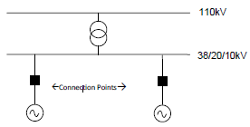
Further information on Nodal Controller works can be found at the following: https://www.esbnetworks.ie/who-we-are/innovation/our-innovation-strategy/working-with-the-tso.
Compliance and testing material developed for Type B Wind Farms and is available, as appropriate, on request from ESB Networks.
- Type B Signal list including Voltage control requirements.
- Type B Reactive Power Test Procedure.

Performance Scalar Testing
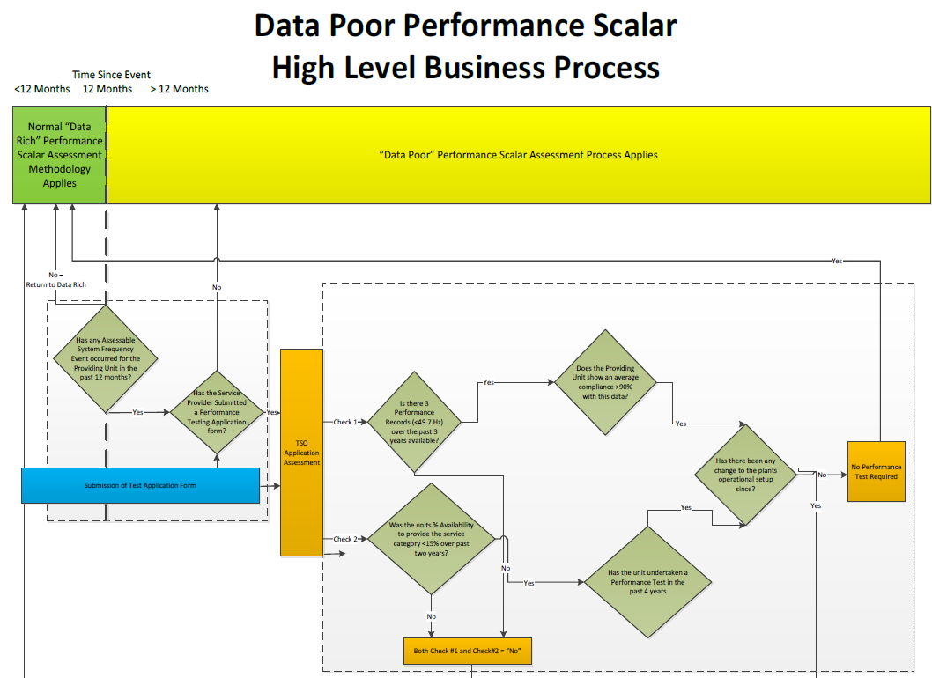
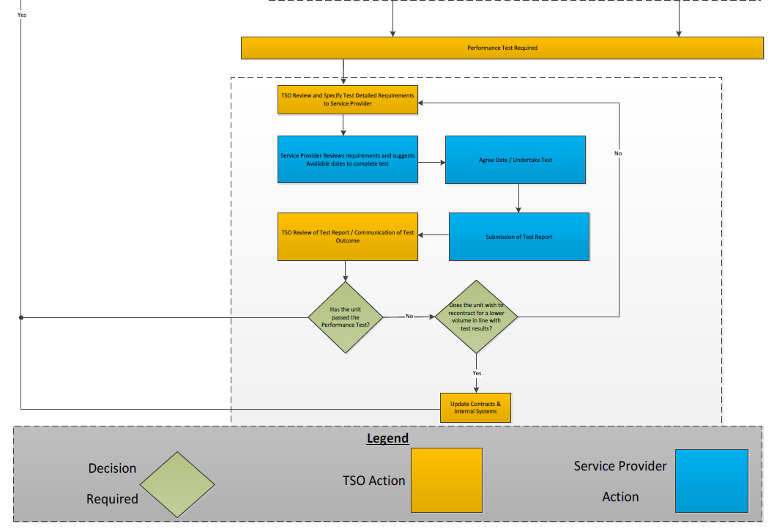

Imporatant Dates
Customers shall engage as early as possible in the compliance process. The following DS3 contract dates are applied.
- Testing dates with the TSO are agreed to a date and shall not be after 2 April 2018, for testing to take place.
- Report (and Wiring Cert where applicable) for provision of the POR service must be approved by the TSO by 24 April 2018.
- The Providing Unit must be registered in SEM by 1 May 2018 in order to qualify to provide this service.

Contact Details
Units seeking to make changes to their characteristics and contract values shall contact the TSO using the relevant contact details:

Contracts and Settlement
The role of the CAS team is to issue, maintain and update contracts as, and when, applicable. They also deal with initial requests for changes to contracted values.
For new units who wish to apply for System Services in the future or existing units without a previous System Services contract, the unit shall begin the process contacting the Contracts and Settlement team at CAS@eirgrid.com, CAS@soni.ltd.uk. In this email the unit shall provide as much information as possible about their request.
Any queries about contract values or the changing of contracted values should be made to the Contracts and settlements team at CAS@eirgrid.com (CAS@SONI.ltd.uk for NI units).

Neartime
Near Time Operations is an all-island team that schedules and manages the outage programme facilitating works, supports Real Time Operations and the transition to the I-SEM, while ensuring the safety and security of the system.
- Neartime@eirgrid.com
- Neartime@soni.ltd.uk

Compliance and Testing
The role of the compliance and testing team is to ensure that all the contracted values for a unit are verified through approved tested and performance data. The team coordinates testing with NCC and CHCC, reviews and approves test procedures, data and reports, schedule 9 contract parameters and recommends derogation or operational certificate as appropriate.
The compliance and testing team can be contacted using the following details as appropriate:
- Generator_testing@eirgrid.com
- Generator_testing@soni.ltd.uk

http://www.eirgridgroup.com/customer-and-industry/general-customer-information/grid-code-compliance-test/compliance-testing/system-services-testing/index.xml
http://www.eirgridgroup.com/site-files/library/EirGrid/DS3-System-Services-Protocol-Regulated-Arrangements_final.pdf
http://www.eirgridgroup.com/site-files/library/EirGrid/DS3-Performance-Measurement-Device-Standards-for-Fast-Acting-Services.pdf
http://www.eirgridgroup.com/site-files/library/EirGrid/DS3-System-Services-Proven-Technology-Types.pdf
http://www.eirgridgroup.com/site-files/library/EirGrid/Progress-Summary-Template.xlsx
http://www.eirgridgroup.com/site-files/library/EirGrid/WFPS_Schedule_of_GridCodeComplianceTests.xlsx
All signals lists are available here: http://www.eirgridgroup.com/customer-and-industry/general-customer-information/grid-code-compliance-test/compliance-testing/system-services-testing/index.xml
http://www.eirgridgroup.com/site-files/library/EirGrid/WFPS_LoadProfileRequestForm.xlsx
http://www.eirgridgroup.com/site-files/library/EirGrid/GeneratorTestProfileTemplate.xlsx
http://www.eirgridgroup.com/customer-and-industry/general-customer-information/grid-code-compliance-test/compliance-testing/system-services-testing/index.xml
https://www.esbnetworks.ie/docs/default-source/publications/distribution-code-v5-0.pdf?sfvrsn=6

