Fast Frequency Response (FFR), Primary, Secondary and Tertiary Reserve (POR, SOR, TOR1)
System Services
Test Report
Interconnectors
Site Name

DISCLAIMER:
This Document contains information (and/or attachments) which may be privileged or confidential. All content is intended solely for the use of the individual or entity to whom it is addressed. If you are not the intended recipient please be aware that any disclosure, copying, distribution or use of the contents of this message is prohibited. If you suspect that you have received this Document in error please notify EirGrid or its subsidiaries immediately. EirGrid and its subsidiaries do not accept liability for any loss or damage arising from the use of this document or any reliance on the information it contains or the accuracy or up to date nature thereof. Use of this document and the information it contains is at the user’s sole risk. In addition, EirGrid and its subsidiaries strongly recommend that any party wishing to make a decision based on the content of this document should not rely solely upon data and information contained herein and should consult EirGrid or its subsidiaries in advance.
Further information can be found at: http://www.eirgridgroup.com/legal/

Document Version History
Revision 2.0 published 29th March 2019

Version | Date | Comment | Name | Company
0.1 | Insert Date | Minor version (v0.1) - First submission for review and approval | Insert Name | Unit Company Name
1.0 | Insert Date | Revised to version 1.0 following approval by EirGrid, SONI. | Insert Name | Unit Company Name

Introduction
The Unit shall submit the latest version of this test report template as published on the EirGrid, SONI websites.
The report shall be developed for technical and non-technical readers and shall follow the agreed test programme. The report is submitted to generator_testing@eirgrid.com or generation-outages@soni.ltd.uk as appropriate.
Submission of this document is required if a Unit does not have and existing FFR, POR, SOR or TOR1 Contract or is making changes or updates to any of the affected parameters.
To complete the report, the Unit shall have either:
- Recorded frequency response data as per the test procedure agreed with EirGrid, SONI; or
- Performance Data showing frequency response capability.
Any issue with meeting any requirements or completing this report, please contact generator_testing@eirgrid.com or generation-outages@soni.ltd.uk as appropriate.

Abbreviations
CHCC Castlereagh House Control Centre
NCC National Control Centre
MVAr Mega Volt Ampere – reactive
MW Mega Watt
TSO Transmission System Operator
MEC Maximum Export Capacity
MIC Maximum Import Capacity
RPM Revolutions Per Minute
kV kilovolt
EDIL Electronic Dispatch Instruction Logger
POR Primary Operating Reserve
SOR Secondary Operating Reserve
TOR Tertiary Operating Reserve
FFR Fast Frequency Response
HVDC High Voltage Direct Current

Unit DATA
Unit Test Coordinator | Unit to Specify Name, Company and contact details.
Unit name | Unit to Specify
Unit connection point | HV Bushings of T101 in XX 110kV station
Unit connection voltage | Unit to Specify
Registered Import Capacity | Unit to Specify
Registered Export Capacity | Unit to Specify
Contracted MEC | Unit to Specify
Contracted MIC | Unit to Specify
Installed Plant | Unit to Specify
Control system Droop Setting (expected) | Unit to Specify

System Services definitions

Fast frequency response
FFR is defined as the additional increase in MW output from a unit or a reduction in demand following a frequency event that is available within two seconds of the start of the event and sustainable for at least eight seconds afterwards
The extra energy provided by the MW increase, in the timeframe from the FFR response time to 10 seconds shall be greater than any loss of energy in the ten-to-twenty second timeframe afterwards due to a reduction in MW output. The energy provided and drawn should be compared to the pre-event output.
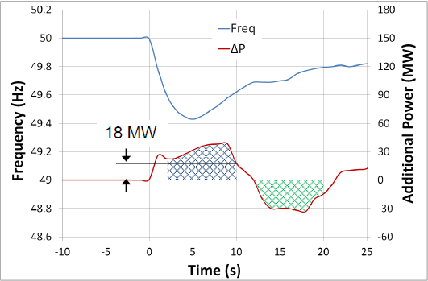
Figure 1: FFR being delivered after a frequency event
As shown in the diagram above, in order to be eligible for FFR the amount indicated by the blue hatched area (Power provided) must be greater than the green hatched area (Power drawn). If the amount of power drawn exceeds (or is equal to) the amount of power given (within the time frame) then the unit will not be eligible for an FFR contract.

POR, SOR & TOR1

Operating Reserve
Operating Reserve is defined as the additional MW output provided from Generation plant, reduction of Active power transfer to an external system or increase of Active power transfer to the Transmission system by interconnectors, or reduction in Customer demand, which must be realisable in real time operation to contain and correct any potential Transmission system deviation to an acceptable level.

Primary Operating Reserve (POR)
Primary Operating Reserve (POR) is the additional MW output (and/or reduction in Demand) required at the frequency nadir (minimum), compared to the pre-incident output (or Demand) where the nadir occurs between 5 and 15 seconds after an Event.

Secondary Operating Reserve (SOR)
Secondary Operating Reserve (SOR) is the additional MW output (and/or reduction in Demand) required compared to the pre-incident output (or Demand), which is fully available and sustainable over the period from 15 to 90 seconds following an Event.

Tertiary Operating Reserve band 1 (TOR1)
Tertiary Operating Reserve band 1 (TOR1) is the additional MW output (and/or reduction in Demand) required compared to the pre-incident output (or Demand) which is fully available and sustainable over the period from 90 seconds to 5 minutes following an Event.

Dynamic & Static Response

FFR Dynamic Capability requirements
Dynamic response is when a Unit tracks the system frequency and adjust its response accordingly. A Unit providing a dynamic response shall meet the following criteria:
- The unit shall track changes in frequency dynamically.
- Contain at least 10 discrete steps or sources which can dynamically adjust load contributions in response to frequency. No individual step shall be larger than 5MW and the response shall be provided in a linear, monotonically increasing manner. All step sizes shall be no more than +/- 1MW of the average step size.
- The unit shall have the capability to commit to a frequency trigger set point greater than or equal to 49.8 Hz and less than or equal to 49.985 Hz.
- Have frequency measurement installed locally.
- The unit shall be able to operate with a minimum trajectory of 2Hz in response to a Reserve Trigger.
- While the basic energy recovery requirement of the FFR product is to apply, to qualify as a dynamic provider, the unit shall be able to operate without recovering its resource until the system frequency has recovered to within 5% of the pre-event frequency in steady-state for a period of up to 5 mins (the exact timeframe will be instructed by the TSOs);
- The unit’s provision of POR, SOR and TOR1, if contracted for any of these Services, shall mirror its FFR response characteristics, i.e. the unit shall have the capability of continuing along the trajectory of the applicable frequency response curve for the extended timeframes obligated of POR, SOR and TOR1, as required of the TSOs in response to a Reserve Trigger.
- The unit shall have a PMU in situ. PMU shall meet the current metering standards.

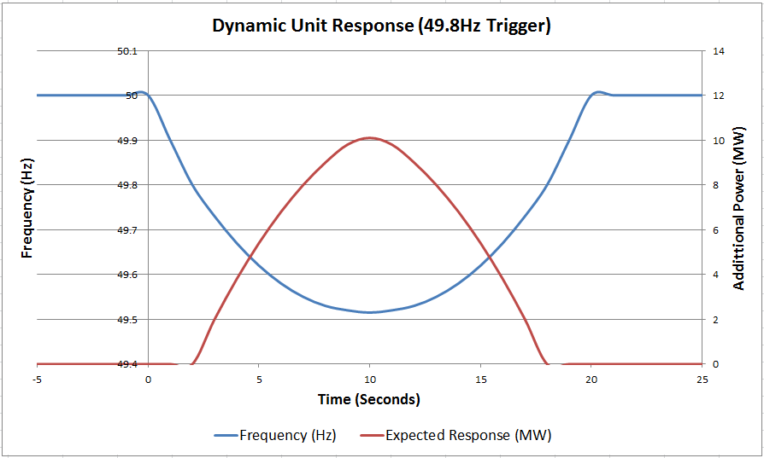

Figure 2: Example of a Dynamic unit response with a trigger point of 49.8Hz
As shown in figure 2, above, as the frequency drops the unit does not respond until the trigger point is reached (in this example the trigger point is set at 49.8Hz). When this point is reached the unit output begins ramping up in discrete steps (steps in accordance with the requirements stated in section 5.3.1), staying as close as possible to the expected output. The output steps down also as the frequency returns to nominal (50Hz). This is what is expected of a dynamic response.

Static response capability requirements
A Static response is where the Unit provides its entire response at one single trigger point.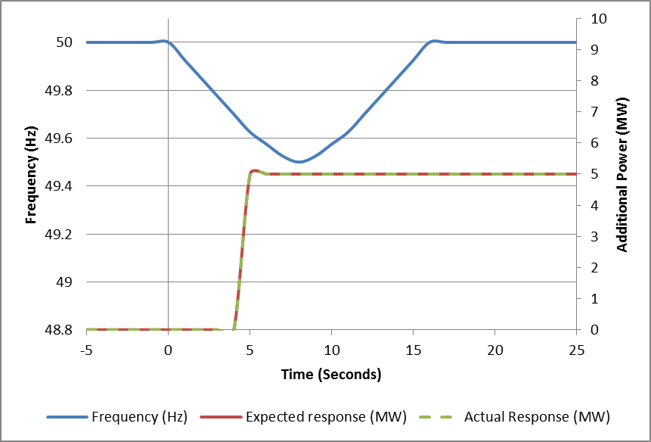
Figure 4: Example of a Static response from a unit with a trigger point of 49.8Hz

Assessment
The MW amount is based on the absolute lowest sustainable value the unit is capable of delivering in the given timeframe for the service.
The following are examples of how the different operating reserve services are graphed and assessed:
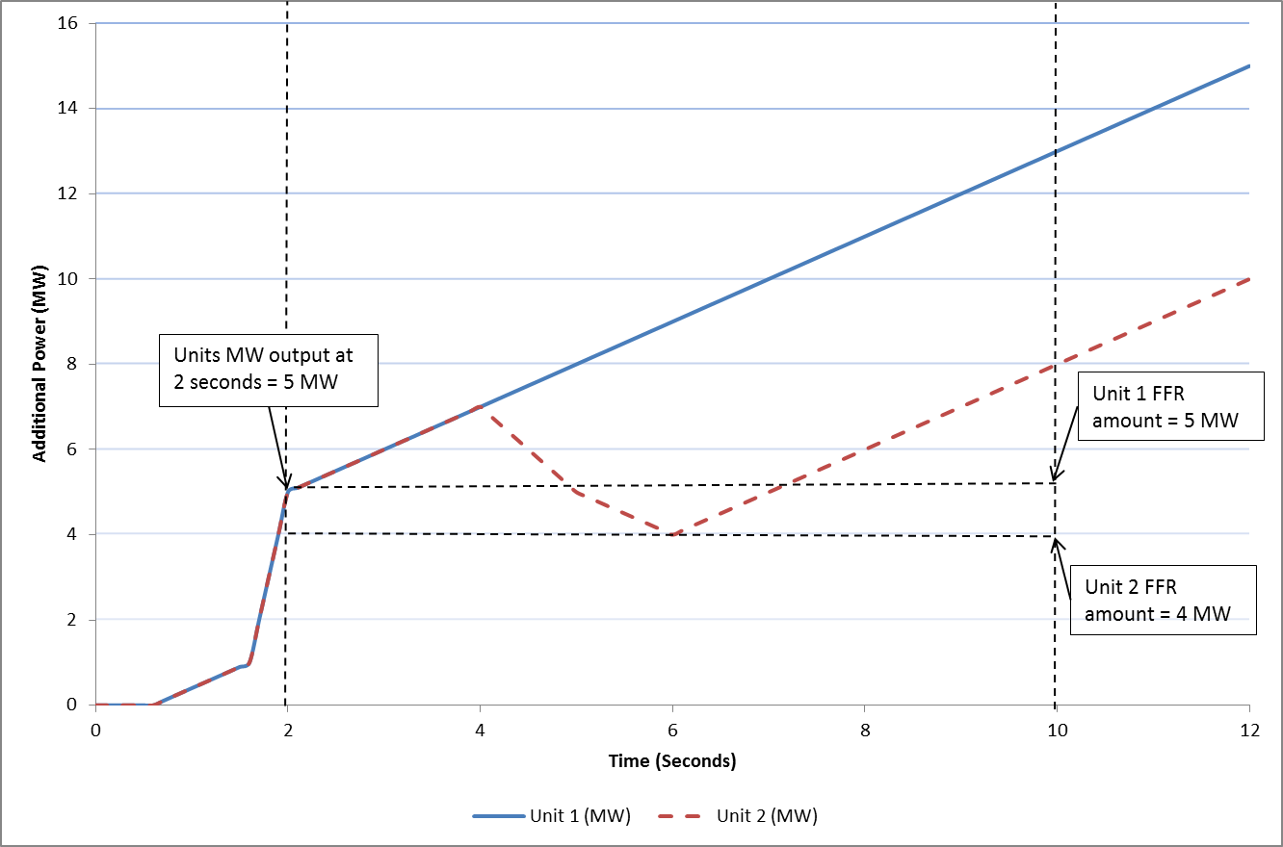
Figure 5: Example of how to measure the FFR MW amount
As shown in figure 5, above, both units begin ramping up and both reach 5MW at two seconds. Both begin ramping up over the course of the time period, however unit 2 (red dashed line) output drops to 4MW at one point where as Unit 1 (blue solid line) continues to ramp up. This shows that Unit 1 has a lowest sustainable MW output over the time period of 5MW and Unit 2 has a lowest sustainable MW output of 4MW. These are the units’ FFR MW capacities.

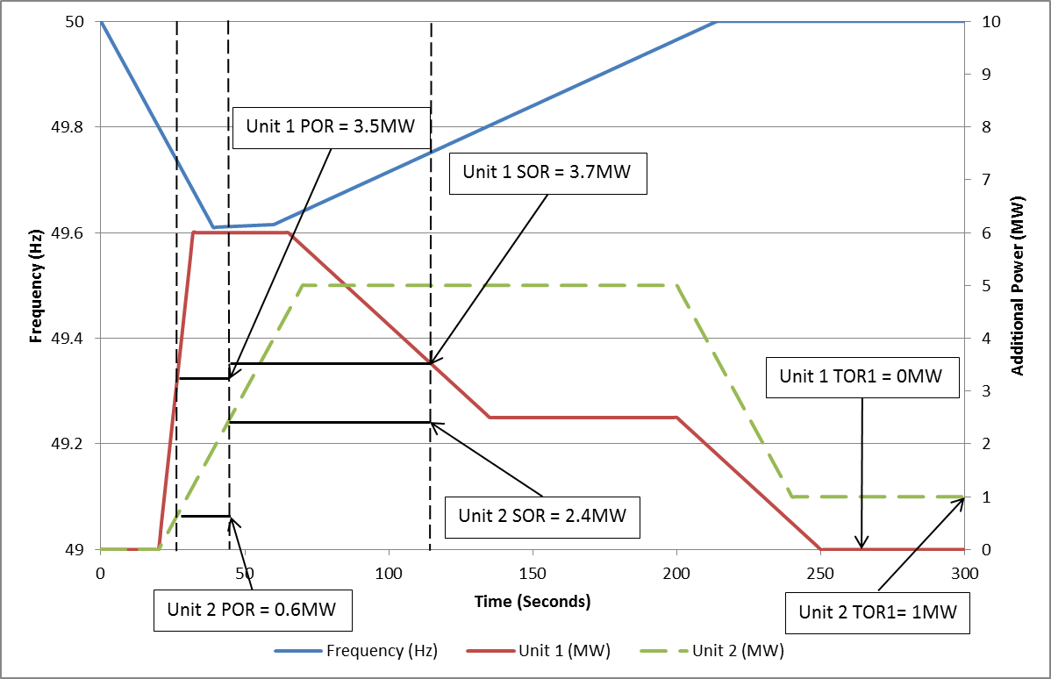
Figure 6: Example of how to measure the POR, SOR and TOR1 MW amounts

FFR scalar
A product scalar incentivising advance FFR provision is available if the FFR can be provided prior to the two second threshold. If a unit wished to avail of this scalar then it is necessary to demonstrate this capability in the graphs in this report and specify the exact time this provision can be reached and sustained for. For this scalar a 20ms (or quicker) sampling rate shall be used for the measurements with agreement from EirGrid, SONI where applicable.
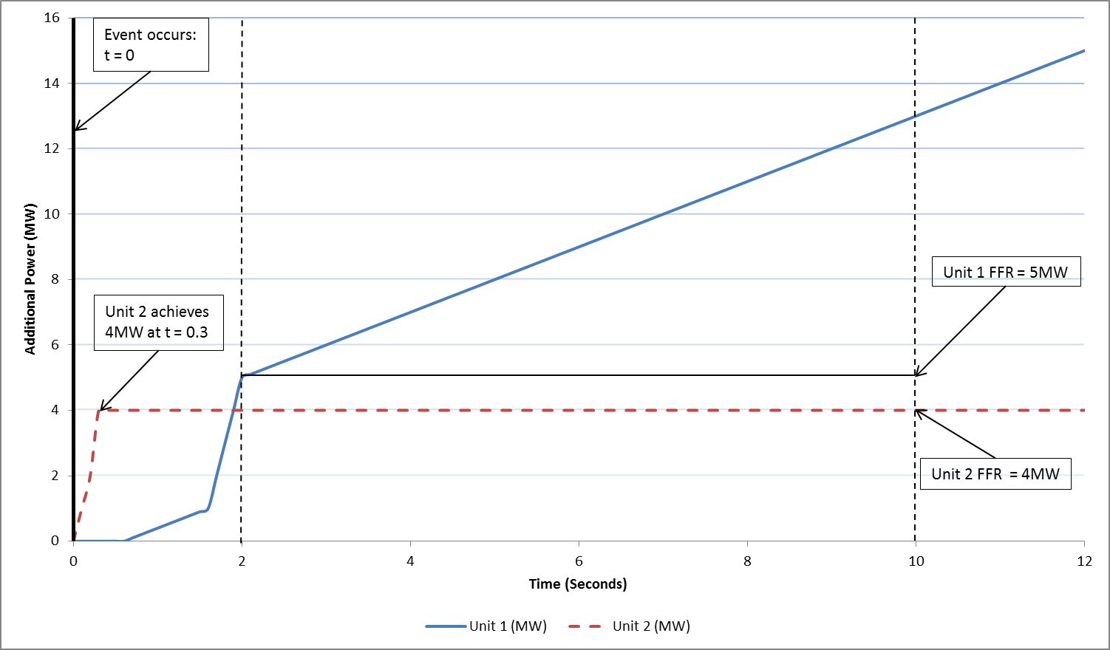
Figure 7: Example showing a unit achieving its’ FFR at 0.3 seconds, qualifying it for the FFR Scalar

Results

Summary of testing
Testing was completed on [DATE].
[Insert comment on the results, highlighting any issues encountered in performing the test or in analysing the results].
[Include outline of operation of frequency control as set out under IOP with Other TSO].
[Insert Report summary]
[Include any relevant test notes here, relating to how the test was carried out or to any specific conditions encountered during the test.]
[Any abnormal behaviour during the test (spikes, dips, unusual vibrations, etc.) shall be noted and documented. The reasons behind these shall be detailed along with any corrective actions taken and what its effects are on the unit and/or the result. If possible a clear graph of the issue shall also be presented.]
[The following values are as a result of testing information analysed below]

FFR, POR, SOR, TOR1 Results
The following table shows the minimum sustained FFR, POR, SOR and TOR values achieved for each load range during testing.
No. | Load Level |  | (a) FFR Energy Provided  (2 – 10 Sec) | (b) FFR Energy drawn  (10 – 20 Sec) | FFR Eligibility: is (a) MW > (b) MW? | FFR | POR  (5 -15 Sec) | SOR  (15 – 90 Sec) | TOR1  (90 – 300 Sec)
1 |  |  | ______MWs | ______MWs | Yes/No | ______MW | ______MW | ______MW | ______MW
2 |  |  | ______MWs | ______MWs | Yes/No | ______MW | ______MW | ______MW | ______MW
3 |  |  | ______MWs | ______MWs | Yes/No | ______MW | ______MW | ______MW | ______MW
4 |  |  | ______MWs | ______MWs | Yes/No | ______MW | ______MW | ______MW | ______MW
 |  | Assess each of the load points above, for FFR, POR, SOR and TOR and identify the maximum value achieved.
Maximum Value |  |  | MW range over which the unit can provide FFR  _____MW to _____MW |  |  | ______MW | ______MW | ______MW | ______MW

Deadband test

Parameter Settings
Test Details
Deadband Settable range | From +/-___Hz to +/-____Hz
Deadband setting for test | +/-___Hz
Droop | ___%
Trajectory | ______MW/Hz  From edge of deadband
Dyrnamic Frequency Response Mode | ON / OFF
Static Frequency Response | ON / OFF
PMax Limit (Under-frequency response) | _____MW
PMax Limit (Over-frequency response) | ______MW
Simulated Frequency Description | - Reference frequency at To_____Hz  - Simulated Frequency ______Hz  - Simulated Frequency Ramp Rate ____ms

Graph of results
[State sample rate for the tests i.e. if it is 20ms or 100ms]
[Insert graph with analysis of results in next section, include data points and clear labelling on the graph for points of interest i.e. at 5 seconds, MW was…..]

Analysis
[Insert comment on dynamic provision]

Test 1

Parameter Settings
Test Details
Deadband Settable range | From +/-___Hz to +/-____Hz
Deadband setting for test | +/-___Hz
Droop | ___%
Trajectory | ______MW/Hz  From edge of deadband
Dyrnamic Frequency Response Mode | ON / OFF
Static Frequency Response | ON / OFF
PMax Limit (Under-frequency response) | _____MW
PMax Limit (Over-frequency response) | ______MW
Simulated Frequency Description | - Reference frequency at To_____Hz  - Simulated Frequency ______Hz  - Simulated Frequency Ramp Rate ____ms

Graph of Results
[State sample rate for the tests]
[Insert graph with analysis of results, include data points and clear labelling on the graph for points of interest i.e. at 5 seconds, MW was….]

Analysis

Test 2 [update title as appropriate]
[Include analysis of proportional response]

Test 3 [update as appropriate]

Test 4 [update as appropriate]

Static Frequency Settings and trigger points
[Use table to provide existing contract values which shows settable range and values and trigger points and time delays as applicable]

Online signalling Commissioned and Data measurement
[Include table or online signalling that is available wrt system services Signalling requirements]

Commissioned Values post test
Parameter | Setting
Droop Setting | _____%  ______MW/Hz
Deadband | +/-___Hz
Dynamic Frequency Response Mode | ON/OFF
Dynamic Frequency Trigger point when Frequency response is on | +/-___Hz
Static Frequency Response Mode | ON/OFF
Dynamic Frequency Trigger point when Frequency response is on | +/-___Hz
[Include any time delays or limitations for provision of response.]

http://www.eirgridgroup.com/ or http://www.soni.ltd.uk/
Definitions form DS3 System Services Decision Paper SEM-13-098: https://www.semcommittee.com/sites/semcommittee.com/files/media-files/SEM-13-098%20%20DS3%20System%20Services%20Technical%20Definitions%20Decision%20Paper%20-%20FINAL_0.pdf
Where average step size = (Available FFR volume / number of discrete steps)
Trajectory is defined in the DS3 System services contract paper Pg.39: http://www.eirgridgroup.com/site-files/library/EirGrid/DS3-System-Services-Contracts-Recommendations_final.pdf
DS3 System Services Technical Definitions Decision Paper SEM-13-098 20/12/2013, page 10 https://www.semcommittee.com/sites/semcommittee.com/files/media-files/SEM-13-098%20%20DS3%20System%20Services%20Technical%20Definitions%20Decision%20Paper%20-%20FINAL_0.pdf
For example, a battery charging to its pre-event output
Assuming that the units meet the FFR requirements of not drawing more energy from the grid in the subsequent 10 – 20 second time period afterwards than it supplied.

