System Services
Reserve Test Procedure

Fast Frequency Response (FFR), Primary, Secondary and Tertiary Reserve (POR, SOR, TOR1, TOR2)

Interconnector

Unit Name

DISCLAIMER:
This Document contains information (and/or attachments) which may be privileged or confidential. All content is intended solely for the use of the individual or entity to whom it is addressed. If you are not the intended recipient please be aware that any disclosure, copying, distribution or use of the contents of this message is prohibited. If you suspect that you have received this Document in error please notify EirGrid or its subsidiaries immediately. EirGrid and its subsidiaries do not accept liability for any loss or damage arising from the use of this document or any reliance on the information it contains or the accuracy or up to date nature thereof. Use of this document and the information it contains is at the user’s sole risk. In addition, EirGrid and its subsidiaries strongly recommend that any party wishing to make a decision based on the content of this document should not rely solely upon data and information contained herein and should consult EirGrid or its subsidiaries in advance.
Further information can be found at: http://www.eirgridgroup.com/legal/

Document Revision History
Revision 3.0 published 12th November 2019

Version | Date | Comment | Name | Company
0.1 | Insert date | Minor version (v0.1) - First submission for review and approval | Insert name | Insert company
1.0 | Insert Date | Major version (V1.0) Approved Version by EirGrid / SONI | Insert Name | EirGrid / SONI

Introduction
The Unit must submit the latest version of this test procedure as published on the EirGrid or SONI website.
The order of this test can be rearranged only in agreement with EirGrid/SONI
The purpose of this document is to detail the data required to apply for a System Services Contract and to detail the necessary test procedures required to be performed should that data not be readily available.
If this data is already available then this document does not need to be completed. The Operating reserve test report should be completed and submitted to EirGrid/SONI
All yellow sections must be filled in before the test procedure will be approved. All grey sections must be filled in during testing. If any test requirements or steps are unclear, or if there is an issue with meeting any requirements or carrying out any steps, please contact generator_testing@eirgrid.com or generation_testing@soni.ltd.uk
On the day of testing, suitably qualified technical personnel are required on site to assist in undertaking the tests. The personnel shall have the ability to:
- Set up and disconnect the control system and instrumentation as required;
- Ability to fully understand the Unit’s function and its relationship to the System;
- Liaise with NCC/CHCC as required;
- Mitigate issues arising during the test and report on system incidents.
The availability of personnel at NCC/CHCC will be necessary in order to initiate the necessary instructions for the test. NCC/CHCC will determine:
- If network conditions allow the testing to proceed.
- Which tests will be carried out
- When the tests will be carried out.
On completion of this test, the following shall be submitted to generator_testing@eirgrid.com or generation_testing @soni.ltd.uk

Submission | Timeline
A scanned copy of the test procedure, as completed and signed on site on the day of testing | 1 working day
Test data in CSV or Excel format | 1 working day
Test report | 10 working days

Abbreviations
CHCC Castlereagh House Control Centre
NCC National Control Centre
MVAr Mega Volt Ampere – reactive
MW Mega Watt
TSO Transmission System Operator
MEC Maximum Export Capacity
MIC Maximum Import Capacity
RPM Revolutions Per Minute
kV kilovolt
EDIL Electronic Dispatch Instruction Logger
POR Primary Operating Reserve
SOR Secondary Operating Reserve
TOR Tertiary Operating Reserve
FFR Fast Frequency Response
HVDC High Voltage Direct Current

Unit DATA
Unit Test Coordinator | Unit to Specify Name, Company and contact details.
Unit name | Unit to Specify
Unit connection point | HV Bushings of T101 in XX 110kV station
Unit connection voltage | Unit to Specify
Registered Import Capacity | Unit to Specify
Registered Export Capacity | Unit to Specify
Contracted MEC | Unit to Specify
Contracted MIC | Unit to Specify
Installed Plant | Unit to Specify
Control system Droop Setting (expected) | Unit to Specify

System Services definitions

Fast frequency response
FFR is defined as the additional increase in MW output from a unit or a reduction in demand following a frequency event that is available within two seconds of the start of the event and sustainable for at least eight seconds afterwards

The extra energy provided by the MW increase, in the timeframe from the FFR response time to 10 seconds shall be greater than any loss of energy in the ten-to-twenty second timeframe afterwards due to a reduction in MW output. The energy provided and drawn should be compared to the pre-event output.

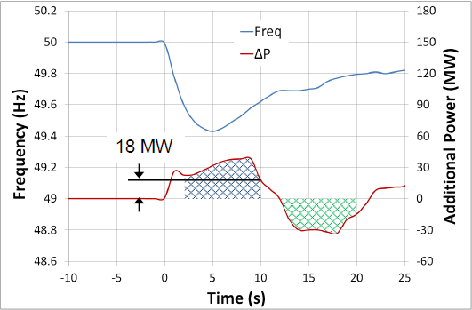
Figure 1: FFR being delivered after a frequency event

As shown in the diagram above, in order to be eligible for FFR the amount indicated by the blue hatched area (Power provided) must be greater than the green hatched area (Power drawn). If the amount of power drawn exceeds (or is equal to) the amount of power given (within the time frame) then the unit will not be eligible for an FFR contract.

FFR Response Time
A Providing Unit’s contracted FFR Response Time is the time from when the frequency falls through its contracted Reserve Trigger (T=0) to the time at which the Providing Unit must have achieved its contracted FFR volume, as dictated by its contracted FFR response curve.
The FFR response time provided shall be based on test data.
Please note that the FFR Response Time, as recorded on the Providing Unit’s installed performance measurement equipment, will be evaluated as part of the FFR performance monitoring process.
The product scalar for faster response of FFR will be based on the FFR response time of the Providing Unit.

POR, SOR & TOR1

Operating Reserve
Operating Reserve is defined as the additional MW output provided from Generation plant, reduction of Active power transfer to an external system or increase of Active power transfer to the Transmission system by interconnectors, or reduction in Customer demand, which must be realisable in real time operation to contain and correct any potential Transmission system deviation to an acceptable level.

Primary Operating Reserve (POR)
Primary Operating Reserve (POR) is the additional MW output (and/or reduction in Demand) required at the frequency nadir (minimum), compared to the pre-incident output (or Demand) where the nadir occurs between 5 and 15 seconds after an Event.

Secondary Operating Reserve (SOR)

Secondary Operating Reserve (SOR) is the additional MW output (and/or reduction in Demand) required compared to the pre-incident output (or Demand), which is fully available and sustainable over the period from 15 to 90 seconds following an Event.

Tertiary Operating Reserve band 1 (TOR1)
Tertiary Operating Reserve band 1 (TOR1) is the additional MW output (and/or reduction in Demand) required compared to the pre-incident output (or Demand) which is fully available and sustainable over the period from 90 seconds to 5 minutes following an Event.

Tertiary Operating Reserve band 1 (TOR2)
Tertiary Operating Reserve band 1 (TOR2) is the additional MW output (and/or reduction in Demand) required compared to the pre-incident output (or Demand) which is fully available and sustainable over the period from 5 minutes to 20 minutes following an Event.

Dynamic, Static & Stepped Static Response

FFR Dynamic Capability requirements
Dynamic response is when a Unit tracks the system frequency and adjust its response accordingly. A Unit providing a dynamic response shall meet the following criteria:
- The unit shall track changes in frequency dynamically.
- Contain at least 10 discrete steps or sources which can dynamically adjust load contributions in response to frequency. No individual step shall be larger than 5MW and the response shall be provided in a linear, monotonically increasing manner. All step sizes shall be no more than +/- 1MW of the average step size.
- The unit shall have the capability to commit to a frequency trigger set point greater than or equal to 49.8 Hz and less than or equal to 49.985 Hz.
- Have frequency measurement installed locally.
- The unit shall be able to operate with a minimum trajectory of 2Hz in response to a Reserve Trigger.
- While the basic energy recovery requirement of the FFR product is to apply, to qualify as a dynamic provider, the unit shall be able to operate without recovering its resource until the system frequency has recovered to within 5% of the pre-event frequency in steady-state for a period of up to 5 mins (the exact timeframe will be instructed by the TSOs);
- The unit’s provision of POR, SOR and TOR1, if contracted for any of these Services, shall mirror its FFR response characteristics, i.e. the unit shall have the capability of continuing along the trajectory of the applicable frequency response curve for the extended timeframes obligated of POR, SOR and TOR1, as required of the TSOs in response to a Reserve Trigger.
- The unit shall have a PMU in situ. PMU shall meet the current metering standards.

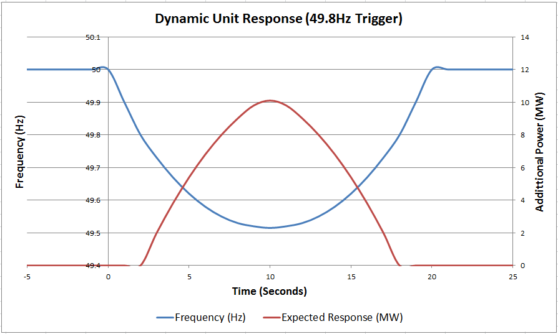

Figure 2: Example of a Dynamic unit response with a trigger point of 49.8Hz

As shown in figure 2, above, as the frequency drops the unit does not respond until the trigger point is reached (in this example the trigger point is set at 49.8Hz). When this point is reached the unit output begins ramping up in discrete steps (steps in accordance with the requirements stated in section 5.3.1), staying as close as possible to the expected output. The output steps down also as the frequency returns to nominal (50Hz). This is what is expected of a dynamic response.

Static response capability requirements
A Static response is where the Unit provides its entire response at one single trigger point.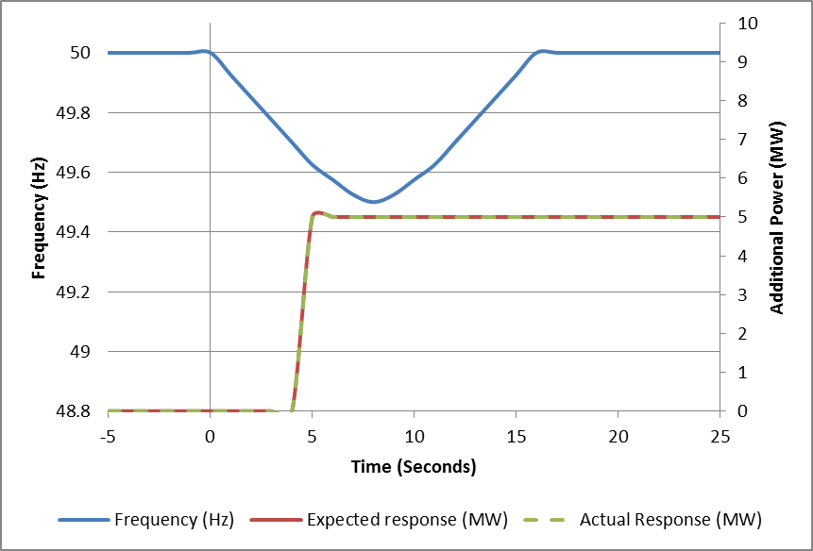
Figure 4: Example of a Static response from a unit with a trigger point of 49.8Hz

site Safety requirements
The following is required for the EirGrid/SONI witness to attend site:
Personal Protective Equipment Requirements  - Site Safety boots  - Hard Hat with chin strap  - Hi Vis  - Arc Resistive clothing  - Safety Glasses  - Gloves  - Safe Pass | - Yes / No  - Yes / No  - Yes / No  - Yes / No  - Yes / No  - Yes / No  - Yes / No
Site Induction requirements | Yes / No  (If Yes, Unit to specify how and when the induction must carried out)
Any further information | Unit to specify

Test Description and Pre Conditions

Purpose of the Test
The purpose of this test is to verify:
- The lowest sustainable amount of energy provided by the unit in the 2 – 10 second timeframe after a frequency event.
- The unit does not draw in more energy in the ten second timeframe after the governor control system decrement rate is correctly implemented.
- The levels of Primary, Secondary and Tertiary Operating Reserves provided by the unit.
- Verify that the unit meets the conditions for dynamic response (For dynamic response only)
- Verify the trigger point frequency(ies) of the Unit.
- Verify the response time of the Unit.
This is achieved by injecting a frequency profile at a range of different frequencies and periods of time.
Is the frequency injected using software or external hardware? | Unit to specify
Can the frequency be injected as a ramp or as a step? | Unit to specify
Frequency injected as an offset to the system frequency or is the governor/control system isolated from the system frequency? | Unit to specify

Frequency injection profile
The following frequency profile is to be used for the testing. It will test the units’ capability for all Reserve services and the units Dynamic, Stepped-Static or Static response.

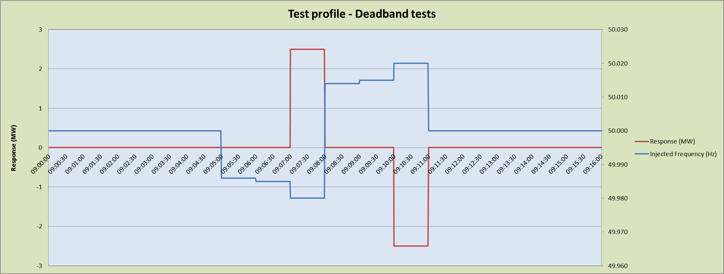

Figure 5: Expected response from Deadband testing

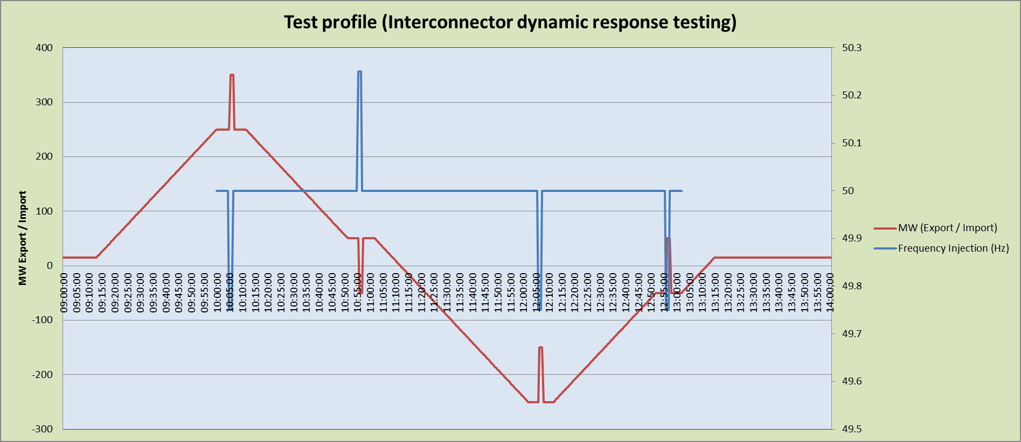
Figure 6: Expected response from Dynamic Response testing

Instrumentation and Onsite Data Trending
All of the following trends and screenshots must be recorded by the Unit during the test. Failure to provide any of these trends will result in test cancellation.
No. | Signal Name | Sample Rate | Source
1 | Active Power at Connection Point (MW) | Unit to specify, 100ms or as agreed with TSO (20ms for FFR scalar product) | Unit to specify
2 | Reactive Power at Connection Point (MVAr) | Unit to specify, 100ms or as agreed with TSO (20ms for FFR scalar product) | Unit to specify
3 | Active Power (MW) | Unit to specify, 100ms or as agreed with TSO (20ms for FFR scalar product) | Unit to specify
4 | Reactive Power (MVAr) | Unit to specify, 100ms or as agreed with TSO (20ms for FFR scalar product) | Unit to specify
5 | Simulated Frequency (Hz) | Unit to specify, 100ms or as agreed with TSO (20ms for FFR scalar product) | Unit to specify
6 | Interconnector Connection Voltage (kV) | Unit to specify, 100ms or as agreed with TSO (20ms for FFR scalar product) | Unit to specify
12 | Other signals as required by the unit or by the TSO | Unit to specify, 100ms or as agreed with TSO (20ms for FFR scalar product) | Unit to specify
13 | Alarm/Event page | Screenshot of alarms / events for duration of the test.
14 | Generator Overview Screen | Screenshots may be required where test data/milestone/event is not available through the trends listed above.
15 | EDIL instructions | Screenshot as logged during the test.

Additional signals for system services
Please note that the list of signals required for this test, as stated above in section 8, may be altered at any time to include any additional signals deemed necessary for system services. If in any doubt please contact the generator testing team at: generator_testing@eirgrid.com or generation_testing @soni.ltd.uk

Initial Conditions
Should “No” be answered to any of the following, contact the EirGrid/SONI test coordinator and agree next steps in advance of making any corrective actions.
No. | Conditions | Check on day of test
1 | Test Profiles have been submitted and approved by EirGrid/SONI | Yes/No
2 | Approval from other System Operator (National Grid) has been granted | Yes/No
3 | Normal start up support auxiliary systems in service. | Yes/No
4 | Required signals, as described in section 8 are available | Yes / No

Test Steps

Deadband Tests
The following test steps are to verify the high and low frequency deadbands as well as demonstrating proportional dynamic response in advance of full Dynamic Frequency Response testing (9.2).

No. | Parameter |  | Unit
i | Nominal Frequency | 50.000 | Hz
ii | Deadband used for testing | + / - 0.015 | Hz
iii | High Frequency Deadband | 50.015 | Hz
iv | Low Frequency Deadband | 49.985 | Hz

Deadband Checks

Step | Action | Time | Comment
1 | Request NCC/CHCC permission to begin test.  If applicable, request NCC/CHCC to issue an EDIL Dispatch Instruction to facilitate testing
2 | Request permission from National Grid to begin test.
3 | Begin data recording of signals
4 | Note Import / Export level |  | __________ MW Import / Export
5 | Inject a frequency step of 50.000Hz  Maintain injection for five minutes  Note Import / export value (MW) |  | __________ MW Import / Export
6 | Inject a frequency step of 49.986Hz  Maintain injection for one minute  Note Import / export value (MW) |  | __________ MW Import / Export
7 | Inject a frequency step of 49.985Hz  Maintain injection for one minute.  Note Import / export value (MW) |  | __________ MW Import / Export
8 | Inject a frequency step of 49.980Hz  Maintain injection for one minute.  Note Import / export value (MW) |  | __________ MW Import / Export
9 | Inject a frequency step of 50.014Hz  Maintain injection for one minute.  Note Import / export value (MW) |  | __________ MW Import / Export
10 | Inject a frequency step of 50.015Hz  Maintain injection for one minute.  Note Import / export value (MW) |  | __________ MW Import / Export
11 | Inject a frequency step of 50.020Hz  Maintain injection for one minute.  Note Import / export value (MW) |  | __________ MW Import / Export
12 | Inject a frequency step of 50.000Hz  Maintain injection for one minute.  Note Import / export value (MW) |  | __________ MW Import / Export
13 | Deadband Testing completed

Dynamic Frequency Response
The following test steps are to verify the amount of FFR, POR, SOR and TOR1 available. There are tests for Static and Dynamic responses. The unit shall agree in advance with EirGrid / SONI which tests the unit shall be undertaking on the day.

Dynamic Frequency Response testing (9.2) will only commence upon successful completion of deadband testing (9.1)

No. | Parameter |  | Unit
i | Nominal Frequency | 50.000 | Hz
ii | Deadband used for deadband tests | + / - 0.015 | Hz
iii | High Frequency Deadband | 50.015 | Hz
iv | Low Frequency Deadband | 49.985 | Hz
v | Injection Position 1 | 250 Import | MW - Direction
vi | Injection Position 2 | 50 Import | MW - Direction
vii | Injection Position 3 | 250 Export | MW - Direction
viii | Injection Position 4 | 50 Export | MW - Direction
ix | Agreed Ramp Rate | 10 | MW/min
x | Injection magnitude (from nominal) | + / - 0.250 | Hz
xi | Injection duration 1 | 250 | ms
xii | Injection rate 1 | + / - 1.00 | Hz/s
xiii | Injection duration 2 | 5 | s
xiv | Injection rate 2 | + / - 0.05 | Hz/s

Step | Action | Event Time | Comment
1 | Request NCC/CHCC permission to begin test.
2 | Request National Grid permission to begin test.
3 | Begin data recording of signals
4 | Request NCC/CHCC to issue an EDIL Dispatch Instruction to Injection position 1  (Where applicable) |  | Injection Position 1:  __________ MW Import / Export
5 | Ramp to Injection position 1 at agreed ramp rate  Confirms when unit has reached agreed start position  Hold position for period of five minutes and note Import / export value (MW) |  | __________ MW Import / Export
6 | Inject low frequency equal to the Injection magnitude, at injection rate 1  Injection ramp duration:250 ms  Setpoint: 49.750 Hz  Injection rate: 1 Hz/s  Hold injection for 90 seconds.  Note Import / export value (MW) |  | __________ MW Import / Export
7 | Inject a frequency equal to Nominal Frequency at injection rate 1.  Injection ramp duration: 250 ms  Setpoint: 50.000 Hz  Injection rate: 1 Hz/s  Hold injection for five minutes.  Note Import / export value (MW) |  | __________ MW Import / Export
8 | Request NCC/CHCC to issue an EDIL Dispatch Instruction to Injection position 2  (Where applicable) |  | Injection Position 2:  __________ MW Import / Export
9 | Ramp to Injection position 2 at agreed ramp rate  Confirms when unit has reached agreed start position  Hold position for period of five minutes and note Import / export value (MW) |  | __________ MW Import / Export
10 | Inject high frequency equal to the Injection magnitude at injection rate 2  I.e. Injection ramp duration: 5 seconds  Setpoint: 50.250 Hz  Injection rate: 0.05 Hz/s  Hold injection for 90 seconds.  Note Import / export value (MW) |  | __________ MW Import / Export
11 | Inject a frequency equal to Nominal Frequency at injection rate 2  I.e. Injection ramp duration: 5 seconds  Setpoint: 50.000 Hz  Injection rate: 0.05 Hz/s  Hold injection for five minutes.  Note Import / export value (MW) |  | __________ MW Import / Export
12 | Request NCC/CHCC to issue an EDIL Dispatch Instruction to Injection position 3  (Where applicable) |  | Injection Position 3: __________ MW Import / Export
13 | Ramp to Injection position 3 at agreed ramp rate  Confirms when unit has reached agreed start position  Hold position for period of five minutes and note Import / export value (MW) |  | __________ MW Import / Export
14 | Inject low frequency equal to the Injection magnitude, at injection rate 1  I.e. Injection ramp duration: 250 ms  Setpoint: 49.750 Hz  Injection rate: 1 Hz/s  Hold injection for 90 seconds.  Note Import / export value (MW) |  | __________ MW Import / Export
15 | Inject a frequency equal to Nominal Frequency at injection rate 1  I.e. Injection ramp duration: 250 ms  Setpoint: 50.000 Hz  Injection rate: 1 Hz/s  Hold injection for five minutes.  Note Import / export value (MW) |  | __________ MW Import / Export
16 | Request NCC/CHCC to issue an EDIL Dispatch Instruction to Injection position 4  (Where applicable) |  | Injection Position 4:  __________ MW Import / Export
17 | Ramp to Injection position 4 at agreed ramp rate  Confirms when unit has reached agreed start position  Hold position for period of five minutes and note Import / export value (MW) |  | __________ MW Import / Export
18 | Inject low frequency equal to the Injection magnitude, at injection rate 2  Injection ramp duration: 5 seconds  Setpoint: 49.750 Hz  Injection rate: 0.05 Hz/s  Hold injection for 90 seconds.  Note Import / export value (MW) |  | __________ MW Import / Export
19 | Inject a frequency equal to Nominal Frequency at injection rate 2  Injection ramp duration: 5 seconds  Setpoint: 50.000 Hz  Injection rate: 0.05 Hz/s  Hold injection for five minutes.  Note Import / export value (MW) |  | __________ MW Import / Export
20 | Request NCC/CHCC to issue an EDIL Dispatch Instruction to market schedule (Where applicable)
21 | Ramp to market schedule position at agreed ramp rate  Confirms when unit has reached position  Deadband Testing complete |  | Agreed Ramp rate:  ____MW/min

Comments & Sign-off
Comments:

Unit Witness signoff that this test has been carried out according to the test procedure above.
Signature: __________________________________ Date / Time: ____________________
EirGrid/SONI Witness signoff that this test has been carried out according to the test procedure above.
Signature: __________________________________ Date / Time: ____________________

http://www.eirgrid.com/operations/gridcode/compliancetesting/cdgutestprocedures/#d.en.17699
Definitions form DS3 System Services Decision Paper SEM-13-098: https://www.semcommittee.com/sites/semcommittee.com/files/media-files/SEM-13-098%20%20DS3%20System%20Services%20Technical%20Definitions%20Decision%20Paper%20-%20FINAL_0.pdf
Where average step size = (Available FFR volume / number of discrete steps)
Trajectory is defined in the DS3 System services contract paper Pg.39: http://www.eirgridgroup.com/site-files/library/EirGrid/DS3-System-Services-Contracts-Recommendations_final.pdf
DS3 System Services Technical Definitions Decision Paper SEM-13-098 20/12/2013, page 10 https://www.semcommittee.com/sites/semcommittee.com/files/media-files/SEM-13-098%20%20DS3%20System%20Services%20Technical%20Definitions%20Decision%20Paper%20-%20FINAL_0.pdf
For example, a battery charging to its pre-event output

