Steady-State Reactive Power (SSRP)
System Services
Test Report
Interconnector
Unit Name

DISCLAIMER:
This Document contains information (and/or attachments) which may be privileged or confidential. All content is intended solely for the use of the individual or entity to whom it is addressed. If you are not the intended recipient please be aware that any disclosure, copying, distribution or use of the contents of this message is prohibited. If you suspect that you have received this Document in error please notify EirGrid or its subsidiaries immediately. EirGrid and its subsidiaries do not accept liability for any loss or damage arising from the use of this document or any reliance on the information it contains or the accuracy or up to date nature thereof. Use of this document and the information it contains is at the user’s sole risk. In addition, EirGrid and its subsidiaries strongly recommend that any party wishing to make a decision based on the content of this document should not rely solely upon data and information contained herein and should consult EirGrid or its subsidiaries in advance.
Further information can be found at: http://www.eirgridgroup.com/legal/

Document Version History
Revision 3.0 published 12th November 2019

Version | Date | Comment | Name | Company
0.1 | Insert date | Minor version (v0.1) - First submission for review and approval | Insert name | Insert company
1.0 | Insert Date | Revised to version 1.0 following approval by EirGrid, SONI. | Insert Name | Unit Company Name

Introduction
The Unit shall submit the latest version of this test report template as published on the EirGrid or SONI websites.
The report shall be developed for technical and non-technical readers and shall follow the agreed test programme. The report is submitted to generator_testing@eirgrid.com or generator_testing @soni.ltd.uk as appropriate. This template is based on the published test procedure templates.
Submission of this document is required if a Unit does not have and existing SSRP DS3 System Services Contract or is making changes or updates to any of the effected parameters.
To complete the report, the Unit shall have the following:
- Recorded active and reactive power data as per the test procedure agreed with EirGrid, SONI; or
- Performance Data showing full reactive power capability.
Any issue with meeting any requirements or completing this report, please contact generator_testing@eirgrid.com or generation_testing @soni.ltd.uk as appropriate

Abbreviations
NCC National Control Centre
CHCC Castlereagh House Control Centre
SSRP Steady-State Reactive Power
MVAr Mega Volt Ampere – reactive
MW Mega Watt
TSO Transmission System Operator
MEC Maximum Export Capacity
MIC Maximum Import Capacity
kV kilovolt
Hz Hertz – unit of frequency
SVC Static Var compensator
Q_{range, Import} Maximum MVAr range (leading and lagging) at the connection point when importing.
Q_{range, Export} Maximum MVAr range (leading and lagging) at the connection point when exporting.
P_{range, Import} Active power range (from Registered MW Minimum to Registered MW Maximum) at the connection point when exporting.
P_{range, Export} Active power range (from Registered MW Minimum to Registered MW Maximum) at the connection point when exporting.
P_{Max Export} Registered Export Capacity (MW) at connection point.
P_{Min Export} Minimum Export Load (MW) at connection point.
P_{Max Import} Registered Import Capacity (MW) at connection point.
P_{Min Import} Minimum Import Load (MW) at connection point.
Q_{Max, Import} Maximum Lagging MVAr achieved at the connection point when importing.
Q_{Max, Export} Maximum Lagging MVAr achieved at the connection point when exporting.
Q_{Min, Import} Minimum Leading MVAr achieved at the connection point when importing.
Q_{Min, Export} Minimum Leading MVAr achieved at the connection point when exporting.

Unit Data
Unit test coordinator | Unit to Specify Name, Company and contact details.
Unit name | Name:_________
Unit connection point | HV Bushings of T101 in XX 110kV station
Unit connection voltage | ________kV
Interconnector registered import capacity | ___________MW
Interconnector registered export capacity | ___________MW
Interconnector minimum import load | ___________MW
Interconnector minimum export load | ___________MW
Contracted MEC | ___________MW
Contracted MIC | ___________MW
Installed plant | Name: _______  ___________MVA  Name: _______  ___________MW
Mode of operation | Import / Export  SVC

System Services
The definitions referenced in this document are for indicative purposes only. In the event of inconsistency between the definitions in this document and those in the DS3 System Services Agreement, the definitions in the DS3 System Services Agreement shall prevail.

Steady-State Reactive Power
SSRP is defined as the dispatchable reactive power range (Q_{Range}) in MVAr that can be provided across the full range of active power output (P_{Range})

Reactive Power Factor calculation
$$RP Factor= \frac{Active Power Range across which reactive power can be provided \left(P_{Range}\right)}{Registered Capacity}$$
$$SSRP Volume= Q_{Range} x RP Factor$$
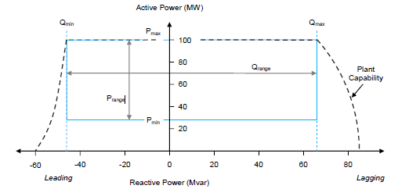Figure 1: Example graph showing the P and Q ranges. Min Load is shown as the bottom blue line (Pmin).

Results

Report Summary
Testing was completed on [DATE].
Comment on the results, highlighting any issues encountered in performing the test or in analysing the results.
[Insert Report summary]
[Include any relevant test notes here, relating to how the test was carried out or to any specific conditions encountered during the test.]
[Abnormal behaviour in the data (spikes, dips, unusual vibrations, etc.) shall be noted and documented. The reasons behind these shall be detailed along with any corrective actions taken and what its effects are on the unit and/or the result. If possible a clear graph of the issue should also be presented].
[Data shall be presented as a full PQ chart with significant points highlighted and clearly labelled. A table of values and/or results shall accompany the graph].

Table of results
Import Mode | Value | Comments
PMin Import, QMin Leading | ______MW ;_______MVAr
PMax Import , QMin Leading | ______MW ;_______MVAr
PMax Import , QMax Lagging | ______MW ;_______MVAr
PMin Import, QMax Lagging | ______MW ;_______MVAr
Export Mode | Value | Comments
PMax Export, QMin Leading | ______MW ;_______MVAr
PMax Export , QMin Leading | ______MW ;_______MVAr
PMax Export, QMax Lagging | ______MW ;_______MVAr
P Max Export , QMax Lagging | ______MW ;_______MVAr
SVC Mode | Value | Comments
SVC mode, full leading | _______MVAr
SVC mode, full lagging | _______MVAr

System Service Values
Reading | Value | Comment
Registered Import Capacity | ______MW
P range Import | _______MW to _____MW
Q range Import | ______MVAr to _______MVAr
RP factor Import |  | Insert Calculation and value per Section 6.2
SRP Volume Import |  | Insert Calculation and value as per Section 6.2
Reading | Value | Comment
Registered Export Capacity | ______MW
P range Export | _______MW to _____MW
Q range Export | ______MVAr to _______MVAr
RP factor Export |  | Insert Calculation and value per Section 6.2
SRP Volume Export |  | Insert Calculation and value as per Section 6.2
Reading | Value | Comment
Q range in SVC mode | ______MVAr to _______MVAr
RP Factor in SVC mode |  | Insert Calculation and value per Section 6.2

Graph of results
[Insert a full graph of the results showing the full reactive power capability of the unit, all relevant values shall be displayed, such as the full Q_{range} (x-axis) and the full P range (y-axis). Each corner point shall also have its value clearly labelled; the chart shall also have the theoretical values shown, conventional PQ chart shall include the OEL and UEL limiters].
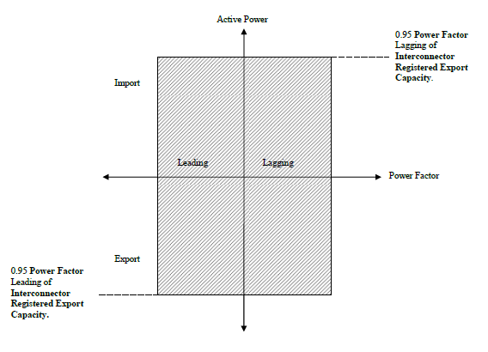
Figure 2: Example graph of a unit’s reactive power capability

http://www.eirgridgroup.com / http://www.soni.ltd.uk/
http://www.eirgrid.com/operations/gridcode/compliancetesting/wfpstestprocedures/#d.en.17698

