Grid Code
Modification Proposal Form

Email to gridcode@eirgrid.com
Title of Modification Proposal:
Housekeeping Modification on WFPS Voltage Control

MPID (EirGrid Use Only): MPID 270

Date: | 26th September 2016
Company Name: | EirGrid
Applicant Name: | Lisa McMullan
Email Address: | Lisa.mcmullan@eirgrid.com |  | Tel: | 01 2370549
Grid Code Version: | 6.0
Grid Code Section(s) Impacted by Modification Proposal: | WFPS 1.6 Transmission System Voltage Requirements.
Modification Proposal Justification:

WFPS 1.6.2.5 details the relevant points appropriate to Voltage Regulation. MPID228 was a modification on reactive power that was proposed and approved by the CER, 26 February 2013.

Figure WFPS 1.3 was not updated at this time to align with the revised text in section WFPS1.6.3.1. This housekeeping modification will align section WFPS1.6.3 and figure WFPS 1.3.
Red-line Version of Impacted Grid Code Section(s) - show proposed changes to text:
Deleted text in strike-through red font and new text highlighted in blue font

WFPS1.6.2.5 Figure WFPS1.3 shows the relevant points appropriate to the Voltage Regulation System for a Controllable WFPS. X is the HV side of the WTG transformer, Y is the lower voltage side of the Grid Connected Transformer and Z is the Connection Point.

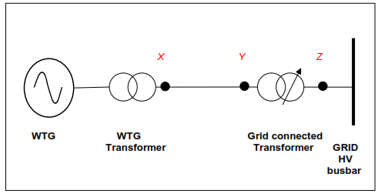
Figure WFPS1.3 - Locations for Voltage Regulation set-point (Z) and the Power Factor range (Y Z). The HV side of the WTG transformer is (X)

Green-line Version of Impacted Grid Code Section(s) - show proposed final text:

WFPS1.6.2.5 Figure WFPS1.3 shows the relevant points appropriate to the Voltage Regulation System for a Controllable WFPS. X is the HV side of the WTG transformer, Y is the lower voltage side of the Grid Connected Transformer and Z is the Connection Point.

Figure WFPS1.3 - Locations for Voltage Regulation set-point (Z) and the Power Factor range (Z). The HV side of the WTG transformer is (X)

