RfG

PPM Test Report

[Insert Power Park Module Name]

Version 0.1

DISCLAIMER:

This Document contains information (and/or attachments) which may be privileged or confidential. All content is intended solely for the use of the individual or entity to whom it is addressed. If you are not the intended recipient please be aware that any disclosure, copying, distribution or use of the contents of this message is prohibited. If you suspect that you have received this Document in error please notify EirGrid or its subsidiaries immediately. EirGrid and its subsidiaries do not accept liability for any loss or damage arising from the use of this document or any reliance on the information it contains or the accuracy or up to date nature thereof. Use of this document and the information it contains is at the user’s sole risk. In addition, EirGrid and its subsidiaries strongly recommends that any party wishing to make a decision based on the content of this document should not rely solely upon data and information contained herein and should consult EirGrid or its subsidiaries in advance.

Further information can be found at: <http://www.eirgrid.com/aboutus/legal/>

Table of Contents

1 Document Version History 4

2 Template Introduction 4

2.1 Purpose 4

2.2 The Reader 4

2.3 Pre Submission guidelines 4

3 Introduction 5

4 Abbreviations 6

5 Grid Code References 7

6 Active Power Control Test 16

6.1 Purpose of the Test 16

6.2 Pass Criteria Summary 16

6.3 Instrumentation and Onsite Data Trending 17

6.4 Ramp Rate Settings 17

6.5 AAP & MW Limiter Test 18

6.6 Ramp Rate Adjustment Test 19

6.7 Active Power Control Test 22

6.8 Local Shutdown & Start-up Test 31

7 Frequency Response 32

7.1 Purpose of the Test 32

7.2 Pass Criteria Summary 32

7.3 Instrumentation and Onsite Data Trending 33

7.4 Frequency Response Settings 34

7.5 Frequency Droop Setting 35

7.6 Frequency Response On, Curve 1, APC On (RfG Frequency Sensitive Mode) 37

7.7 Frequency Response On, Curve 1, APC Off (RfG Limited Frequency Sensitive Mode) 43

7.8 Frequency Response On, Curve 2, APC On 46

7.9 Frequency Response On, Curve 2, APC Off 50

7.10 Frequency Response Off, Curve 1, APC On 53

7.11 Frequency Response Off, Curve 1, APC Off 54

7.12 Frequency Response Off, Curve 2, APC On 55

7.13 Frequency Response Off, Curve 2, APC Off 56

7.14 DMOL 57

7.15 Frequency Response Ramp Rate Priority in Curve 1 59

7.16 Frequency Response Ramp Rate Priority in Curve 2 61

8 Reactive Power Capability 63

8.1 Purpose of the Test 63

8.2 Pass Criteria Summary 63

8.3 Instrumentation and Onsite Data Trending 63

8.4 Test Analysis 64

8.5 Table of measured reactive power capability 67

9 Reactive Power Control Test 68

9.1 Purpose of the Test 68

9.2 Pass Criteria Summary 68

9.3 Instrumentation and Onsite Data Trending 68

9.4 AVR & PF Settings 69

9.5 Automatic Voltage Regulation Mode 70

9.6 Automatic Voltage Regulation Response Rate 73

9.7 Mvar Control Mode 74

9.8 Power Factor Control Mode 77

9.9 Functional checks and Bumpless Transfer 80

10 Black Start Shutdown Test 81

10.1 Purpose of the Test 81

10.2 Pass Criteria 81

10.3 Instrumentation and Onsite Data Trending 81

10.4 Black Start Shutdown Test Analysis 81

11 Appendix 1 – Frequency Response Setings 83

# ipp TEST PROCEDURE Version History

|  |  |  |  |  |
| --- | --- | --- | --- | --- |
| **Document Version History** | | | | |
| **Version** | **Date** | **Comment** | **Name** | **Company** |
| 0.1 | dd/mm/yyyy | First submission for review/approval |  |  |
|  |  |  |  |  |
|  |  |  |  |  |

# Template Introduction

This section is for information on the template only and shall be deleted on submission.

## Purpose

Grid Code Compliance is the responsibility of the PPM. The test report template provides a guideline of expected report standard to be submitted by a PPM on completion of Grid Code Compliance Test programme.

The report shall be submitted for acceptance to [generator_testing@eirgrid.com](mailto:generator_testing@eirgrid.com) not greater than 20BD following completion of the test programme.

The purpose of the report is:

1. **Present the data recorded during Grid Code Compliance Testing**
2. **Analyse the performance of the PPM during testing**
3. **Assess the compliance of the PPM against the pass criteria for each test**

## The Reader

The report shall be developed for technical and non-technical readers and shall follow the agreed test programme. The report is submitted to [generator_testing@eirgrid.com](mailto:generator_testing@eirgrid.com). This template is based on the published test procedure templates[1].

The formatting and content of the report is at the discretion of PPM and shall be altered as appropriate for varying test methods or data analysis.

Sections that highlight ‘*Include, Insert, Analyse, Explain’* identified in italics shall be completed with the relevant material.

Detailed graphs shall be placed on a separate page in order to maximise their size and legibility.

This document includes extracts from submitted test reports, as an example of analysis/performance.

## Pre Submission guidelines

The following steps shall be carried out before submitting the report:

1. Identify all pass criteria as agreed in the test procedure.
2. Ensure that all pass criteria are correct (correct Grid Code/Distribution Code references, *etc.*)
3. Include a graph of each test, with additional graphs where appropriate *e.g.* examination of a ramp rate or response to set-point within 10 seconds.
4. Include a table with assessment of test data vs. criteria for each test. *e.g.*
   1. Compare active power (MW and % of Registered Capacity) to set-point (MW and % of Registered Capacity)
   2. Ramp Rate settings vs. measured ramp rates (MW and % of Registered Capacity)
   3. Response to set-point within 10 seconds of receipt of set-point.
   4. Frequency Response Ramp Rates (MW and % of Registered Capacity)
   5. Frequency Response is in line with specified curves (MW and % of Registered Capacity/set-point/AAP)
   6. *Etc.*
5. Include analysis of any deviations in AAP or active power, or any non-compliance identified in table.
6. Address any non-compliances that can be addressed and re-tested before the deadline for achieving an Operational Certificate
   1. Submit the Load Profile Request Form[2] before 10am 2 days in advance of carrying out any software update, to [generator_testing@eirgrid.com](mailto:generator_testing@eirgrid.com)
   2. Request a Grid Code Compliance Test date to [generator_testing@eirgrid.com](mailto:generator_testing@eirgrid.com) in line with the existing process, noting what testing is to be carried out
7. Apply for time limited derogation for any non-compliance that cannot be addressed in the short term.
8. Update report to reflect any additional testing or derogation applications and submit to [generator_testing@eirgrid.com](mailto:generator_testing@eirgrid.com).

Derogation applications shall include tested values (*i.e.* derogation from a ramp rate of 20%/min to 15%/min, as opposed to a derogation from ramp rates).

The PPM is welcome to discuss and seek clarification of requirements or arrange a meeting prior to submission of the report.

# Introduction

____ PPM is located in full address____ and is connected to the transmission system at ____ 110 kV station. ____ PPM consists of __ x _______ generation units, with an installed capacity of __ MW and an MEC of __ MW. The PPM energised in ____.

|  |  |
| --- | --- |
| Contact Name, Postal Address and e-mail address for issuance of an Operational Certificate | PPM to Specify |
| PPM Point of contact and contact number: | PPM to Specify |
| PPM connection point | PPM to Specify  (*i.e.* T121 HV bushings) |
| PPM connection voltage | PPM to Specify |
| Registered Capacity | PPM to Specify |
| Limiter applied to Exported MW | PPM to Specify |
| Limiter applied to AAP | PPM to Specify |
| DMOL | PPM to Specify |
| Approved/pending derogations | PPM to specify DAID numbers |
| Maximum Leading (importing) Mvar at connection point | PPM to Specify |
| Maximum Lagging (exporting) Mvar at connection point | PPM to Specify |

Table X

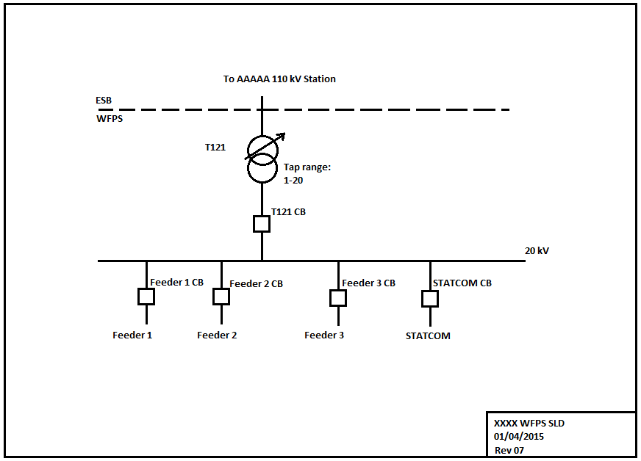Single Line Diagram

Testing was carried out by *[insert PPM test coordinator]* and *[insert EirGrid testing coordinator]* on dd/mm/yyyy.

The following tests were carried out in accordance with the agreed test programme and are included in this report:

1. Active Power Control.
2. Frequency Response.
3. Reactive Power Capability.
4. Reactive Power Control.
5. Black Start Shutdown.

# Abbreviations

AAP Available Active Power

APC Active Power Control

AVR Automatic Voltage Regulation

DMOL Designed Minimum Operating Level

HV High Voltage

Leading Mvar Absorbing Mvar from System

Lagging Mvar Producing Mvar

MEC Maximum Export Capacity

Mvar Mega Volt Ampere – reactive

MW Mega Watt

NCC National Control Centre

PPMCS Power Park Module Control System

PPM Power Park Module

PF Power Factor

TSO Transmission System Operator

WFCS Power park module Control System

WFPS Power park module Power Station

WTG Resource Generation unit Generator

# Grid Code References

|  |  |
| --- | --- |
| Grid Code Version: | PPM to specify |

|  |  |
| --- | --- |
| **Design Minimum Operating Level (DMOL):** | The minimum **Active Power** output of **Controllable PPM** where all **Generation Units** are generating electricity and capable of ramping upwards at any of the specified ramp rates (given available resource), and shall not be greater than 12% of **Registered Capacity**. |
| **Governor Droop** | The percentage drop in the **Frequency** that would cause the **Generation Unit** under free governor action to change its output from zero to its full **Capacity**. In the case of a **Controllable PPM**, it is the percentage drop in the **Frequency** that would cause the **Controllable PPM** to increase its output from zero to its full **Registered Capacity.** |
| **Voltage Regulation System Slope Setting** | The percentage change in **Transmission System** **Voltage** that would cause the **Reactive Power** output of the **Interconnector** or **Controllable PPM** to vary from maximum **Mvar** production to maximum **Mvar** absorption or vice-versa. |

**SDC2.B.1** The **Mvar Output** of any **CDGU** in respect of which a **Dispatch Instruction** is given under SDC2.4.2.4(b) shall, in accordance with its declared **Technical Parameters**, be adjusted to the new target **Mvar** level so **Instructed**, within, a tolerance of +/- 2% of the target or +/- 2 **Mvar**, whichever is greater. The **Reactive Power** output of a **CDGU** shall not be adjusted (other than under **AVR** action) except in response to a **Dispatch Instruction** from the **TSO**.

**PPM1.5.1** No additional **Generation Unit** shall be started while the **Transmission System Frequency** is above 50.2 Hz.

**PPM1.5.2 ACTIVE POWER MANAGEMENT**

A PPM  **Control System** shall be installed by the **Controllable PPM** to allow for the provision of **Active Power Control** and **Frequency** **Response** from the **Controllable PPM**. The PPM **Control System** and **Frequency Response System** shall provide the functionality as specified in this section PPM1.5.2.

**PPM1.5.2.1 Active Power Control**

The PPM  **Control System** shall be capable of operating each Generation Unitat a reduced level if the **Controllable PPM’s Active Power** output has been restricted by the **TSO**. In this **Active Power Dispatch Mode**, the PPM **Control System** shall be capable of receiving an on-line **Active Power Control Set-point** sent by the **TSO** and shall commence implementation of the set-point within 10 seconds of receipt of the signal from the **TSO**. The rate of change of output to achieve the **Active Power Control Set-point** should be the **Active** **Power Control Set-Point Ramp Rate** setting of the PPM **Control System**, as advised by the TSO, as per PPM1.5.4. The **TSO** acknowledges that if the **Active Power** output of the **Controllable PPM** is initially less than the **Design Minimum Operating Level**, and if the **Controllable PPM** is expected to increase its **Active Power** output, then it may not be able to achieve the specified ramp rate at first, due to Generation Units going through a start-up sequence. In such a case, Generation Units shall start up as quickly as the technology allows, and in any case, not longer than three minutes from the time the **Active Power Control Set-point** was received.

Manual local measures shall be allowed in cases where the automatic remote control devices are out of service. The **Active Power** set point must be reached within 1 hour.

PPM1.5.3.1 In **Resource Following Mode**, the **Frequency Response System** shall have the capabilities as displayed in the *Power-Frequency Response Curve* in *Figures PPM1.2,* where the power and frequency ranges required for points A, B, C, D, E are defined below in *Table PPM 1.1 and Table PPM1.2. Controllable PPM Frequency Response and Governor Droop shall be calculated with respect to Registered Capacity.* **PPM**. The **Frequency Response System** shall adjust the **Active Power** output of the **Controllable PPM** according to a **Governor Droop**, settable by the **TSO** in a range from 2% to 12% and defaulting to 4%, when operating in the ranges outside the deadband range FB-FC in the Power-Frequency Response Curve. .

PPM1.5.3.2

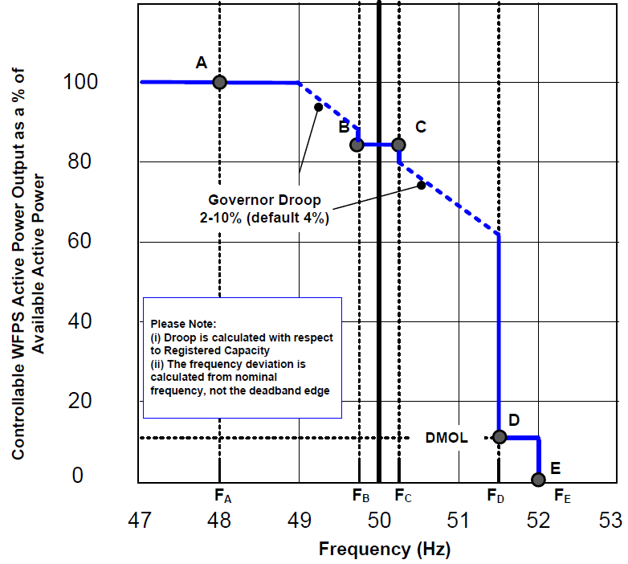

*Figure PPM 1.2 –Example of Power-Frequency Response Curve for Reosurce Following Mode*

PPM1.5.3.3 When acting to control **Transmission System Frequency**, the **Controllable PPM** shall provide at least 60% of its expected additional **Active Power** response within 5 seconds, and 100% of its expected additional **Active Power** response within 15 seconds of the start of the **Transmission System Frequency** excursion outside the range FB-FC, or in the case of a **Controllable PPM** in **Active Power Control Mode**, when the **Transmission System Frequency** goes outside the deadband set out in PPM1.5.3.2.

PPM1.5.3.4 When the **Transmission System Frequency** is in the range FC-FD, the **Controllable PPM** shall ensure that its **Active Power Output** does not increase beyond the **Active Power** value of the **Controllable PPM** when the **Transmission System Frequency** first exceeded FC, due to an increase in **Available Active Power** in that period.

PPM1.5.3.5 If the **Frequency** drops below FA, then the **Frequency Response System** shall act to maximise the **Active Power** output of the **Controllable PPM**, irrespective of the **Governor Droop Setting**. If the **Frequency** rises above FD, then the **Frequency Response System** shall act to reduce the **Active Power** output of the **Controllable PPM** to its **DMOL** value. If the **Frequency** rises above FE, then the **Frequency Response System** shall act to reduce the **Active Power** output of the **Controllable PPM** to zero. Any Generation Unit which has disconnected shall be brought back on load as fast as technically feasible, provided the **Transmission System Frequency** has fallen below 50.2 Hz.

PPM1.5.3.6 Points ‘A’, ‘B’, ‘C’, ‘D’ and ‘E’ shall depend on a combination of the **Transmission System Frequency**, **Active** **Power** and **Active Power Control Set-point** settings. These settings may be different for each **Controllable PPM** depending on system conditions and **Controllable PPM** location. These settings are defined in *Table PPM 1.1*

|  |  |  |
| --- | --- | --- |
| Point | ***Transmission System Frequency***  *(Hz)* | ***Controllable PPM Active Power*** *Output*  *(****%*** *of* ***Available******Active Power****)* |
| A | ***FA*** | ***PA*** |
| B | ***FB*** | Minimum of : ***PB*** or  **Active Power Control Set-point** (converted to a % of **Available** **Active Power**) |
| C | ***FC*** | Minimum of: ***PC*** or  **Active Power Control Set-point** (converted to a % of **Available** **Active Power**) |
| D | ***FD*** | Minimum of: ***PD*or**  **Active Power Control Set-point** (converted to a % of **Available** **Active Power**) |
| E | ***FE*** | ***PE*** = 0 % |

*Table PPM1.1:* ***Transmission System Frequency*** *and %* ***Available Active Power*** *Settings for the Points ‘A’, ‘B’, ‘C’, ‘D’ and ‘E’ illustrated in Figure PPM1.2*

Two settings for each of ***FA, FB, FC, FD, FE, PA, PB, PC, PD*** and ***PE*** shall be specified by the **TSO** at least 120 **Business Days** prior to the **Controllable PPM’s** scheduled **Operational Date** (refer to PPM1.5.3.15 below).The **Controllable PPM** shall be responsible for implementing the appropriate settings during **Commissioning**.

PPM1.5.3.7 The table below, *Table PPM1.2,* shows the **Transmission System Frequency** and **Active** **Power** ranges for ***FA, FB, FC, FD, FE, PA, PB, PC, PD*** and ***PE****.*

|  |  |  |  |
| --- | --- | --- | --- |
|  | ***Transmission System Frequency*** *(Hz)* |  | ***Available Active Power*** *(%)* |
|  |  |  | ***Registered Capacity ≥ 5 MW*** |
| ***FA*** | *47.0-49.5* | ***PA*** | *50-100* |
| ***FB*** | *49.5-50* | ***PB*** | *15-100* |
| ***FC*** | *50-50.5* | ***PC*** |
| ***FD*** | *50.5-52.0* | ***PD*** | *15-100 but not less than* ***DMOL*** |
| ***FE*** | ***PE*** | *0* |

*Table PPM 1.2:* ***Transmission System Frequency*** *&* ***Active******Power*** *ranges appropriate to Figure PPM 1.2.*

For the **Transmission System Frequency** values in *Table PPM 1.2* above, *FA* ≤ *FB* ≤ *FC* ≤ *FD* ≤ *FE*.

PPM1.5.3.8 Alterations to the **Controllable PPM’s Active Power** output, triggered by **Transmission System Frequency** changes, shall be achieved by proportionately altering the **Active Power** output of all available Generation Units as opposed to switching individual Generation Units on or off, insofar as possible.

PPM1.5.3.9 No time delays, such as moving average frequency filters, other than those necessarily inherent in the design of the **Frequency Response System** shall be introduced. The **Frequency Response System** shall continuously monitor the **Transmission System Frequency** in order to continuously determine the **Controllable PPM’s** appropriate **Active Power** output by taking account of the **Controllable PPM’s** **Available** **Active Power** or **Controlled** **Active Power**.

PPM1.5.3.10 If the **Transmission System Frequency** rises to a level above ‘D’-’E’, as defined by the *Power-Frequency Response Curve in Figure PPM1.2*, the **TSO** accepts that Generation Units may disconnect. Any Generation Unit which has disconnected shall be brought back on load as fast as technically feasible (provided the **Transmission System Frequency** has fallen below 50.2 Hz).

PPM1.5.3.11 The maximum admissible **Active Power** reduction from maximum output with falling frequency shall be no greater than;

1. Steady State Domain: 2% of the **Maximum Capacity** at 50 Hz, per 1 Hz frequency drop, below 49.5 Hz
2. Transient Domain: 2% of the **Maximum Capacity** at 50 Hz, per 1 Hz frequency drop, below 49 Hz

PPM1.5.3.12 In response to **Low Frequency Events**, **Controllable PPMs** shall take into account;

* 1. operating conditions of each **Controllable PPM** in respect of (c)PPM1.5.3.11(c); and
  2. **Available Active Power**.

PPM1.5.3.13 In response to **Low Frequency Events**, **Controllable PPMs** shall be capable of providing a power increase up to **Maximum Capacity**. Stable operation in response to **Low Frequency Events** shall be ensured.

**Controllable PPMs** capable of acting as a load, shall be capable of disconnecting their load in the case of a **Low Frequency Event**. This requirement does not extend to auxiliary supplies or **Energy Storage Power Stations**.**PPM1.5.3.15 Procedure for Setting and Changing the *Power-Frequency Response Curves***

Two *Power-Frequency Response Curves* (Curve 1 and Curve 2) shall be specified by the **TSO** at least 120 **Business Days** prior to the **Controllable PPM’s** scheduled **Operational Date.** The **Controllable PPM** shall be responsible for implementing the appropriate settings during **Commissioning**. The **Frequency Response System** shall be required to change between the two curves within one minute from receipt of the appropriate signal from the **TSO**. The **TSO** shall give the **Controllable PPM** a minimum of two weeks notice if changes to either of the curve’s parameters ***(i.e. FA, FB, FC, FD, FE, PA, PB, PC, PD*** or ***PE)***, are required. The **Controllable PPM** shall formally confirm that any requested changes have been implemented within two weeks of receiving the **TSO’s** formal request.

**PPM** **1.5.3.15 Procedure for Setting and Changing the *Power-Frequency ResponseCurves***

Two *Power-Frequency Response Curves* (Curve 1 and Curve 2) shall be specified by the **TSO** at least 120 **Business Days** prior to the **Controllable PPM’s** scheduled **Operational Date.** The **Controllable PPM** shall be responsible for implementing the appropriate settings during **Commissioning**. The **Frequency Response System** shall be required to change between the two curves within one minute from receipt of the appropriate signal from the **TSO**. The **TSO** shall give the **Controllable PPM** a minimum of two weeks’ notice if changes to either of the curve’s parameters ***(i.e. FA, FB, FC, FD, FE, PA, PB, PC, PD*** or ***PE)***, are required. The **Controllable PPM** shall formally confirm that any requested changes have been implemented within two weeks of receiving the **TSO’s** formal request.

**PPM1.5.4 RAMP RATES**

**PPM1.5.4.1** The PPM **Control System** shall be capable of controlling the ramp rate of its **Active Power** output. There shall be three ramp rate capabilities, designated **Resource Following Ramp Rate**, **Active** **Power Control Set-Point Ramp Rate**, and **Frequency Response Ramp Rate**. The PPM **Control System** shall operate the ramp rates with the following order of priority (high to low): **Frequency Response Ramp Rate**; **Active** **Power Control Set-Point Ramp Rate**; **Resource Following Ramp Rate**. The **Resource Following Ramp Rate** shall be used during **Start-Up**, normal operation, and **Shutdown**. The **TSO** shall specify the Resource **Following Ramp Rate** and the **Active** **Power Control Set-Point Ramp Rate** in percentage of **Registered Capacity** per minute. The **Frequency Response Ramp Rate** shall be the maximum possible ramp rate of the **Controllable PPM** agreed with the **TSO** and with the characteristics as set out in PPM1.5.3.1**.** The **TSO** acknowledges that rapidly changing resource availability may cause temporary deviations from the ramp rate settings of the **Controllable PPM**, but these deviations should not be allowed to exceed 3% of **Registered Capacity** or +/- 0.5MW

**PPM1.5.4.2** It shall be possible to vary the **Resource Following Ramp Rate** and the **Active** **Power Control Set-Point Ramp Rate** each independently over a range between 1% and 100% of **Registered Capacity** per minute.

**PPM1.6.2 AUTOMATIC VOLTAGE REGULATION**

PPM1.6.2.1 **Controllable PPMs** shall have a continuously-variable and continuously-acting **Voltage** **Regulation** **System** with similar response characteristics to a conventional **Automatic Voltage Regulator** and shall perform generally as described in BS4999 part 140, or equivalent European Standards.

PPM1.6.2.2 Under steady state conditions, the **Voltage Regulation System** shall be capable of implementing the following **Reactive Power** control modes which shall be available to the **TSO:**

1. The **Controllable PPM** shall be capable of receiving a **Power Factor** control (PF) set-point to maintain the **Power Factor** set-point at the **Connection Point;**

The **Controllable PPM** shall be capable of controlling the **Reactive Power**  at least within the **Reactive Power** ranges specified in PPM1.6.3, with setting steps of no greater than 0.01 p.u.. The **Power Factor** shall be maintained within a tolerance of ± 0.5 %. The tolerance will be measured with reference to the maximum **Reactive Power** at the **Connection Point.**

1. The **Controllable PPM** shall be capable of receiving a **Reactive Power** control (Q) set-point to maintain the **Reactive Power** set-point at the **Connection Point**;

The **Controllable PPM** shall be capable of setting the **Reactive Power** set-point at least within the **Reactive Power** range specified in PPM1.6.3, with setting steps no greater than 5 Mvar or 5 % (whichever is smaller) of maximum **Reactive Power**, controlling the **Reactive Power** at the connection point to an accuracy within ± 5 Mvar or ± 5 % (whichever is smaller) of the maximum **Reactive Power**;

1. The **Controllable PPM** shall be capable of receiving a **Voltage Regulation** (kV) **Set-point** for the **Voltage** at the **Connection Point.** The **Voltage Regulation System** shall act to regulate the **Voltage** at this point by continuous modulation of the **Controllable PPM’s Reactive Power** output, without violating the rapid **Voltage** changelimits as set out in CC.10.13.1.

The **Controllable PPM** shall be capable of contributing to voltage control at the **Connection Point** by provision of **Reactive Power** exchange with the **Transmission System** with a **Voltage Regulation Set-point** covering 0.95 to 1.05 p.u. in steps no greater than 0.01 p.u.. The **Reactive Power** output shall be zero when the grid voltage value at the connection point equals the **Voltage Regulation Set-point**.

The speed of response of the **Voltage Regulation System** shall be such that, following a step change in **Voltage** at the **Connection Point** the **Controllable PPM** shall achieve 90 % of its steady-state **Reactive Power** response within 1 second. The **Reactive Power** must settle at the steady-state **Reactive Power** response within 5 seconds, with a steady-state **Reactive Power** tolerance no greater than 5 % of the maximum **Reactive Power**.

Subject to agreement with TSO, the **Voltage Regulation Set-point** may be operated with or without a deadband selectable in a range from zero to ±5% of reference 1 p.u **Transmission System** voltage in steps no greater than 0.5%.

A change to the **Power Factor** control (PF) set-point, **Reactive Power** control (Q) set-point or **Voltage Regulation** (kV) **Set-Point** shall be implemented by the **Controllable PPM** within 20 seconds of receipt of the appropriate signal from the **TSO,** within its reactive power capability range as specified in PPM1.6.3.

PPM1.6.2.3 The **Voltage Regulation** **System** **Slope Setting** shall be capable of being set to any value between 2 % and 7 %. The setting shall be specified by the **TSO** at least 120 **Business Days** prior to the **Controllable PPM’s** scheduled **Operational Date.** The **Controllable PPM** shall be responsible for implementing the appropriate settings during **Commissioning**. The slope setting may be varied from time to time depending on **Transmission System** needs. The **TSO** shall give the **Controllable PPM** a minimum of two weeks notice if a change is required. The **Controllable PPM** shall formally confirm that any requested changes have been implemented within two weeks of receiving the **TSO’s** formal request.

PPM1.6.2.4 The speed of response of the **Voltage** **Regulation System** shall be such that, following a step change in **Voltage** at the **Connection Point** the **Controllable PPM** shall achieve 90 % of its steady-state **Reactive Power** response within 1 second. The response may require a transition from maximum **Mvar** production to maximum **Mvar** absorption or vice-versa.

PPM1.6.3.1 **Controllable PPMPPMs** operating in **Power Factor** control mode, **Voltage** **Control** mode or constant **Reactive Power** mode shall be at least capable of operating at any point within the P-Q capability ranges illustrated in *Figure PPMPPM1.4,* as measured at the **Connection Point** over the normal and disturbed **Transmission System Voltage** ranges specified in CC.8.3.2; subject to the exception in PPM1.6.3.2, where additional Reactive Power compensation may be utilised to compensate for the Reactive Power demand of the connection between the Connection Point and the Controllable PPM.

Referring to *Figure PPM1.4:*

Point A represents the minimum Mvar absorption capability of the **Controllable PPM** at 100% **Registered Capacity** and is equivalent to 0.95 power factor leading;

Point B represents the minimum Mvar production capability of the **Controllable PPM** at 100% **Registered Capacity** and is equivalent to 0.95 power factor lagging;

Point C represents the minimum Mvar absorption capability of the **Controllable PPM** at 12% **Registered Capacity** and is equivalent to the same **Mvar** as Point A;

Point D represents the minimum Mvar production capability of the **Controllable PPM** at 12% **Registered Capacity** and is equivalent to the same **Mvar** as Point B;

Point E represents the minimum Mvar absorption capability of the **Controllable PPM** at the cut-in speed of the individual Generation Units;

Point F represents the minimum Mvar production capability of the **Controllable PPM** at the cut-in speed of the individual Generation Units;

The **TSO** accepts that the values of Points E and F may vary depending on the number of **Generation** generating electricity in a low resource scenario;

*Figure PPM1.4* represents the minimum expected **Reactive Power** capabilities of the **Controllable PPM**. The **Controllable PPM** is obliged to tell the **TSO**/**DSO** if it can exceed these capabilities, and submit the actual P-Q capability diagram based upon the installed plant and **Collector Network** characteristics to the **TSO** during **Commissioning.**

The **Grid Connected Transformer** tap changing range must be capable of ensuring nominal voltage at point Y for any **Voltage** at the **Connection Point** (Point Z) within the ranges specified in PPM1.6.1.



*Figure PPM1.4 –* Minimum**Reactive Power** Capability of **Controllable PPM**

*Figure PPM1.4* represents the minimum expected **Reactive Power** capabilities of the **Controllable PPM**. The **Controllable PPM** is obliged to tell the **TSO**/**DSO** if it can exceed these capabilities, and submit the actual P-Q capability diagram based upon the installed plant and **Collector Network** characteristics to the **TSO** during **Commissioning.**

PPM1.6.3.4 Without prejudice to PPM1.6.3.1, **Controllable PPMs** shall comply with the following **Reactive Power** requirements at **Registered Capacity** at the **Connection Point**;

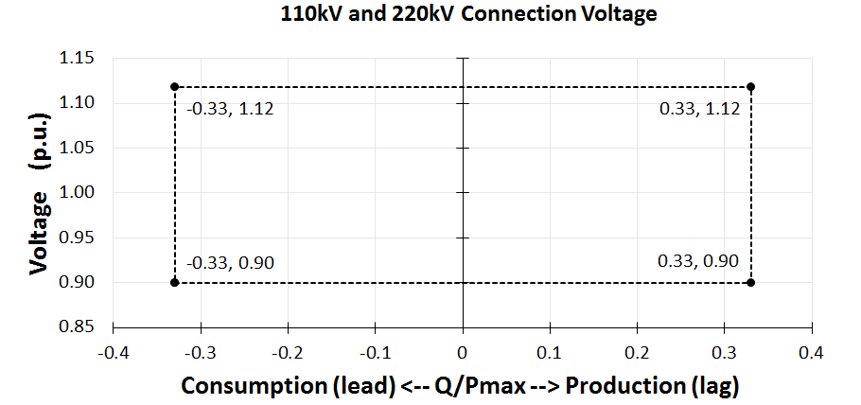

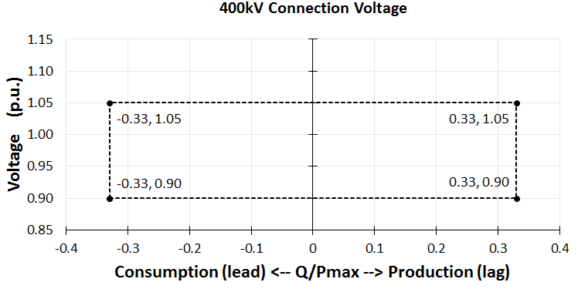

In the event of power oscillations, **Controllable PPMs** shall retain steady-state stability when operating at any operating point of the **Reactive Power** capability.

PPM1.7.2.3 **Frequency Response**

**The Frequency Response Curve**signal shall be sent by the **TSO** to the **Controllable PPM** in the event that a change from *Power-Frequency Response Curve 1* to *Power Frequency Response Curve 2*, or vice versa, is required.

The **Controllable PPM** is required to make it possible for the **TSO** to remotely enable/ disable the **Frequency Response System**. The associated status indication is described in PPM1.7.1.5.

The **Controllable PPM** shall make it possible for the **TSO** to set the **Governor Droop** value of the **Frequency Response System** in values from 2% to 10%.

**Note:**PPM 1.5.3.11 to PPM 1.5.3.14 in the Grid Code reflect RfG Frequency Sensitive Mode and Limited Frequecy Sensitive Mode Over & Under.

Please note that this test procedure will assess compliance via the existing Frequency Cuves (Curve 1 & Curve 2).

PPM1.7.2.5 **Black Start Shutdown**

Means shall be provided by the **Controllable PPM** to facilitate the disconnection of the **Controllable PPM** by the **TSO** and to also prevent re-connection in the event of **Black Start**. The **TSO** shall send a **Black Start Shutdown** signal and upon receipt, the **Controllable PPM** shall be required to trip the circuit-breaker(s) at the **Controllable PPM’s Connection Point** and shutdown the **Controllable PPM** in a controlled manner. The precise circuit-breakers for which this facility shall be provided shall be specified by the **TSO** at least 120 **Business Days** prior to the **Controllable PPM’s** scheduled **Operational Date.**  **Controllable PPMs** may only be reconnected (i.e. made live) when the **Network** is fully restored following instruction from the **TSO[3]** and only earlier if the **TSO** deems it acceptable to do so.

# Active Power Control Test

## Purpose of the Test

The purpose of this test is to demonstrate the Active Power Control functions of the PPMCS, including ramp rates applied during shutdown and start-up; and to demonstrate DMOL of the PPM.

## Pass Criteria Summary

The following is the pass criteria for the test. Test data shall be assessed against each of these.

| **Criteria** | **Criteria Assessed** | **Criteria Passed** |
| --- | --- | --- |
| **Active Power Control** | | |
| Active Power Output is limited to the MEC of the PPM | **Yes / No** | **Yes / No** |
| PPMCS receives all online Active Power Control Set-points, commences implementation of all set-points within 10 seconds of receipt and provides the correct set-point feedback |  |  |
| When APC is ON, PPM regulates its active power output to within the greater of ±0.5 MW or ±3% of Registered Capacity of the Active Power Control Set-point |  |  |
| PPMCS operates each Generation Unit at a reduced level while operating at a reduced output, greater than DMOL |  |  |
| All Generation Units start-up in less than 3 minutes of receipt of set-point, when dispatched up from 0 MW |  |  |
| PPMCS does not respond to any set-points sent while Active Power Control is OFF |  |  |
| **Ramp Rates** | | |
| Rate of change of output is equal to the Active Power Control Set-point Ramp Rate when ramping to Active Power Control Set-points greater than or equal to DMOL, with temporary deviations not exceeding ±3% of Registered Capacity |  |  |
| PPM output ramps to AAP at the Resource Following Ramp Rate when Active Power Control is turned OFF (unless acting under Frequency Response Ramp Rate) |  |  |
| Rate of change of output when ramping up due to increase in resource is no greater than Resource Following Ramp Rate |  |  |
| Rate of change of output is equal to Resource Following Ramp Rate on shutdown and on start-up |  |  |
| Demonstration that the Resource Following Ramp Rate and Active Power Control Set-point Ramp Rate can each be set independently over a range between 1% and 100% of Registered Capacity per minute |  |  |
| **DMOL** | | |
| DMOL is in line with declared value and no greater than 12% of Registered Capacity |  |  |
| **Available Active Power** | | |
| AAP is limited to the MEC of the PPM |  |  |
| AAP signal is a measure of the active power the PPM is capable of delivering |  |  |
| AAP signal is independent of the active power output when under curtailment or dispatch |  |  |
| % Mechanical availability signals are correct under dispatch |  |  |

## Instrumentation and Onsite Data Trending

|  |  |  |  |
| --- | --- | --- | --- |
| **No.** | **Data Trending and Recording** | **Resolution** | **Recorded** |
| 1 | Available active power from the prevailing resource in MW, derived by algorithm in the PPMCS (*Figure PPM1.3, Point Y*) | PPM to Specify (≥10 Hz) | Yes / No |
| 2 | Actual active power from the power park module in MW (*Figure PPM1.3, Point Y*) | PPM to Specify (≥10 Hz) | Yes / No |
| 3 | APC ON/OFF | PPM to Specify (≥ 10 Hz) | Yes / No |
| 4 | APC set-point from NCC | PPM to Specify (≥10 Hz) | Yes / No |
| 5 | Grid Frequency | PPM to Specify (≥10 Hz) | Yes / No |
| 6 | Number of generators online | PPM to Specify (≥10 Hz) | Yes / No |
| 7 | % Mechanical Availability | PPM to Specify (≥10 Hz) | Yes / No |

## Ramp Rate Settings

|  |  |
| --- | --- |
| **Calculation** | **Value** |
| Active Power Control Set-point Ramp Rate of 20% of Registered Capacity per minute | ____ MW/min  (PPM to specify calculation and formula used) |
| Resource Following Ramp Rate of 20% of Registered Capacity per minute | ____ MW/min  (PPM to specify calculation and formula used) |
| If Generation Units are out of service, will the PPM ramp at a reduced ramp rate? | ____ MW/min  (PPM to specify calculation and formula used) |

## AAP & MW Limiter Test

*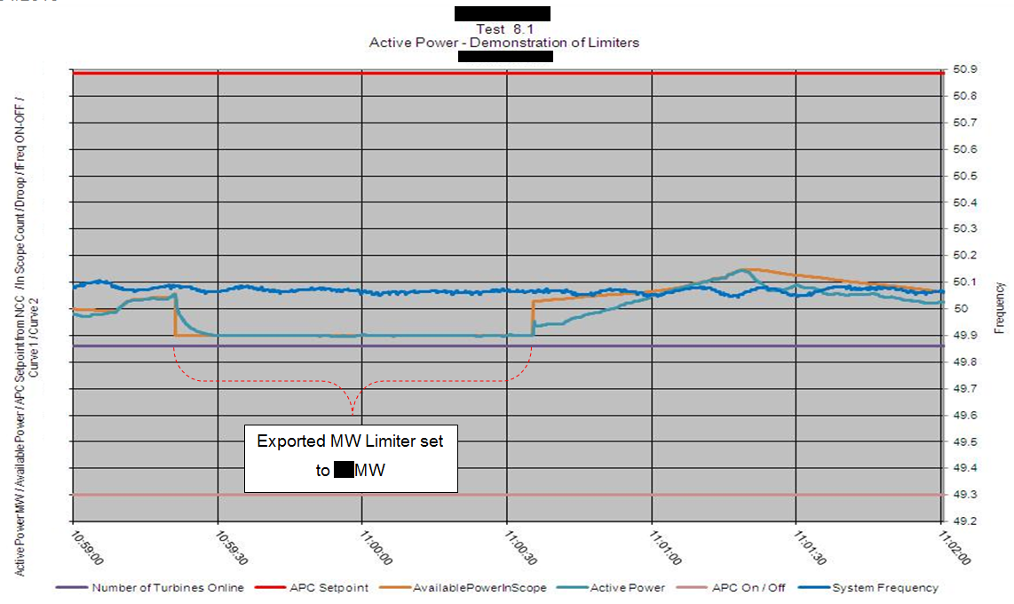Graph X – Demonstration of Limiters*

Demonstration of limiters was carried out on dd/mm/yyyy. The Export Limiter test is included in Graph X.

*[Include any relevant test notes here, relating to how the test was carried out or any specific conditions encountered during this test].*

Following completion of this test, the AAP limiter has been set to __ MW and the Export limiter has been set to __ MW.

| **Criteria** | **Criteria Assessed** | **Criteria Passed** |
| --- | --- | --- |
| **Active Power Control** | | |
| Active Power Output is limited to the MEC of the PPM |  |  |
| **Available Active Power** | | |
| AAP is limited to the MEC of the PPM |  |  |

**Criteria – Active Power Output is limited to the MEC of the PPM**

As illustrated in Graph X, the Export limiter was set to __ MW from hh:mm to hh:mm. While the limit was set to __ MW, the average Active Power output was __ MW. The maximum Active Power output during this period was __ MW.

**Criteria – AAP is limited to the MEC of the PPM**

As illustrated in Graph X, the AAP limiter was set to __ MW from hh:mm to hh:mm. While the limit was set to __ MW, the average Active AAP was __ MW. The maximum AAP during this period was __ MW.

## Ramp Rate Adjustment Test

*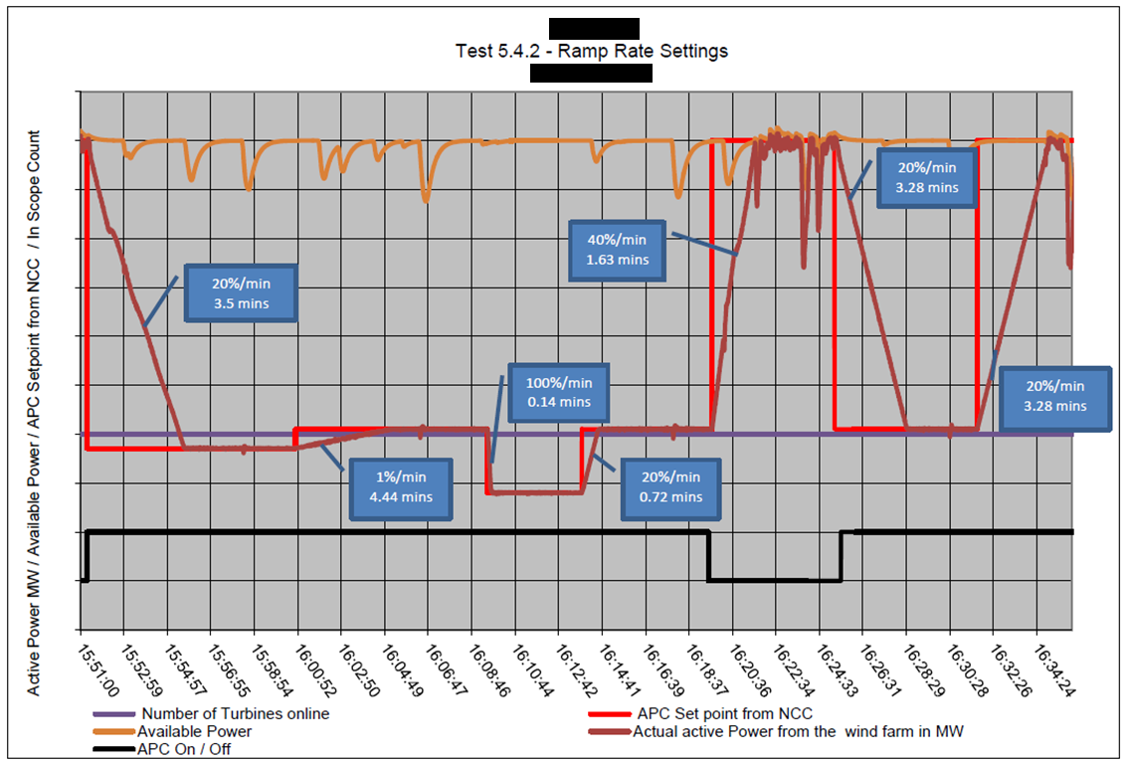Graph X – Ramp Rate Settings*

Ramp Rate Adjustment test was carried out on dd/mm/yyyy as shown in Graph X.

*[Include any relevant test notes here, relating to how the test was carried out or any specific conditions encountered during this test].*

| **Criteria** | **Criteria Assessed** | **Criteria Passed** |
| --- | --- | --- |
| **Ramp Rates** | | |
| Rate of change of output is equal to the Active Power Control Set-point Ramp Rate when ramping to Active Power Control Set-points greater than or equal to DMOL, with temporary deviations not exceeding ±3% of Registered Capacity |  |  |
| Demonstration that the Resource Following Ramp Rate and Active Power Control Set-point Ramp Rate can each be set independently over a range between 1% and 100% of Registered Capacity per minute |  |  |

**Criteria – Rate of change of output is equal to the Active Power Control Set-point Ramp Rate when ramping to Active Power Control Set-points greater than or equal to DMOL, with temporary deviations not exceeding ±3% of Registered Capacity**

*[Include a graph of any anomalous ramps, such as ramps that are outside of the Grid Code requirements].*

*Graphs shall be overlaid with the correct ramp rate. Where appropriate (e.g. for faster ramps) additional graphs shall be provided, zooming in on the relevant data.*

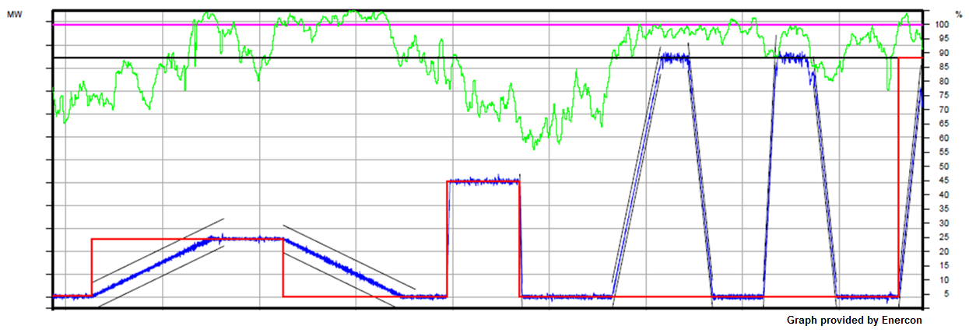

*Graph X – Ramp Rate Settings*

*Include analysis of any deviations from the specified ramp rate, noting the Grid Code requirement is for temporary deviations of no more than 3% of Registered Capacity.*

*Explain how ramps were measured i.e. ramping began 6 seconds after the set-point was received. Ramp rate was measured from the point where the active power began ramping to the time when it reached the set-point, or for the ramp from 3 MW to 7 MW the ramp rate was measured from when the active power first exceeded 3.5 MW to when it first exceeded 6.5 MW, in order to minimise measurement errors.*

| Step | Set-point | Initial Time | Final Time | Initial Power | Final Power | ΔP/Δt | Set-point Ramp Rate Setting | Resource Following Ramp Rate Setting | Maximum Deviation (% of Reg. Cap.) |
| --- | --- | --- | --- | --- | --- | --- | --- | --- | --- |
| 3 - 5 | a MW – b MW | 13:52:40 | 14:04:40 | a MW | b MW | h MW/min | h MW/min | - | +2%  -1.5% |
| 5 -6 | b MW – c MW | 14:12:27 | 14:24:40 | b MW | c MW | i MW/min | i MW/min | - | +1.7%  -2.3% |
| 7 -8 | c MW – d MW | 14:29:24 | 14:29:42 | c MW | d MW | j MW/min | j MW/min | - | … |
| 8 – 9 | d MW – e MW | 14:36:57 | 14:37:14 | d MW | e MW | k MW/min | k MW/min | - | … |
| 9 - 11 | e MW – APC off | 14:46:30 | 14:51:33 | e MW | f MW | l MW/min | - | l MW/min | … |
| 11 - 12 | APC off – APC on | 14:54:22 | 14:56:56 | f MW | e MW | m MW/min | m MW/min | - | … |
| 12 - 14 | e MW - APC off | 15:02:09 | 15:03:24 | e MW | f MW | n MW/min | - | n MW/min | … |
| 14 - 15 | APC off – APC on – | 15:07:20 | 15:09:45 | f MW | e MW | o MW/min | o MW/min | - | … |
| 15 - 16 | e MW – g MW | 15:16:08 | 15:18:20 | e MW | g MW | p MW/min | p MW/min | - | … |

Table X

**Criteria – Demonstration that the Resource Following Ramp Rate and Active Power Control Set-point Ramp Rate can each be set independently over a range between 1% and 100% of Registered Capacity per minute**

During this test, the Active Power Control Set-point Ramp Rate was set to the following values, demonstrating that each ramp rate can be set independently, and over a range of values between 1% and 100% of Registered Capacity per minute*.*

*[Include a table of all ramp rate settings that were implemented during this test].*

|  |  |  |
| --- | --- | --- |
| **% of Registered Capacity/min** | **MW/min** | **Ramp Rate** |
| 1%/min | a MW/min | Active Power Control |
| 20%/min | b MW/min | Resource Following |
| 100%/min | c MW/min | Active Power Control |

Table X

## Active Power Control Test

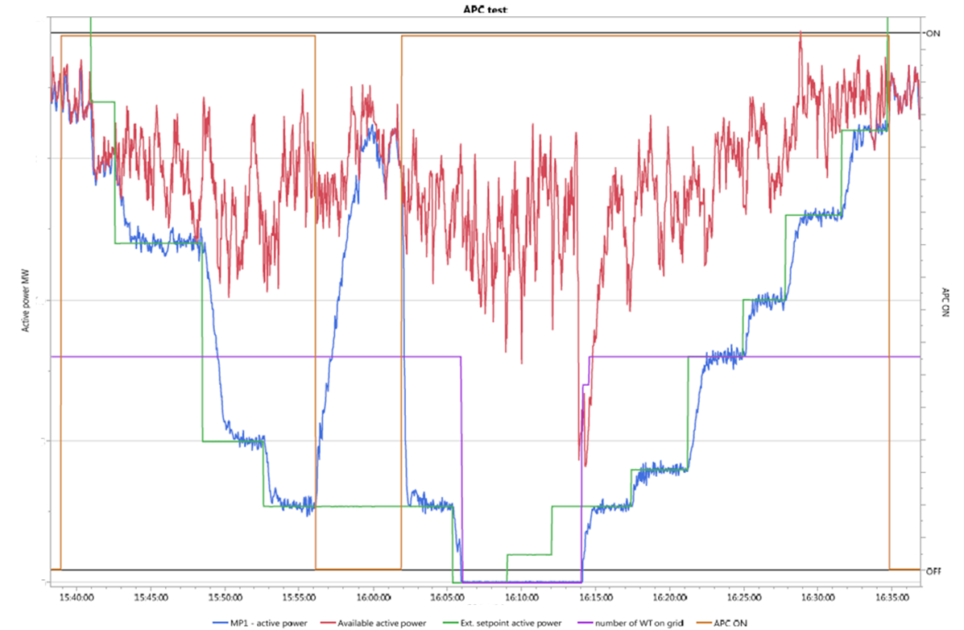*Graph X – Active Power Control Test*

Active Power Control test was carried out on dd/mm/yyyy as shown in Graph X.

*[Include any relevant test notes here, relating to how the test was carried out or any specific conditions encountered during this test].*

| **Criteria** | **Criteria Assessed** | **Criteria Passed** |
| --- | --- | --- |
| **Active Power Control** | | |
| PPMCS receives all online Active Power Control Set-points, commences implementation of all set-points within 10 seconds of receipt and provides the correct set-point feedback. |  |  |
| When APC is ON, PPM regulates its active power output to within the greater of ±0.5 MW or ±3% of Registered Capacity of the Active Power Control Set-point |  |  |
| PPMCS operates each Generation Unit at a reduced level while operating at a reduced output, greater than DMOL |  |  |
| All Generation Units start-up in less than 3 minutes of receipt of set-point, when dispatched up from 0 MW |  |  |
| PPMCS does not respond to any set-points sent while Active Power Control is OFF |  |  |
| **Ramp Rates** | | |
| Rate of change of output is equal to the Active Power Control Set-point Ramp Rate when ramping to Active Power Control Set-points greater than or equal to DMOL, with temporary deviations not exceeding ±3% of Registered Capacity |  |  |
| PPM output ramps to AAP at the Resource Following Ramp Rate when Active Power Control is turned OFF (unless acting under Frequency Response Ramp Rate) |  |  |
| Rate of change of output when ramping up due to increase in resource is no greater than Resource Following Ramp Rate |  |  |
| **DMOL** | | |
| DMOL is in line with declared value and no greater than 12% of Registered Capacity |  |  |
| **Available Active Power** | | |
| AAP signal is a measure of the active power the PPM is capable of delivering. |  |  |
| AAP signal is independent of the active power output when under curtailment or dispatch. |  |  |
| % Mechanical availability signals are correct under dispatch |  |  |

**Criteria – PPMCS receives all online Active Power Control Set-points**

As per the signed test procedure that was scanned and submitted to [generator_testing@eirgrid.com](mailto:generator_testing@eirgrid.com), All Active Power Control set-points were received on the day of testing, with the exception of a XX MW set-point which was issued while Active Power Control was OFF. No set-points required to be resent.

**Criteria – PPM regulates its active power output to within the greater of ±0.5 MW or ±3% of Registered Capacity of the Active Power Control Set-point**

*[Include a graph of any anomalies such as over-shoots or fluctuations].*

*Identify and analyse any overshoots or fluctuations in active power. Provide an explanation for any deviations from the standard set out in the pass criteria.*

| **Step** | **Set-point** | **APC Status** | **Time** | **Minimum MW** | **Average MW** | **Maximum MW** | **Average AAP** |
| --- | --- | --- | --- | --- | --- | --- | --- |
| 3 | a MW | ON | 13:52:40 | b MW | c MW | d MW | e MW |
| 4 | f MW | ON | 14:12:27 | g MW | h MW | i MW | j MW |
| 5 | k MW | ON | 14:29:24 | l MW | m MW | n MW | o MW |
| 6 | p MW | OFF | 14:36:57 | q MW | r MW | s MW | t MW |
| … |  |  |  |  |  |  |  |
|  |  |  |  |  |  |  |  |
|  |  |  |  |  |  |  |  |
| 11 | v MW | ON | 15:16:08 | w MW | x MW | y MW | z MW |

Table X

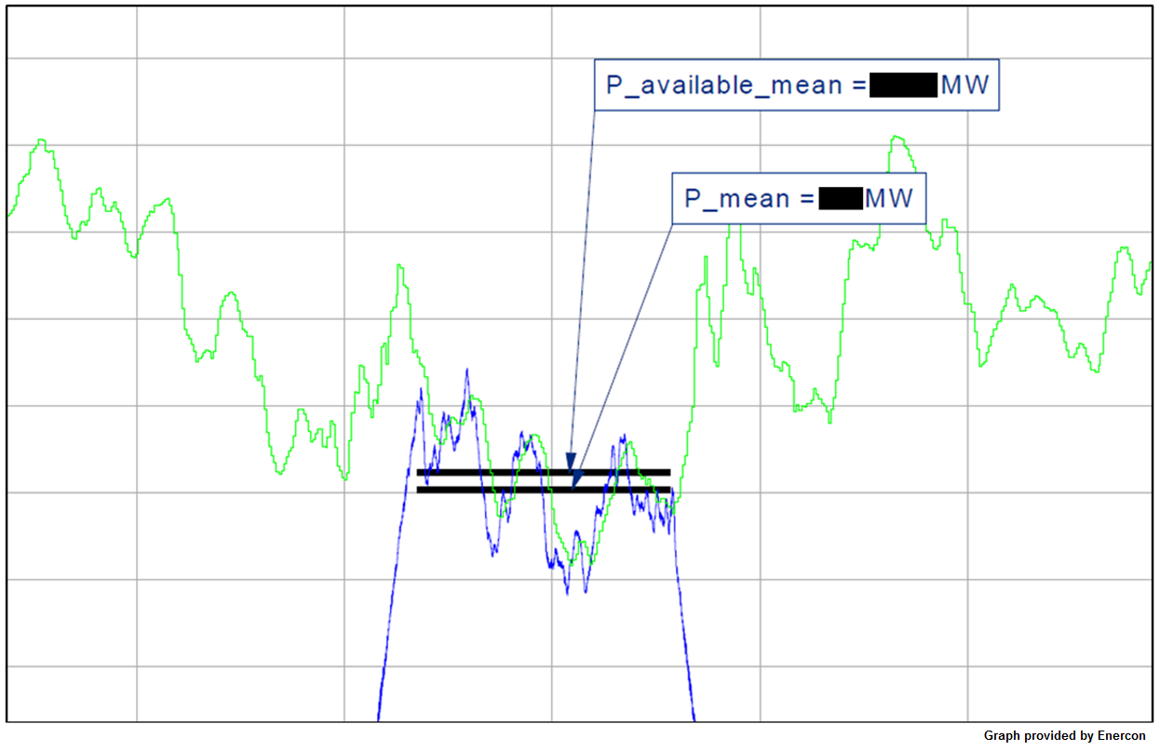

**Criteria – Rate of change of output is equal to the Active Power Control Set-point Ramp Rate when ramping to Active Power Control Set-points greater than or equal to DMOL, with temporary deviations not exceeding ±3% of Registered Capacity.**

*[Include a graph of any anomalous ramps, such as ramps that are outside of the Grid Code requirements].*

*Graphs shall be overlaid with the correct ramp rate.*

*[Identify and analyse all ramps which used the Active Power Control Set-point Ramp Rate].*

*[Include a table for ramp rate measured and expected as well as max deviation as % of Registered Capacity].*

*[Explain where ramps were measured from and to i.e. ramping began 6 seconds after the set-point was received. Ramp rate was measured from the point where the active power began ramping to the time when it reached the set-point or AAP (whichever is lower), or for the ramp from 3 MW to 7 MW the ramp rate was measured from when the active power first exceeded 3.5 MW to when it first exceeded 6.5 MW, in order to minimise measurement errors].*

Note. During the ramp from A MW to B MW, the Active Power Control Set-point ramp rate was exceeded as the AAP at a rate greater than the Active Power Control Set-point ramp rate.

Note. During the ramp from C MW to D MW, the AAP dropped below the set-point so the Active Power Control Set-point ramp rate could not be maintained due to lack of energy available.

| **Step** | **Set-point** | **Initial Time** | **Final Time** | **Initial Power** | **Final Power** | **ΔP/Δt** | **Delay Time** |
| --- | --- | --- | --- | --- | --- | --- | --- |
| 2 - 3 | a MW – b MW | 15:44:04 | 15:45:18 | a MW | b MW | X MW/min | 0.6 s |
| 3 -4 | b MW – c MW | 15:49:20 | 15:50:33 | b MW | c MW | X MW/min | 0.5 s |
| 4 - 5 | c MW -DMOL | 15:54:44 | 15:55:28 | c MW | d MW | X MW/min | 0.7 s |
| 5 - 6 | DMOL – e MW | 16:00:44 | 16:00:52 | d MW | e MW | X MW/min | 0.4 s |
| 6 - 7 | e MW – APC off | 16:04:06 | 16:06:45 | e MW | f MW | X MW/min | 0.8 s |
| 7 - 9 | APC off – APC on | 16:12:51 | 16:15:05 | f MW | e MW | X MW/min | 4.4 s |
| 9 - 10 | e MW – 0 MW | 16:20:09 | 16:20:32 | e MW | 0 MW | X MW/min | 0.9 s |
| 10 - 11 | 0 MW – g MW | 16:24:31 | 16:24:45 | 0 MW | g MW | X MW/min | 3.4 s |
| 11 - 12 | g MW – h MW | 16:28:01 | 16:28:45 | g MW | h MW | X MW/min | 0.9 s |
| 12 - 13 | h MW – i MW | 16:33:21 | 16:33:50 | h MW | i MW | X MW/min | 1.1 s |
| 13 - 14 | i MW – j MW | 16:37:50 | 16:39:20 | i MW | j MW | X MW/min | 1.4 s |
| 14 - 15 | j MW – k MW | 16:44:25 | 16:45:15 | j MW | k MW | X MW/min | 1 s |

Table X

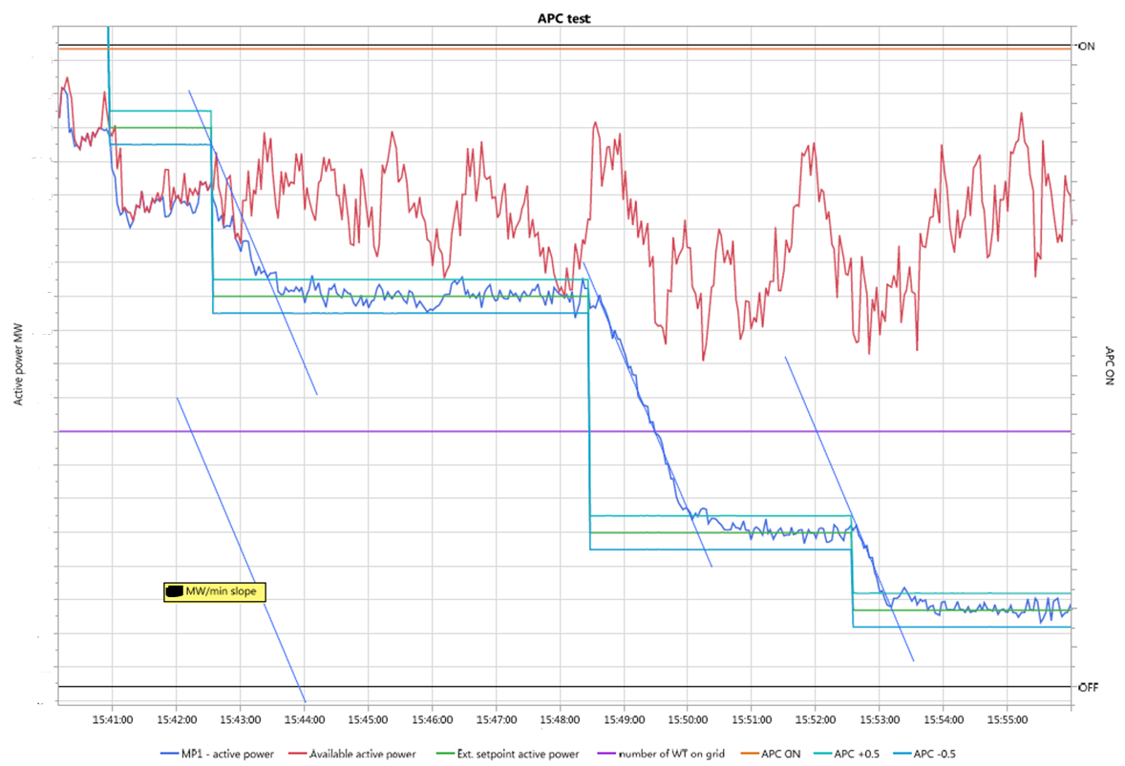

Graph X

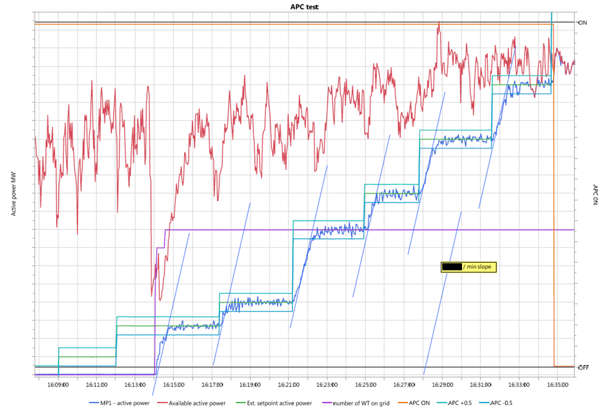

Graph X

**Criteria – PPMCS does not respond to any set-points sent while Active Power Control is OFF**

At hh:mm, Active Power Control was turned off and the PPM ramped from X MW to Y MW (AAP). At hh:mm, while Active Power Control was turned off, NCC issued a Z MW set-point per agreed test procedure. When Active Power Control was turned back on at hh:mm, the PPM ramped back to the previous set-point of X MW.

**Criteria – PPMCS commences implementation of all set-points within 10 seconds of receipt and provides the correct set-point feedback**

**Criteria – All Generation Units start-up in less than 3 minutes of receipt of set-point, when dispatched up from 0 MW**

As per Table A and Table B, the PPM responded to all set-points within 10 seconds of receipt, with the exception of the set-point from 0 MW to X MW.

Measured Response Time is calculated as the time between change in set-point (per recorded data) and corresponding change in MW (per recorded data).

All generation units started within 3 minutes each time that the PPM ramped up from 0 MW, with the exception of the last ramp up from 0 MW.

*[Insert graph of the relevant test data, showing that all Generation Units started within 3 minutes].*

*Graph X – PPM Ramping Up from 0 MW*

At hh:mm:ss the PPM was dispatched from 0 MW to X MW. Generation unit X did not start up due to a _________. The fault was cleared at hh:mm and the generation unit started manually. All other Generation Units started up within the 3 minute requirement.

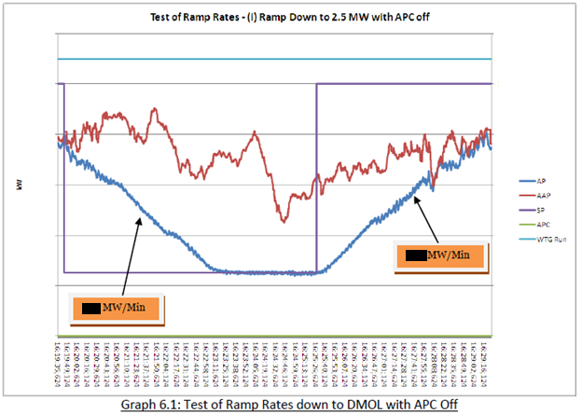

**Criteria – DMOL is in line with declared value and no greater than 12% of Registered Capacity**

**Criteria – PPMCS operates each Generation Unit at a reduced level while operating at a reduced output, greater than DMOL**

At DMOL (X MW), each generation unit is online, operating at its minimum set-point of Y MW. Hence, all Generation Units are operating at a reduced level. Less than X MW, generation units are shut down to meet set-points. The PPM can ramp from X MW to 100% of Registered Capacity in line with Frequency Response requirements (per Grid Code definition of DMOL). This is demonstrated further during Frequency Response testing.

| **Step** | **Initial Time** | **Final Time** | **Initial Power**  **(MW)** | **Final Power**  **(MW)** | **ΔP/ΔT**  **(MW/Min)** | **ΔP/ΔT**  **(%MEC)** |
| --- | --- | --- | --- | --- | --- | --- |
| Ramp Down 1 | 15:19:44 | 15:23:22 | a | b | c | d |
| Ramp Up 1 | 15:25:28 | 15:29:02 | e | f | g | h |

Table X

At hh:mm, all Generation Units were brought online when the PPM output ramped from 0 MW to DMOL (X MW). *[Insert a graph demonstrating that all Generation Units were brought online to meet the set-point of DMOL].*

|  |  |  |
| --- | --- | --- |
| **Demonstrated DMOL (MW)** | **Demonstrated DMOL (% of Registered Capacity)** | **Grid Code Requirement (% of Registered Capacity)** |
| X MW | Y% | 12% |

Table X

**Criteria – PPM output ramps to AAP at the Resource Following Ramp Rate when Active Power Control is turned OFF (unless acting under Frequency Response Ramp Rate)**

As illustrated in Graph X, when APC is turned off at hh:mm and hh:mm, active power ramps up to AAP at the Resource Following Ramp Rate.

*Include explanation of deviation from the ramp rates identified.*

*Graph X – AAP While Active Power is Ramping Up and Down*

**Criteria – AAP signal is a measure of the active power the PPM is capable of delivering**

**Criteria – AAP signal is independent of the active power output when under curtailment or dispatch**

*Include analysis of AAP while under dispatch when compared to AAP when APC is off or APC set-point is > AAP. If the AAP increases as active power ramps up, this would indicate that the AAP is not independent of the active power output when under dispatch and is not accurate while APC set-point is low.*

Note. At hh:mm the AAP dropped as 4 of the Generation Units carried out safety checks during the start-up sequence.

*Graph X – % Mechanical Availability vs. Active Power, AAP and APC Set-Point*

**Criteria – % Mechanical availability signals are correct under dispatch**

% Mechanical Availability drops from 100% to 90% during the Active Power Control test at hh:mm. This is due to Generator X becoming unavailable due to a fault. When the fault was manually cleared at hh:mm, the Mechanical Availability returned to 100%.

*[Insert graph showing % Mechanical Availability signal throughout the Active Power Control test (along with Active Power, Available Active Power, APC set-point signals].*

## Local Shutdown & Start-up Test

*Graph X – Shutdown and Start-Up*

Local Shutdown and Start-up test was carried out on dd/mm/yyyy. A graph of the Local Shutdown and Start-up test is included in Graph X.

*[Include any relevant test notes here, relating to how the test was carried out or any specific conditions encountered during this test].*

| **Criteria** | **Criteria Assessed** | **Criteria Passed** |
| --- | --- | --- |
| **Ramp Rates** | | |
| Rate of change of output is equal to Resource Following Ramp Rate on shutdown and on start-up |  |  |

**Criteria – Rate of change of output is equal to Resource Following Ramp Rate on shutdown and on start-up**

The PPM was shut down and started up locally at hh:mm on dd/mm/yyyy as part of the Active Power Control test. During shutdown and start-up, the PPM followed the Resource Following Ramp Rate, as demonstrated in the following analysis.

*[Identify and analyse ramp rates during shutdown and start-up. Is Active Power Control Set-point or Resource Following Ramp Rate used?].*

Table X for ramp rate measured and expected as well as max deviation in %.

*[Explain how the ramp rates were measured. i.e. the ramp rate was measured from when the active power first exceeded 0.5 MW to when it reached 6.5 MW, in order to minimise measurement errors].*

| **Step No.** | **Action** | **Time** | **Measured MW/min** | **Measured %/min** | **Required MW/min** | **Required %/min** | **Comments** |
| --- | --- | --- | --- | --- | --- | --- | --- |
| 1 | Local Shut-down | hh:mm:ss | x MW/min | x%/min | x MW/min | 20%/min | PPM ramped at Resource Following Ramp |
| 2 | Local Start-Up | hh:mm:ss | y MW/min | y%/min | y MW/min | 20%/min | PPM ramped at Resource Following Ramp |

Table X

# Frequency Response

## Purpose of the Test

The purpose of this test is to confirm the ability of the PPM to respond to changes in system frequency. The PPM shall be capable of operating with a “Governor Droop” – e.g. able to continuously adjust its active power output in response to changes in frequency. As the grid frequency cannot be changed at will, the test will require frequency to be simulated by means of injection of a frequency signal into the PPMCS.

## Pass Criteria Summary

The following is the pass criteria for the test. Test data shall be assessed against each of these.

| **Criteria** | **Criteria Assessed** | **Criteria Passed** |
| --- | --- | --- |
| **Governor Droop** | | |
| Governor droop is calculated with respect to Registered Capacity. |  |  |
| Governor droop is calculated with respect to 50 Hz. |  |  |
| Governor droop is settable in a range from 2% to 12%, online, from NCC. |  |  |
| When Frequency Response is OFF, no response shall be provided. |  |  |
| The PPMCS continuously recalculates its expected response during the frequency excursion. |  |  |
| **Rate of Response** | | |
| PPM provides ≥60% of its expected response within 5 seconds and 100% of its expected response within 15 seconds. |  |  |
| Ramp Rates shall be prioritised with Frequency Response Ramp Rate given the highest priority. |  |  |
| **Frequency Response Curve** | | |
| For frequency < FA, MW output ramps directly to 100% of AAP. |  |  |
| For frequency between FA and FB, MW output is based on frequency droop setting |  |  |
| For frequency ≥ FB and ≤ FC, no response shall be provided |  |  |
| For frequency between FC and FD, MW output is based on frequency droop setting. |  |  |
| For frequency > FD, MW output ramps directly to DMOL |  |  |
| For frequency > FE, MW output ramps directly to 0 MW |  |  |
| Deadband of +/-15 mHz is applied in Active Power Control Mode and in Curve 2 |  |  |
| **Latching etc.** | | |
| For frequency > FC, MW output does not increase above its value at the time frequency exceeded FC, due to AAP increasing. |  |  |
| Any Generation Unit which has disconnected due to frequency ≥ 50.8 Hz, shall be brought back on load when frequency falls less than 50.2 Hz. |  |  |
| No additional Generation Unit can be started while frequency is above 50.2 Hz. |  |  |
| Frequency response is achieved by altering the output of all Generation Units as opposed to switching Generation Units on or off, insofar as possible. |  |  |
| For active power output levels ≥ DMOL, all Generation Units shall be generating electricity. |  |  |
| PPM regulates its active power output to within the greater of ±0.5 MW or ±3% of Registered Capacity of the Active Power Control Set-point adjusted for frequency response. |  |  |

## Instrumentation and Onsite Data Trending

|  |  |  |  |
| --- | --- | --- | --- |
| **No.** | **Data Trending and Recording** | **Resolution** | **Recorded** |
| 1 | Available active power from the prevailing resource in MW, derived by algorithm in the PPMCS (*Figure PPM1.3, Point Y*) | PPM to Specify (≥ 10 Hz) | Yes / No |
| 2 | Actual active power from the PPM in MW (*Figure PPM1.3, Point Y*) | PPM to Specify (≥ 10 Hz) | Yes / No |
| 3 | APC ON/OFF | PPM to Specify (≥ 10 Hz) | Yes / No |
| 4 | APC set-point from NCC | PPM to Specify (≥10 Hz) | Yes / No |
| 5 | Frequency Response ON/OFF | PPM to Specify (≥10 Hz) | Yes / No |
| 6 | Frequency Response Curve1/Curve2 | PPM to Specify (≥10 Hz) | Yes / No |
| 7 | Frequency Droop Setting | PPM to Specify (≥10 Hz) | Yes/No |
| 8 | Simulated Test Frequency | PPM to Specify (≥10 Hz) | Yes / No |
| 9 | Grid Frequency | PPM to Specify (≥10 Hz) | Yes / No |
| 10 | Number of generation units online | PPM to Specify (≥10 Hz) | Yes / No |
| 11 | % Mechanical Availability | PPM to Specify (≥10 Hz) | Yes / No |

## Frequency Response Settings

|  |  |
| --- | --- |
| **Calculation** | **Value** |
| Theoretical change in MW for frequency increase of 0.25 Hz with Frequency Droop of 4% | ____ MW  (PPM to specify calculation and formula used) |
| Theoretical change in MW for frequency increase of 0.25 Hz with Frequency Droop of 2% | ____ MW  (PPM to specify calculation and formula used) |
| Theoretical change in MW for frequency decrease of 0.5 Hz with Frequency Droop of 12% | ____ MW  (PPM to specify calculation and formula used) |

## Frequency Droop Setting

*Graph X – PPM Frequency Droop Setting*

Frequency Droop Setting test was carried out on dd/mm/yyyy. A graph of the Frequency Droop Setting test is included, above.

*[Include any relevant test notes here, relating to how the test was carried out or any specific conditions encountered during this test].*

| **Criteria** | **Criteria Assessed** | **Criteria Passed** |  |
| --- | --- | --- | --- |
| **Governor Droop** | | | |
| Governor droop is calculated with respect to Registered Capacity and 50 Hz |  |  |  |
| Governor droop is settable in a range from 2% to 12%, online, from NCC. |  |  |  |
| **Rate of Response** | | | |
| PPM provides ≥60% of its expected response within 5 seconds and 100% of its expected response within 15 seconds. |  |  |  |
| Ramp Rates shall be prioritised with Frequency Response Ramp Rate given the highest priority. |  |  |  |
| PPM regulates its active power output to within the greater of ±0.5 MW or ±3% of Registered Capacity of the Active Power Control Set-point adjusted for frequency response. |  |  |  |

**Criteria – Governor Droop is calculated with respect to Registered Capacity and 50 Hz.**

**Criteria – PPM regulates its active power output to within the greater of ±0.5 MW or ±3% of Registered Capacity of the Active Power Control Set-point adjusted for frequency response.**

*[Include a graph of any anomalies and any supporting plots/diagrams].*

*Analyse the performance of the PPM in relation to the criteria.*

| **Step** | **Time** | **Simulated Frequency** | **Set-point** | **Droop** | **Required MW** | **Actual MW** |
| --- | --- | --- | --- | --- | --- | --- |
|  |  |  |  |  |  |  |
|  |  |  |  |  |  |  |
|  |  |  |  |  |  |  |
|  |  |  |  |  |  |  |

Table X

Expected response is calculated using the following equation:

$$ΔMW = \frac{Δf*Registered Capacity}{f_{nominal}*Droop}$$

**Criteria – Governor Droop is settable in a range from 2% to 12%, online from NCC**

As shown in table *X*, the droop was set to 2%, 4% and 12% during the Frequency Droop Setting test, demonstrating that it is settable in the range 2% to 12%.

**Criteria – PPM provides ≥60% of its expected response within 5 seconds and 100% of its expected response within 15 seconds**

*[Include a graph of any anomalies and any supporting plots/diagrams].*

*Analyse the performance of the PPM in relation to the criteria.*

| **Step** | **Time** | **Initial MW** | **Required MW** | **MW required after 5 seconds** | **MW achieved after 5 seconds** | **MW required after 15 seconds** | **MW achieved after 15 seconds** |
| --- | --- | --- | --- | --- | --- | --- | --- |
|  |  |  |  |  |  |  |  |
|  |  |  |  |  |  |  |  |
|  |  |  |  |  |  |  |  |
|  |  |  |  |  |  |  |  |

Table X

**Criteria – Ramp Rates shall be prioritised with Frequency Response Ramp Rate given the highest priority**

As shown in Table *X*, during the simulated frequency deviations, the rate of response of the PPM was not limited by the Active Power Control Set-point or Resource Following Ramp Rates.

## Frequency Response On, Curve 1, APC On (RfG Frequency Sensitive Mode)

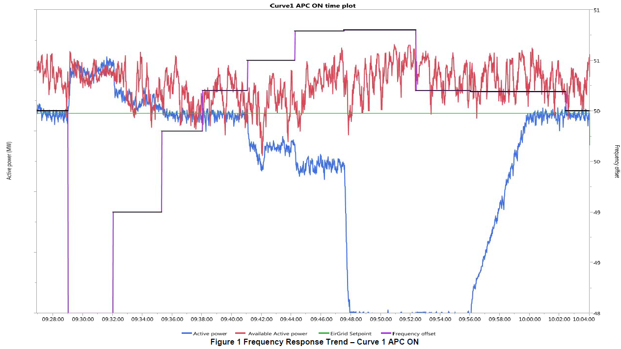

Graph X

Frequency Response On, Curve 1, APC On (RfG Frequency Sensitive Mode) test is included within graph X.

*[Include any relevant test notes here, relating to how the test was carried out or any specific conditions encountered during this test].*

| **Criteria** | **Criteria Assessed** | **Criteria Passed** |
| --- | --- | --- |
| **Rate of Response** | | |
| PPM provides ≥60% of its expected response within 5 seconds and 100% of its expected response within 15 seconds. |  |  |
| **Frequency Response Curve** | | |
| For frequency < FA, MW output ramps directly to 100% of AAP. |  |  |
| For frequency between FA and FB, MW output is based on frequency droop setting |  |  |
| For frequency ≥ FB and ≤ FC, no response shall be provided |  |  |
| For frequency between FC and FD, MW output is based on frequency droop setting. |  |  |
| For frequency > FD, MW output ramps directly to DMOL |  |  |
| For frequency > FE, MW output ramps directly to 0 MW |  |  |
| Deadband of +/-15 mHz is applied in Active Power Control Mode and in Curve 2 |  |  |
| **Latching etc.** | | |
| Any Generation Unit which has disconnected due to frequency ≥ 50.8 Hz, shall be brought back on load when frequency falls less than 50.2 Hz. |  |  |
| Frequency response is achieved by altering the output of all Generation Units as opposed to switching Generation Units on or off, insofar as possible |  |  |
| For active power output levels ≥ DMOL, all Generation Units shall be generating electricity. |  |  |
| PPM regulates its active power output to within the greater of ±0.5 MW or ±3% of Registered Capacity of the Active Power Control Set-point adjusted for frequency response. |  |  |

**Criteria – For frequency < FA, MW output ramps directly to 100% of AAP**

**Criteria – For frequency between FA and FB, MW output is based on frequency droop setting**

**Criteria – For frequency ≥ FB and ≤ FC, no response shall be provided**

**Criteria – For frequency between FC and FD, MW output is based on frequency droop setting**

**Criteria – For frequency > FD, MW output ramps directly to DMOL**

**Criteria – For frequency > FE, MW output ramps directly to 0 MW**

**Criteria – Deadband of +/-15 mHz is applied in Active Power Control Mode and in Curve 2**

**Criteria – PPM regulates its active power output to within the greater of ±0.5 MW or ±3% of Registered Capacity of the Active Power Control Set-point adjusted for frequency response**

*[Include a graph of any anomalies and any supporting plots/diagrams].*

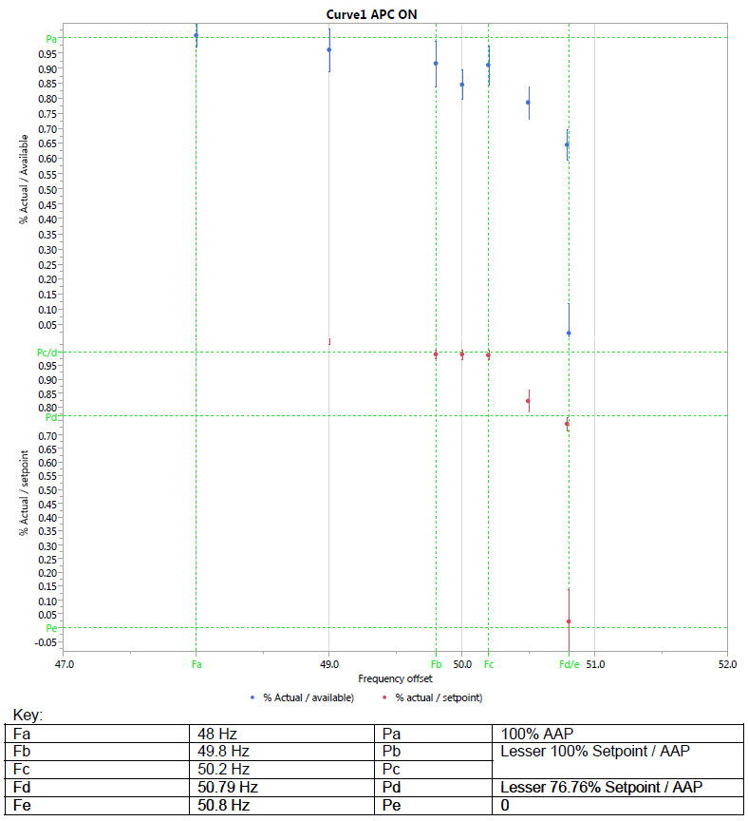

Graph X

*Analyse the performance of the PPM in relation to the criteria.*

| **Step** | **Time** | **Simulated Frequency** | **Set-point** | **AAP** | **Droop** | **Required MW** | **Actual MW** | **Max Deviation** |
| --- | --- | --- | --- | --- | --- | --- | --- | --- |
| 1 |  | 49 Hz |  |  |  |  |  | -0.5 MW to +0.3 MW |
| 2 |  | 49.75 Hz |  |  |  |  |  |  |
| 3 |  | 49.984 Hz |  |  |  |  |  |  |
| 4 |  | 49.985 Hz |  |  |  |  |  |  |
| 5 |  | 49.985 Hz |  |  |  |  |  |  |
|  |  |  |  |  |  |  |  |  |
|  |  |  |  |  |  |  |  |  |

Table X

**Criteria – PPM provides ≥60% of its expected response within 5 seconds and 100% of its expected response within 15 seconds**

*[Include a graph of any anomalies and any supporting plots/diagrams].*

*Analyse the performance of the PPM in relation to the criteria.*

| **Frequency Step (Hz)** | **Time** | **Initial MW** | **Required MW** | **MW required after 5 seconds** | **MW achieved after 5 seconds** | **MW required after 15 seconds** | **MW achieved after 15 seconds** |
| --- | --- | --- | --- | --- | --- | --- | --- |
| 50 – 49 Hz |  |  |  |  |  |  |  |
| 49 – 49.75 Hz |  |  |  |  |  |  |  |
| 49.75 – 49.984 Hz |  |  |  |  |  |  |  |
|  |  |  |  |  |  |  |  |

Table X

**Criteria – Any Generation Unit which has disconnected due to frequency ≥ 50.8 Hz, shall be brought back on load when frequency falls less than 50.2 Hz**

*[Include a graph of any anomalies and any supporting plots/diagrams].*

*Analyse the performance of the PPM in relation to the criteria.*

| **Step** | **Time** | **Simulated Frequency** | **Actual MW** | **# Generation units Online** |
| --- | --- | --- | --- | --- |
|  |  |  |  |  |
|  |  |  |  |  |
|  |  |  |  |  |
|  |  |  |  |  |

Table X

**Criteria – Frequency response is achieved by altering the output of all Generation Units as opposed to switching Generation Units on or off, insofar as possible**

**Criteria – For active power output levels ≥ DMOL, all Generation Units shall be generating electricity**

*[Include a graph of any anomalies and any supporting plots/diagrams].*

When the frequency was changed from X Hz to Y Hz, the MW output reduced from XX MW to DMOL. As shown in Table X, no generation units were stopped until the active power was reduced less than DMOL.

| **Step** | **Time** | **Simulated Frequency** | **Actual MW** | **# Generation units Online** |
| --- | --- | --- | --- | --- |
|  |  |  |  |  |
|  |  |  |  |  |
|  |  |  |  |  |
|  |  |  |  |  |

Table X

*Graph X – Frequency Response When Dispatched less than DMOL*

Additional test steps were carried out to demonstrate the performance of the PPM when dispatched less than DMOL.

DMOL is XX MW. While the PPM was dispatched less than DMOL and a high frequency was injected, the PPM did not shut down any additional generators to regulate further downwards, in line with the frequency curve settings. This is demonstrated in in Table X.

| **Step** | **Time** | **Simulated Frequency** | **Actual MW** | **# Generators Online** |
| --- | --- | --- | --- | --- |
|  |  |  |  |  |
|  |  |  |  |  |
|  |  |  |  |  |
|  |  |  |  |  |

Table X

While the Grid Code requirement of “≥60% of expected response within 5 seconds and 100% of expected response in 15 seconds” does not apply below DMOL, the PPM is expected to provide frequency response at the maximum possible rate. The performance of the PPM is analysed.

| **Frequency Step (Hz)** | **Time** | **Initial MW** | **Required MW** | **MW required after 5 seconds** | **MW achieved after 5 seconds** | **MW required after 15 seconds** | **MW achieved after 15 seconds** |
| --- | --- | --- | --- | --- | --- | --- | --- |
| 50 – 49 Hz |  |  |  |  |  |  |  |
| 49 – 49.75 Hz |  |  |  |  |  |  |  |
| 49.75 – 49.984 Hz |  |  |  |  |  |  |  |
|  |  |  |  |  |  |  |  |

Table X

## Frequency Response On, Curve 1, APC Off (RfG Limited Frequency Sensitive Mode)

*Graph X – PPM Frequency Droop Setting*

Frequency Response On, Curve 1, APC Off (RfG Limited Frequency Sensitive Mode) test was carried out on dd/mm/yyyy. A graph of the Frequency Response On, Curve 1, APC Off (RfG Limited Frequency Sensitive Mode) test is included.

*[Include any relevant test notes here, relating to how the test was carried out or any specific conditions encountered during this test].*

| **Criteria** | **Criteria Assessed** | **Criteria Passed** |
| --- | --- | --- |
| **Governor Droop** | | |
| The PPMCS continuously recalculates its expected response during the frequency excursion |  |  |
| **Rate of Response** | | |
| PPM provides ≥60% of its expected response within 5 seconds and 100% of its expected response within 15 seconds. |  |  |
| **Frequency Response Curve** | | |
| For frequency < FA, MW output ramps directly to 100% of AAP. |  |  |
| For frequency between FA and FB, MW output is based on frequency droop setting |  |  |
| For frequency ≥ FB and ≤ FC, no response shall be provided |  |  |
| For frequency between FC and FD, MW output is based on frequency droop setting. |  |  |
| For frequency > FD, MW output ramps directly to DMOL |  |  |
| For frequency > FE, MW output ramps directly to 0 MW |  |  |
| **Latching etc.** | | |
| For frequency > FC, MW output does not increase above its value at the time frequency exceeded FC, due to AAP increasing. |  |  |
| Any Generation Unit which has disconnected due to frequency ≥ 50.8 Hz, shall be brought back on load when frequency falls less than 50.2 Hz. |  |  |
| PPM regulates its active power output to within the greater of ±0.5 MW or ±3% of Registered Capacity of the Active Power Control Set-point adjusted for frequency response. |  |  |

**Criteria – For frequency < FA, MW output ramps directly to 100% of AAP**

**Criteria – For frequency between FA and FB, MW output is based on frequency droop setting**

**Criteria – For frequency ≥ FB and ≤ FC, no response shall be provided**

**Criteria – For frequency between FC and FD, MW output is based on frequency droop setting**

**Criteria – For frequency > FD, MW output ramps directly to DMOL**

**Criteria – For frequency > FE, MW output ramps directly to 0 MW**

**Criteria – PPM regulates its active power output to within the greater of ±0.5 MW or ±3% of Registered Capacity of the Active Power Control Set-point adjusted for frequency response**

*[Include a graph of any anomalies and any supporting plots/diagrams].*

*Analyse the performance of the PPM in relation to the criteria.*

| **Step** | **Time** | **Simulated Frequency** | **AAP** | **Droop** | **Required MW** | **Actual MW** | **Max Deviation** |
| --- | --- | --- | --- | --- | --- | --- | --- |
| 1 |  | 49 Hz |  |  |  |  | -0.5 MW to +0.3 MW |
| 2 |  | 49.75 Hz |  |  |  |  |  |
| 3 |  | 49.984 Hz |  |  |  |  |  |
| 4 |  | 49.985 Hz |  |  |  |  |  |
| 5 |  | 49.985 Hz |  |  |  |  |  |
|  |  |  |  |  |  |  |  |
|  |  |  |  |  |  |  |  |

Table X

**Criteria – PPM provides ≥60% of its expected response within 5 seconds and 100% of its expected response within 15 seconds**

*[Include a graph of any anomalies and any supporting plots/diagrams].*

*Analyse the performance of the PPM in relation to the criteria.*

| **Frequency Step (Hz)** | **Time** | **Initial MW** | **Required MW** | **MW required after 5 seconds** | **MW achieved after 5 seconds** | **MW required after 15 seconds** | **MW achieved after 15 seconds** |
| --- | --- | --- | --- | --- | --- | --- | --- |
| 50 – 49 Hz |  |  |  |  |  |  |  |
| 49 – 49.75 Hz |  |  |  |  |  |  |  |
| 49.75 – 49.984 Hz |  |  |  |  |  |  |  |
|  |  |  |  |  |  |  |  |

Table X

**Criteria – The PPMCS continuously recalculates its expected response during the frequency excursion**

*[Include a graph of a frequency change that affects the MW output of the PPM].*

During the test, the active power output is continuously varying. The required output is continuously calculated, based on the frequency and available active power at any given time. This can be seen in Table X, when the frequency changes from X Hz to Y Hz.

**Criteria – For frequency > FC, MW output does not increase above its value at the time frequency exceeded FC, due to AAP increasing**

*[Include a graph of any anomalies and any supporting plots/diagrams].*

*Analyse the performance of the PPM in relation to the criteria.*

| **Step** | **Time** | **Simulated Frequency** | **Actual MW** | **# Generation units Online** |
| --- | --- | --- | --- | --- |
|  |  |  |  |  |
|  |  |  |  |  |
|  |  |  |  |  |
|  |  |  |  |  |

Table X

**Criteria – Any Generation Unit which has disconnected due to frequency ≥ 50.8 Hz, shall be brought back on load when frequency falls less than 50.2 Hz**

*[Include a graph of any anomalies and any supporting plots/diagrams].*

*Analyse the performance of the PPM in relation to the criteria.*

| **Step** | **Time** | **Simulated Frequency** | **Actual MW** | **# Generation units Online** |
| --- | --- | --- | --- | --- |
|  |  |  |  |  |
|  |  |  |  |  |
|  |  |  |  |  |
|  |  |  |  |  |

Table X

## Frequency Response On, Curve 2, APC On

*Graph X – Frequency Response On, Curve 2, APC On*

Frequency Response On, Curve 2, APC On test is included in the Graph X.

*[Include any relevant test notes here, relating to how the test was carried out or any specific conditions encountered during this test].*

| **Criteria** | **Criteria Assessed** | **Criteria Passed** |
| --- | --- | --- |
| **Rate of Response** | | |
| PPM provides ≥60% of its expected response within 5 seconds and 100% of its expected response within 15 seconds. |  |  |
| **Frequency Response Curve** | | |
| For frequency < FA, MW output ramps directly to 100% of AAP. |  |  |
| For frequency between FA and FB, MW output is based on frequency droop setting |  |  |
| For frequency ≥ FB and ≤ FC, no response shall be provided |  |  |
| For frequency between FC and FD, MW output is based on frequency droop setting. |  |  |
| For frequency > FD, MW output ramps directly to DMOL |  |  |
| For frequency > FE, MW output ramps directly to 0 MW |  |  |
| Deadband of +/-15 mHz is applied in Active Power Control Mode and in Curve 2 |  |  |
| Any Generation Unit which has disconnected due to frequency ≥ 50.8 Hz, shall be brought back on load when frequency falls less than 50.2 Hz. |  |  |
| PPM regulates its active power output to within the greater of ±0.5 MW or ±3% of Registered Capacity of the Active Power Control Set-point adjusted for frequency response. |  |  |

**Criteria – For frequency < FA, MW output ramps directly to 100% of AAP**

**Criteria – For frequency between FA and FB, MW output is based on frequency droop setting**

**Criteria – For frequency ≥ FB and ≤ FC, no response shall be provided**

**Criteria – For frequency between FC and FD, MW output is based on frequency droop setting**

**Criteria – For frequency > FD, MW output ramps directly to DMOL**

**Criteria – For frequency > FE, MW output ramps directly to 0 MW**

**Criteria – Deadband of +/-15 mHz is applied in Active Power Control Mode and in Curve 2**

**Criteria – PPM regulates its active power output to within the greater of ±0.5 MW or ±3% of Registered Capacity of the Active Power Control Set-point adjusted for frequency response**

*[Include a graph of any anomalies and any supporting plots/diagrams].*

*Analyse the performance of the PPM in relation to the criteria.*

| **Step** | **Time** | **Simulated Frequency** | **Set-point** | **AAP** | **Droop** | **Required MW** | **Actual MW** | **Max Deviation** |
| --- | --- | --- | --- | --- | --- | --- | --- | --- |
| 1 |  | 49 Hz |  |  |  |  |  | -0.5 MW to +0.3 MW |
| 2 |  | 49.75 Hz |  |  |  |  |  |  |
| 3 |  | 49.984 Hz |  |  |  |  |  |  |
| 4 |  | 49.985 Hz |  |  |  |  |  |  |
| 5 |  | 49.985 Hz |  |  |  |  |  |  |
|  |  |  |  |  |  |  |  |  |
|  |  |  |  |  |  |  |  |  |

Table X

**Criteria – PPM provides ≥60% of its expected response within 5 seconds and 100% of its expected response within 15 seconds**

*[Include a graph of any anomalies and any supporting plots/diagrams].*

*Analyse the performance of the PPM in relation to the criteria.*

| **Frequency Step (Hz)** | **Time** | **Initial MW** | **Required MW** | **MW required after 5 seconds** | **MW achieved after 5 seconds** | **MW required after 15 seconds** | **MW achieved after 15 seconds** |
| --- | --- | --- | --- | --- | --- | --- | --- |
| 50 – 49 Hz |  |  |  |  |  |  |  |
| 49 – 49.75 Hz |  |  |  |  |  |  |  |
| 49.75 – 49.984 Hz |  |  |  |  |  |  |  |
|  |  |  |  |  |  |  |  |

Table X

**Criteria – Any Generation Unit which has disconnected due to frequency ≥ 50.8 Hz, shall be brought back on load when frequency falls less than 50.2 Hz**

*[Include a graph of any anomalies and any supporting plots/diagrams].*

*Analyse the performance of the PPM in relation to the criteria.*

| **Step** | **Time** | **Simulated Frequency** | **Actual MW** | **# Generators Online** |
| --- | --- | --- | --- | --- |
|  |  |  |  |  |
|  |  |  |  |  |
|  |  |  |  |  |
|  |  |  |  |  |

Table X

**Criteria – Frequency response is achieved by altering the output of all Generation Units as opposed to switching Generation Units on or off, insofar as possible**

*[Include a graph of any anomalies and any supporting plots/diagrams].*

When the frequency was changed from X Hz to Y Hz, the MW output reduced from XX MW to DMOL. As shown in Table X, no generation units were stopped until the active power was reduced less than DMOL.

| **Step** | **Time** | **Simulated Frequency** | **Actual MW** | **# Generators Online** |
| --- | --- | --- | --- | --- |
|  |  |  |  |  |
|  |  |  |  |  |
|  |  |  |  |  |
|  |  |  |  |  |

Table X

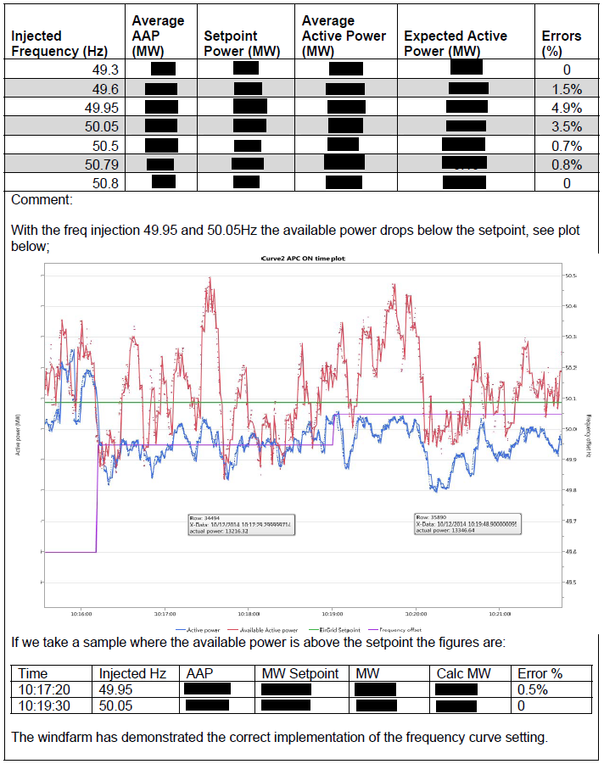

The power park module has demonstrated the correct implementation of the frequency curve setting.

Graph X

## Frequency Response On, Curve 2, APC Off

*Graph X – Frequency Response On, Curve 2, APC Off*

Frequency Response On, Curve 2, APC Off test is included in Graph X.

*[Include any relevant test notes here, relating to how the test was carried out or any specific conditions encountered during this test].*

| **Criteria** | **Criteria Assessed** | **Criteria Passed** |
| --- | --- | --- |
| **Rate of Response** | | |
| PPM provides ≥60% of its expected response within 5 seconds and 100% of its expected response within 15 seconds. |  |  |
| **Frequency Response Curve** | | |
| For frequency < FA, MW output ramps directly to 100% of AAP. |  |  |
| For frequency between FA and FB, MW output is based on frequency droop setting |  |  |
| For frequency ≥ FB and ≤ FC, no response shall be provided |  |  |
| For frequency between FC and FD, MW output is based on frequency droop setting. |  |  |
| For frequency > FD, MW output ramps directly to DMOL |  |  |
| For frequency > FE, MW output ramps directly to 0 MW |  |  |
| Deadband of +/-15 mHz is applied in Active Power Control Mode and in Curve 2 |  |  |
| **Latching etc.** | | |
| Any Generation Unit which has disconnected due to frequency ≥ 50.8 Hz, shall be brought back on load when frequency falls less than 50.2 Hz. |  |  |
| PPM regulates its active power output to within the greater of ±0.5 MW or ±3% of Registered Capacity of the Active Power Control Set-point adjusted for frequency response. |  |  |

**Criteria – For frequency < FA, MW output ramps directly to 100% of AAP**

**Criteria – For frequency between FA and FB, MW output is based on frequency droop setting**

**Criteria – For frequency ≥ FB and ≤ FC, no response shall be provided**

**Criteria – For frequency between FC and FD, MW output is based on frequency droop setting**

**Criteria – For frequency > FD, MW output ramps directly to DMOL**

**Criteria – For frequency > FE, MW output ramps directly to 0 MW**

**Criteria – Deadband of +/-15 mHz is applied in Active Power Control Mode and in Curve 2**

**Criteria – PPM regulates its active power output to within the greater of ±0.5 MW or ±3% of Registered Capacity of the Active Power Control Set-point adjusted for frequency response**

*[Include a graph of any anomalies and any supporting plots/diagrams].*

*Analyse the performance of the PPM in relation to the criteria.*

| **Step** | **Time** | **Simulated Frequency** | **AAP** | **Droop** | **Required MW** | **Actual MW** | **Max Deviation** |
| --- | --- | --- | --- | --- | --- | --- | --- |
| 1 |  | 49 Hz |  |  |  |  | -0.5 MW to +0.3 MW |
| 2 |  | 49.75 Hz |  |  |  |  |  |
| 3 |  | 49.984 Hz |  |  |  |  |  |
| 4 |  | 49.985 Hz |  |  |  |  |  |
| 5 |  | 49.985 Hz |  |  |  |  |  |
|  |  |  |  |  |  |  |  |
|  |  |  |  |  |  |  |  |

Table X

**Criteria – PPM provides ≥60% of its expected response within 5 seconds and 100% of its expected response within 15 seconds**

*[Include a graph of any anomalies and any supporting plots/diagrams].*

*Analyse the performance of the PPM in relation to the criteria.*

| **Frequency Step (Hz)** | **Time** | **Initial MW** | **Required MW** | **MW required after 5 seconds** | **MW achieved after 5 seconds** | **MW required after 15 seconds** | **MW achieved after 15 seconds** |
| --- | --- | --- | --- | --- | --- | --- | --- |
| 50 – 49 Hz |  |  |  |  |  |  |  |
| 49 – 49.75 Hz |  |  |  |  |  |  |  |
| 49.75 – 49.984 Hz |  |  |  |  |  |  |  |
|  |  |  |  |  |  |  |  |

Table X

**Criteria – Any Generation Unit which has disconnected due to frequency ≥ 50.8 Hz, shall be brought back on load when frequency falls less than 50.2 Hz**

[Include a graph of any anomalies and any supporting plots/diagrams].

*Analyse the performance of the PPM in relation to the criteria.*

| **Step** | **Time** | **Simulated Frequency** | **Actual MW** | **# Generation units Online** |
| --- | --- | --- | --- | --- |
|  |  |  |  |  |
|  |  |  |  |  |
|  |  |  |  |  |
|  |  |  |  |  |

Table X

**Criteria – Frequency response is achieved by altering the output of all Generation Units as opposed to switching Generation Units on or off, insofar as possible**

*[Include a graph of any anomalies and any supporting plots/diagrams].*

When the frequency was changed from X Hz to Y Hz, the MW output reduced from XX MW to DMOL. As shown in Table X, no generators were stopped until the active power was reduced less than DMOL.

| **Step** | **Time** | **Simulated Frequency** | **Actual MW** | **# Generators Online** |
| --- | --- | --- | --- | --- |
|  |  |  |  |  |
|  |  |  |  |  |
|  |  |  |  |  |
|  |  |  |  |  |

Table X

## Frequency Response Off, Curve 1, APC On

*Graph X – Frequency Response Off, Curve 1, APC On*

Frequency Response Off, Curve 1, APC On test is included in Graph X.

*[Include any relevant test notes here, relating to how the test was carried out or any specific conditions encountered during this test].*

| **Criteria** | **Criteria Assessed** | **Criteria Passed** |
| --- | --- | --- |
| **Governor Droop** | | |
| When Frequency Response is OFF, no response shall be provided. |  |  |

**Criteria – When Frequency Response is OFF, no response shall be provided**

*[Include a graph of any anomalies and any supporting plots/diagrams].*

*Analyse the performance of the PPM in relation to the criteria.*

| **Step** | **Time** | **Simulated Frequency** | **Set-point** | **Droop** | **Required MW** | **Actual MW** |
| --- | --- | --- | --- | --- | --- | --- |
|  |  |  |  |  |  |  |
|  |  |  |  |  |  |  |
|  |  |  |  |  |  |  |
|  |  |  |  |  |  |  |

Table X

## Frequency Response Off, Curve 1, APC Off

*Graph X – Frequency Response Off, Curve 1, APC* *Off*

Frequency Response Off, Curve 1, APC Off test is included within Graph X.

[Include any relevant test notes here, relating to how the test was carried out or any specific conditions encountered during this test].

| **Criteria** | **Criteria Assessed** | **Criteria Passed** |
| --- | --- | --- |
| **Governor Droop** | | |
| When Frequency Response is OFF, no response shall be provided. |  |  |

**Criteria – When Frequency Response is OFF, no response shall be provided**

*[Include a graph of any anomalies and any supporting plots/diagrams].*

*Analyse the performance of the PPM in relation to the criteria.*

| **Step** | **Time** | **Simulated Frequency** | **AAP** | **Droop** | **Required MW** | **Actual MW** |
| --- | --- | --- | --- | --- | --- | --- |
|  |  |  |  |  |  |  |
|  |  |  |  |  |  |  |
|  |  |  |  |  |  |  |
|  |  |  |  |  |  |  |

Table X

## Frequency Response Off, Curve 2, APC On

*Graph X – Frequency Response Off, Curve 2, APC On*

Frequency Response Off, Curve 2, APC On test is included within Graph X.

[Include any relevant test notes here, relating to how the test was carried out or any specific conditions encountered during this test].

| **Criteria** | **Criteria Assessed** | **Criteria Passed** |
| --- | --- | --- |
| **Governor Droop** | | |
| When Frequency Response is OFF, no response shall be provided. |  |  |

**Criteria – When Frequency Response is OFF, no response shall be provided**

*[Include a graph of any anomalies and any supporting plots/diagrams].*

*Analyse the performance of the PPM in relation to the criteria.*

| **Step** | **Time** | **Simulated Frequency** | **Set-point** | **Droop** | **Required MW** | **Actual MW** |
| --- | --- | --- | --- | --- | --- | --- |
|  |  |  |  |  |  |  |
|  |  |  |  |  |  |  |
|  |  |  |  |  |  |  |
|  |  |  |  |  |  |  |

Table X

## Frequency Response Off, Curve 2, APC Off

*Graph X – Frequency Response Off, Curve 2, APC* *Off*

Frequency Response Off, Curve 2, APC Off test is included within Graph X.

*Include any relevant test notes here, relating to how the test was carried out or any specific conditions encountered during this test].*

| **Criteria** | **Criteria Assessed** | **Criteria Passed** |
| --- | --- | --- |
| **Governor Droop** | | |
| When Frequency Response is OFF, no response shall be provided. |  |  |

**Criteria – When Frequency Response is OFF, no response shall be provided**

*[Include a graph of any anomalies and any supporting plots/diagrams].*

*Analyse the performance of the PPM in relation to the criteria.*

| **Step** | **Time** | **Simulated Frequency** | **AAP** | **Droop** | **Required MW** | **Actual MW** |
| --- | --- | --- | --- | --- | --- | --- |
|  |  |  |  |  |  |  |
|  |  |  |  |  |  |  |
|  |  |  |  |  |  |  |
|  |  |  |  |  |  |  |

Table X

## DMOL

*Graph X – DMOL*

DMOL test is included in Graph X.

*[Include any relevant test notes here, relating to how the test was carried out or any specific conditions encountered during this test].*

| **Criteria** | **Criteria Assessed** | **Criteria Passed** |
| --- | --- | --- |
| **Rate of Response** | | |
| PPM provides ≥60% of its expected response within 5 seconds and 100% of its expected response within 15 seconds. |  |  |
| **Latching etc.** | | |
| Frequency response is achieved by altering the output of all Generation Units as opposed to switching Generation Units on or off, insofar as possible. |  |  |
| For active power output levels ≥ DMOL, all Generation Units shall be generating electricity. |  |  |

**Criteria – PPM provides ≥60% of its expected response within 5 seconds and 100% of its expected response within 15 seconds**

*[Include a graph of any anomalies and any supporting plots/diagrams].*

*Analyse the performance of the PPM in relation to the criteria.*

| **Step** | **Time** | **Initial MW** | **Required MW** | **MW required after 5 seconds** | **MW achieved after 5 seconds** | **MW required after 15 seconds** | **MW achieved after 15 seconds** |
| --- | --- | --- | --- | --- | --- | --- | --- |
| 50 – 49 Hz |  |  |  |  |  |  |  |
| DMOL – Registered Capacity MW |  |  |  |  |  |  |  |

Table X

**Criteria – Frequency response is achieved by altering the output of all Generation Units as opposed to switching Generation Units on or off, insofar as possible**

**Criteria – For active power output levels ≥ DMOL, all Generation Units shall be generating electricity**

*[Include a graph of any anomalies and any supporting plots/diagrams].*

While the PPM was dispatched to DMOL (XX MW) all Generation Units were online and generating electricity, As shown in Table X.

|  |  |  |  |  |
| --- | --- | --- | --- | --- |
| **Step** | **Time** | **Simulated Frequency** | **Actual MW** | **# Generators Online** |
|  |  |  |  |  |

Table X

## Frequency Response Ramp Rate Priority in Curve 1

*Graph X – Frequency Response Ramp Rate Priority in Curve 1*

Frequency Response Ramp Rate Priority in Curve 1 test is included within Graph X.

[Include any relevant test notes here, relating to how the test was carried out or any specific conditions encountered during this test].

| **Criteria** | **Criteria Assessed** | **Criteria Passed** |
| --- | --- | --- |
| **Rate of Response** | | |
| PPM provides ≥60% of its expected response within 5 seconds and 100% of its expected response within 15 seconds. |  |  |
| Ramp Rates shall be prioritised with Frequency Response Ramp Rate given the highest priority. |  |  |

**Criteria – PPM provides ≥60% of its expected response within 5 seconds and 100% of its expected response within 15 seconds**

*[Include a graph of any anomalies and any supporting plots/diagrams].*

*Analyse the performance of the PPM in relation to the criteria.*

| **Frequency Step (Hz)** | **Time** | **MW at time of injection** | **Required MW** | **MW required after 5 seconds** | **MW achieved after 5 seconds** | **MW required after 15 seconds** | **MW achieved after 15 seconds** |
| --- | --- | --- | --- | --- | --- | --- | --- |
| 50 – 50.79 Hz |  |  |  |  |  |  |  |
| 50 – 47 Hz |  |  |  |  |  |  |  |
| 50 – 50.79 Hz |  |  |  |  |  |  |  |

Table X

**Criteria – Ramp Rates shall be prioritised with Frequency Response Ramp Rate given the highest priority**

As shown in Table X, when the simulated frequency deviations took place during a ramp in Active Power Control mode, the ramp rate changed from Active Power Control Set-point Ramp Rate to the Frequency Response Ramp Rate.

As shown in Table X, when the simulated frequency deviations took place during a ramp in Resource Following mode, the ramp rate changed from Resource Following Ramp Rate to the Frequency Response Ramp Rate.

## Frequency Response Ramp Rate Priority in Curve 2

*Graph X – Frequency Response Ramp Rate Priority in Curve 2*

Frequency Response Ramp Rate Priority in Curve 2 test is included in Graph X.

*[Include any relevant test notes here, relating to how the test was carried out or any specific conditions encountered during this test].*

| **Criteria** | **Criteria Assessed** | **Criteria Passed** |
| --- | --- | --- |
| **Rate of Response** | | |
| PPM provides ≥60% of its expected response within 5 seconds and 100% of its expected response within 15 seconds. |  |  |
| Ramp Rates shall be prioritised with Frequency Response Ramp Rate given the highest priority. |  |  |

**Criteria – PPM provides ≥60% of its expected response within 5 seconds and 100% of its expected response within 15 seconds**

*[Include a graph of any anomalies and any supporting plots/diagrams].*

*Analyse the performance of the PPM in relation to the criteria.*

| **Frequency Step (Hz)** | **Time** | **MW at time of injection** | **Required MW** | **MW required after 5 seconds** | **MW achieved after 5 seconds** | **MW required after 15 seconds** | **MW achieved after 15 seconds** |
| --- | --- | --- | --- | --- | --- | --- | --- |
| 50 – 50.79 Hz |  |  |  |  |  |  |  |
| 50 – 47 Hz |  |  |  |  |  |  |  |
| 50 – 50.79 Hz |  |  |  |  |  |  |  |

Table X

**Criteria – Ramp Rates shall be prioritised with Frequency Response Ramp Rate given the highest priority**

As shown in Table X, when the simulated frequency deviations took place during a ramp in Active Power Control mode, the ramp rate changed from Active Power Control Set-point Ramp Rate to the Frequency Response Ramp Rate.

As shown in Table X, when the simulated frequency deviations took place during a ramp in Resource Following mode, the ramp rate changed from Resource Following Ramp Rate to the Frequency Response Ramp Rate.

# Reactive Power Capability

## Purpose of the Test

The purpose of this test is to demonstrate the limits of the PPM reactive power capability curve at the connection point. The test is undertaken at various load levels for both the export of reactive power from the PPM and for the import of reactive power to the PPM.

## Pass Criteria Summary

The following is the pass criteria for the test. Test data shall be assessed against each of these criteria.

| **Criteria** | **Criteria Assessed** | **Criteria Passed** |
| --- | --- | --- |
| **Reactive Power Capability** | | |
| Demonstration that the measured P-Q capability is in line with the submitted P-Q capability diagram |  |  |
| Demonstration that the measured P-Q capability meets or exceeds the minimum expected reactive power capabilities of the controllable PPM, as defined in Grid Code *Figure PPM1.4,* as measured at the Connection Point |  |  |

## Instrumentation and Onsite Data Trending

|  |  |  |  |
| --- | --- | --- | --- |
| **No.** | **Data Trending and Recording** | **Resolution** | **Recorded** |
| 1 | Available active power from the prevailing resource in MW, derived by algorithm in the PPMCS (*Figure PPM1.3, Point Y*) | PPM to Specify (≥10 Hz) | Yes / No |
| 2 | Actual active power from the power park module in MW (*Figure PPM1.3, Point Y*) | PPM to Specify (≥10 Hz) | Yes / No |
| 3 | Power park module voltage measured at the lower voltage side of the grid connected transformer (*Figure PPM1.3, Point Y*) | PPM to Specify (≥10 Hz) | Yes / No |
| 4 | Grid voltage measured at the connection point (*Figure PPM1.3, Point Z*) | PPM to Specify (≥10 Hz) | Yes / No |
| 5 | Reactive power measured at the lower voltage side of the grid connected transformer, (*Figure PPM1.3, Point Y*) | PPM to Specify (≥10 Hz) | Yes / No |
| 6 | Reactive power measured at the connection point (*Figure PPM1.3, Point Z*) | PPM to Specify (≥10 Hz) | Yes / No |
| 7 | Grid transformer tap position | PPM to Specify (≥10 Hz) | Yes / No |
| 8 | AVR (kV) set-point (*Figure PPM1.3, Point Y*) | PPM to Specify (≥10 Hz) | Yes / No |

## Test Analysis

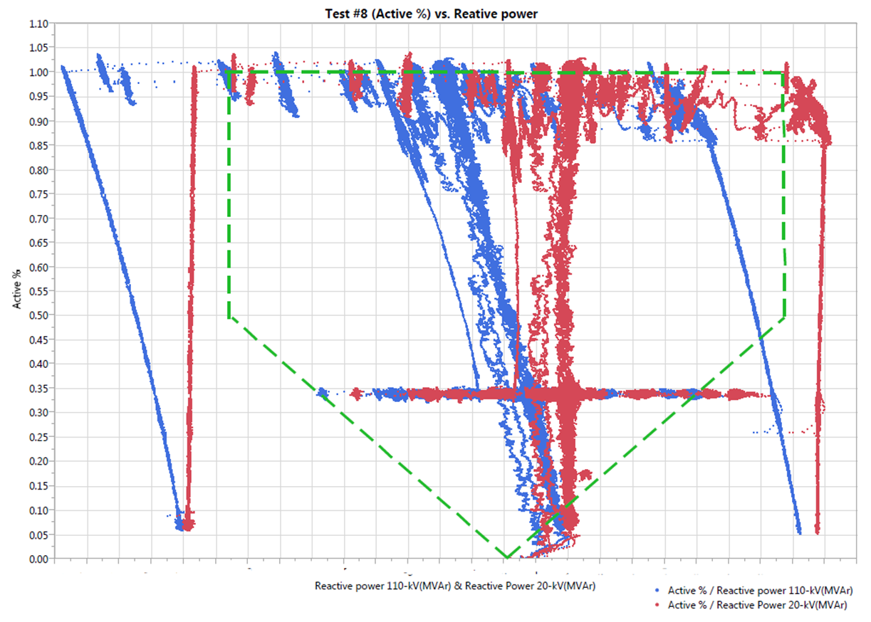

*Graph X – Reactive Power Capability*

A scatter plot of the Reactive Power Capability test is included in Graph X.

*[Include any relevant test notes here, relating to how the test was carried out or any specific conditions encountered during this test].*

| **Criteria** | **Criteria Assessed** | **Criteria Passed** |
| --- | --- | --- |
| **Reactive Power Capability** | | |
| Demonstration that the measured P-Q capability is in line with the submitted P-Q capability diagram |  |  |
| Demonstration that the measured P-Q capability meets or exceeds the minimum expected reactive power capabilities of the controllable PPM, as defined in Grid Code *Figure PPM1.4,* as measured at the Connection Point |  |  |

**Criteria – Demonstration that the measured P-Q capability meets or exceeds the minimum expected reactive power capabilities of the controllable PPM, as defined in Grid Code Figure PPM1.4, as measured at the Connection Point**

*[Include a graph of any anomalies and any supporting plots/diagrams].*

*Analyse the performance of the PPM in relation to the criteria.*

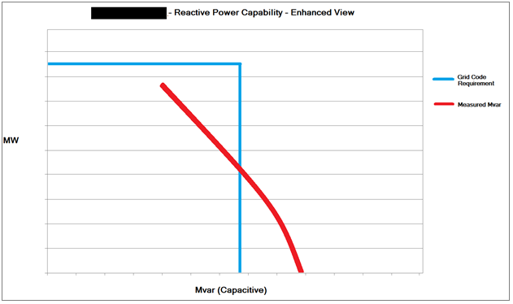

*Graph 2 – Reactive Power Capability – Enhanced View*

Graph 2 shows an enhanced view of the 1.5 Mvar issue in reactive power capability.

**Criteria – Demonstration that the measured P-Q capability is in line with the submitted P-Q capability diagram**

*[Include a graph of any anomalies and any supporting plots/diagrams].*

*Analyse the performance of the PPM in relation to the criteria.*

Note whether or not the reactive capability of the power park module at low MW is dependent on resource. *i.e.* PPM has a greater reactive capability when curtailed to 5 MW during high resource, than it has when the PPM is only available for 5 MW. This dependency on resource shall be quantified.

*[Include a graph of the relevant trends recorded during the test].*

*Graph X – Leading Reactive Power Capability Test*

*Graph X – Lagging Reactive Power Capability Test*

## Table of measured reactive power capability

| **MW** | **Leading Mvar Capability** | **Lagging Mvar Capability** |
| --- | --- | --- |
| 0 | 0 | 0 |
| 1 | -2 | 2 |
| 2 | -4 | 4 |
| 3 | -7 | 7 |
| 4 | -10 | 10 |
| 5 | -10 | 10 |
| 6 | -10 | 10 |
| . | . | . |
| . | . | . |
| . | . | . |
| Registered Capacity MW | -15 | 8 |

Table X

# Reactive Power Control Test

## Purpose of the Test

The purpose of this test is to confirm correct operation of AVR system in kV, Q and PF control modes, and changing between modes.

## Pass Criteria Summary

The following is the pass criteria for the test. Test data shall be assessed against each of these criteria.

| **Criteria** | **Criteria Assessed** | **Criteria Passed** |
| --- | --- | --- |
| **AVR Control** | | |
| PPM receives all kV set-points, implements kV all set-points within 20 seconds of receipt of the set-point and provides the correct set-point feedback |  |  |
| PPM regulates its reactive power at the point of connection correctly based on the voltage slope setting, system voltage and kV set-point |  |  |
| Demonstration that the Voltage Regulation System Slope Setting can be set between 2% and 7% |  |  |
| Voltage Regulation System responds to a step change in voltage at the connection point, it achieves 90% of its steady-state response within 1 second |  |  |
| **Mvar Control** | | |
| PPM receives all Mvar set-points, implements Mvar all set-points within 20 seconds of receipt of the set-point and provides the correct set-point feedback |  |  |
| PPM maintains the Mvar set-point at the connection point |  |  |
| **Power Factor Control** | | |
| PPM receives all PF set-points, implements PF all set-points within 20 seconds of receipt of the set-point and provides the correct set-point feedback |  |  |
| PPM maintains the PF per phase angle set-point at the connection point |  |  |
| **Bumpless Transfer** | | |
| Voltage Regulation System implements bumpless transfer between reactive power control modes |  |  |

## Instrumentation and Onsite Data Trending

| **No.** | **Data Trending and Recording** | **Resolution** | **Recorded** |
| --- | --- | --- | --- |
| 1 | Available active power from the prevailing resource in MW, derived by algorithm in the PPMCS (*Figure PPM1.3, Point Y*) | PPM to Specify (≥10 Hz) | Yes / No |
| 2 | Actual active power from the power park module in MW (*Figure PPM1.3, Point Z*) | PPM to Specify (≥10 Hz) | Yes / No |
| 3 | Power park module voltage measured at the lower voltage side of the grid connected transformer (*Figure PPM1.3, Point Y*) | PPM to Specify (≥10 Hz) | Yes / No |
| 4 | Grid voltage measured at the connection point (*Figure PPM1.3, Point Z*) | PPM to Specify (≥10 Hz) | Yes / No |
| 5 | Reactive power measured at the lower voltage side of the grid connected transformer, (*Figure PPM1.3, Point Y*) | PPM to Specify (≥10 Hz) | Yes / No |
| 6 | Reactive power measured at the connection point (*Figure PPM1.3, Point Z*) | PPM to Specify (≥10 Hz) | Yes / No |
| 7 | Grid transformer tap position | PPM to Specify (≥10 Hz) | Yes / No |
| 8 | AVR (kV) set-point (*Figure PPM1.3, Point Y*) | PPM to Specify (≥10 Hz) | Yes / No |
| 9 | Mvar set-point (*Figure PPM1.3, Point Y*) | PPM to Specify (≥10 Hz) | Yes / No |
| 9 | PF set-point (*Figure PPM1.3, Point Y*) | PPM to Specify (≥10 Hz) | Yes / No |

## AVR & PF Settings

|  |  |
| --- | --- |
| **Calculation** | **Value** |
| 1kV change in set-point with Voltage Regulation System slope of 4% | ____ Mvar  (PPM to specify calculation and formula used) |
| Mvar for set-point of +8 degrees at 30% of Registered Capacity (PPM exporting Mvar) | ____ Mvar  (PPM to specify calculation and formula used) |
| Mvar for set-point of -12 degrees at 50% of Registered Capacity (PPM importing Mvar) | ____ Mvar  (PPM to specify calculation and formula used) |

## Automatic Voltage Regulation Mode

*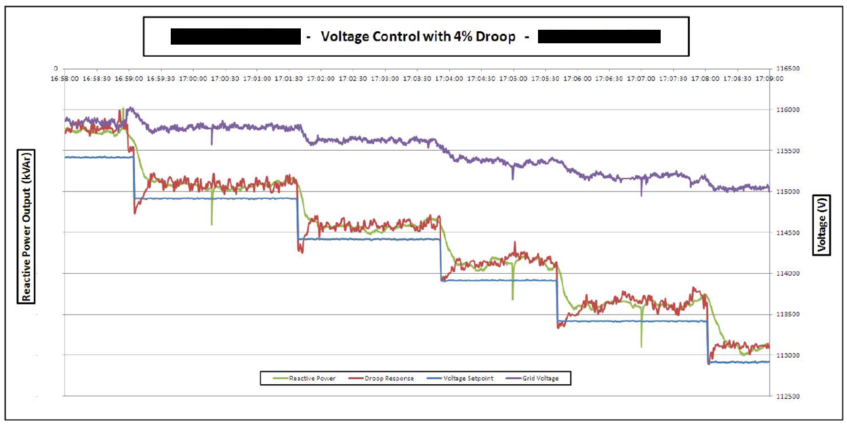Graph X – Automatic Voltage Regulation Mode*

A graph of the Automatic Voltage Regulation test is included in Graph X.

*[Include any relevant test notes here, relating to how the test was carried out or any specific conditions encountered during this test].*

Required Mvar post-settling is calculated using the following equation, where ${Mvar}_{range}$ is the Mvar range required under Grid Code, calculated as ±0.33 Q/Pmax:

| **Criteria** | **Criteria Assessed** | **Criteria Passed** |
| --- | --- | --- |
| **AVR Control** | | |
| PPM receives all kV set-points, implements kV all set-points within 20 seconds of receipt of the set-point and provides the correct set-point feedback |  |  |
| PPM regulates its reactive power at the point of connection correctly based on the voltage slope setting, system voltage and kV set-point |  |  |
| Demonstration that the Voltage Regulation System Slope Setting can be set between 2% and 7% |  |  |
| Voltage Regulation System responds to a step change in voltage at the connection point, it achieves 90% of its steady-state response within 1 second |  |  |

**Criteria – PPM receives all kV set-points**

As per the signed test procedure that was scanned and submitted to [generator_testing@eirgrid.com](mailto:generator_testing@eirgrid.com), All kV set-points were received on the day of testing.

**Criteria – Set-point Implementation and Feedback within 20 seconds of receipt**

Table X demonstrates that each set-point was implemented within 20 seconds of receipt.

*[Insert a table showing the implementation times of each set-point received].*

| **Time of Set-point** | **Time of Mvar Settling** | **Implementation Time** |
| --- | --- | --- |
| 12:43:07 | 12:43:10 | 3 seconds |
| 12:49:48 | 12:49:50 | 2 seconds |
|  |  |  |

Table X

**Criteria – PPM regulates its reactive power at the point of connection correctly based on the voltage slope setting, system voltage and kV set-point**

**Criteria – Voltage Regulation System responds to a step change in voltage at the connection point, it achieves 90% of its steady-state response within 1 second**

The criteria are assessed for each set-point change in the test procedure. A workbook is available for download at [www.eirgrid.com/operations/gridcode/compliancetesting/PPMtestprocedures](http://www.eirgrid.com/operations/gridcode/compliancetesting/wfpstestprocedures), which will assist in the calculation of data required for demonstration of Compliance with these criteria.

As shown in Table X, the PPM response is within +/-2 Mvar of the required response (based on droop calculation) for each step. The PPM achieved greater than 90% of the required response within 1 second of each set-point change. An overshoot of X Mvar was observed on 3 of the set-points, with a settling time of Y-Z seconds.

| **Mvar Measured Pre-Event** | **Time of Set-point Change** | **New Set-point Received (kV)** | **System Voltage Post Settling (kV)** | **Mvar Required Post Settling** | **Mvar Measured Post Settling** | **Mvar Required After 1 Second** | **Mvar Measured After 1 Second** |
| --- | --- | --- | --- | --- | --- | --- | --- |
| 4.2 | 12:43:07 | 116 | 115.1 | 13.5 | 13.51 | 12.57 | 12.89 |
| 13.5 | 12:49:48 | 116.5 | 115.3 | 18 | 17.95 | 17.55 | 17.7 |
|  |  |  |  |  |  |  |  |
|  |  |  |  |  |  |  |  |

Table X

*Required Mvar 1 second after response begins is calculated as:*

*Measured Mvar prior to set-point change + (Required Mvar change * 0.9)*

**Criteria – Demonstration that the Voltage Regulation System Slope Setting can be set between 1% and 10%**

*[Include a graph of any anomalies and any supporting plots/diagrams].*

*Analyse the performance of the PPM in relation to the criteria.*

As demonstrated in the test steps, the Voltage Regulation System Slope was set to 2%, 4% and 7%. A sample calculation at each of those slope settings is included in Table X.

| **Time** | **Droop Setting** | **kV Set-point** | **System Voltage post settling** | **Measured Mvar post settling** | **Required Mvar post settling** |
| --- | --- | --- | --- | --- | --- |
|  | 2% |  |  |  |  |
|  | 4% |  |  |  |  |
|  | 7% |  |  |  |  |

Table X

*[Insert a graph of each individual set-point change].*

*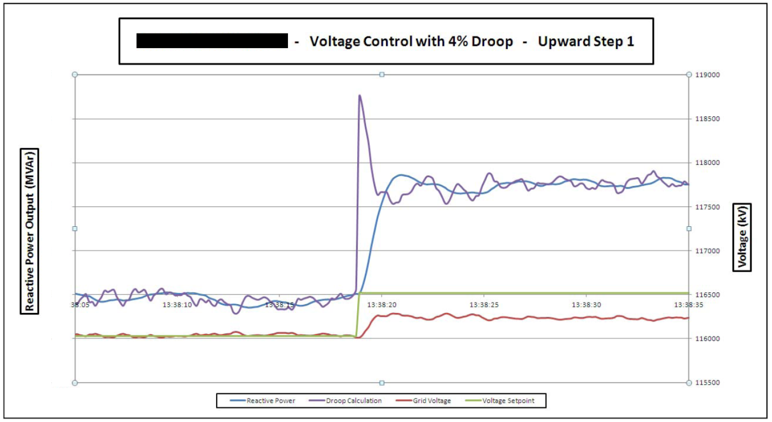Graph X – +0.5 kV step at hh:mm:ss*

*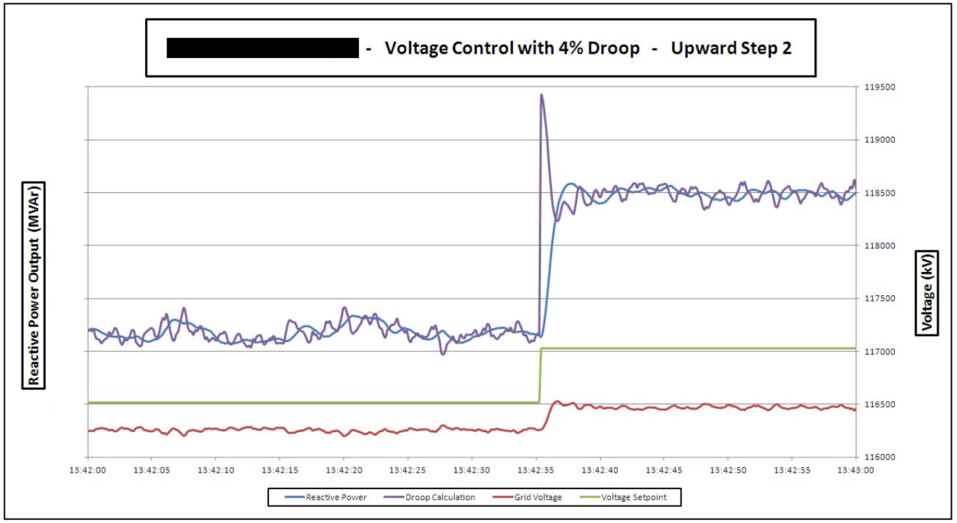Graph 2 – +0.5 kV step at hh:mm:ss*

## Automatic Voltage Regulation Response Rate

*Graph X – Automatic Voltage Regulation Response Rate*

Automatic Voltage Regulation Response Rate test is included within Graph X.

*[Include any relevant test notes here, relating to how the test was carried out or any specific conditions encountered during this test].*

| **Criteria** | **Criteria Assessed** | **Criteria Passed** |
| --- | --- | --- |
| **AVR Control** | | |
| Voltage Regulation System responds to a step change in voltage at the connection point, it achieves 90% of its steady-state response within 1 second |  |  |

**Criteria – Voltage Regulation System responds to a step change in voltage at the connection point, it achieves 90% of its steady-state response within 1 second**

*[Include a graph of any anomalies and any supporting plots/diagrams].*

*Analyse the performance of the PPM in relation to the criteria. If there is more than one step change carried out in this test, include a table with analysis of each step change carried out.*

| **Description** | **Value** | **Unit** |
| --- | --- | --- |
| kV set-point | 116 | kV |
| System voltage post settling | 115.1 | kV |
| Required Mvar post settling (based on 4% droop) | 13.5 | Mvar |
| Measured Mvar post settling | 13.51 | Mvar |
| Measured Mvar prior to set-point change | 4.2 | Mvar |
| Required Mvar change | 9.3 | Mvar |
| Required Mvar 1 second after set-point change | 12.57 | Mvar |
| Measured Mvar 1 second after set-point change | 12.89 | Mvar |

*Required Mvar 1 second after set-point change is calculated as:   
Measured Mvar prior to set-point change + (Required Mvar change * 0.9)*

## Mvar Control Mode

*Graph X – Mvar Control Mode*

A graph of the Mvar Control Mode test is included in Graph X.

*[Include any relevant test notes here, relating to how the test was carried out or any specific conditions encountered during this test].*

| **Criteria** | **Criteria Assessed** | **Criteria Passed** |
| --- | --- | --- |
| **Mvar Control** | | |
| PPM receives all Mvar set-points, implements Mvar all set-points within 20 seconds of receipt of the set-point and provides the correct set-point feedback |  |  |
| PPM maintains the Mvar set-point at the connection point |  |  |

**Criteria – PPM receives all Mvar set-points**

As per the signed test procedure that was scanned and submitted to [generator_testing@eirgrid.com](mailto:generator_testing@eirgrid.com), All Mvar set-points were received on the day of testing.

**Criteria – Set-point Implementation and Feedback within 20 seconds of receipt**

Table X demonstrates that each set-point was implemented within 20 seconds of receipt.

*[Insert a table showing the implementation times of each set-point received].*

| **Time of Set-point** | **Time of Mvar Settling** | **Implementation Time** |
| --- | --- | --- |
| 12:43:07 | 12:43:10 | 3 seconds |
| 12:49:48 | 12:49:50 | 2 seconds |
|  |  |  |

Table X

**Criteria – PPM Maintains the Mvar set-point at the connection point**

*[Include a graph of any anomalies and any supporting plots/diagrams].*

*Analyse the performance of the PPM in relation to the criteria. As shown in Table X, the PPM response is within +/-2 Mvar of the required response.*

*[Include a table detailing the Minimum, Maximum and Average Mvar for each set-point tested].*

| **Time** | **Set-point** | **Minimum Mvar** | **Maximum Mvar** | **Average Mvar** |
| --- | --- | --- | --- | --- |
| hh:mm:ss | a Mvar | b Mvar | c Mvar | a Mvar |
| hh:mm:ss | d Mvar | e Mvar | f Mvar | d Mvar |
| … |  |  |  |  |

Table X

*Graph X – Change from 8 Mvar Set-point to 17 Mvar Set-point*

*Graph 2 – Change from 17 Mvar Set-point to 0 Mvar Set-point*

## Power Factor Control Mode

*Graph X – Power Factor Control Mode*

A graph of the Power Factor Control Mode test is included in Graph X.

*[Include any relevant test notes here, relating to how the test was carried out or any specific conditions encountered during this test].*

The set-point for Power Factor is sent and received as an angle and can be calculated as follows, where a +ive angle denotes a +ive PF and a –ive PF denotes a –ive PF:

$$PF=Cos(set-point)$$

For a given set-point, the required Mvar at any time is calculated as follows:

$$Mvar=MW*Tan(set-point)$$

| **Criteria** | **Criteria Assessed** | **Criteria Passed** |
| --- | --- | --- |
| **Power Factor Control** | | |
| PPM receives all PF set-points, implements PF all set-points within 20 seconds of receipt of the set-point and provides the correct set-point feedback |  |  |
| PPM maintains the PF per phase angle set-point at the connection point |  |  |

**Criteria – PPM receives all PF set-points**

As per the signed test procedure that was scanned and submitted to [generator_testing@eirgrid.com](mailto:generator_testing@eirgrid.com), All Mvar set-points were received on the day of testing.

**Criteria – Set-point Implementation and Feedback within 20 seconds of receipt**

Table X demonstrates that each set-point was implemented within 20 seconds of receipt.

*[Insert a table showing the implementation times of each set-point received].*

| **Time of Set-point** | **Time of Mvar Settling** | **Implementation Time** |
| --- | --- | --- |
| 12:43:07 | 12:43:10 | 3 seconds |
| 12:49:48 | 12:49:50 | 2 seconds |
|  |  |  |

Table X

**Criteria – PPM maintains the PF set-point at the connection point**

*[Include a graph of any anomalies and any supporting plots/diagrams].*

*Analyse the performance of the PPM in relation to the criteria.*

As shown in Table X, the PPM response is within +/-2 Mvar of the required response.

*[Include a table detailing the Minimum, Maximum and Average Mvar for each set-point tested].*

| **Time** | **Active Power (MW)** | **PF Set-point (degrees)** | **Required Mvar** | **Minimum Mvar** | **Maximum Mvar** | **Average Mvar** |
| --- | --- | --- | --- | --- | --- | --- |
| hh:mm:ss | a MW | b degrees | c Mvar | d Mvar | e Mvar | c Mvar |
| hh:mm:ss | f MW | g degrees | h Mvar | i Mvar | j Mvar | h Mvar |
| … |  |  |  |  |  |  |

*Table X*

*Graph X – Change from 8 degrees Set-point to 12 degrees Set-point*

*Graph 2 – Change from 12 degrees Set-point to 8 degrees Set-point*

## Functional checks and Bumpless Transfer

*Graph X – Functional Checks and Bumpless Transfer*

A graph of the Functional Checks and Bumpless Transfer test is included in Graph X.

*[Include any relevant test notes here, relating to how the test was carried out or any specific conditions encountered during this test].*

| **Criteria** | **Criteria Assessed** | **Criteria Passed** |
| --- | --- | --- |
| **Bumpless Transfer** | | |
| Voltage Regulation System implements Bumpless transfer between reactive power control modes |  |  |

**Criteria – Voltage Regulation System implements Bumpless transfer between reactive power control modes**

*[Include a graph of any anomalies and any supporting plots/diagrams].*

*Analyse the performance of the PPM in relation to the criteria.*

| **Time** | **Mode pre-transfer** | **Mode post-transfer** | **Last received Set-point in post-transfer mode** | **Implemented Set-point in post-transfer mode** | **Mvar before mode transfer** | **Mvar after mode transfer** | **Mvar deviations during mode transfer** |
| --- | --- | --- | --- | --- | --- | --- | --- |
| 12:43:07 | kV | Q | -3 Mvar | +2 Mvar | +2 Mvar | +2 Mvar | 0.01 Mvar |
| 12:49:48 | Q | kV | 115.0 kV | 116.3 kV | +4 Mvar | +4 Mvar | 0 Mvar |
|  |  |  |  |  |  |  |  |
|  |  |  |  |  |  |  |  |

Table X

# Black Start Shutdown Test

## Purpose of the Test

The purpose of this test is to confirm correct operation of the Black Start Shutdown scheme at the controllable PPM.

## Pass Criteria

The following is the pass criteria for the test. Any subsequent report for this test shall be assessed against each of these criteria.

1. PPM opens the specified CB upon receipt of the Black Start Shutdown signal.
2. The specified CB is inhibited from closing while the Black Start Shutdown signal is ON.

## Instrumentation and Onsite Data Trending

No instrumentation and onsite data trending is necessary for this test. All required information is recorded manually in this test procedure.

## Black Start Shutdown Test Analysis

The Black Start Shutdown test for ___ PPM was carried out on dd/mm/yyyy by ______ (Company) and was witnessed by _____ (EirGrid). The functionality of the Black Start Shutdown is described in the following tables.

*[Include any relevant test notes here, relating to how the test was carried out or any specific conditions encountered during this test].*

|  |  |  |
| --- | --- | --- |
| Initial Conditions | T121 110 kV cubicle Sub Remote Control Switch  EirGrid Remote Control Enable Switch | OFF  ON |
| Action | NCC enable Black Start Shutdown command | Time: |
| Outcome | T121 110 kV CB:  T121 PPM 20 kV CB:  Blue Alert Lamp: | |
| Additional Notes |  | |

|  |  |  |
| --- | --- | --- |
| Initial Conditions | T121 110 kV cubicle Sub Remote Control Switch  EirGrid Remote Control Enable Switch | ON  OFF |
| Action | NCC enable Black Start Shutdown command | Time: |
| Outcome | T121 110 kV CB:  T121 PPM 20 kV CB:  Blue Alert Lamp: | |
| Additional Notes |  | |

|  |  |  |
| --- | --- | --- |
| Initial Conditions | T121 110 kV cubicle Sub Remote Control Switch  EirGrid Remote Control Enable Switch  Black Start Shutdown command | ON  ON  ON |
| Action | Attempt to close PPM 20 kV CB at mimic panel | Time: |
| Outcome | T121 110 kV CB:  T121 PPM 20 kV CB:  Blue Alert Lamp: | |
| Additional Notes |  | |

|  |  |  |
| --- | --- | --- |
| Initial Conditions | T121 110 kV cubicle Sub Remote Control Switch  EirGrid Remote Control Enable Switch  Black Start Shutdown command | ON  ON  ON |
| Action | PPM turn EirGrid Remote Control Enable Switch OFF | Time: |
| Outcome | T121 110 kV CB:  T121 PPM 20 kV CB:  Blue Alert Lamp: | |
| Additional Notes |  | |

|  |  |  |
| --- | --- | --- |
| Initial Conditions | T121 110 kV cubicle Sub Remote Control Switch  EirGrid Remote Control Enable Switch  Black Start Shutdown command | ON  OFF  ON |
| Action | Attempt to close PPM 20 kV CB at mimic panel | Time: |
| Outcome | T121 110 kV CB:  T121 PPM 20 kV CB:  Blue Alert Lamp: | |
| Additional Notes |  | |

|  |  |  |
| --- | --- | --- |
| Initial Conditions | T121 110 kV cubicle Sub Remote Control Switch  EirGrid Remote Control Enable Switch  Black Start Shutdown command | ON  OFF  ON |
| Action | NCC remove Black Start Shutdown Command | Time: |
| Outcome | T121 110 kV CB:  T121 PPM 20 kV CB:  Blue Alert Lamp: | |
| Additional Notes |  | |

# Appendix 1 – Frequency Response Setings



**Curve 1: Resource Following Mode (RfG Limited Frequency Sensitive Mode)**

|  |  |  |  |
| --- | --- | --- | --- |
|  | ***Transmission System Frequency*** *f (Hz)* |  | ***Required Active Power Output*** |
|  | *f < 48* |  | *100% of AAP* |
| ***FA*** | *48* | ***PA*** | *100% of AAP* |
| ***Under Frequency Response*** | *48 < f < 49.8* |  | *100% of AAP* |
| ***FB*** | *f = 49.8* | ***PB*** | *100% of AAP* |
| ***+/-0.2Hz Deadband*** | *49.8 < f < 50.2* |  | *100% of AAP* |
| ***FC*** | *f = 50.2* | ***PC*** | *100% of AAP* |
| ***Over Frequency Response*** | *50.2 < f < 50.79* |  | *AAP + ∆MW2* |
| ***FD*** | *f = 50.79* | ***PD*** | *Minimum of: AAP and DMOL* |
| ***FE*** | *f = 50.8* | ***PE*** | *0%3* |
|  | *f > 50.8* |  | *0%3* |

**Curve 1: Active Power Control Mode (RfG Frequency Sensitive Mode)**

|  |  |  |  |
| --- | --- | --- | --- |
|  | ***Transmission System Frequency*** *f (Hz)* |  | ***Required Active Power Output*** |
|  | *f < 48* |  | *100% of AAP* |
| ***FA*** | *f = 48* | ***PA*** | *100% of AAP* |
| ***Under Frequency Response*** | *48 < f < 49.985* |  | *Minimum of: APC Set-point + ∆MW and AAP* |
| ***FB*** | *f = 49.985* | ***PB*** | *Minimum of: APC Set-point and AAP* |
| ***+/-0.015Hz Deadband*** | *49.985 < f < 50.015* |  | *Minimum of: APC Set-point and AAP* |
| ***FC*** | *f = 50.015* | ***PC*** | *Minimum of: APC Set-point and AAP* |
| ***Over Frequency Response*** | *50.015 < f < 50.79* |  | *Minimum of: APC Set-point + ∆MW and AAP + ∆MW1, 2* |
| ***FD*** | *f = 50.79* | ***PD*** | *Minimum of: APC Set-point and AAP and DMOL* |
| ***FE*** | *f = 50.8* | ***PE*** | *0%3* |
|  | *f > 50.8* |  | *0%3* |

**Curve 2: Resource Following Mode**

|  |  |  |  |
| --- | --- | --- | --- |
|  | ***Transmission System Frequency*** *f (Hz)* |  | ***Required Active Power Output*** |
|  | *f <49.3* |  | *100% of AAP* |
| ***FA*** | *f = 49.3* | ***PA*** | *100% of AAP* |
| ***Under Frequency Response*** | *49.3 < f < 49.985* |  | *95% of Available Active Power + ∆MW* |
| ***FB*** | *f = 49.985* | ***PB*** | *95% of Available Active Power. This is = to 5% Reserve.* |
| ***+/-0.015Hz Deadband*** | *49.985 < f < 50.015* |  | *95% of Available Active Power. This is = to 5% Reserve.* |
| ***FC*** | *f = 50.015* | ***PC*** | *95% of Available Active Power. This is = to 5% Reserve.* |
| ***Over Frequency Response*** | *50.015 < f < 50.79* |  | *95% of AAP + ∆MW2* |
| ***FD*** | *f = 50.79* | ***PD*** | *Minimum of: AAP and DMOL* |
| ***FE*** | *f = 50.8* | ***PE*** | *0%3* |
|  | *f > 50.8* |  | *0%3* |

**Curve 2: Active Power Control Mode**

|  |  |  |  |  |
| --- | --- | --- | --- | --- |
|  | | ***Transmission System Frequency*** *f (Hz)* |  | ***Required Active Power Output*** |
|  | | *f < 49.3* |  | *100% of AAP* |
| ***FA*** | | *f = 49.3* | ***PA*** | *100% of AAP* |
| ***Under Frequency Response*** | | *49.3 < f < 49.985* |  | *Minimum of: AAP and APC Set-point + ∆MW* |
| ***FB*** | | *f = 49.985* | ***PB*** | *Minimum of: APC Set-point and 95% of AAP* |
| ***+/-0.015Hz Deadband*** | | *49.985 < f < 50.015* |  | *Minimum of: APC Set-point and 95% of AAP* |
| ***FC*** | | *f = 50.015* | ***PC*** | *Minimum of: APC Set-point and 95% of AAP* |
| ***Over Frequency Response*** | | *50.015 < f < 50.79* |  | *Minimum of: APC Set-point + ∆MW and 95% of AAP + ∆MW1, 2* |
| ***FD*** | | *f = 50.79* | ***PD*** | *Minimum of: APC Set-point and AAP and DMOL* |
| ***FE*** | | *f = 50.8* | ***PE*** | *0%3* |
|  | | *f > 50.8* |  | *0%3* |
| 1 APC Set-point + ∆MW shall have a lower limit of the minimum of: APC Set-point and DMOL. | | | |
| 2 (95% of) AAP + ∆MW shall have a lower limit of the minimum of AAP and DMOL | | | |
| 3 Any Generation Unit which has disconnected due to high frequency shall be brought back on load as fast as technically feasible, provided the Frequency has fallen less than 50.2Hz. | | | |

1. [http://www.eirgrid.com/operations/gridcode/compliancetesting/PPMtestprocedures/#d.en.17698](http://www.eirgrid.com/operations/gridcode/compliancetesting/wfpstestprocedures/#d.en.17698)
2. <http://www.eirgrid.com/media/LoadProfileRequestForm.xlsx>
3. This instruction will be in the form of a Black Start Shutdown OFF command