Fast Frequency Response (FFR), Primary, Secondary and Tertiary Reserve (POR, SOR, TOR1, TOR2)
System Services
Test Report
Synchronous Machine
Unit Name

DISCLAIMER:
This Document contains information (and/or attachments) which may be privileged or confidential. All content is intended solely for the use of the individual or entity to whom it is addressed. If you are not the intended recipient please be aware that any disclosure, copying, distribution or use of the contents of this message is prohibited. If you suspect that you have received this Document in error please notify EirGrid or its subsidiaries immediately. EirGrid and its subsidiaries do not accept liability for any loss or damage arising from the use of this document or any reliance on the information it contains or the accuracy or up to date nature thereof. Use of this document and the information it contains is at the user’s sole risk. In addition, EirGrid and its subsidiaries strongly recommend that any party wishing to make a decision based on the content of this document should not rely solely upon data and information contained herein and should consult EirGrid or its subsidiaries in advance.
Further information can be found at: http://www.eirgridgroup.com/legal/

Document Version History
Revision 3.0 published 12th November 2019

Version | Date | Comment | Name | Company
0.1 | Insert Date | Minor version (v0.1) - First submission for review and approval | Insert Name | Unit Company Name
1.0 | Insert Date | Revised to version 1.0 following approval by EirGrid, SONI. | Insert Name | Unit Company Name

Introduction
The Unit shall submit the latest version of this test report template as published on the EirGrid, SONI websites.
The report shall be developed for technical and non-technical readers and shall follow the agreed test programme. The report is submitted to generator_testing@eirgrid.com or generator_testing@soni.ltd.uk as appropriate.
Submission of this document is required if a Unit does not have and existing FFR, POR, SOR or TOR1 Contract or is making changes or updates to any of the affected parameters.
Any issue with meeting any requirements or completing this report, please contact generator_testing@eirgrid.com or generator_testing@soni.ltd.uk as appropriate.

Abbreviations
HV High Voltage
MW Mega Watt
MEC Maximum Export Capacity
kV kilovolt
Hz Hertz – unit of frequency
POR Primary Operating Reserve
SOR Secondary Operating Reserve
TOR Tertiary Operating Reserve
FFR Fast Frequency Response

Unit Data

Unit Data
Unit name | Name:_________
Unit connection point | HV Bushings of T101 in XX 110kV station
Contracted MEC | ___________MW
Unit connection voltage | ________kV
Unit fuel type | Name:_________
Operating modes | e.g. OCGT, CCGT, Sync Comp etc.
Registered capacity / maximum continuous rating | ___________MW
Minimum load  Minimum generation | ___________MW  ___________MW
Installed plant | Name: _______  ___________MVA  Name: _______  ___________MW
House load | ___________MW
Governor droop setting | _______%
Power system stabiliser | On / Off

System Services definitions
The definitions referenced in this document are for indicative purposes only. In the event of inconsistency between the definitions in this document and those in the DS3 System Services Agreement, the definitions in the DS3 System Services Agreement shall prevail.

Fast frequency response (FFR)
FFR is defined as the additional increase in MW output from a unit or a reduction in demand following a frequency event that is available within two seconds of the start of the event and sustainable over the period from FFR Response Time to 10 seconds.
The extra energy provided, in the two-to-ten second timeframe, by the MW increase shall be greater than any loss of energy in the ten-to-twenty second timeframe afterwards due to a reduction in MW output.
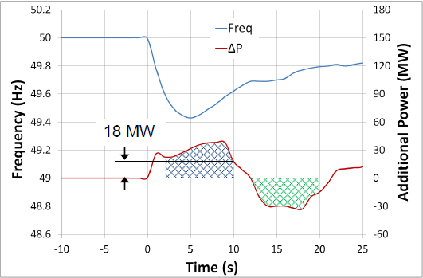
Figure 1: Example graph showing the additional power provided to, and drawn from, the grid
As shown in the diagram above, in order to be eligible for FFR the amount indicated by the blue hatched area (Power provided) shall be greater than the green hatched area (Power drawn).

FFR Response Time
A Providing Unit’s contracted FFR Response Time is the time from when the frequency falls through its contracted Reserve Trigger (T=0) to the time at which the Providing Unit must have achieved its contracted FFR volume, as dictated by its contracted FFR response curve.
The FFR response time provided in Section 7.4 shall be based on test data.
Please note that the FFR Response Time, as recorded on the Providing Unit’s installed performance measurement equipment, will be evaluated as part of the FFR performance monitoring process.
The product scalar for faster response of FFR will be based on the FFR response time of the Providing Unit.

Operating Reserve (POR, SOR, TOR1 and TOR2)

Operating Reserve
Operating Reserve is defined as the additional MW output provided from Generation plant, reduction of Active power transfer to an external system or increase of Active power transfer to the Transmission system by interconnectors, or reduction in Customer demand, which shall be realisable in real time operation to contain and correct any potential Transmission system deviation to an acceptable level.

Primary Operating Reserve (POR)
Primary Operating Reserve (POR) is the additional MW output (and/or reduction in Demand) required at the frequency nadir (minimum), compared to the pre-incident output (or Demand) where the nadir occurs between 5 and 15 seconds after an Event.

Secondary Operating Reserve (SOR)
Secondary Operating Reserve (SOR) is the additional MW output (and/or reduction in Demand) required at the frequency nadir (minimum), compared to the pre-incident output (or Demand) which is fully available and sustainable over the period from 15 to 90 seconds following an event.

Tertiary Operating Reserve band 1 (TOR1)
Tertiary Operating Reserve (TOR1) is the additional MW output (and/or reduction in Demand) required at the frequency nadir (minimum), compared to the pre-incident output (or Demand) which is fully available and sustainable over the period from 90 seconds to 5 minutes following an event.

Tertiary Operating Reserve band 1 (TOR2)
Tertiary Operating Reserve (TOR2) is the additional MW output (and/or reduction in Demand) required at the frequency nadir (minimum), compared to the pre-incident output (or Demand) which is fully available and sustainable over the period from 5 minutes to 20 minutes following an event.

Assessment REquirements
The MW amount is based on the absolute lowest sustainable value the unit is capable of in the given timeframe for the service.

POR, SOR, TOR1, TOR2 Assessment examples
The following are examples of how the different operating reserve services are graphed and assessed.
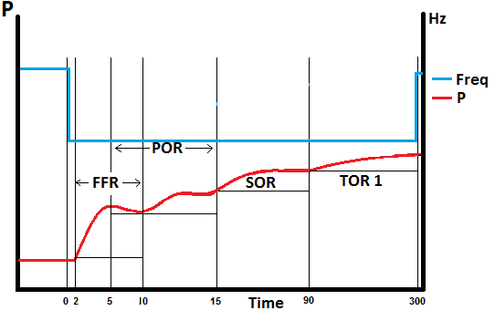
Figure 2: Example of how to measure the lowest MW value for each service
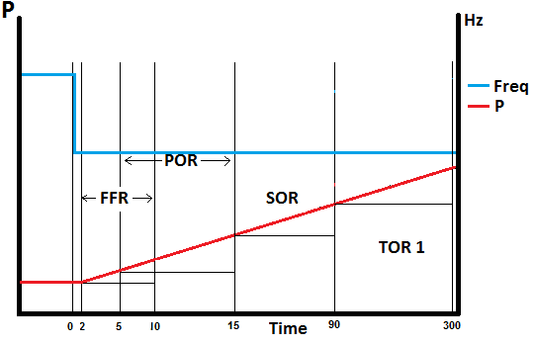
Figure 3: Levels shown with a linear response
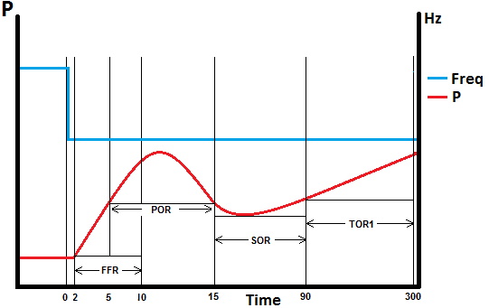
Figure 4: Levels shown with an overshoot response
The lines show where the lowest sustainable values are measured over the timeframe for each service.

FFR Assessment
The assessment of FFR is the lowest MW amount sustained over the 2 – 10 second timeframe compared to the pre-event output.
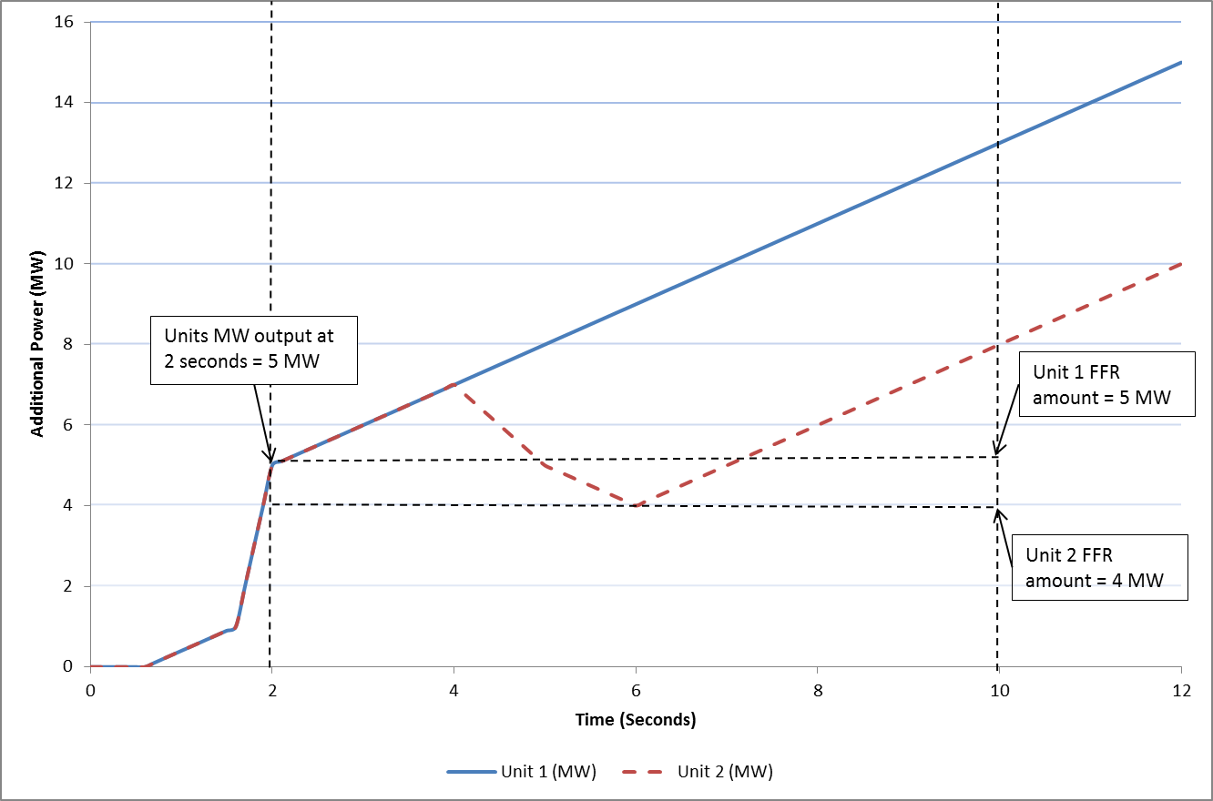
Figure 5: Example graph showing two units frequency response in the FFR timeframe
In figure 5, above, Unit 1 reaches 5 MW by the two second mark and continues ramping upwards over the course of the FFR timeframe. 5 MW is therefore the lowest sustainable MW amount provided over the timeframe by Unit 1.
Unit 2 also gets to 5 MW by two seconds, like Unit 1. Unlike Unit 1, it drops to 4 MW in the time frame. 4 MW is therefore the lowest sustainable MW amount provided over the timeframe by Unit 2.
The Pre-Event output is defined as the mean of the providing unit’s output between T-1.5 seconds and T-0.5 seconds from the time of the frequency passing through the reserve trigger for the providing unit (T=0). In the example above the pre-event output is 0MW.

FFR Response Time
A Providing Unit’s contracted FFR Response Time is the time from when the frequency falls through its contracted Reserve Trigger (T=0) to the time at which the Providing Unit must have achieved its contracted FFR volume, as dictated by its contracted FFR response curve.
The FFR response time provided in Section 7.4 shall be based on test data.
Please note that the FFR Response Time, as recorded on the Providing Unit’s installed performance measurement equipment, will be evaluated as part of the FFR performance monitoring process.
The product scalar for faster response of FFR will be based on the FFR response time of the Providing Unit.
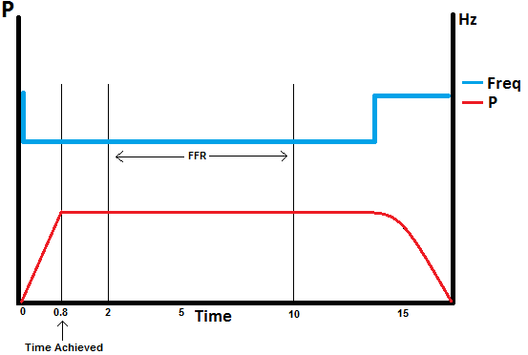
Figure 6: FFR volume achieved before the FFR time period

FFR Eligibility
Measure the energy provided (in MW seconds) in the timeframe from FFR response time to 10 seconds following an event, compared to the pre-event output. Measure the energy drawn (in MW seconds) during the 10-20 second timeframe following an event, compared to the pre-event output.
If a unit draws more energy from the grid in the 10 – 20 second period after this then it will not qualify for an FFR contract.
Figure 5 FFR Energy provided in blue and FFR Energy withdrawn in green

Results

Summary
Testing was completed on [DATE].
[Insert comment on the results, highlighting any issues encountered in performing the test or in analysing the results].
[Insert Report summary]
[Include any relevant test notes here, relating to how the test was carried out or to any specific conditions encountered during the test.]
[Any abnormal behaviour during the test (spikes, dips, unusual vibrations, etc.) shall be noted and documented. The reasons behind these shall be detailed along with any corrective actions taken and what its effects are on the unit and/or the result. If possible a clear graph of the issue shall also be presented.]
[The unit shall show how their base load on the day of testing correlates to their registered capacity using their ambient correction curves.]

Proposed Reserve Curve
The Unit shall provide a proposed reserve curve showing the levels of Operating Reserve at varying MW outputs:
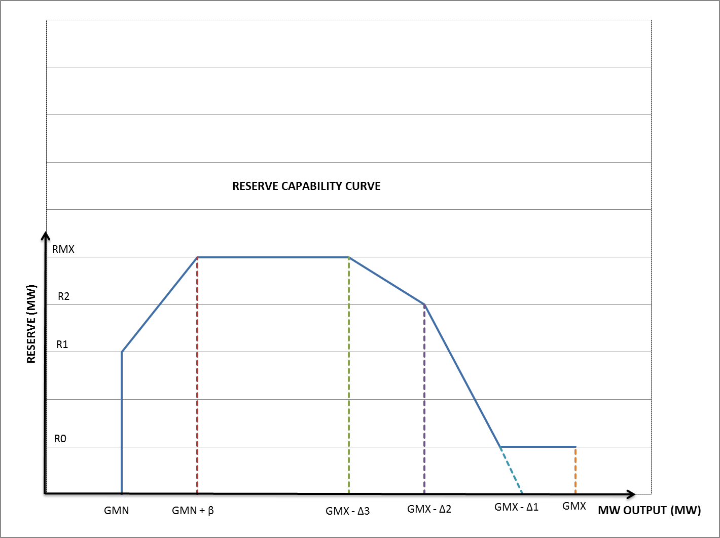
Figure 8: Example Reserve Curve

 | FFR | POR | SOR | TOR1 | TOR2
RMX (Max reserve volume)
GMN (Min Load)
R0
R1
R2
DELTA1
DELTA2
DELTA3
BETA

FFR, POR, SOR, TOR1, TOR2 Results
The following table shows the minimum sustained FFR, POR, SOR and TOR values achieved for each load range during testing.
No. | % Of Registered Capacity |  | Frequency Injected |  | (a) FFR Energy Provided  (FFR Response Time – 10 Sec) | (b) FFR Energy drawn  (10 – 20 Sec) | FFR Eligibility: is (a) MW > (b) MW? | FFR | POR  (5 -15 Sec) | SOR  (15 – 90 Sec) | TOR1  (90 – 300 Sec) | TOR2  (5nin – 20min
1 | 95% |  | 49.5Hz |  | ______MWs | ______MWs | Yes/No | ______MW | ______MW | ______MW | ______MW | ______MW
3 | 90% |  | 49.5Hz |  | ______MWs | ______MWs | Yes/No | ______MW | ______MW | ______MW | ______MW | ______MW
4 | 75% |  | 49.5Hz |  | ______MWs | ______MWs | Yes/No | ______MW | ______MW | ______MW | ______MW | ______MW
5 | 50% |  | 49.5Hz |  | ______MWs | ______MWs | Yes/No | ______MW | ______MW | ______MW | ______MW | ______MW
6 | Minimum Load |  | 49.5Hz |  | ______MWs | ______MWs | Yes/No | ______MW | ______MW | ______MW | ______MW | ______MW
 |  |  |  | Assess each of the load points above, for FFR, POR, SOR and TOR and identify the maximum value achieved.
Maximum Value |  |  |  |  | MW range over which the unit can provide FFR  _____MW to _____MW |  |  | ______MW | ______MW | ______MW | ______MW | _____MW

Non-Minimum Phase Systems (e.g. Hydro)
Using test data demonstrate and assess the magnitude and duration of initial drop in output. e.g.
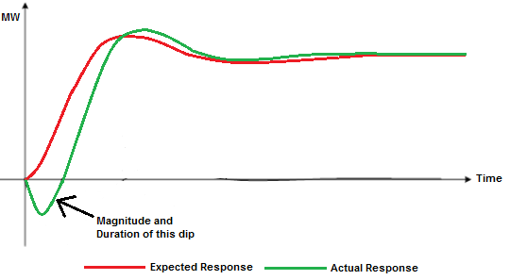
Figure 9: Example graph of non-minimum phase system response to frequency event

Graphs of results
[Insert full plots of the results demonstrating the frequency response of the unit for each load setpoint. Graphs shall be clear and highlight all relevant values and time periods, including levels. All Graphs shall be clearly labelled and easy to read.]
[Graph shall be a time series plot with Power and Frequency on the y axis and time on the x axis.]
[Include any relevant test notes here, relating to how the test was carried out or any specific conditions encountered during this test].

http://www.eirgridgroup.com/ http://www.soni.ltd.uk/

