Steady-State Reactive Power (SSRP)
System Services Test Report
Synchronous Machine
Unit Name

DISCLAIMER:
This Document contains information (and/or attachments) which may be privileged or confidential. All content is intended solely for the use of the individual or entity to whom it is addressed. If you are not the intended recipient please be aware that any disclosure, copying, distribution or use of the contents of this message is prohibited. If you suspect that you have received this Document in error please notify EirGrid or its subsidiaries immediately. EirGrid and its subsidiaries do not accept liability for any loss or damage arising from the use of this document or any reliance on the information it contains or the accuracy or up to date nature thereof. Use of this document and the information it contains is at the user’s sole risk. In addition, EirGrid and its subsidiaries strongly recommend that any party wishing to make a decision based on the content of this document should not rely solely upon data and information contained herein and should consult EirGrid or its subsidiaries in advance.
Further information can be found at: http://www.eirgridgroup.com/legal/

Document Version History
Revision 3.0 published 12th November 2019

Version | Date | Comment | Name | Company
0.1 | Insert date | Minor version (v0.1) - First submission for review and approval | Insert name | Insert company
1.0 | Insert Date | Revised to version 1.0 following approval by EirGrid, SONI. | Insert Name | Unit Company Name

Introduction
The Unit shall submit the latest version of this test report template as published on the EirGrid or SONI websites.
The report shall be developed for technical and non-technical readers and shall follow the agreed test programme. The report is submitted to generator_testing@eirgrid.com or generator_testing@soni.ltd.uk as appropriate.
Submission of this document is required if a Unit does not have and existing SSRP DS3 System Services Contract or is making changes or updates to any of the effected parameters.
To complete the report, the Unit shall have either:
- Recorded active and reactive power data as per the test procedure agreed with EirGrid, SONI; or
- Performance Data showing full reactive power capability.
Any issue with meeting any requirements or completing this report, please contact generator_testing@eirgrid.com or generator_testing@soni.ltd.uk as appropriate.

Abbreviations
SSRP Steady-State Reactive Power
MVAr Mega Volt Ampere – reactive
MW Mega Watt
TSO Transmission System Operator
MEC Maximum Export Capacity
RPM Revolutions per Minute
kV kilovolt
Hz Hertz – unit of frequency
AVR Automatic Voltage regulation
Q_{range} Reactive Power range from full leading to full lagging defined by P_{Max} and P_{Min}
P_{range} Active Power range from P_{Max} to P_{min}
P_{Max} Registered Capacity
P_{Min} Minimum power output
Q_{Max} Maximum Lagging MVAr that can be delivered over the full P_{range}
Q_{Min} Minimum Leading MVAr that can be delivered over the full P_{range}

Unit Data
Unit Test Coordinator | Unit to Specify Name, Company and contact details.
Unit name | Name:_________
Unit connection point | HV bushings of T101 in XX 110kV station
Unit connection voltage | ________kV
Unit Fuel Type(s) | Primary:_________  Secondary:_________
Registered Capacity / Maximum Continuous Rating | ___________MW
Minimum Load  Minimum Generation | ___________MW  ___________MW
Contracted MEC | ___________MW
Installed Plant | Name: _______  ___________MVA  Name: _______  ___________MW
House Load | ___________MW
Is the AVR fully commissioned and functional? | Yes/No
AVR Droop Setting | _______%

System Services
The definitions referenced in this document are for indicative purposes only. In the event of inconsistency between the definitions in this document and those in the DS3 System Services Agreement, the definitions in the DS3 System Services Agreement shall prevail.

Steady-State Reactive Power
SSRP is defined as the dispatchable reactive power range (Q_{Range}) in MVAr that can be provided across the full range of active power output (P_{Range}).

Reactive Power Factor calculation
$$RP Factor= \frac{Active Power Range across which reactive power can be provided \left(P_{Range}\right)}{Registered Capacity}$$
$$SSRP Volume= Q_{Range} x RP Factor$$
For dispatchable synchronous condensers and loads RP Factor = 1.
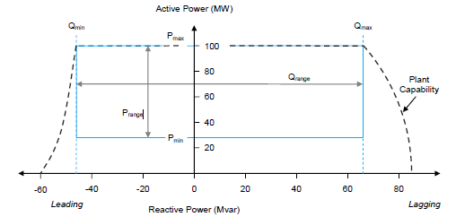
Figure 1: Example graph showing the P and Q ranges. Min Load is shown as the bottom blue line (Pmin).

Assessment
P_{range} is the MW range from Minimum Load to Registered Capacity
Q_{min} is the maximum leading MVAr the unit can absorb over P_{range}. Q_{max} is the maximum lagging MVAr the unit can produce over P_{range}.
Q_{min} and Q_{max} are based on reactive power measured at the generator terminals.
Figure 2: Example graph showing the P and Q ranges. Min Load is shown as the bottom blue line (Pmin).

Results

Summary
Testing was completed on [DATE].
[Insert comment on the results, highlighting any issues encountered in performing the test or in analysing the results].
[Insert Report summary]
[Include any relevant test notes here, relating to how the test was carried out or to any specific conditions encountered during the test.]
[Abnormal behaviour in the data (spikes, dips, unusual vibrations, etc.) shall be noted and documented. The reasons behind these shall be detailed along with any corrective actions taken and what its effects are on the unit and/or the result. If possible a clear graph of the issue should also be presented]
[Insert a full graph of the results showing the full reactive power capability of the unit, all relevant values shall be displayed, such as the full Q range (x-axis) and the full P range (y-axis). Each corner point must also have its value clearly labelled; the chart shall also have the theoretical values shown, conventional PQ chart shall include the OEL and UEL limiters. A full table of values supporting these graphs shall be included also.]

Table of results
Point | Value
Registered capacity, full lagging  (PMax, QMax) | _________MW, _______MVAr
Registered capacity, full leading  (PMax, QMin) | _________MW, _______MVAr
Minimum Load/ Minimum Generation, full lagging  (PMin, QMax) | _________MW, _______MVAr
Minimum Load/ Minimum Generation, full leading  (PMin, QMin) | _________MW, _______MVAr
Sync Comp mode, full leading | _________MW, _______MVAr
Sync Comp mode full lagging | _________MW, _______MVAr

System Services Values
Mode: __________________ (e.g. combined / open half cycle etc.) (Add additional tables as required for each mode

Reading | Value | Comment
Registered Capacity, (NI) Maximum Continuous Rating | ______MW
P range | _______MW to _____MW
Q range | ______MVAr to _______MVAr
RP factor |  | Insert Calculation and value per Section 6.2
SRP volume |  | Insert Calculation and value as per Section 6.2
Q range in Sync Comp mode | ______MVAr to _______MVAr
RP factor in Sync Comp mode |  | Insert Calculation and value per Section 6.2

Graphs of results
[Insert a full graph of the results showing the full reactive power capability of the unit, all relevant values shall be displayed, such as the full Q_{range} (x-axis) and the full P range (y-axis). Each corner point shall also have its value clearly labelled; the chart shall also have the theoretical values shown, conventional PQ chart shall include the OEL and UEL limiters. A full table of values supporting these graphs shall be included also].
[Include any relevant test notes here, relating to how the test was carried out or any specific conditions encountered during this test].
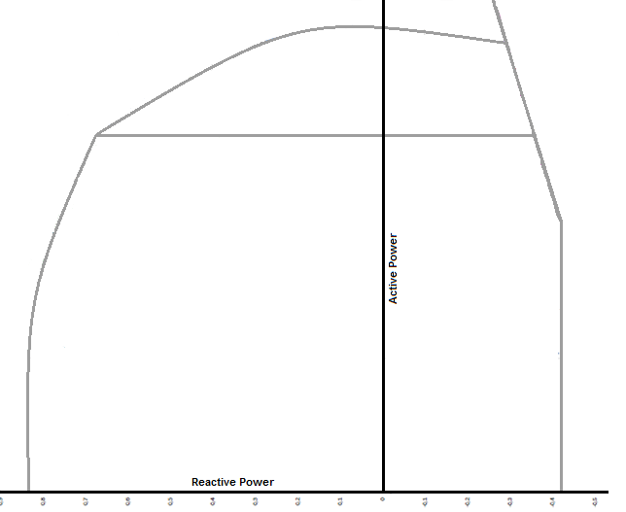
Figure 3: Example graph of a unit’s reactive power capability

http://www.eirgridgroup.com/ http://www.soni.ltd.uk/

