EIRGRID_GROUP_2015 Functional Document Template (21.8.15).pdf

Test 46 & 48 Operating Reserves, Governor Droop and RCOF

[Insert Unit Name]

Version 0.1

# Document Revision History

EirGrid template version 0.3, published 1 September 2016.

|  |  |  |
| --- | --- | --- |
| **Document Version History** | | |
| **Version** | **Date** | **Comment** |
| 0.1 | Dd/mm/yyyy | First submission for review/approval |
|  |  |  |

DISCLAIMER:

This Document contains information (and/or attachments) which may be privileged or confidential. All content is intended solely for the use of the individual or entity to whom it is addressed. If you are not the intended recipient please be aware that any disclosure, copying, distribution or use of the contents of this message is prohibited. If you suspect that you have received this Document in error please notify EirGrid or its subsidiaries immediately. EirGrid and its subsidiaries do not accept liability for any loss or damage arising from the use of this document or any reliance on the information it contains or the accuracy or up to date nature thereof. Use of this document and the information it contains is at the user’s sole risk. In addition, EirGrid and its subsidiaries strongly recommend that any party wishing to make a decision based on the content of this document should not rely solely upon data and information contained herein and should consult EirGrid or its subsidiaries in advance.

Further information can be found at: [http://www.eirgridgroup.com/legal/**I**](http://www.eirgridgroup.com/legal/I)

# Introduction

The Unit must submit the latest version of this test procedure as published on the EirGrid or SONI website[[1]](#footnote-1).

All yellow sections must be filled in before the test procedure will be approved. All grey sections must be filled in during testing. If any test requirements or steps are unclear, or if there is an issue with meeting any requirements or carrying out any steps, please contact [generator\_testing@eirgrid.com](mailto:generator_testing@eirgrid.com).

On the day of testing, suitably qualified technical personnel are required on site to assist in undertaking the tests. The personnel shall have the ability to:

1. Set up and disconnect the control system and instrumentation as required;
2. Ability to fully understand the Unit’s function and its relationship to the System;
3. Liaise with NCC/CHCC as required;
4. Mitigate issues arising during the test and report on system incidents.

The availability of personnel at NCC/CHCC will be necessary in order to initiate the necessary instructions for the test. NCC/CHCC will determine:

1. If network conditions allow the testing to proceed.
2. Which tests will be carried out
3. When the tests will be carried out.

On completion of this test, the following shall be submitted to [generator\_testing@eirgrid.com](mailto:generator_testing@eirgrid.com):

|  |  |
| --- | --- |
| **Submission** | **Timeline** |
| A scanned copy of the test procedure, as completed and signed on site on the day of testing | 1 working day |
| Test data in CSV or Excel format | 1 working day |
| Test report | 10 working days |

# Abbreviations

CHCC Castlereagh House Control Centre

NCC National Control Centre

Mvar Mega Volt Ampere – reactive

MW Mega Watt

TSO Transmission System Operator

MEC Maximum Export Capacity

RPM Revolutions Per Minute

kV kilovolt

EDIL Electronic Dispatch Instruction Logger

POR Primary Operating Reserve

SOR Secondary Operating Reserve

TOR Tertiary Operating Reserve

ROCOF Rate of Change of Frequency

# Unit DATA

|  |  |
| --- | --- |
| Unit Test Coordinator | Unit to Specify Name, Company and contact details. |
| Unit name | Unit to Specify |
| Unit connection point | Unit to Specify |
| Unit connection voltage | Unit to Specify |
| Unit Fuel Type | Primary Fuel / Secondary Fuel |
| Registered Capacity | Unit to Specify |
| Contracted MEC | Unit to Specify |
| Installed Plant | Unit to Specify |
| House Load (estimated) | Unit to Specify |
| Governor Droop Setting (expected) | Unit to Specify |

|  |  |
| --- | --- |
| % of Registered Capacity | MW |
| 5% | Unit to specify |
| 8% | Unit to specify |
| 10% | Unit to specify |
| 25% | Unit to specify |

# Eirgrid Grid Code references

|  |  |
| --- | --- |
| Grid Code Version: | Unit to specify |

## Operating Reserve

CC 7.3.1.1

(u) **Operating Reserve**

(i) **POR** not less than 5% **Registered Capacity**

To be provided, at a minimum, at **MW Outputs** in the range from 50% to 95% **Registered Capacity**, with provision in the range of 95% to 100**% Registered Capacity** to be not less than that indicated by a straight line with unity decay from 5% of **Registered Capacity** at 95% output to 0 at 100% output.

(ii) **SOR** not less than 5% **Registered Capacity**

To be provided, at a minimum, at **MW Outputs** in the range from 50% to 95% **Registered Capacity**, with provision in the range of 95% to 100% **Registered Capacity** to be not less than that indicated by a straight line with unity decay from 5% of **Registered Capacity** at 95% output to 0 at 100% output.

(iii) **TOR1** not less than 8% **Registered Capacity**

To be provided, at a minimum, at **MW Outputs** in the range from 50% to 92% **Registered Capacity**, with provision in the range of 92% to 100% **Registered Capacity** to be not less than that indicated by a straight line with unity decay from 8% of Registered Capacity at 92% output to 0 at 100% output.

(iv) **TOR2** not less than 10% **Registered Capacity**

To be provided, at a minimum, at **MW Outputs** in the range from 50% to 90% **Registered Capacity**, with provision in the range of 90% to 100% **Registered Capacity** to be not less than that indicated by a straight line with unity decay from 10% of Registered Capacity at 90% output to 0 at 100% output.

**Governor:**

CC.7.3.7

Each **Generation Unit** must be fitted with a fast acting proportional turbine speed governor and unit load controller or equivalent control device to provide **Frequency** response under normal operating conditions in accordance with OC4. The governor must be designed and operated to the appropriate

(a) European Standards; or

(b) In the absence of a relevant European Standards, such other standard which is in common use within the European Union

as at the time when the installation of which it forms a part was designed. Normal governor regulation shall be between 3% and 5%.

OC4.6.3.3 **Primary Operating Reserve (POR)**

OC4.6.3.3.1 **Primary Operating Reserve (POR)** is the additional MW output (and/or reduction in **Demand**) required at the **Frequency** nadir (minimum), compared to the pre-incident output (or **Demand**) where the nadir occurs between 5 and 15 seconds after an **Event.**

OC4.6.3.3.2 If the actual **Frequency** nadir is before 5 seconds or after 15 seconds after the event, then for the purpose of **POR** monitoring (in accordance with OC 10.4.4) the nadir is deemed to be the lowest Frequency which did occur between 5 and 15 seconds after the **Event.**

OC4.6.3.4 **Secondary Operating Reserve (SOR)**

OC4.6.3.4.1 **Secondary Operating Reserve (SOR)** is the additional MW output (and/or reduction in **Demand**) required compared to the pre-incident output (or **Demand**), which is fully available and sustainable over the period from 15 to 90 seconds following an **Event.**

OC4.6.3.5 **Tertiary Operating Reserve**

OC4.6.3.5.1 **Tertiary Operating Reserve band 1 (TOR1)** is the additional MW output (and/or reduction in **Demand**) required compared to the pre-incident output (or **Demand**) which is fully available and sustainable over the period from 90 seconds to 5 minutes following an **Event.**

OC4.6.3.5.2 **Tertiary Operating Reserve band 2 (TOR2)** is the additional MW output (and/or reduction in **Demand**) required compared to the pre-incident output (or **Demand**) which is fully available and sustainable over the period from 5 minutes to 20 minutes following an **Event.**

## Rate of Change of Frequency

### Rate of Change of Frequency (existing Grid Code)

CC.7.3.1 The conditions specified in this section of the code apply to all **Generation Units** connected to or connecting to the **Transmission System**. Unless explicitly stated all conditions specified apply over the full operating capabilities of the **Generation Unit** at the **Connection Point**.

(d) remain synchronised to the **Transmission System** during rate of change of **Transmission System Frequency** of values up to and including 0.5 Hz per second;

CC.7.3.7 Each **Generation Unit** must be fitted with a fast acting proportional turbine speed governor and unit load controller or equivalent control device to provide **Frequency** response under normal operating conditions in accordance with OC4. The governor must be designed and operated to the appropriate

(a) European Standards; or

(b) In the absence of a relevant European Standards, such other standard which is in common use within the European Union

as at the time when the installation of which it forms a part was designed. Normal governor regulation shall be between 3% and 5%.

### CER Decision Paper (14081)[[2]](#footnote-2)

*Section 3.3*

*5. New units: new units will be required to declare compliance (*with the 1 Hz per second ROCOF measured over 500 ms) *during the commissioning process.*

## Grid Code Definitions

**Governor Droop**

The percentage drop in the **Frequency** that would cause the **Generation Unit** under free governor action to change its output from zero to its full **Capacity**. In the case of a **Controllable WFPS**, it is the percentage drop in the **Frequency** that would cause the **Controllable WFPS** to increase its output from zero to its full **Registered Capacity**

**Primary Operating Reserve (POR)**

The additional increase in **MW Output** (and/or reduction in **Demand**) required at the **Frequency** nadir (minimum), compared to the pre-incident output (or **Demand**) where the nadir occurs between 5 and 15 seconds after an event. If the actual **Frequency** nadir is before 5 seconds or after 15 seconds after the event, then for the purpose of POR monitoring the nadir is deemed to be the lowest **Frequency** which occurred between 5 and 15 seconds after the event.

**Registered Capacity**

The maximum **Capacity**, expressed in whole MW, that a **Generation Unit** can deliver on a sustained basis, without accelerated loss of equipment life, at the **Connection Point** which is under the dispatch (or control of a **Controllable WFPS**) of the **TSO**. This shall be the value at 10°C, 70 % relative humidity and 1013 hPa. The values of an **Interconnector’s Operating Characteristics** for operation of the **Interconnector** pursuant to the **Grid Code** registered under the **Connection Conditions**.

**Secondary Operating Reserve (SOR)**

The additional **MW Output** (and/or reduction in **Demand**) required compared to the pre-incident output (or **Demand**), which is fully available by 15 seconds from the time of the start of the **Frequency** fall and sustainable up to 90 seconds following an **Event.**

**Tertiary Operating Reserve band 1**

The additional **MW Output** (and/or reduction in **Demand**) required compared to the pre-incident output (or **Demand**) which is fully available and sustainable over the period from 90 seconds to 5 minutes following an event.

**Tertiary Operating Reserve band 2**

The additional **MW Output** (and/or reduction in **Demand**) required compared to the pre-incident output (or **Demand**) which is fully available and sustainable over the period from 5 minutes to 20 minutes following an event

## Calculation of MW response and Governor Droop

$$ΔMW=\frac{\left(Δf\right)\left(Registered Capacity\right)}{\left(f_{n} \right)\left(droop\right)}$$

ΔMW=Expected MW

Δf = frequency change in Hz

Registered Capacity = XXX MW (expected value)

Fn = 50 Hz

Droop = 0.04 (expected value)

# SONI Grid Code references

## Operating Reserve

OC3.4.2 **Operating Reserve**

OC3.4.2.1 **Operating Reserve** is additional output from **Generating Plant** in Northern Ireland, additional **Interconnector** transfer and/or reduction in **Demand** which must be realisable in real time operation to respond in order to contribute to containing and correcting any **System Frequency** deviation to an acceptable level, within the limits specified in the Electricity Supply Regulations (N.I.) 1991, in the event of a loss of generation or a loss of import from any **Interconnector** or mismatch between generation output and **Demand**.

OC3.4.2.2 The **Operating Reserve** from **Generating Plant** must be capable of providing response in four distinct time scales:

OC3.4.2.2.1 **Primary Operating Reserve**

The automatic response to **NI System Frequency** changes which is released increasingly from the time of **Frequency** change and fully available by 5 seconds, and, subject to the **Unit Load Controller** adjustment determined pursuant to the CC where applicable, must be sustainable, for at least 15 seconds.

OC3.4.2.2.2 **Secondary Operating Reserve**

The additional **MW** output compared to the pre-incident output, which is fully available and sustainable over the period from 15 to 90 seconds following an **Event**.

OC3.4.2.2.3 **Tertiary Operating Reserve band 1**

The additional **MW** output required compared to the pre-**Event** output which is fully available and sustainable from 90 seconds to 5 minutes following an **Event**.

OC3.4.2.2.4 **Tertiary Operating Reserve band 2**

The additional **MW** output required compared to the pre-**Event** output which is fully available and sustainable from 5 minutes to 20 minutes following an **Event**.

Compliance will be based on the requirements of the relevant Generator Unit Agreement (GUA), Harmonised Ancillary Service (HAS) Agreement or Minimum Function Specification (MFS).

Relevant section of the MFS for OCGTs and CCGTs below:

All generation plant must be capable of automatically providing a change of output in response to rapid changes in system frequency as stated in the Grid Code (OC3.4.2). Response is required to both falling and rising frequency and is based on a nominal governor droop of 4%. The generating plant must be capable of providing response over four timescales as follows:

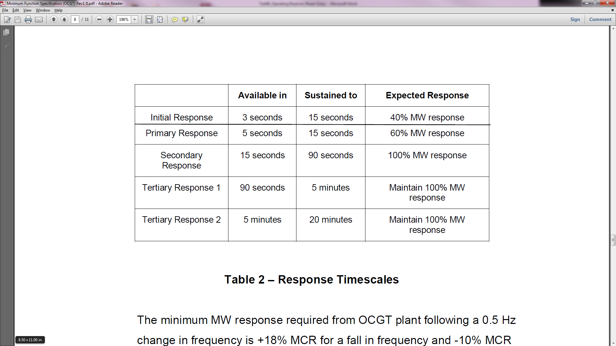

The minimum MW response required from CCGT and OCGT plant following a 0.5 Hz change in frequency is +18% MCR for a fall in frequency and -10% MCR for an increase in frequency. The response varies with loading according to Figure 2.

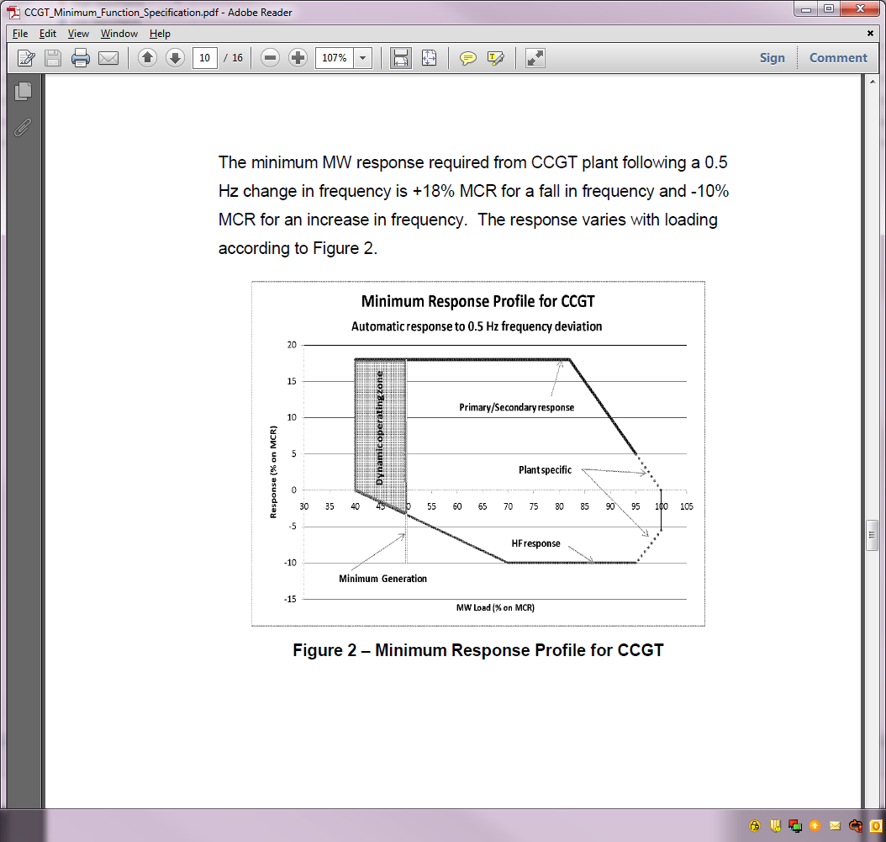

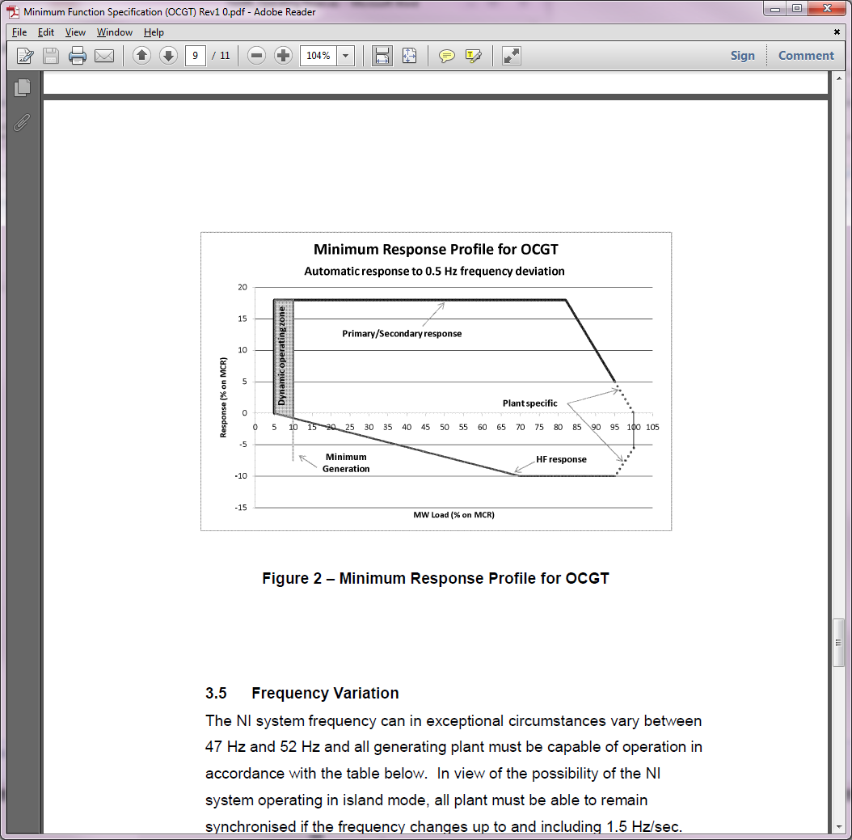

**Governor:**

CC.S1.1.5.5 The **TSO** may specify in the relevant **Connection Agreement** that a **Generating Unit** must be fitted with a **Unit Load Controller**. Where so specified, the **Generator** mustensure that the **Unit Load Controller** is in operation at all times and in accordancewith the settings for **Frequency** trigger and reset point, time delay and droop asspecified in the relevant **Connection Agreement** or such other settings as the **TSO** may notify to the **Generator** in writing on not less than two **Business Days'** notice,unless directed otherwise by the **TSO**.

## Rate of Change of Frequency

### Rate of Change of Frequency (existing Grid Code)

CC8.8.3 Variations in **System Frequency**

The **DNO** shall provide in the **Distribution Code** that, apart from those circumstances set out in CC8.8.4, all **Independent Generating Plant** connected to the **Distribution** **System** with an **Output** of 100 kW or more shall stay connected and operate:

(a) continuously where the **System Frequency** varies within the range 49.5 to 52.0 Hz;

(b) for a period of up to one hour where the **System Frequency** varies within the range 48.0 to 49.5 Hz; and

(c) for a period of up to 5 minutes where the **System Frequency** varies within

the range 47.0 to 48.0 Hz.

The **DNO** shall notify the **TSO** if an **Independent Generating Plant** above 100KW does not operate within the parameters set out above and, if required by the **TSO,** shall use reasonable endeavours to enforce the **Distribution Code** obligations on the **Independent Generating Plant**.

CC8.8.4 The requirements of CC8.8.3 do not apply where:

(a) the islanding protection has operated correctly, consistent with the settings

agreed with the **DNO**;

(b) the **System Frequency** has changed at a rate greater than 0.5HZ/s; or

(c) there is manual intervention by the **Generator**.

### Proposed Modification (Regulatory approved with phased implementation)

CC5.3.2 In exceptional circumstances, **System Frequency** will rise to 52 Hz or fall to 47 Hz but sustained operation outside the range specified in the Electricity Supply Regulations

(N.I.) 1991(as amended, updated or superseded) is not envisaged. **Users** should take these factors into account in the design of **Plant** and **Apparatus**.

CC5.3.3 In exceptional circumstances, **System Frequency** will vary causing a considerable **Rate of Change of Frequency**. Under such conditions, **Users** must ensure that their **Plant** and **Apparatus** remains **synchronised** to the **NI System** for a **Rate of Change** **of Frequency** up to and including 1 Hz per second as measured over a rolling 500 milliseconds period within the frequency range mentioned in CC5.3.2.

CC5.3.4 Notwithstanding CC5.3.3, until such time as a notification given by the **TSO** pursuant to this CC5.3.4 that there is additional system re-enforcement, **Users** must ensure that their **Plant** and **Apparatus** remains **synchronised** to the **NI System** for a **Rate of** **Change of Frequency** up to and including 2 Hz per second as measured over a rolling 500 milliseconds period within the frequency range mentioned in CC5.3.2. For the avoidance of doubt, this requirement relates to the capabilities of **Generating Units** only and does not impose the need for **Rate of Change of Frequency** protection nor does it impose a specific setting for anti-islanding protection relays.

# site Safety requirements

The following is required for the EirGrid/SONI witness to attend site:

|  |  |
| --- | --- |
| Personal Protective Equipment Requirements   1. Site Safety boots 2. Hard Hat with chin strap 3. Hi Vis 4. Arc Resistive clothing 5. Safety Glasses 6. Gloves 7. Safe Pass | 1. Yes / No 2. Yes / No 3. Yes / No 4. Yes / No 5. Yes / No 6. Yes / No 7. Yes / No |
| Site Induction requirements | Yes / No  (If Yes, Unit to specify how and when the induction must carried out) |
| Any further information | Unit to specify |

# Test Description and Pre Conditions

## Purpose

This purpose of this test is to verify that:

* the minimum required levels of Primary, Secondary and Tertiary Operating Reserves are provided by the unit.
* the governor decrement rate is correctly implemented.
* the governor is continuously acting and responds with the required droop characteristic
* the governor reacts in a correct manner to a simulated ROCOF event.

This is achieved by injecting a simulated frequency into the governor and recording the Units response.

It is recommended that the governor is isolated from the system frequency in order to perform this test as the natural variation in system frequency will not be a factor in the Units measured response. In order to accurately determine 100% of output the unit will run at base load for a period of time before the frequency injections begin.

This test is to be performed separately on each fuel or fuel mix that the Unit is capable of running on.

# Pass Criteria

## Ireland

The Unit must demonstrate that:

* the minimum required levels of Primary, Secondary and Tertiary Operating Reserves are provided by the unit.
* the governor decrement rate is correctly implemented.
* the governor is continuously acting and responds with the required droop characteristic
* the governor reacts in a correct manner to a simulated ROCOF event.

for the following test cases:

|  |  |  |  |  |  |  |  |  |
| --- | --- | --- | --- | --- | --- | --- | --- | --- |
| **No.** | **Load Level** | **Frequency Injection** | **POR**  **(5-15sec) Requirement** | **SOR**  **(15-90sec) Requirement** | **TOR1**  **(90-300sec) Requirement** | **TOR2**  **(5-20min) Requirement** | **Estimated response with a 4 % droop** | **Hold Step for a minimum of** |
| 1 | Min load | -0.2Hz  (Step) | 5% | 5% | 8% | 10% | +10% | 20 minutes |
| 2 | Min load | -0.5Hz  (ramp of 1Hz/sec) | N/A | N/A | N/A | N/A | +25% | 10 minutes |
| 3 | Min Load | +0.5Hz  (ramp of 1Hz/sec) | N/A | N/A | N/A | N/A | -25% | 10 minutes |
| 4 | 75% | -0.2Hz  (Step) | 5% | 5% | 8% | 10% | +10% | 20 minutes |
| 5 | 75% | -0.5Hz  (ramp of 1Hz/sec) | N/A | N/A | N/A | N/A | +25% | 10 minutes |
| 6 | 75% | +0.5Hz  (ramp of 1Hz/sec) | N/A | N/A | N/A | N/A | -25% | 10 minutes |
| 7 | 90% | -0.2Hz  (Step) | 5% | 5% | 8% | 10% | +10% | 20 minutes |
| 8 | 90% | -0.5Hz  (ramp of 1Hz/sec) | N/A | N/A | N/A | N/A | +10% | 10 minutes |
| 9 | 92% | -0.2Hz  (Step) | 5% | 5% | 8% | 8% | +8% | 20 minutes |
| 10 | 95% | -0.2Hz  (Step) | 5% | 5% | 5% | 5% | +5% | 20 minutes |
| 11 | 100% | +0.5Hz  (ramp of 1Hz/sec) | N/A | N/A | N/A | N/A | -25% | 10 minutes |

## Northern Ireland

**Criteria of Assessment:**

**** Primary Response capability of the unit/module (% on unit/module Registered Capacity) as per the GUA/HAS Agreement or MFS

**** Secondary Response capability of the unit/module (% on unit/module Registered

Capacity) as per the GUA/HAS Agreement or MFS

**** High Frequency Response capability of the unit/module (% on unit/module Registered

Capacity) as per the GUA/HAS Agreement or MFS

**** Stable operation from Designed Minimum Operating Level to maximum Declared

Availability.

**** Continuous frequency modulation capability across full generator operating range.

**** Capable of experiencing large frequency disturbances and high rates of change without

tripping.

|  |  |  |  |  |
| --- | --- | --- | --- | --- |
| **No.** | **Load Level** | **Frequency Injection**  **(for 22 min)** | **Estimated response with a 4 % droop** | **Hold Step for a minimum of** |
| 1 | Min load | -0.2Hz  (Step) | +10% | 20 minutes |
| 2 | Min load | -0.5Hz  (ramp of 1Hz/sec) | +25% | 10 minutes |
| 3 | Min load | -0.5Hz  (ramp of 2Hz/sec) | +25% | 10 minutes |
| 4 | 75% | -0.2Hz  (Step) | +10% | 20 minutes |
| 5 | 75% | -0.5Hz  (ramp of 1Hz/sec) | +25% | 20 minutes |
| 6 | 75% | +0.5Hz  (ramp of 1Hz/sec) | -25% | 10 minutes |
| 7 | 75% | +0.5Hz  (ramp of 2Hz/sec) | -25% | 10 minutes |
| 8 | 90% | -0.2Hz  (Step) | +10% | 20 minutes |
| 9 | 90% | -0.5Hz  (ramp of 1Hz/sec) | +10% | 10 minutes |
| 10 | 90% | -0.5Hz  (ramp of 2Hz/sec) | +10% | 10 minutes |
| 11 | 92% | -0.2Hz  (Step) | +8% | 20 minutes |
| 12 | 95% | -0.2Hz  (Step) | +5% | 20 minutes |
| 13 | 100% | +0.5Hz  (ramp of 1Hz/sec) | -25% | 10 minutes |
| 14 | 100% | +0.5Hz  (ramp of 2Hz/sec) | -25% | 10 minutes |

# Instrumentation and Onsite Data Trending

All of the following trends and screenshots must be recorded by the Unit during the test. Failure to provide any of these trends will result in test cancellation.

|  |  |  |  |
| --- | --- | --- | --- |
| **No.** | **Signal Name** | **Sample Rate** | **Source** |
| 1 | Active Power at Connection Point (MW) | Unit to specify, 100ms or as agreed with TSO | Unit to specify |
| 2 | Reactive Power at Connection Point (Mvar) | Unit to specify, 100ms or as agreed with TSO | Unit to specify |
| 3 | Active Power at Generator (MW) | Unit to specify, 100ms or as agreed with TSO | Unit to specify |
| 4 | Reactive Power at Generator (Mvar) | Unit to specify, 100ms or as agreed with TSO | Unit to specify |
| 5 | Generator Circuit Breaker position (Open / Closed) | Unit to specify, | Unit to specify |
| 6 | Generator Voltage (kV) | Unit to specify, 100ms or as agreed with TSO | Unit to specify |
| 7 | Turbine Speed (RPM) | Unit to specify, 100ms or as agreed with TSO | Unit to specify |
| 8 | Shaft Vibration (*µ*mp-p) | Unit to specify, 100ms or as agreed with TSO | Unit to specify |
| 9 | Blade Path Temperature (°C) | Unit to specify, 100ms or as agreed with TSO | Unit to specify |
| 10 | Bearing Metal Temperature (°C) | Unit to specify, 100ms or as agreed with TSO | Unit to specify |
| 11 | Process variables e.g. Inlet Guide Vane position, Fuel Control Valve position etc. | Unit to specify, 100ms or as agreed with TSO | Unit to specify |
| 12 | Other signals as required by the unit or by the TSO | Unit to specify, 100ms or as agreed with TSO | Unit to specify |
| 13 | Governor Control Signals | Unit to specify, 100ms or as agreed with TSO | Unit to specify |
| 14 | Alarm/Event page | Screenshot of alarms / events for duration of the test. | |
| 15 | Generator Overview Screen | Screenshots may be required where test data/milestone/events are not available through the trends listed above. | |
| 16 | EDIL instructions | Screenshot as logged during the test. | |

## Initial Conditions

Should “No” be answered to any of the following, contact [the](mailto:generator_testing@eirgrid.com) EirGrid test coordinator and agree next steps in advance of making any corrective actions.

|  |  |  |
| --- | --- | --- |
| **No.** | **Conditions** | **Check on day of test** |
| 1 | Test Profiles have been submitted and approved by [neartime@eirgrid.com](mailto:neartime@eirgrid.com). | Yes/No |
| 2 | Unit Fuel Type: Primary Fuel / Secondary Fuel | Yes/No |
| 3 | Normal start up support auxiliary systems in service. | Yes/No |
| 4 | Required signals, as described in section 8.3 are available | Yes / No |

# Test Steps

Test steps for Northern Ireland plant to be agreed with SONI prior to testing.

## Verification of Base Load

|  |  |  |  |
| --- | --- | --- | --- |
| **Step** | **Action** | **Event Time** | **Comment** |
| 1 | Request NCC permission to   1. Turn frequency response off 2. Issue an EDIL Dispatch Instruction to bring the unit to full output |  |  |
| 2 | Begin data recording of signals as set out in section 8.3 |  |  |
| 3 | When the Unit reaches full load record the Active Power Output at the connection point and maintain this output until the Unit has stabilised |  | Stable Full Load level = \_\_\_\_\_MW at connection point. |
| 4 | Record the sustained Active Power Output level. This will constitute 100% of load for calculation of all but the minimum load test points to follow |  |  |
| 5 | Request NCC permission to turn Frequency Response on |  |  |

## 100% +0.5 Hz Ramp at 1 Hz/Second

|  |  |  |  |
| --- | --- | --- | --- |
| **Step** | **Action** | **Event Time** | **Comment** |
| 1 | Generator control room contacts NCC and confirms the MW swing that will occur during the frequency injection |  | 100% Load: \_\_\_MW |
| 2 | Confirm data recording of signals as set out in section 8.3 |  |  |
| 3 | Inject **Ramp change of -0.5Hz at a rate of 1 Hz per second** and maintain the frequency injection for a minimum of **10 minutes** |  | Completion time (t+10mins): \_\_\_\_ |
| 4 | Remove the frequency simulation and allow the unit to return its pre injection load under governor action |  |  |
| 5 | Stop recording |  |  |
| 6 | Step completed |  |  |

## 95% -0.2 Hz Step

|  |  |  |  |
| --- | --- | --- | --- |
| **Step** | **Action** | **Event Time** | **Comment** |
| 1 | Generator control room contacts NCC and requests the following:   1. Issue an EDIL Dispatch Instruction to bring the unit to **XX MW (95%)** 2. Confirmation of the MW swing that will occur during the frequency injection |  | 95% Load: \_\_\_MW |
| 2 | Confirm data recording of signals as set out in section 8.3 |  |  |
| 3 | Inject **Step change of -0.2Hz** and maintain the frequency injection for a minimum of **20 minutes** |  | Completion time (t+20mins): \_\_\_\_ |
| 5 | Remove the frequency simulation and allow the unit to return its pre injection load under governor action |  |  |
| 6 | Stop recording |  |  |
| 7 | Step completed |  |  |

## 92% -0.2 Hz Step

|  |  |  |  |
| --- | --- | --- | --- |
| **Step** | **Action** | **Event Time** | **Comment** |
| 1 | Generator control room contacts NCC and requests the following:   1. Issue an EDIL Dispatch Instruction to bring the unit to **XX MW (92%)** 2. Confirmation of the MW swing that will occur during the frequency injection |  | 92% Load: \_\_\_MW |
| 2 | Confirm data recording of signals as set out in section 8.3 |  |  |
| 3 | Inject **Step change of -0.2Hz** and maintain the frequency injection for a minimum of **20 minutes** |  | Completion time (t+20mins): \_\_\_\_ |
| 4 | Remove the frequency simulation and allow the unit to return its pre injection load under governor action |  |  |
| 5 | Stop recording |  |  |
| 6 | Step completed |  |  |

## 90% -0.2 Hz Step

|  |  |  |  |
| --- | --- | --- | --- |
| **Step** | **Action** | **Event Time** | **Comment** |
| 1 | Generator control room contacts NCC and requests the following:   1. Issue an EDIL Dispatch Instruction to bring the unit to **XX MW (90%)** 2. Confirmation of the MW swing that will occur during the frequency injection |  | 90% Load: \_\_\_MW |
| 2 | Confirm data recording of signals as set out in section 8.3 |  |  |
| 3 | Inject **Step change of -0.2Hz** and maintain the frequency injection for a minimum of **20 minutes** |  | Completion time (t+20mins): \_\_\_\_ |
| 5 | Remove the frequency simulation and allow the unit to return its pre injection load under governor action |  |  |
| 6 | Stop data recording |  |  |
| 7 | Test completed |  |  |

## 90% -0.5 Hz Ramp at 1 Hz/Second

|  |  |  |  |
| --- | --- | --- | --- |
| **Step** | **Action** | **Event Time** | **Comment** |
| 1 | Generator control room contacts NCC and requests the following:   1. Confirmation of **XX MW (90%)** 2. Confirmation of the MW swing that will occur during the frequency injection |  | 90% Load: \_\_\_MW |
| 2 | Confirm data recording of signals as set out in section 8.3 |  |  |
| 3 | Inject **Ramp change of -0.5Hz at a rate of 1 Hz per second** and maintain the frequency injection for a minimum of **10 minutes** |  | Completion time (t+10mins): \_\_\_\_ |
| 4 | Remove the frequency simulation and allow the unit to return its pre injection load under governor action |  |  |
| 5 | Stop recording |  |  |
| 6 | Step completed |  |  |

## 75% -0.2 Hz Step

|  |  |  |  |
| --- | --- | --- | --- |
| **Step** | **Action** | **Event Time** | **Comment** |
| 1 | Generator control room contacts NCC and requests the following:   1. Issue an EDIL Dispatch Instruction to bring the unit to **XX MW (75%)** 2. Confirmation of the MW swing that will occur during the frequency injection |  | 75% Load: \_\_\_MW |
| 2 | Confirm data recording of signals as set out in section 8.3 |  |  |
| 3 | Inject **Step change of +0.2Hz** and maintain the frequency injection for a minimum of **20 minutes** and note the completion time. |  | Completion time (t+20mins): \_\_\_\_. |
| 4 | Remove the frequency simulation and allow the unit to return its pre injection load under governor action |  |  |
| 5 | Stop data recording |  |  |
| 6 | Step completed |  |  |

## 75% -0.5 Hz Ramp at 1 Hz/Second

|  |  |  |  |
| --- | --- | --- | --- |
| **Step** | **Action** | **Event Time** | **Comment** |
| 1 | Generator control room contacts NCC and requests the following:   1. Confirmation of **XX MW (75%)** 2. Confirmation of the MW swing that will occur during the frequency injection |  | 75% Load: \_\_\_MW |
| 2 | Confirm data recording of signals as set out in section 8.3 |  |  |
| 3 | Inject **Ramp change of -0.5 Hz at a rate of 1 Hz per second** and mmaintain the frequency injection for a minimum of **10 minutes** |  | Completion time (t+10mins): \_\_\_\_ |
| 4 | Remove the frequency simulation and allow the unit to return its pre injection load under governor action |  |  |
| 5 | Stop data recording |  |  |
| 6 | Step completed |  |  |

## 75% +0.5 Hz Ramp at 1 Hz/Second

|  |  |  |  |
| --- | --- | --- | --- |
| **Step** | **Action** | **Event Time** | **Comment** |
| 1 | Generator control room contacts NCC and requests the following:   1. Confirmation of **XX MW (75%)** 2. Confirmation of the MW swing that will occur during the frequency injection |  | 75% Load: \_\_\_MW |
| 2 | Confirm data recording of signals as set out in section 8.3 |  |  |
| 3 | Inject **Ramp change of +0.5 Hz at a rate of 1 Hz per second** and mmaintain the frequency injection for a minimum of **10 minutes** |  | Completion time (t+10mins): \_\_\_\_ |
| 4 | Remove the frequency simulation and allow the unit to return its pre injection load under governor action |  |  |
| 5 | Stop data recording |  |  |
| 6 | Step completed |  |  |

## Min load -0.2 Hz Step

|  |  |  |  |
| --- | --- | --- | --- |
| **Step** | **Action** | **Event Time** | **Comment** |
| 1 | Generator control room contacts NCC and requests the following:   1. Issue an EDIL Dispatch Instruction to bring the unit to Minimum Load of **XX MW** 2. Confirmation of the MW swing that will occur during the frequency injection |  | Minimum Load: \_\_\_MW. |
| 2 | Confirm data recording of signals as set out in section 8.3 |  |  |
| 3 | Inject **Step change of 0.2 Hz** and maintain the frequency injection for a minimum of **20 minutes** and note the completion time |  | Completion time (t+20mins) \_\_\_\_\_\_. |
| 4 | Remove the frequency simulation and allow the unit to return its pre injection load under governor action |  |  |
| 5 | Stop data recording |  |  |
| 6 | Step completed |  |  |

## Min load -0.5 Hz Ramp at 1 Hz/Second

|  |  |  |  |
| --- | --- | --- | --- |
| **Step** | **Action** | **Event Time** | **Comment** |
| 1 | Generator control room contacts NCC and requests the following:   1. Confirmation of Minimum Load of **XX MW** 2. Confirmation of the MW swing that will occur during the frequency injection |  | Minimum Load: \_\_\_MW |
| 2 | Confirm data recording of signals as set out in section 8.3 |  |  |
| 3 | Inject **Ramp change of -0.5Hz at a rate of 1Hz per second** and maintain the frequency injection for a minimum of **10 minutes** and note the completion time. |  | Completion time (t+10mins): \_\_\_\_. |
| 4 | Remove the frequency simulation and allow the unit to return its pre injection load under governor action |  |  |
| 5 | Stop data recording |  |  |
| 6 | Test completed |  |  |

## Min load +0.5 Hz Ramp at 1 Hz/Second

|  |  |  |  |
| --- | --- | --- | --- |
| **Step** | **Action** | **Event Time** | **Comment** |
| 1 | Generator control room contacts NCC and requests the following:   1. Confirmation of Minimum Load of **XX MW** 2. Confirmation of the MW swing that will occur during the frequency injection |  | Minimum Load: \_\_\_MW |
| 2 | Confirm data recording of signals as set out in section 8.3 |  |  |
| 3 | Inject **Ramp change of +0.5Hz at a rate of 1Hz per second** and maintain the frequency injection for a minimum of **10 minutes** and note the completion time. |  | Completion time (t+10mins): \_\_\_\_. |
| 4 | Remove the frequency simulation and allow the unit to return its pre injection load under governor action |  |  |
| 5 | Stop data recording |  |  |
| 6 | Test completed |  |  |

|  |
| --- |
| **Comments:** |
| Unit Witness signoff that this test has been carried out according to the test procedure above.  Signature: \_\_\_\_\_\_\_\_\_\_\_\_\_\_\_\_\_\_\_\_\_\_\_\_\_\_\_\_\_\_\_\_\_\_ Date: \_\_\_\_\_\_\_\_\_\_\_\_\_\_\_\_\_\_\_\_ |
| EirGrid/SONI Witness signoff that this test has been carried out according to the test procedure above.  Signature: \_\_\_\_\_\_\_\_\_\_\_\_\_\_\_\_\_\_\_\_\_\_\_\_\_\_\_\_\_\_\_\_\_\_ Date: \_\_\_\_\_\_\_\_\_\_\_\_\_\_\_\_\_\_\_\_ |

1. <http://www.eirgridgroup.com/library> [↑](#footnote-ref-1)
2. <http://www.eirgridgroup.com/library> [↑](#footnote-ref-2)