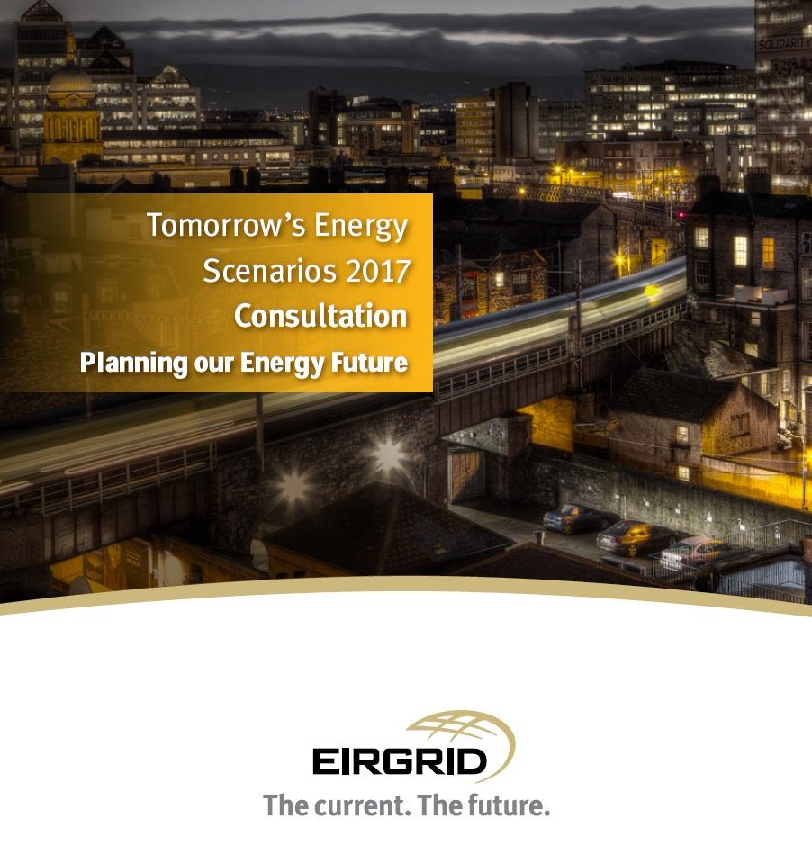

Tomorrow’s Energy Scenarios 2017 Consultation is the first step in the engagement process for ‘Planning our Energy Future’. To continue the conversation on our draft scenarios we would like to get your input on the future of energy in Ireland.
To gather this feedback we have posed some questions which you can find below. You can submit your answers online or by filling out this form and returning it to us by email to scenarios@eirgrid.com.
We will be accepting input and feedback on our draft scenarios until March 31st 2017.
To get further information on our draft scenarios please visit http://www.eirgridgroup.com/customer-and-industry/energy-future.
Alternatively, please email us your views on Tomorrow’s Energy Scenarios to scenarios@eirgrid.com and one of our team will be in touch.
1. Details: (Optional)
Please provide an email address if you would like further information on the development of Tomorrow's Energy Scenarios in future.

Name: Please insert name here.
Organisation: Please insert organisation here.
Email Address: Please insert email address here.

2. Do you feel the Tomorrow's Energy Scenarios 2017 Consultation document has helped you better understand the future possibilities of Ireland’s energy industry?

☐ Yes ☐ No ☐ Unsure

Please provide details on the reasons for your choice:
Please provide further feedback here.

3. Do you feel the Tomorrow's Energy Scenarios 2017 Consultation document has helped you understand the link between electricity supply and demand and the future needs of the electricity grid?

☐ Yes ☐ No ☐ Unsure

Please provide details on the reasons for your choice:
Please provide further feedback here.

4. Which draft scenario do you believe is the most likely scenario? (Please choose one)

☐ Steady Evolution
☐ Low Carbon Living
☐ Slow Change
☐ Consumer Action

Please provide details on the reasons for your choice:
Please provide further feedback here.

5. Do you believe the draft scenarios are credible?
Yes No Unsure
Steady Evolution ☐ ☐ ☐
Low Carbon Living ☐ ☐ ☐
Slow Change ☐ ☐ ☐
Consumer Action ☐ ☐ ☐

Please provide details on the reasons for your choice:
Please provide further feedback here.

6. Do you believe the draft scenario names accurately represent the scenarios presented?
Yes No Unsure
Steady Evolution ☐ ☐ ☐
Low Carbon Living ☐ ☐ ☐
Slow Change ☐ ☐ ☐
Consumer Action ☐ ☐ ☐

Please provide details on the reasons for your choice:
Please provide further feedback here.

7. Do you believe each individual draft scenario has a consistent story?
Yes No Unsure
Steady Evolution ☐ ☐ ☐
Low Carbon Living ☐ ☐ ☐
Slow Change ☐ ☐ ☐
Consumer Action ☐ ☐ ☐

Please provide details on the reasons for your choice:
Please provide further feedback here.

8. Are there any scenarios which we have not considered and you believe we should?

☐ Yes ☐ No ☐ Unsure

Please provide details on the reasons for your choice:
Please provide further feedback here.

9. Are there any input components to electricity demand which you believe we have not considered?

☐ Yes ☐ No ☐ Unsure

Please provide details on the reasons for your choice:
Please provide further feedback here.

10. Are there any input components to electricity supply which you believe we have not considered?

☐ Yes ☐ No ☐ Unsure

Please provide details on the reasons for your choice:
Please provide further feedback here.

11. Do you believe Tomorrow’s Energy Scenarios will be useful for your business or industry? If so, how?

☐ Yes ☐ No ☐ Unsure

Please provide details on the reasons for your choice:
Please provide further feedback here.

12. Are there any further details which you would like us to provide in our final Tomorrow’s Energy Scenarios document?

Please provide further feedback here.

