|  |  |
| --- | --- |
| Template change control details | |
| Version | 0.1 |
| Date | 26/05/2015 |
| Grid Code Version | 5 |

**Test Report:**

**(Insert Name) WFPS Grid Code Compliance**

DISCLAIMER:

This Document contains information (and/or attachments) which may be privileged or confidential. All content is intended solely for the use of the individual or entity to whom it is addressed. If you are not the intended recipient please be aware that any disclosure, copying, distribution or use of the contents of this message is prohibited. If you suspect that you have received this Document in error please notify EirGrid or its subsidiaries immediately. EirGrid and its subsidiaries do not accept liability for any loss or damage arising from the use of this document or any reliance on the information it contains or the accuracy or up to date nature thereof. Use of this document and the information it contains is at the user’s sole risk. In addition, EirGrid and its subsidiaries strongly recommends that any party wishing to make a decision based on the content of this document should not rely solely upon data and information contained herein and should consult EirGrid or its subsidiaries in advance.

Further information can be found at: <http://www.eirgrid.com/aboutus/legal/>

Table of Contents

1 Document Version History 4

2 Template Introduction 4

2.1 Purpose 4

2.2 The Reader 4

2.3 Pre Submission guidelines 4

3 Introduction 5

4 Abbreviations 6

5 Grid Code References 7

6 Active Power Control Test 14

6.1 Purpose of the Test 14

6.2 Pass Criteria Summary 14

6.3 Instrumentation and Onsite Data Trending 15

6.4 Ramp Rate Settings 15

6.5 AAP & MW Limiter Test 16

6.6 Ramp Rate Adjustment Test 17

6.7 Active Power Control Test 20

6.8 Local Shutdown & Start-up Test 29

7 Frequency Response 30

7.1 Purpose of the Test 30

7.2 Pass Criteria Summary 30

7.3 Instrumentation and Onsite Data Trending 31

7.4 Frequency Response Settings 32

7.5 Frequency Droop Setting 33

7.6 Frequency Response On, Curve 1, APC On 35

7.7 Frequency Response On, Curve 1, APC Off 41

7.8 Frequency Response On, Curve 2, APC On 44

7.9 Frequency Response On, Curve 2, APC Off 48

7.10 Frequency Response Off, Curve 1, APC On 51

7.11 Frequency Response Off, Curve 1, APC Off 52

7.12 Frequency Response Off, Curve 2, APC On 53

7.13 Frequency Response Off, Curve 2, APC Off 54

7.14 DMOL 55

7.15 Frequency Response Ramp Rate Priority in Curve 1 57

7.16 Frequency Response Ramp Rate Priority in Curve 2 59

8 Reactive Power Capability 61

8.1 Purpose of the Test 61

8.2 Pass Criteria Summary 61

8.3 Instrumentation and Onsite Data Trending 61

8.4 Test Analysis 62

8.5 Table of measured reactive power capability 65

9 Reactive Power Control Test 66

9.1 Purpose of the Test 66

9.2 Pass Criteria Summary 66

9.3 Instrumentation and Onsite Data Trending 66

9.4 AVR & PF Settings 67

9.5 Automatic Voltage Regulation Mode 68

9.6 Automatic Voltage Regulation Response Rate 71

9.7 Mvar Control Mode 72

9.8 Power Factor Control Mode 75

9.9 Functional checks and Bumpless Transfer 78

10 Black Start Shutdown Test 79

10.1 Purpose of the Test 79

10.2 Pass Criteria 79

10.3 Instrumentation and Onsite Data Trending 79

10.4 Black Start Shutdown Test Analysis 79

11 Appendix 1 – Frequency Response Setings 81

# Document Version History

|  |  |  |  |  |
| --- | --- | --- | --- | --- |
| **Version** | **Date** | **Comment** | **Name** | **Company** |
| 0.1 | Xx/xx/xxxx | XX | User | User |
|  |  |  |  |  |
|  |  |  |  |  |

# Template Introduction

This section is for information on the template only and shall be deleted on submission.

## Purpose

Grid Code Compliance is the responsibility of the WFPS. The test report template provides a guideline of expected report standard to be submitted by a WFPS on completion of Grid Code Compliance Test programme.

The report shall be submitted for acceptance to [generator_testing@eirgrid.com](mailto:generator_testing@eirgrid.com) not greater than 20BD following completion of the test programme.

The purpose of the report is:

1. **Present the data recorded during Grid Code Compliance Testing**
2. **Analyse the performance of the WFPS during testing**
3. **Assess the compliance of the WFPS against the pass criteria for each test**

## The Reader

The report shall be developed for technical and non-technical readers and shall follow the agreed test programme. The report is submitted to [generator_testing@eirgrid.com](mailto:generator_testing@eirgrid.com). This template is based on the published test procedure templates[1].

The formatting and content of the report is at the discretion of WFPS and shall be altered as appropriate for varying test methods or data analysis.

Sections that highlight ‘*Include, Insert, Analyse, Explain’* identified in italics shall be completed with the relevant material.

Detailed graphs shall be placed on a separate page in order to maximise their size and legibility.

This document includes extracts from submitted test reports, as an example of analysis/performance.

## Pre Submission guidelines

The following steps shall be carried out before submitting the report:

1. Identify all pass criteria as agreed in the test procedure.
2. Ensure that all pass criteria are correct (correct Grid Code/Distribution Code references, *etc.*)
3. Include a graph of each test, with additional graphs where appropriate *e.g.* examination of a ramp rate or response to set-point within 10 seconds.
4. Include a table with assessment of test data vs. criteria for each test. *e.g.*
   1. Compare active power (MW and % of Registered Capacity) to set-point (MW and % of Registered Capacity)
   2. Ramp Rate settings vs. measured ramp rates (MW and % of Registered Capacity)
   3. Response to set-point within 10 seconds of receipt of set-point.
   4. Frequency Response Ramp Rates (MW and % of Registered Capacity)
   5. Frequency Response is in line with specified curves (MW and % of Registered Capacity/set-point/AAP)
   6. *Etc.*
5. Include analysis of any deviations in AAP or active power, or any non-compliance identified in table.
6. Address any non-compliances that can be addressed and re-tested before the deadline for achieving an Operational Certificate
   1. Submit the Load Profile Request Form[2] before 10am 2 days in advance of carrying out any software update, to [generator_testing@eirgrid.com](mailto:generator_testing@eirgrid.com)
   2. Request a Grid Code Compliance Test date to [generator_testing@eirgrid.com](mailto:generator_testing@eirgrid.com) in line with the existing process, noting what testing is to be carried out
7. Apply for time limited derogation for any non-compliance that cannot be addressed in the short term.
8. Update report to reflect any additional testing or derogation applications and submit to [generator_testing@eirgrid.com](mailto:generator_testing@eirgrid.com).

Derogation applications shall include tested values (*i.e.* derogation from a ramp rate of 20%/min to 15%/min, as opposed to a derogation from ramp rates).

The WFPS is welcome to discuss and seek clarification of requirements or arrange a meeting prior to submission of the report.

# Introduction

____ WFPS is located in full address____ and is connected to the transmission system at ____ 110 kV station. ____ WPFS consists of __ x _______ turbines, with an installed capacity of __ MW and an MEC of __ MW. The WFPS energised in ____.

|  |  |
| --- | --- |
| Contact Name, Postal Address and e-mail address for issuance of an Operational Certificate | WFPS to Specify |
| WFPS Point of contact and contact number: | WFPS to Specify |
| WFPS connection point | WFPS to Specify  (*i.e.* T121 HV bushings) |
| WFPS connection voltage | WFPS to Specify |
| Registered Capacity | WFPS to Specify |
| Limiter applied to Exported MW | WFPS to Specify |
| Limiter applied to AAP | WFPS to Specify |
| DMOL | WFPS to Specify |
| Approved/pending derogations | WFPS to specify DAID numbers |
| Maximum Leading (importing) Mvar at connection point | WFPS to Specify |
| Maximum Lagging (exporting) Mvar at connection point | WFPS to Specify |

Table X

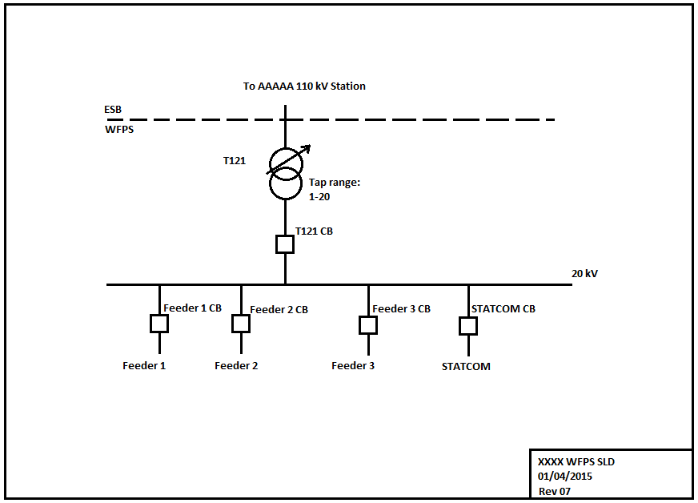Single Line Diagram

Testing was carried out by *[insert WFPS test coordinator]* and *[insert EirGrid testing coordinator]* on dd/mm/yyyy.

The following tests were carried out in accordance with the agreed test programme and are included in this report:

1. Active Power Control.
2. Frequency Response.
3. Reactive Power Capability.
4. Reactive Power Control.
5. Black Start Shutdown.

# Abbreviations

AAP Available Active Power

APC Active Power Control

AVR Automatic Voltage Regulation

DMOL Designed Minimum Operating Level

HV High Voltage

Leading Mvar Absorbing Mvar from System

Lagging Mvar Producing Mvar

MEC Maximum Export Capacity

Mvar Mega Volt Ampere – reactive

MW Mega Watt

NCC National Control Centre

PF Power Factor

TSO Transmission System Operator

WFCS Wind Farm Control System

WFPS Wind Farm Power Station

WTG Wind Turbine Generator

# Grid Code References

|  |  |
| --- | --- |
| Grid Code Version: | WFPS to specify |

|  |  |
| --- | --- |
| **Design Minimum Operating Level (DMOL):** | The minimum **Active Power** output of **Controllable WFPS** where all **WTGs** are generating electricity and capable of ramping upwards at any of the specified ramp rates (given available wind), and shall not be greater than 12% of **Registered Capacity**. |
| **Governor Droop** | The percentage drop in the **Frequency** that would cause the **Generation Unit** under free governor action to change its output from zero to its full **Capacity**. In the case of a **Controllable WFPS**, it is the percentage drop in the **Frequency** that would cause the **Controllable WFPS** to increase its output from zero to its full **Registered Capacity.** |
| **Voltage Regulation System Slope Setting** | The percentage change in **Transmission System** **Voltage** that would cause the **Reactive Power** output of the **Interconnector** or **Controllable WFPS** to vary from maximum **Mvar** production to maximum **Mvar** absorption or vice-versa. |

**SDC2.B.1** The **Mvar Output** of any **CDGU** in respect of which a **Dispatch Instruction** is given under SDC2.4.2.4(b) shall, in accordance with its declared **Technical Parameters**, be adjusted to the new target **Mvar** level so **Instructed**, within, a tolerance of +/- 2% of the target or +/- 2 **Mvar**, whichever is greater. The **Reactive Power** output of a **CDGU** shall not be adjusted (other than under **AVR** action) except in response to a **Dispatch Instruction** from the **TSO**.

**WFPS1.5.1** No additional **WTG** shall be started while the **Transmission System Frequency** is above 50.2 Hz.

**WFPS1.5.2 ACTIVE POWER MANAGEMENT**

A **Wind Farm Control System** shall be installed by the **Controllable WFPS** to allow for the provision of **Active Power Control** and **Frequency** **Response** from the **Controllable WFPS**. The **Wind Farm Control System** and **Frequency Response System** shall provide the functionality as specified in this section WFPS1.5.2.

**WFPS1.5.2.1 Active Power Control**

The **Wind Farm Control System** shall be capable of operating each **WTG** at a reduced level if the **Controllable WFPS’s Active Power** output has been restricted by the **TSO**. In this **Active Power Dispatch Mode**, the **Wind Farm Control System** shall be capable of receiving an on-line **Active Power Control Set-point** sent by the **TSO** and shall commence implementation of the set-point within 10 seconds of receipt of the signal from the **TSO**. The rate of change of output to achieve the **Active Power Control Set-point** should be the **Active** **Power Control Set-Point Ramp Rate** setting of the **Wind Farm Control System**, as advised by the TSO, as per WFPS1.5.4. The **TSO** acknowledges that if the **Active Power** output of the **Controllable WFPS** is initially less than the **Design Minimum Operating Level**, and if the **Controllable WFPS** is expected to increase its **Active Power** output, then it may not be able to achieve the specified ramp rate at first, due to **WTG**s going through a start-up sequence. In such a case, **WTGs** shall start up as quickly as the technology allows, and in any case, not longer than three minutes from the time the **Active Power Control Set-point** was received.

WFPS1.5.3.1 In **Wind Following Mode**, the **Frequency Response System** shall have the capabilities as displayed in the *Power-Frequency Response Curve* in *Figures WFPS1.2,* where the power and frequency ranges required for points A, B, C, D, E are defined below in *Table WFPS1.1 and Table WFPS1.2.* The **Frequency Response System** shall adjust the **Active Power** output of the **Controllable WFPS** according to a **Governor Droop**, settable by the **TSO** in a range from 2% to 10% and defaulting to 4%, when operating in the ranges outside the deadband range FB-FC in the Power-Frequency Response Curve. **Controllable WFPS****Frequency Response**and **Governor Droop** shall be calculated with respect to **Registered Capacity**.

WFPS1.5.3.2 When in **Active Power Control Mode,** the **Controllable WFPS** shall always operate in **Frequency Sensitive Mode** with a **Governor Droop** as set out in WFPS1.5.3.1 and with a deadband of +/-15mHz, or as otherwise agreed with the **TSO.**

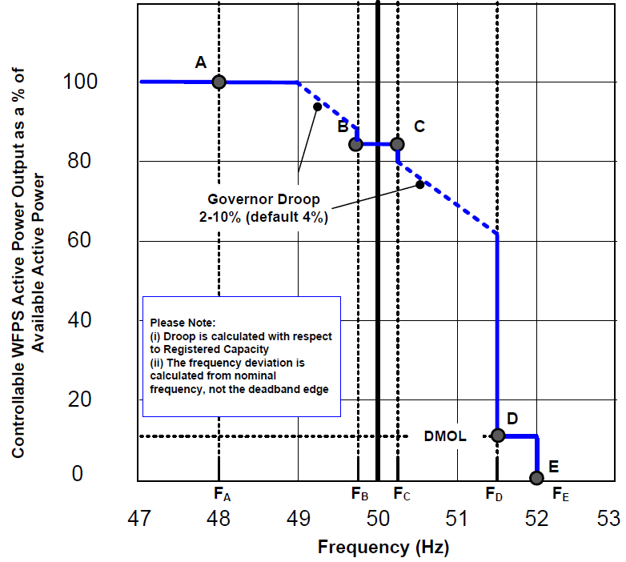

*Figure WFPS1.2 –Example of Power-Frequency Response Curve for Wind Following Mode*

WFPS1.5.3.3 When acting to control **Transmission System Frequency**, the **Controllable WFPS** shall provide at least 60% of its expected additional **Active Power** response within 5 seconds, and 100% of its expected additional **Active Power** response within 15 seconds of the start of the **Transmission System Frequency** excursion outside the range FB-FC, or in the case of a **Controllable WFPS** in **Active Power Dispatch Mode**, when the **Transmission System Frequency** goes outside the deadband set out in WFPS1.5.3.2.

WFPS1.5.3.4 When the **Transmission System Frequency** is in the range FC-FD, the **Controllable WFPS** shall ensure that its **Active Power Output** does not increase beyond the **Active Power** value of the **Controllable WFPS** when the **Transmission System Frequency** first exceeded FC, due to an increase in **Available Active Power** in that period.

WFPS1.5.3.5 If the **Frequency** drops below FA, then the **Frequency Response System** shall act to maximise the **Active Power** output of the **Controllable WFPS**, irrespective of the **Governor Droop Setting**. If the **Frequency** rises above FD, then the **Frequency Response System** shall act to reduce the **Active Power** output of the **Controllable WFPS** to its **DMOL** value. If the **Frequency** rises above FE, then the **Frequency Response System** shall act to reduce the **Active Power** output of the **Controllable WFPS** to zero. Any **WTG** which has disconnected shall be brought back on load as fast as technically feasible, provided the **Transmission System Frequency** has fallen below 50.2 Hz.

WFPS1.5.3.6 Points ‘A’, ‘B’, ‘C’, ‘D’ and ‘E’ shall depend on a combination of the **Transmission System Frequency**, **Active** **Power** and **Active Power Control Set-point** settings. These settings may be different for each **Controllable WFPS** depending on system conditions and **Controllable WFPS** location. These settings are defined in *Table WFPS1.1* below.

|  |  |  |
| --- | --- | --- |
| Point | ***Transmission System Frequency***  *(Hz)* | ***Controllable WFPS Active Power*** *Output*  *(****%*** *of* ***Available******Active Power****)* |
| A | ***FA*** | ***PA*** |
| B | ***FB*** | Minimum of : ***PB*** or  **Active Power Control Set-point** (converted to a % of **Available** **Active Power**) |
| C | ***FC*** | Minimum of: ***PC*** or  **Active Power Control Set-point** (converted to a % of **Available** **Active Power**) |
| D | ***FD*** | Minimum of: ***PD*or**  **Active Power Control Set-point** (converted to a % of **Available** **Active Power**) |
| E | ***FE*** | ***PE*** = 0 % |

*Table WFPS1.1:* ***Transmission System Frequency*** *and %* ***Available Active Power*** *Settings for the Points ‘A’, ‘B’, ‘C’, ‘D’ and ‘E’ illustrated in Figure WFPS1.2*

Two settings for each of ***FA, FB, FC, FD, FE, PA, PB, PC, PD*** and ***PE*** shall be specified by the **TSO** at least 120 **Business Days** prior to the **Controllable WFPS’s** scheduled **Operational Date** (refer to WFPS1.5.3.11 below).The **Controllable WFPS** shall be responsible for implementing the appropriate settings during **Commissioning**.

WFPS1.5.3.7 The table below, *Table WFPS1.2,* shows the **Transmission System Frequency** and **Active** **Power** ranges for ***FA, FB, FC, FD, FE, PA, PB, PC, PD*** and ***PE****.*

|  |  |  |  |
| --- | --- | --- | --- |
|  | ***Transmission System Frequency*** *(Hz)* |  | ***Available Active Power*** *(%)* |
|  |  |  | ***Registered Capacity ≥ 5 MW*** |
| ***FA*** | *47.0-49.5* | ***PA*** | *50-100* |
| ***FB*** | *49.5-50* | ***PB*** | *15-100* |
| ***FC*** | *50-50.5* | ***PC*** |
| ***FD*** | *50.5-52.0* | ***PD*** | *15-100 but not less than* ***DMOL*** |
| ***FE*** | ***PE*** | *0* |

*Table WFPS1.2:* ***Transmission System Frequency*** *&* ***Active******Power*** *ranges appropriate to Figure WFPS1.2.*

For the **Transmission System Frequency** values in *Table WFPS1.2* above, *FA* ≤ *FB* ≤ *FC* ≤ *FD* ≤ *FE*.

WFPS1.5.3.8 Alterations to the **Controllable WFPS’s Active Power** output, triggered by **Transmission System Frequency** changes, shall be achieved by proportionately altering the **Active Power** output of all available **WTG**s as opposed to switching individual **WTG**s on or off, insofar as possible.

WFPS1.5.3.9 No time delays, such as moving average frequency filters, other than those necessarily inherent in the design of the **Frequency Response System** shall be introduced. The **Frequency Response System** shall continuously monitor the **Transmission System Frequency** in order to continuously determine the **Controllable WFPS’s** appropriate **Active Power** output by taking account of the **Controllable WFPS’s** **Available** **Active Power** or **Controlled** **Active Power**.

WFPS1.5.3.10 If the **Transmission System Frequency** rises to a level above ‘D’-’E’, as defined by the *Power-Frequency Response Curve in Figure WFPS1.2*, the **TSO** accepts that **WTG**s may disconnect. Any **WTG** which has disconnected shall be brought back on load as fast as technically feasible (provided the **Transmission System Frequency** has fallen below 50.2 Hz).

**WFPS1.5.3.11 Procedure for Setting and Changing the *Power-Frequency Response Curves***

Two *Power-Frequency Response Curves* (Curve 1 and Curve 2) shall be specified by the **TSO** at least 120 **Business Days** prior to the **Controllable WFPS’s** scheduled **Operational Date.** The **Controllable WFPS** shall be responsible for implementing the appropriate settings during **Commissioning**. The **Frequency Response System** shall be required to change between the two curves within one minute from receipt of the appropriate signal from the **TSO**. The **TSO** shall give the **Controllable WFPS** a minimum of two weeks notice if changes to either of the curve’s parameters ***(i.e. FA, FB, FC, FD, FE, PA, PB, PC, PD*** or ***PE)***, are required. The **Controllable WFPS** shall formally confirm that any requested changes have been implemented within two weeks of receiving the **TSO’s** formal request.

**WFPS1.5.4 RAMP RATES**

**WFPS1.5.4.1** The **Wind Farm Control System** shall be capable of controlling the ramp rate of its **Active Power** output. There shall be three ramp rate capabilities, designated **Wind Following Ramp Rate**, **Active** **Power Control Set-Point Ramp Rate**, and **Frequency Response Ramp Rate**. The **Wind Farm Control System** shall operate the ramp rates with the following order of priority (high to low): **Frequency Response Ramp Rate**; **Active** **Power Control Set-Point Ramp Rate**; **Wind Following Ramp Rate**. The **Wind Following Ramp Rate** shall be used during **Start-Up**, normal operation, and **Shutdown**. The **TSO** shall specify the **Wind Following Ramp Rate** and the **Active** **Power Control Set-Point Ramp Rate** in percentage of **Registered Capacity** per minute. The **Frequency Response Ramp Rate** shall be the maximum possible ramp rate of the **Controllable WFPS** agreed with the **TSO** and with the characteristics as set out in WFPS1.5.2.2.2**.** The **TSO** acknowledges that rapidly changing wind speeds may cause temporary deviations from the ramp rate settings of the **Controllable WFPS**, but these deviations should not be allowed to exceed 3% of **Registered Capacity**.

**WFPS1.5.4.2** It shall be possible to vary the **Wind Following Ramp Rate** and the **Active** **Power Control Set-Point Ramp Rate** each independently over a range between 1% and 100% of **Registered Capacity** per minute.

**WFPS1.6.2 AUTOMATIC VOLTAGE REGULATION**

WFPS1.6.2.1 **Controllable WFPS’s** shall have a continuously-variable and continuously-acting **Voltage** **Regulation** **System** with similar response characteristics to a conventional **Automatic Voltage Regulator** and shall perform generally as described in BS4999 part 140, or equivalent European Standards.

WFPS1.6.2.2 Under steady state conditions, the **Voltage Regulation System** shall be capable of implementing the following **Reactive Power** control modes which shall be available to the **TSO:**

1. The **Controllable WFPS** shall be capable of receiving a **Power Factor** control (PF) set-point to maintain the **Power Factor** set-point at the **Connection Point;**
2. The **Controllable WFPS** shall be capable of receiving a **Reactive Power** control (Q) set-point to maintain the **Reactive Power** set-point at the **Connection Point**;
3. The **Controllable WFPS** shall be capable of receiving a **Voltage Regulation** (kV) **Set-point** for the **Voltage** at the **Connection Point.** The **Voltage Regulation System** shall act to regulate the **Voltage** at this point by continuous modulation of the **Controllable WFPS’s Reactive Power** output, without violating the **Voltage Step Emissions** limits as set out in the IEC standard 61000-3-7:1996 *Assessment of Emission limits for fluctuating loads in MV and HV power systems*.

A change to the **Power Factor** control (PF) set-point, **Reactive Power** control (Q) set-point or **Voltage Regulation** (kV) **Set-Point** shall be implemented by the **Controllable WFPS** within 20 seconds of receipt of the appropriate signal from the **TSO,** within its reactive power capability range as specified in WFPS1.6.3.

WFPS1.6.2.3 The **Voltage Regulation** **System** **Slope Setting** shall be capable of being set to any value between 1 % and 10 %. The setting shall be specified by the **TSO** at least 120 **Business Days** prior to the **Controllable WFPS’s** scheduled **Operational Date.** The **Controllable WFPS** shall be responsible for implementing the appropriate settings during **Commissioning**. The slope setting may be varied from time to time depending on **Transmission System** needs. The **TSO** shall give the **Controllable WFPS** a minimum of two weeks notice if a change is required. The **Controllable WFPS** shall formally confirm that any requested changes have been implemented within two weeks of receiving the **TSO’s** formal request.

WFPS1.6.2.4 The speed of response of the **Voltage** **Regulation System** shall be such that, following a step change in **Voltage** at the **Connection Point** the **Controllable WFPS** shall achieve 90 % of its steady-state **Reactive Power** response within 1 second. The response may require a transition from maximum **Mvar** production to maximum **Mvar** absorption or vice-versa.

WFPS1.6.2.5 *Figure WFPS1.3* shows the relevant points appropriate to the **Voltage Regulation** **System** for a **Controllable WFPS**. *X* is the HV side of the **WTG** transformer, *Y* is the lower voltageside of the **Grid Connected Transformer** and *Z* is the **Connection Point**.

**WTG WTG Grid connected**

**Transformer Transformer GRID**

**HV**

**busbar**

*X**Y**Z*

*Figure WFPS1.3 - Locations for* ***Voltage Regulation*** *set-point (Z) and the* ***Power Factor*** *range (Y). The HV side of the* ***WTG*** *transformer is (X).*

WFPS1.6.3.1 **Controllable WFPSs** operating in **Power Factor** control mode, **Voltage** **Control** mode or constant **Reactive Power** mode shall be at least capable of operating at any point within the P-Q capability ranges illustrated in *Figure WFPS1.4,* as measured at the **Connection Point** over the normal and disturbed **Transmission System Voltage** ranges specified in CC.8.3.2.

Referring to *Figure WFPS1.4:*

Point A represents the minimum Mvar absorption capability of the **Controllable WFPS** at 100% **Registered Capacity** and is equivalent to 0.95 power factor leading;

Point B represents the minimum Mvar production capability of the **Controllable WFPS** at 100% **Registered Capacity** and is equivalent to 0.95 power factor lagging;

Point C represents the minimum Mvar absorption capability of the **Controllable WFPS** at 12% **Registered Capacity** and is equivalent to the same **Mvar** as Point A;

Point D represents the minimum Mvar production capability of the **Controllable WFPS** at 12% **Registered Capacity** and is equivalent to the same **Mvar** as Point B;

Point E represents the minimum Mvar absorption capability of the **Controllable WFPS** at the cut-in speed of the individual **WTGs**;

Point F represents the minimum Mvar production capability of the **Controllable WFPS** at the cut-in speed of the individual **WTGs**;

The **TSO** accepts that the values of Points E and F may vary depending on the number of **WTGs** generating electricity in a low-wind scenario;

*Figure WFPS1.4* represents the minimum expected **Reactive Power** capabilities of the **Controllable WFPS**. The **Controllable WFPS** is obliged to tell the **TSO**/**DSO** if it can exceed these capabilities, and submit the actual P-Q capability diagram based upon the installed plant and **Collector Network** characteristics to the **TSO** during **Commissioning.**

The **Grid Connected Transformer** tap changing range must be capable of ensuring nominal voltage at point Y for any **Voltage** at the **Connection Point** (Point Z) within the ranges specified in WFPS1.6.1.



*Figure WFPS1.4 –* Minimum**Reactive Power** Capability of **Controllable WFPS**

*Figure WFPS1.4* represents the minimum expected **Reactive Power** capabilities of the **Controllable WFPS**. The **Controllable WFPS** is obliged to tell the **TSO**/**DSO** if it can exceed these capabilities, and submit the actual P-Q capability diagram based upon the installed plant and **Collector Network** characteristics to the **TSO** during **Commissioning.**

WFPS1.7.2.3 **Frequency Response**

This signal shall be sent by the **TSO** to the **Controllable WFPS** in the event that a change from *Power-Frequency Response Curve 1* to *Power Frequency Response Curve 2*, or vice versa, is required.

The **Controllable WFPS** is required to make it possible for the **TSO** to remotely enable/ disable the **Frequency Response System**. The associated status indication is described in WFPS1.7.1.5.

The **Controllable WFPS** shall make it possible for the **TSO** to set the **Governor Droop** value of the **Frequency Response System** in values from 2% to 10%.

WFPS1.7.2.5 **Black Start Shutdown**

Means shall be provided by the **Controllable WFPS** to facilitate the disconnection of the **Controllable WFPS** by the **TSO** and to also prevent re-connection in the event of **Black Start**. The **TSO** shall send a **Black Start Shutdown** signal and upon receipt, the **Controllable WFPS** shall be required to trip the circuit-breaker(s) at the **Controllable WFPS’s Connection Point** and shutdown the **Controllable WFPS** in a controlled manner. The precise circuit-breakers for which this facility shall be provided shall be specified by the **TSO** at least 120 **Business Days** prior to the **Controllable WFPS’s** scheduled **Operational Date.**  **Controllable WFPSs** may only be reconnected (i.e. made live) when the **Network** is fully restored following instruction from the **TSO[3]** and only earlier if the **TSO** deems it acceptable to do so.

# Active Power Control Test

## Purpose of the Test

The purpose of this test is to demonstrate the Active Power Control functions of the WFCS, including ramp rates applied during shutdown and start-up; and to demonstrate DMOL of the WFPS.

## Pass Criteria Summary

The following is the pass criteria for the test. Test data shall be assessed against each of these.

| **Criteria** | **Criteria Assessed** | **Criteria Passed** |
| --- | --- | --- |
| **Active Power Control** | | |
| Active Power Output is limited to the MEC of the WFPS | **Yes / No** | **Yes / No** |
| WFCS receives all online Active Power Control Set-points, commences implementation of all set-points within 10 seconds of receipt and provides the correct set-point feedback |  |  |
| When APC is ON, WFPS regulates its active power output to within the greater of ±0.5 MW or ±3% of Registered Capacity of the Active Power Control Set-point |  |  |
| WFCS operates each WTG at a reduced level while operating at a reduced output, greater than DMOL |  |  |
| All WTGs start-up in less than 3 minutes of receipt of set-point, when dispatched up from 0 MW |  |  |
| WFCS does not respond to any set-points sent while Active Power Control is OFF |  |  |
| **Ramp Rates** | | |
| Rate of change of output is equal to the Active Power Control Set-point Ramp Rate when ramping to Active Power Control Set-points greater than or equal to DMOL, with temporary deviations not exceeding ±3% of Registered Capacity |  |  |
| WFPS output ramps to AAP at the Wind Following Ramp Rate when Active Power Control is turned OFF (unless acting under Frequency Response Ramp Rate) |  |  |
| Rate of change of output when ramping up due to increase in wind speed is no greater than Wind Following Ramp Rate |  |  |
| Rate of change of output is equal to Wind Following Ramp Rate on shutdown and on start-up |  |  |
| Demonstration that the Wind Following Ramp Rate and Active Power Control Set-point Ramp Rate can each be set independently over a range between 1% and 100% of Registered Capacity per minute |  |  |
| **DMOL** | | |
| DMOL is in line with declared value and no greater than 12% of Registered Capacity |  |  |
| **Available Active Power** | | |
| AAP is limited to the MEC of the WFPS |  |  |
| AAP signal is a measure of the active power the WFPS is capable of delivering |  |  |
| AAP signal is independent of the active power output when under curtailment or dispatch |  |  |
| % Mechanical availability signals are correct under dispatch |  |  |

## Instrumentation and Onsite Data Trending

|  |  |  |  |
| --- | --- | --- | --- |
| **No.** | **Data Trending and Recording** | **Resolution** | **Recorded** |
| 1 | Available active power from the prevailing wind in MW, derived by algorithm in the WFCS (*Figure WFPS1.3, Point Y*) | WFPS to Specify (≥10 Hz) | Yes / No |
| 2 | Actual active power from the wind farm in MW (*Figure WFPS1.3, Point Y*) | WFPS to Specify (≥10 Hz) | Yes / No |
| 3 | APC ON/OFF | WFPS to Specify (≥ 10 Hz) | Yes / No |
| 4 | APC set-point from NCC | WFPS to Specify (≥10 Hz) | Yes / No |
| 5 | Grid Frequency | WFPS to Specify (≥10 Hz) | Yes / No |
| 6 | Number of turbines online | WFPS to Specify (≥10 Hz) | Yes / No |
| 7 | % Mechanical Availability | WFPS to Specify (≥10 Hz) | Yes / No |

## Ramp Rate Settings

|  |  |
| --- | --- |
| **Calculation** | **Value** |
| Active Power Control Set-point Ramp Rate of 20% of Registered Capacity per minute | ____ MW/min  (WFPS to specify calculation and formula used) |
| Wind Following Ramp Rate of 20% of Registered Capacity per minute | ____ MW/min  (WFPS to specify calculation and formula used) |
| If WTGs are out of service, will the WFPS ramp at a reduced ramp rate? | ____ MW/min  (WFPS to specify calculation and formula used) |

## AAP & MW Limiter Test

*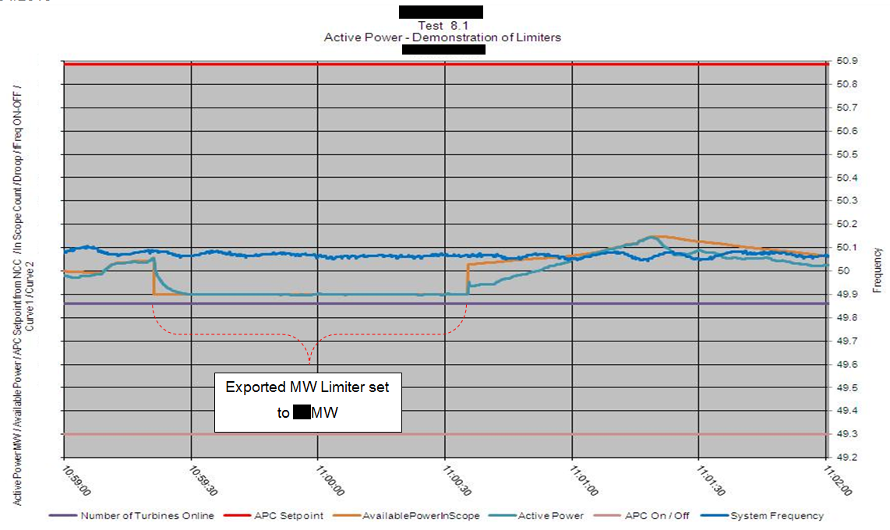Graph X – Demonstration of Limiters*

Demonstration of limiters was carried out on dd/mm/yyyy. The Export Limiter test is included in Graph X.

*[Include any relevant test notes here, relating to how the test was carried out or any specific conditions encountered during this test].*

Following completion of this test, the AAP limiter has been set to __ MW and the Export limiter has been set to __ MW.

| **Criteria** | **Criteria Assessed** | **Criteria Passed** |
| --- | --- | --- |
| **Active Power Control** | | |
| Active Power Output is limited to the MEC of the WFPS |  |  |
| **Available Active Power** | | |
| AAP is limited to the MEC of the WFPS |  |  |

**Criteria – Active Power Output is limited to the MEC of the WFPS**

As illustrated in Graph X, the Export limiter was set to __ MW from hh:mm to hh:mm. While the limit was set to __ MW, the average Active Power output was __ MW. The maximum Active Power output during this period was __ MW.

**Criteria – AAP is limited to the MEC of the WFPS**

As illustrated in Graph X, the AAP limiter was set to __ MW from hh:mm to hh:mm. While the limit was set to __ MW, the average Active AAP was __ MW. The maximum AAP during this period was __ MW.

## Ramp Rate Adjustment Test

*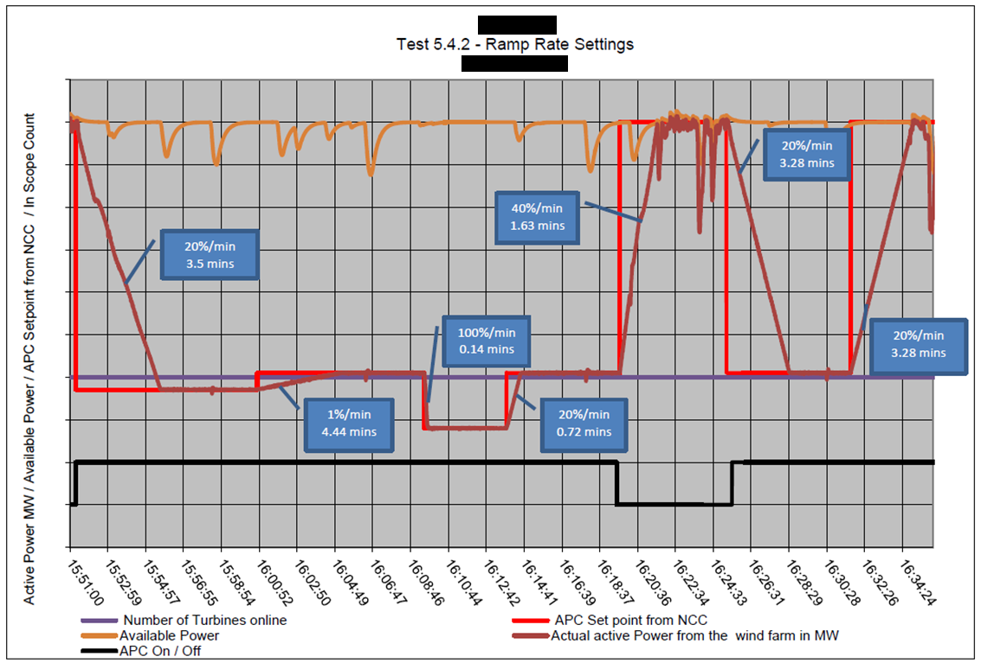Graph X – Ramp Rate Settings*

Ramp Rate Adjustment test was carried out on dd/mm/yyyy as shown in Graph X.

*[Include any relevant test notes here, relating to how the test was carried out or any specific conditions encountered during this test].*

| **Criteria** | **Criteria Assessed** | **Criteria Passed** |
| --- | --- | --- |
| **Ramp Rates** | | |
| Rate of change of output is equal to the Active Power Control Set-point Ramp Rate when ramping to Active Power Control Set-points greater than or equal to DMOL, with temporary deviations not exceeding ±3% of Registered Capacity |  |  |
| Demonstration that the Wind Following Ramp Rate and Active Power Control Set-point Ramp Rate can each be set independently over a range between 1% and 100% of Registered Capacity per minute |  |  |

**Criteria – Rate of change of output is equal to the Active Power Control Set-point Ramp Rate when ramping to Active Power Control Set-points greater than or equal to DMOL, with temporary deviations not exceeding ±3% of Registered Capacity**

*[Include a graph of any anomalous ramps, such as ramps that are outside of the Grid Code requirements].*

*Graphs shall be overlaid with the correct ramp rate. Where appropriate (e.g. for faster ramps) additional graphs shall be provided, zooming in on the relevant data.*

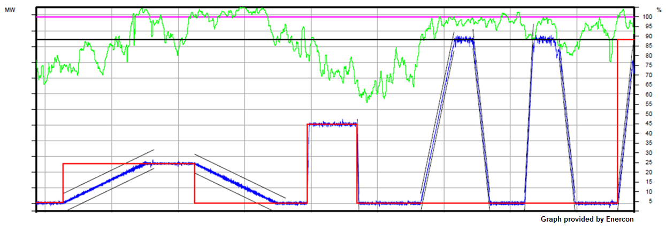

*Graph X – Ramp Rate Settings*

*Include analysis of any deviations from the specified ramp rate, noting the Grid Code requirement is for temporary deviations of no more than 3% of Registered Capacity.*

*Explain how ramps were measured i.e. ramping began 6 seconds after the set-point was received. Ramp rate was measured from the point where the active power began ramping to the time when it reached the set-point, or for the ramp from 3 MW to 7 MW the ramp rate was measured from when the active power first exceeded 3.5 MW to when it first exceeded 6.5 MW, in order to minimise measurement errors.*

| Step | Set-point | Initial Time | Final Time | Initial Power | Final Power | ΔP/Δt | Set-point Ramp Rate Setting | Wind Following Ramp Rate Setting | Maximum Deviation (% of Reg. Cap.) |
| --- | --- | --- | --- | --- | --- | --- | --- | --- | --- |
| 3 - 5 | a MW – b MW | 13:52:40 | 14:04:40 | a MW | b MW | h MW/min | h MW/min | - | +2%  -1.5% |
| 5 -6 | b MW – c MW | 14:12:27 | 14:24:40 | b MW | c MW | i MW/min | i MW/min | - | +1.7%  -2.3% |
| 7 -8 | c MW – d MW | 14:29:24 | 14:29:42 | c MW | d MW | j MW/min | j MW/min | - | … |
| 8 – 9 | d MW – e MW | 14:36:57 | 14:37:14 | d MW | e MW | k MW/min | k MW/min | - | … |
| 9 - 11 | e MW – APC off | 14:46:30 | 14:51:33 | e MW | f MW | l MW/min | - | l MW/min | … |
| 11 - 12 | APC off – APC on | 14:54:22 | 14:56:56 | f MW | e MW | m MW/min | m MW/min | - | … |
| 12 - 14 | e MW - APC off | 15:02:09 | 15:03:24 | e MW | f MW | n MW/min | - | n MW/min | … |
| 14 - 15 | APC off – APC on – | 15:07:20 | 15:09:45 | f MW | e MW | o MW/min | o MW/min | - | … |
| 15 - 16 | e MW – g MW | 15:16:08 | 15:18:20 | e MW | g MW | p MW/min | p MW/min | - | … |

Table X

**Criteria – Demonstration that the Wind Following Ramp Rate and Active Power Control Set-point Ramp Rate can each be set independently over a range between 1% and 100% of Registered Capacity per minute**

During this test, the Active Power Control Set-point Ramp Rate was set to the following values, demonstrating that each ramp rate can be set independently, and over a range of values between 1% and 100% of Registered Capacity per minute*.*

*[Include a table of all ramp rate settings that were implemented during this test].*

|  |  |  |
| --- | --- | --- |
| **% of Registered Capacity/min** | **MW/min** | **Ramp Rate** |
| 1%/min | a MW/min | Active Power Control |
| 20%/min | b MW/min | Wind Following |
| 100%/min | c MW/min | Active Power Control |

Table X

## Active Power Control Test

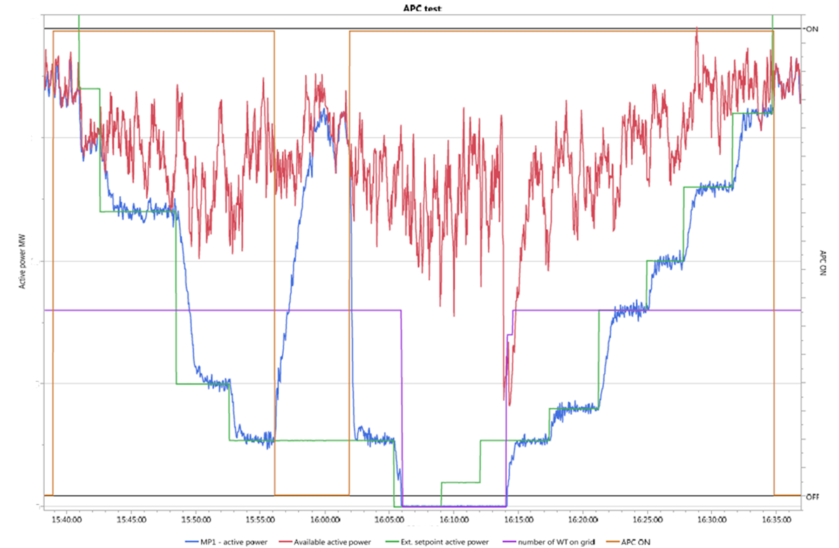*Graph X – Active Power Control Test*

Active Power Control test was carried out on dd/mm/yyyy as shown in Graph X.

*[Include any relevant test notes here, relating to how the test was carried out or any specific conditions encountered during this test].*

| **Criteria** | **Criteria Assessed** | **Criteria Passed** |
| --- | --- | --- |
| **Active Power Control** | | |
| WFCS receives all online Active Power Control Set-points, commences implementation of all set-points within 10 seconds of receipt and provides the correct set-point feedback. |  |  |
| When APC is ON, WFPS regulates its active power output to within the greater of ±0.5 MW or ±3% of Registered Capacity of the Active Power Control Set-point |  |  |
| WFCS operates each WTG at a reduced level while operating at a reduced output, greater than DMOL |  |  |
| All WTGs start-up in less than 3 minutes of receipt of set-point, when dispatched up from 0 MW |  |  |
| WFCS does not respond to any set-points sent while Active Power Control is OFF |  |  |
| **Ramp Rates** | | |
| Rate of change of output is equal to the Active Power Control Set-point Ramp Rate when ramping to Active Power Control Set-points greater than or equal to DMOL, with temporary deviations not exceeding ±3% of Registered Capacity |  |  |
| WFPS output ramps to AAP at the Wind Following Ramp Rate when Active Power Control is turned OFF (unless acting under Frequency Response Ramp Rate) |  |  |
| Rate of change of output when ramping up due to increase in wind speed is no greater than Wind Following Ramp Rate |  |  |
| **DMOL** | | |
| DMOL is in line with declared value and no greater than 12% of Registered Capacity |  |  |
| **Available Active Power** | | |
| AAP signal is a measure of the active power the WFPS is capable of delivering. |  |  |
| AAP signal is independent of the active power output when under curtailment or dispatch. |  |  |
| % Mechanical availability signals are correct under dispatch |  |  |

**Criteria – WFCS receives all online Active Power Control Set-points**

As per the signed test procedure that was scanned and submitted to [generator_testing@eirgrid.com](mailto:generator_testing@eirgrid.com), All Active Power Control set-points were received on the day of testing, with the exception of a XX MW set-point which was issued while Active Power Control was OFF. No set-points required to be resent.

**Criteria – WFPS regulates its active power output to within the greater of ±0.5 MW or ±3% of Registered Capacity of the Active Power Control Set-point**

*[Include a graph of any anomalies such as over-shoots or fluctuations].*

*Identify and analyse any overshoots or fluctuations in active power. Provide an explanation for any deviations from the standard set out in the pass criteria.*

| **Step** | **Set-point** | **APC Status** | **Time** | **Minimum MW** | **Average MW** | **Maximum MW** | **Average AAP** |
| --- | --- | --- | --- | --- | --- | --- | --- |
| 3 | a MW | ON | 13:52:40 | b MW | c MW | d MW | e MW |
| 4 | f MW | ON | 14:12:27 | g MW | h MW | i MW | j MW |
| 5 | k MW | ON | 14:29:24 | l MW | m MW | n MW | o MW |
| 6 | p MW | OFF | 14:36:57 | q MW | r MW | s MW | t MW |
| … |  |  |  |  |  |  |  |
|  |  |  |  |  |  |  |  |
|  |  |  |  |  |  |  |  |
| 11 | v MW | ON | 15:16:08 | w MW | x MW | y MW | z MW |

Table X

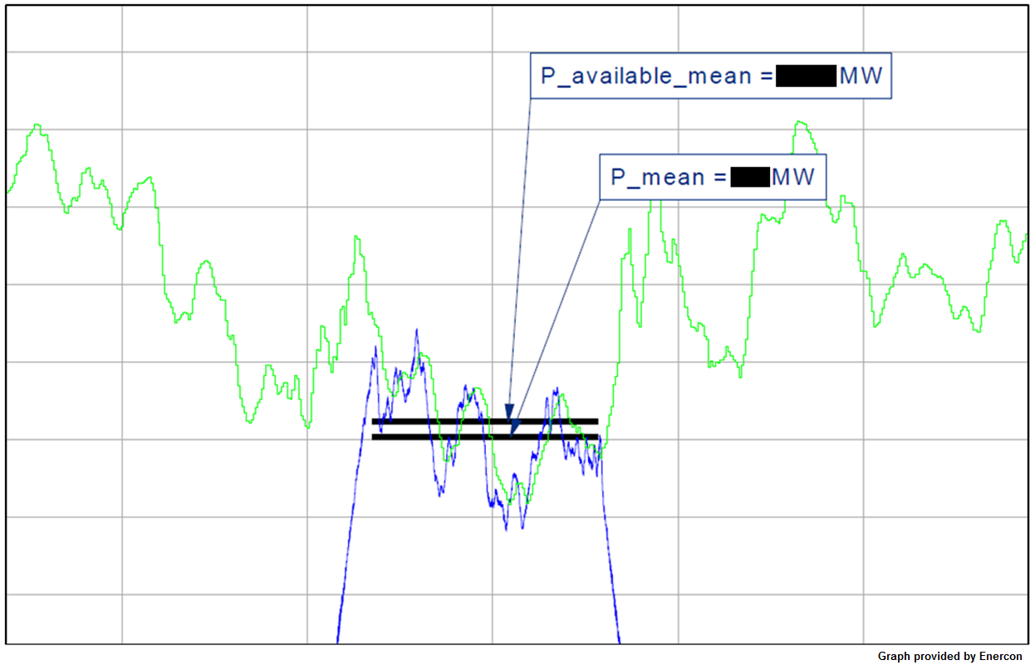

**Criteria – Rate of change of output is equal to the Active Power Control Set-point Ramp Rate when ramping to Active Power Control Set-points greater than or equal to DMOL, with temporary deviations not exceeding ±3% of Registered Capacity.**

*[Include a graph of any anomalous ramps, such as ramps that are outside of the Grid Code requirements].*

*Graphs shall be overlaid with the correct ramp rate.*

*[Identify and analyse all ramps which used the Active Power Control Set-point Ramp Rate].*

*[Include a table for ramp rate measured and expected as well as max deviation as % of Registered Capacity].*

*[Explain where ramps were measured from and to i.e. ramping began 6 seconds after the set-point was received. Ramp rate was measured from the point where the active power began ramping to the time when it reached the set-point or AAP (whichever is lower), or for the ramp from 3 MW to 7 MW the ramp rate was measured from when the active power first exceeded 3.5 MW to when it first exceeded 6.5 MW, in order to minimise measurement errors].*

Note. During the ramp from A MW to B MW, the Active Power Control Set-point ramp rate was exceeded as the AAP at a rate greater than the Active Power Control Set-point ramp rate.

Note. During the ramp from C MW to D MW, the AAP dropped below the set-point so the Active Power Control Set-point ramp rate could not be maintained due to lack of energy available.

| **Step** | **Set-point** | **Initial Time** | **Final Time** | **Initial Power** | **Final Power** | **ΔP/Δt** | **Delay Time** |
| --- | --- | --- | --- | --- | --- | --- | --- |
| 2 - 3 | a MW – b MW | 15:44:04 | 15:45:18 | a MW | b MW | X MW/min | 0.6 s |
| 3 -4 | b MW – c MW | 15:49:20 | 15:50:33 | b MW | c MW | X MW/min | 0.5 s |
| 4 - 5 | c MW -DMOL | 15:54:44 | 15:55:28 | c MW | d MW | X MW/min | 0.7 s |
| 5 - 6 | DMOL – e MW | 16:00:44 | 16:00:52 | d MW | e MW | X MW/min | 0.4 s |
| 6 - 7 | e MW – APC off | 16:04:06 | 16:06:45 | e MW | f MW | X MW/min | 0.8 s |
| 7 - 9 | APC off – APC on | 16:12:51 | 16:15:05 | f MW | e MW | X MW/min | 4.4 s |
| 9 - 10 | e MW – 0 MW | 16:20:09 | 16:20:32 | e MW | 0 MW | X MW/min | 0.9 s |
| 10 - 11 | 0 MW – g MW | 16:24:31 | 16:24:45 | 0 MW | g MW | X MW/min | 3.4 s |
| 11 - 12 | g MW – h MW | 16:28:01 | 16:28:45 | g MW | h MW | X MW/min | 0.9 s |
| 12 - 13 | h MW – i MW | 16:33:21 | 16:33:50 | h MW | i MW | X MW/min | 1.1 s |
| 13 - 14 | i MW – j MW | 16:37:50 | 16:39:20 | i MW | j MW | X MW/min | 1.4 s |
| 14 - 15 | j MW – k MW | 16:44:25 | 16:45:15 | j MW | k MW | X MW/min | 1 s |

Table X

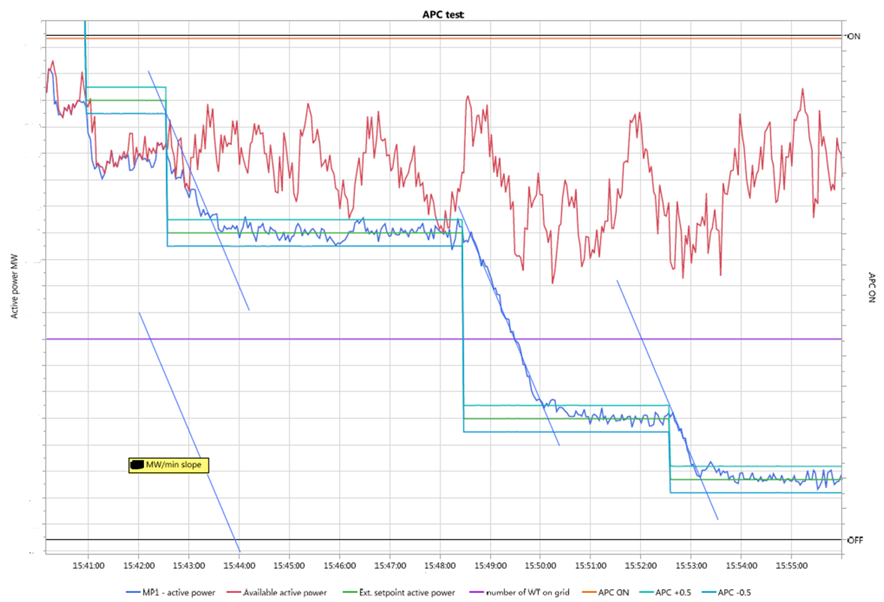

Graph X

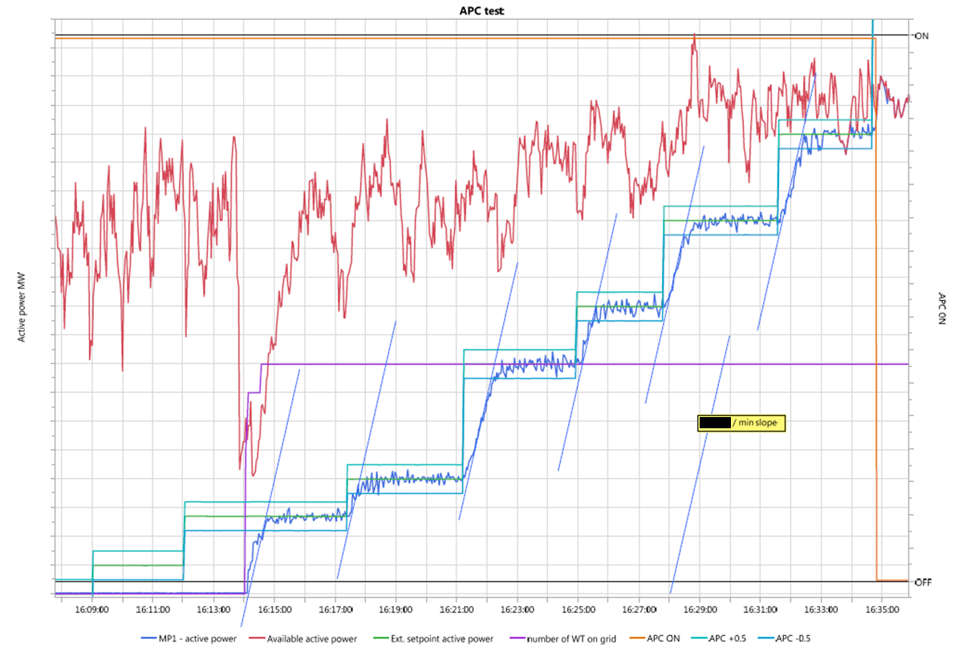

Graph X

**Criteria – WFCS does not respond to any set-points sent while Active Power Control is OFF**

At hh:mm, Active Power Control was turned off and the WFPS ramped from X MW to Y MW (AAP). At hh:mm, while Active Power Control was turned off, NCC issued a Z MW set-point per agreed test procedure. When Active Power Control was turned back on at hh:mm, the WFPS ramped back to the previous set-point of X MW.

**Criteria – WFCS commences implementation of all set-points within 10 seconds of receipt and provides the correct set-point feedback**

**Criteria – All WTGs start-up in less than 3 minutes of receipt of set-point, when dispatched up from 0 MW**

As per Table A and Table B, the WFPS responded to all set-points within 10 seconds of receipt, with the exception of the set-point from 0 MW to X MW.

Measured Response Time is calculated as the time between change in set-point (per recorded data) and corresponding change in MW (per recorded data).

All turbines started within 3 minutes each time that the WFPS ramped up from 0 MW, with the exception of the last ramp up from 0 MW.

*[Insert graph of the relevant test data, showing that all WTGs started within 3 minutes].*

*Graph X – WFPS Ramping Up from 0 MW*

At hh:mm:ss the WFPS was dispatched from 0 MW to X MW. Turbine X did not start up due to a _________. The fault was cleared at hh:mm and the turbine started manually. All other WTGs started up within the 3 minute requirement.

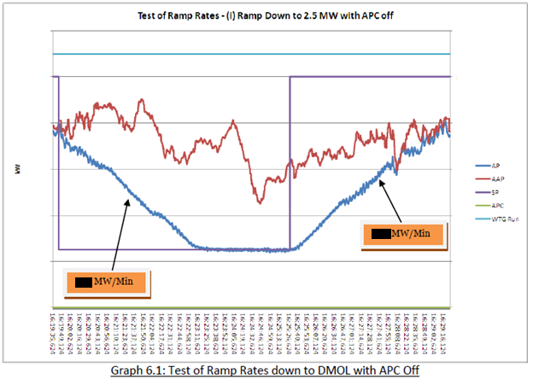

**Criteria – DMOL is in line with declared value and no greater than 12% of Registered Capacity**

**Criteria – WFCS operates each WTG at a reduced level while operating at a reduced output, greater than DMOL**

At DMOL (X MW), each turbine is online, operating at its minimum set-point of Y MW. Hence, all WTGs are operating at a reduced level. Less than X MW, turbines are shut down to meet set-points. The WFPS can ramp from X MW to 100% of Registered Capacity in line with Frequency Response requirements (per Grid Code definition of DMOL). This is demonstrated further during Frequency Response testing.

| **Step** | **Initial Time** | **Final Time** | **Initial Power**  **(MW)** | **Final Power**  **(MW)** | **ΔP/ΔT**  **(MW/Min)** | **ΔP/ΔT**  **(%MEC)** |
| --- | --- | --- | --- | --- | --- | --- |
| Ramp Down 1 | 15:19:44 | 15:23:22 | a | b | c | d |
| Ramp Up 1 | 15:25:28 | 15:29:02 | e | f | g | h |

Table X

At hh:mm, all WTGs were brought online when the WFPS output ramped from 0 MW to DMOL (X MW). *[Insert a graph demonstrating that all WTGs were brought online to meet the set-point of DMOL].*

|  |  |  |
| --- | --- | --- |
| **Demonstrated DMOL (MW)** | **Demonstrated DMOL (% of Registered Capacity)** | **Grid Code Requirement (% of Registered Capacity)** |
| X MW | Y% | 12% |

Table X

**Criteria – WFPS output ramps to AAP at the Wind Following Ramp Rate when Active Power Control is turned OFF (unless acting under Frequency Response Ramp Rate)**

As illustrated in Graph X, when APC is turned off at hh:mm and hh:mm, active power ramps up to AAP at the Wind Following Ramp Rate.

*Include explanation of deviation from the ramp rates identified.*

*Graph X – AAP While Active Power is Ramping Up and Down*

**Criteria – AAP signal is a measure of the active power the WFPS is capable of delivering**

**Criteria – AAP signal is independent of the active power output when under curtailment or dispatch**

*Include analysis of AAP while under dispatch when compared to AAP when APC is off or APC set-point is > AAP. If the AAP increases as active power ramps up, this would indicate that the AAP is not independent of the active power output when under dispatch and is not accurate while APC set-point is low.*

Note. At hh:mm the AAP dropped as 4 of the WTGs carried out safety checks during the start-up sequence.

*Graph X – % Mechanical Availability vs. Active Power, AAP and APC Set-Point*

**Criteria – % Mechanical availability signals are correct under dispatch**

% Mechanical Availability drops from 100% to 90% during the Active Power Control test at hh:mm. This is due to Turbine X becoming unavailable due to a fault. When the fault was manually cleared at hh:mm, the Mechanical Availability returned to 100%.

*[Insert graph showing % Mechanical Availability signal throughout the Active Power Control test (along with Active Power, Available Active Power, APC set-point signals].*

## Local Shutdown & Start-up Test

*Graph X – Shutdown and Start-Up*

Local Shutdown and Start-up test was carried out on dd/mm/yyyy. A graph of the Local Shutdown and Start-up test is included in Graph X.

*[Include any relevant test notes here, relating to how the test was carried out or any specific conditions encountered during this test].*

| **Criteria** | **Criteria Assessed** | **Criteria Passed** |
| --- | --- | --- |
| **Ramp Rates** | | |
| Rate of change of output is equal to Wind Following Ramp Rate on shutdown and on start-up |  |  |

**Criteria – Rate of change of output is equal to Wind Following Ramp Rate on shutdown and on start-up**

The WFPS was shut down and started up locally at hh:mm on dd/mm/yyyy as part of the Active Power Control test. During shutdown and start-up, the WFPS followed the Wind Following Ramp Rate, as demonstrated in the following analysis.

*[Identify and analyse ramp rates during shutdown and start-up. Is Active Power Control Set-point or Wind Following Ramp Rate used?].*

Table X for ramp rate measured and expected as well as max deviation in %.

*[Explain how the ramp rates were measured. i.e. the ramp rate was measured from when the active power first exceeded 0.5 MW to when it reached 6.5 MW, in order to minimise measurement errors].*

| **Step No.** | **Action** | **Time** | **Measured MW/min** | **Measured %/min** | **Required MW/min** | **Required %/min** | **Comments** |
| --- | --- | --- | --- | --- | --- | --- | --- |
| 1 | Local Shut-down | hh:mm:ss | x MW/min | x%/min | x MW/min | 20%/min | WFPS ramped at Wind Following Ramp |
| 2 | Local Start-Up | hh:mm:ss | y MW/min | y%/min | y MW/min | 20%/min | WFPS ramped at Wind Following Ramp |

Table X

# Frequency Response

## Purpose of the Test

The purpose of this test is to confirm the ability of the WFPS to respond to changes in system frequency. The WFPS shall be capable of operating with a “Governor Droop” – e.g. able to continuously adjust its active power output in response to changes in frequency. As the grid frequency cannot be changed at will, the test will require frequency to be simulated by means of injection of a frequency signal into the WFCS.

## Pass Criteria Summary

The following is the pass criteria for the test. Test data shall be assessed against each of these.

| **Criteria** | **Criteria Assessed** | **Criteria Passed** |
| --- | --- | --- |
| **Governor Droop** | | |
| Governor droop is calculated with respect to Registered Capacity. |  |  |
| Governor droop is calculated with respect to 50 Hz. |  |  |
| Governor droop is settable in a range from 2% to 10%, online, from NCC. |  |  |
| When Frequency Response is OFF, no response shall be provided. |  |  |
| The WFCS continuously recalculates its expected response during the frequency excursion. |  |  |
| **Rate of Response** | | |
| WFPS provides ≥60% of its expected response within 5 seconds and 100% of its expected response within 15 seconds. |  |  |
| Ramp Rates shall be prioritised with Frequency Response Ramp Rate given the highest priority. |  |  |
| **Frequency Response Curve** | | |
| For frequency < FA, MW output ramps directly to 100% of AAP. |  |  |
| For frequency between FA and FB, MW output is based on frequency droop setting |  |  |
| For frequency ≥ FB and ≤ FC, no response shall be provided |  |  |
| For frequency between FC and FD, MW output is based on frequency droop setting. |  |  |
| For frequency > FD, MW output ramps directly to DMOL |  |  |
| For frequency > FE, MW output ramps directly to 0 MW |  |  |
| Deadband of +/-15 mHz is applied in Active Power Control Mode and in Curve 2 |  |  |
| **Latching etc.** | | |
| For frequency > FC, MW output does not increase above its value at the time frequency exceeded FC, due to AAP increasing. |  |  |
| Any WTG which has disconnected due to frequency ≥ 50.8 Hz, shall be brought back on load when frequency falls less than 50.2 Hz. |  |  |
| No additional WTG can be started while frequency is above 50.2 Hz. |  |  |
| Frequency response is achieved by altering the output of all WTGs as opposed to switching WTGs on or off, insofar as possible. |  |  |
| For active power output levels ≥ DMOL, all WTGs shall be generating electricity. |  |  |
| WFPS regulates its active power output to within the greater of ±0.5 MW or ±3% of Registered Capacity of the Active Power Control Set-point adjusted for frequency response. |  |  |

## Instrumentation and Onsite Data Trending

|  |  |  |  |
| --- | --- | --- | --- |
| **No.** | **Data Trending and Recording** | **Resolution** | **Recorded** |
| 1 | Available active power from the prevailing wind in MW, derived by algorithm in the WFCS (*Figure WFPS1.3, Point Y*) | WFPS to Specify (≥ 10 Hz) | Yes / No |
| 2 | Actual active power from the WFPS in MW (*Figure WFPS1.3, Point Y*) | WFPS to Specify (≥ 10 Hz) | Yes / No |
| 3 | APC ON/OFF | WFPS to Specify (≥ 10 Hz) | Yes / No |
| 4 | APC set-point from NCC | WFPS to Specify (≥10 Hz) | Yes / No |
| 5 | Frequency Response ON/OFF | WFPS to Specify (≥10 Hz) | Yes / No |
| 6 | Frequency Response Curve1/Curve2 | WFPS to Specify (≥10 Hz) | Yes / No |
| 7 | Frequency Droop Setting | WFPS to Specify (≥10 Hz) | Yes/No |
| 8 | Simulated Test Frequency | WFPS to Specify (≥10 Hz) | Yes / No |
| 9 | Grid Frequency | WFPS to Specify (≥10 Hz) | Yes / No |
| 10 | Number of turbines online | WFPS to Specify (≥10 Hz) | Yes / No |
| 11 | % Mechanical Availability | WFPS to Specify (≥10 Hz) | Yes / No |

## Frequency Response Settings

|  |  |
| --- | --- |
| **Calculation** | **Value** |
| Theoretical change in MW for frequency increase of 0.25 Hz with Frequency Droop of 4% | ____ MW  (WFPS to specify calculation and formula used) |
| Theoretical change in MW for frequency increase of 0.25 Hz with Frequency Droop of 2% | ____ MW  (WFPS to specify calculation and formula used) |
| Theoretical change in MW for frequency decrease of 0.5 Hz with Frequency Droop of 10% | ____ MW  (WFPS to specify calculation and formula used) |

## Frequency Droop Setting

*Graph X – WFPS Frequency Droop Setting*

Frequency Droop Setting test was carried out on dd/mm/yyyy. A graph of the Frequency Droop Setting test is included, above.

*[Include any relevant test notes here, relating to how the test was carried out or any specific conditions encountered during this test].*

| **Criteria** | **Criteria Assessed** | **Criteria Passed** |  |
| --- | --- | --- | --- |
| **Governor Droop** | | | |
| Governor droop is calculated with respect to Registered Capacity and 50 Hz |  |  |  |
| Governor droop is settable in a range from 2% to 10%, online, from NCC. |  |  |  |
| **Rate of Response** | | | |
| WFPS provides ≥60% of its expected response within 5 seconds and 100% of its expected response within 15 seconds. |  |  |  |
| Ramp Rates shall be prioritised with Frequency Response Ramp Rate given the highest priority. |  |  |  |
| WFPS regulates its active power output to within the greater of ±0.5 MW or ±3% of Registered Capacity of the Active Power Control Set-point adjusted for frequency response. |  |  |  |

**Criteria – Governor Droop is calculated with respect to Registered Capacity and 50 Hz.**

**Criteria – WFPS regulates its active power output to within the greater of ±0.5 MW or ±3% of Registered Capacity of the Active Power Control Set-point adjusted for frequency response.**

*[Include a graph of any anomalies and any supporting plots/diagrams].*

*Analyse the performance of the WFPS in relation to the criteria.*

| **Step** | **Time** | **Simulated Frequency** | **Set-point** | **Droop** | **Required MW** | **Actual MW** |
| --- | --- | --- | --- | --- | --- | --- |
|  |  |  |  |  |  |  |
|  |  |  |  |  |  |  |
|  |  |  |  |  |  |  |
|  |  |  |  |  |  |  |

Table X

Expected response is calculated using the following equation:

$$ΔMW = \frac{Δf*Registered Capacity}{f_{nominal}*Droop}$$

**Criteria – Governor Droop is settable in a range from 2% to 10%, online from NCC**

As shown in table *X*, the droop was set to 2%, 4% and 10% during the Frequency Droop Setting test, demonstrating that it is settable in the range 2% to 10%.

**Criteria – WFPS provides ≥60% of its expected response within 5 seconds and 100% of its expected response within 15 seconds**

*[Include a graph of any anomalies and any supporting plots/diagrams].*

*Analyse the performance of the WFPS in relation to the criteria.*

| **Step** | **Time** | **Initial MW** | **Required MW** | **MW required after 5 seconds** | **MW achieved after 5 seconds** | **MW required after 15 seconds** | **MW achieved after 15 seconds** |
| --- | --- | --- | --- | --- | --- | --- | --- |
|  |  |  |  |  |  |  |  |
|  |  |  |  |  |  |  |  |
|  |  |  |  |  |  |  |  |
|  |  |  |  |  |  |  |  |

Table X

**Criteria – Ramp Rates shall be prioritised with Frequency Response Ramp Rate given the highest priority**

As shown in Table *X*, during the simulated frequency deviations, the rate of response of the WFPS was not limited by the Active Power Control Set-point or Wind Following Ramp Rates.

## Frequency Response On, Curve 1, APC On

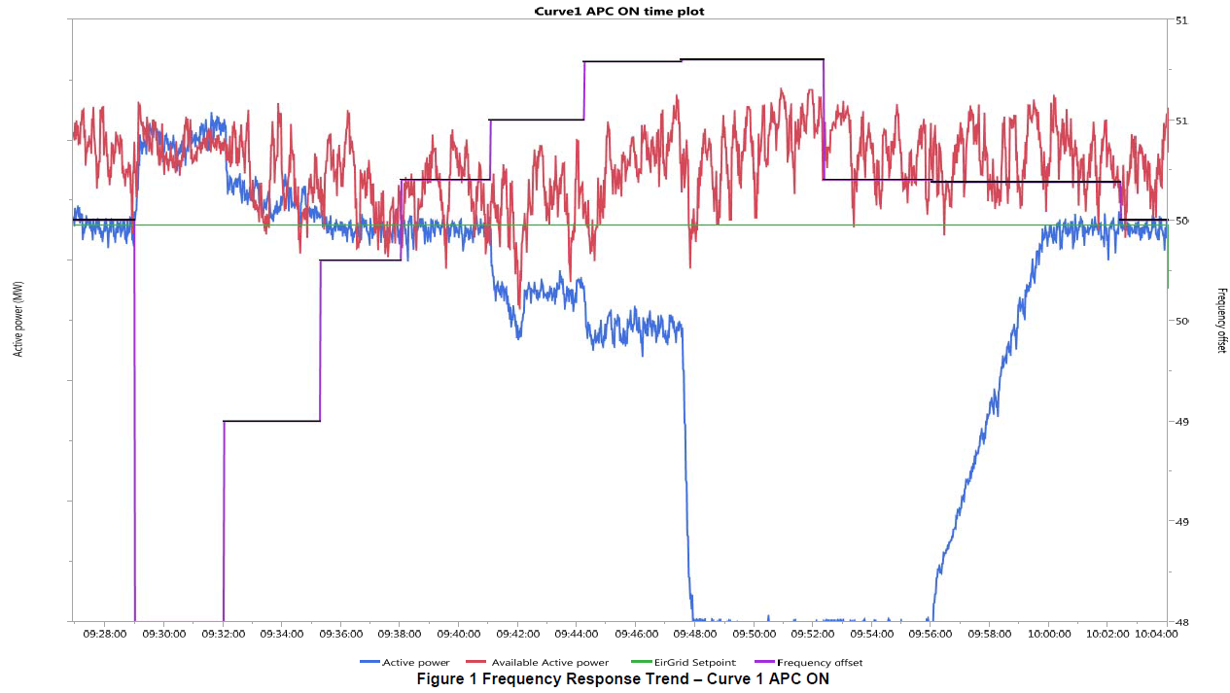

Graph X

Frequency Response On, Curve 1, APC On test is included within graph X.

*[Include any relevant test notes here, relating to how the test was carried out or any specific conditions encountered during this test].*

| **Criteria** | **Criteria Assessed** | **Criteria Passed** |
| --- | --- | --- |
| **Rate of Response** | | |
| WFPS provides ≥60% of its expected response within 5 seconds and 100% of its expected response within 15 seconds. |  |  |
| **Frequency Response Curve** | | |
| For frequency < FA, MW output ramps directly to 100% of AAP. |  |  |
| For frequency between FA and FB, MW output is based on frequency droop setting |  |  |
| For frequency ≥ FB and ≤ FC, no response shall be provided |  |  |
| For frequency between FC and FD, MW output is based on frequency droop setting. |  |  |
| For frequency > FD, MW output ramps directly to DMOL |  |  |
| For frequency > FE, MW output ramps directly to 0 MW |  |  |
| Deadband of +/-15 mHz is applied in Active Power Control Mode and in Curve 2 |  |  |
| **Latching etc.** | | |
| Any WTG which has disconnected due to frequency ≥ 50.8 Hz, shall be brought back on load when frequency falls less than 50.2 Hz. |  |  |
| Frequency response is achieved by altering the output of all WTGs as opposed to switching WTGs on or off, insofar as possible |  |  |
| For active power output levels ≥ DMOL, all WTGs shall be generating electricity. |  |  |
| WFPS regulates its active power output to within the greater of ±0.5 MW or ±3% of Registered Capacity of the Active Power Control Set-point adjusted for frequency response. |  |  |

**Criteria – For frequency < FA, MW output ramps directly to 100% of AAP**

**Criteria – For frequency between FA and FB, MW output is based on frequency droop setting**

**Criteria – For frequency ≥ FB and ≤ FC, no response shall be provided**

**Criteria – For frequency between FC and FD, MW output is based on frequency droop setting**

**Criteria – For frequency > FD, MW output ramps directly to DMOL**

**Criteria – For frequency > FE, MW output ramps directly to 0 MW**

**Criteria – Deadband of +/-15 mHz is applied in Active Power Control Mode and in Curve 2**

**Criteria – WFPS regulates its active power output to within the greater of ±0.5 MW or ±3% of Registered Capacity of the Active Power Control Set-point adjusted for frequency response**

*[Include a graph of any anomalies and any supporting plots/diagrams].*

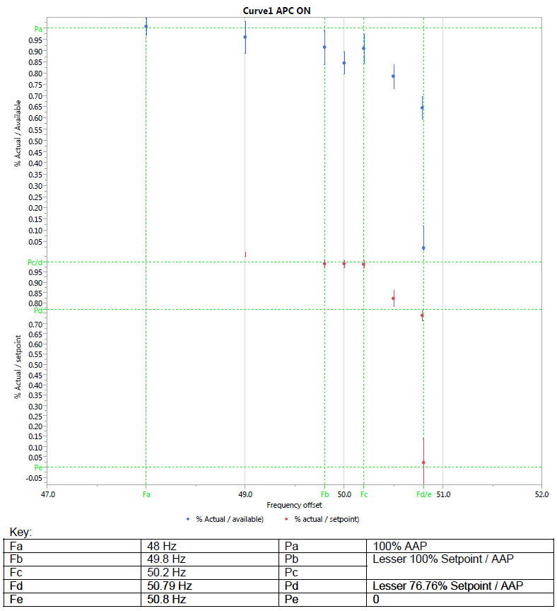

Graph X

*Analyse the performance of the WFPS in relation to the criteria.*

| **Step** | **Time** | **Simulated Frequency** | **Set-point** | **AAP** | **Droop** | **Required MW** | **Actual MW** | **Max Deviation** |
| --- | --- | --- | --- | --- | --- | --- | --- | --- |
| 1 |  | 49 Hz |  |  |  |  |  | -0.5 MW to +0.3 MW |
| 2 |  | 49.75 Hz |  |  |  |  |  |  |
| 3 |  | 49.984 Hz |  |  |  |  |  |  |
| 4 |  | 49.985 Hz |  |  |  |  |  |  |
| 5 |  | 49.985 Hz |  |  |  |  |  |  |
|  |  |  |  |  |  |  |  |  |
|  |  |  |  |  |  |  |  |  |

Table X

**Criteria – WFPS provides ≥60% of its expected response within 5 seconds and 100% of its expected response within 15 seconds**

*[Include a graph of any anomalies and any supporting plots/diagrams].*

*Analyse the performance of the WFPS in relation to the criteria.*

| **Frequency Step (Hz)** | **Time** | **Initial MW** | **Required MW** | **MW required after 5 seconds** | **MW achieved after 5 seconds** | **MW required after 15 seconds** | **MW achieved after 15 seconds** |
| --- | --- | --- | --- | --- | --- | --- | --- |
| 50 – 49 Hz |  |  |  |  |  |  |  |
| 49 – 49.75 Hz |  |  |  |  |  |  |  |
| 49.75 – 49.984 Hz |  |  |  |  |  |  |  |
|  |  |  |  |  |  |  |  |

Table X

**Criteria – Any WTG which has disconnected due to frequency ≥ 50.8 Hz, shall be brought back on load when frequency falls less than 50.2 Hz**

*[Include a graph of any anomalies and any supporting plots/diagrams].*

*Analyse the performance of the WFPS in relation to the criteria.*

| **Step** | **Time** | **Simulated Frequency** | **Actual MW** | **# Turbines Online** |
| --- | --- | --- | --- | --- |
|  |  |  |  |  |
|  |  |  |  |  |
|  |  |  |  |  |
|  |  |  |  |  |

Table X

**Criteria – Frequency response is achieved by altering the output of all WTGs as opposed to switching WTGs on or off, insofar as possible**

**Criteria – For active power output levels ≥ DMOL, all WTGs shall be generating electricity**

*[Include a graph of any anomalies and any supporting plots/diagrams].*

When the frequency was changed from X Hz to Y Hz, the MW output reduced from XX MW to DMOL. As shown in Table X, no turbines were stopped until the active power was reduced less than DMOL.

| **Step** | **Time** | **Simulated Frequency** | **Actual MW** | **# Turbines Online** |
| --- | --- | --- | --- | --- |
|  |  |  |  |  |
|  |  |  |  |  |
|  |  |  |  |  |
|  |  |  |  |  |

Table X

*Graph X – Frequency Response When Dispatched less than DMOL*

Additional test steps were carried out to demonstrate the performance of the WFPS when dispatched less than DMOL.

DMOL is XX MW. While the WFPS was dispatched less than DMOL and a high frequency was injected, the WFPS did not shut down any additional turbines to regulate further downwards, in line with the frequency curve settings. This is demonstrated in in Table X.

| **Step** | **Time** | **Simulated Frequency** | **Actual MW** | **# Turbines Online** |
| --- | --- | --- | --- | --- |
|  |  |  |  |  |
|  |  |  |  |  |
|  |  |  |  |  |
|  |  |  |  |  |

Table X

While the Grid Code requirement of “≥60% of expected response within 5 seconds and 100% of expected response in 15 seconds” does not apply below DMOL, the WFPS is expected to provide frequency response at the maximum possible rate. The performance of the WFPS is analysed.

| **Frequency Step (Hz)** | **Time** | **Initial MW** | **Required MW** | **MW required after 5 seconds** | **MW achieved after 5 seconds** | **MW required after 15 seconds** | **MW achieved after 15 seconds** |
| --- | --- | --- | --- | --- | --- | --- | --- |
| 50 – 49 Hz |  |  |  |  |  |  |  |
| 49 – 49.75 Hz |  |  |  |  |  |  |  |
| 49.75 – 49.984 Hz |  |  |  |  |  |  |  |
|  |  |  |  |  |  |  |  |

Table X

## Frequency Response On, Curve 1, APC Off

*Graph X – WFPS Frequency Droop Setting*

Frequency Response On, Curve 1, APC Off test was carried out on dd/mm/yyyy. A graph of the Frequency Response On, Curve 1, APC Off test is included.

*[Include any relevant test notes here, relating to how the test was carried out or any specific conditions encountered during this test].*

| **Criteria** | **Criteria Assessed** | **Criteria Passed** |
| --- | --- | --- |
| **Governor Droop** | | |
| The WFCS continuously recalculates its expected response during the frequency excursion |  |  |
| **Rate of Response** | | |
| WFPS provides ≥60% of its expected response within 5 seconds and 100% of its expected response within 15 seconds. |  |  |
| **Frequency Response Curve** | | |
| For frequency < FA, MW output ramps directly to 100% of AAP. |  |  |
| For frequency between FA and FB, MW output is based on frequency droop setting |  |  |
| For frequency ≥ FB and ≤ FC, no response shall be provided |  |  |
| For frequency between FC and FD, MW output is based on frequency droop setting. |  |  |
| For frequency > FD, MW output ramps directly to DMOL |  |  |
| For frequency > FE, MW output ramps directly to 0 MW |  |  |
| **Latching etc.** | | |
| For frequency > FC, MW output does not increase above its value at the time frequency exceeded FC, due to AAP increasing. |  |  |
| Any WTG which has disconnected due to frequency ≥ 50.8 Hz, shall be brought back on load when frequency falls less than 50.2 Hz. |  |  |
| WFPS regulates its active power output to within the greater of ±0.5 MW or ±3% of Registered Capacity of the Active Power Control Set-point adjusted for frequency response. |  |  |

**Criteria – For frequency < FA, MW output ramps directly to 100% of AAP**

**Criteria – For frequency between FA and FB, MW output is based on frequency droop setting**

**Criteria – For frequency ≥ FB and ≤ FC, no response shall be provided**

**Criteria – For frequency between FC and FD, MW output is based on frequency droop setting**

**Criteria – For frequency > FD, MW output ramps directly to DMOL**

**Criteria – For frequency > FE, MW output ramps directly to 0 MW**

**Criteria – WFPS regulates its active power output to within the greater of ±0.5 MW or ±3% of Registered Capacity of the Active Power Control Set-point adjusted for frequency response**

*[Include a graph of any anomalies and any supporting plots/diagrams].*

*Analyse the performance of the WFPS in relation to the criteria.*

| **Step** | **Time** | **Simulated Frequency** | **AAP** | **Droop** | **Required MW** | **Actual MW** | **Max Deviation** |
| --- | --- | --- | --- | --- | --- | --- | --- |
| 1 |  | 49 Hz |  |  |  |  | -0.5 MW to +0.3 MW |
| 2 |  | 49.75 Hz |  |  |  |  |  |
| 3 |  | 49.984 Hz |  |  |  |  |  |
| 4 |  | 49.985 Hz |  |  |  |  |  |
| 5 |  | 49.985 Hz |  |  |  |  |  |
|  |  |  |  |  |  |  |  |
|  |  |  |  |  |  |  |  |

Table X

**Criteria – WFPS provides ≥60% of its expected response within 5 seconds and 100% of its expected response within 15 seconds**

*[Include a graph of any anomalies and any supporting plots/diagrams].*

*Analyse the performance of the WFPS in relation to the criteria.*

| **Frequency Step (Hz)** | **Time** | **Initial MW** | **Required MW** | **MW required after 5 seconds** | **MW achieved after 5 seconds** | **MW required after 15 seconds** | **MW achieved after 15 seconds** |
| --- | --- | --- | --- | --- | --- | --- | --- |
| 50 – 49 Hz |  |  |  |  |  |  |  |
| 49 – 49.75 Hz |  |  |  |  |  |  |  |
| 49.75 – 49.984 Hz |  |  |  |  |  |  |  |
|  |  |  |  |  |  |  |  |

Table X

**Criteria – The WFCS continuously recalculates its expected response during the frequency excursion**

*[Include a graph of a frequency change that affects the MW output of the WFPS].*

During the test, the active power output is continuously varying. The required output is continuously calculated, based on the frequency and available active power at any given time. This can be seen in Table X, when the frequency changes from X Hz to Y Hz.

**Criteria – For frequency > FC, MW output does not increase above its value at the time frequency exceeded FC, due to AAP increasing**

*[Include a graph of any anomalies and any supporting plots/diagrams].*

*Analyse the performance of the WFPS in relation to the criteria.*

| **Step** | **Time** | **Simulated Frequency** | **Actual MW** | **# Turbines Online** |
| --- | --- | --- | --- | --- |
|  |  |  |  |  |
|  |  |  |  |  |
|  |  |  |  |  |
|  |  |  |  |  |

Table X

**Criteria – Any WTG which has disconnected due to frequency ≥ 50.8 Hz, shall be brought back on load when frequency falls less than 50.2 Hz**

*[Include a graph of any anomalies and any supporting plots/diagrams].*

*Analyse the performance of the WFPS in relation to the criteria.*

| **Step** | **Time** | **Simulated Frequency** | **Actual MW** | **# Turbines Online** |
| --- | --- | --- | --- | --- |
|  |  |  |  |  |
|  |  |  |  |  |
|  |  |  |  |  |
|  |  |  |  |  |

Table X

## Frequency Response On, Curve 2, APC On

*Graph X – Frequency Response On, Curve 2, APC On*

Frequency Response On, Curve 2, APC On test is included in the Graph X.

*[Include any relevant test notes here, relating to how the test was carried out or any specific conditions encountered during this test].*

| **Criteria** | **Criteria Assessed** | **Criteria Passed** |
| --- | --- | --- |
| **Rate of Response** | | |
| WFPS provides ≥60% of its expected response within 5 seconds and 100% of its expected response within 15 seconds. |  |  |
| **Frequency Response Curve** | | |
| For frequency < FA, MW output ramps directly to 100% of AAP. |  |  |
| For frequency between FA and FB, MW output is based on frequency droop setting |  |  |
| For frequency ≥ FB and ≤ FC, no response shall be provided |  |  |
| For frequency between FC and FD, MW output is based on frequency droop setting. |  |  |
| For frequency > FD, MW output ramps directly to DMOL |  |  |
| For frequency > FE, MW output ramps directly to 0 MW |  |  |
| Deadband of +/-15 mHz is applied in Active Power Control Mode and in Curve 2 |  |  |
| Any WTG which has disconnected due to frequency ≥ 50.8 Hz, shall be brought back on load when frequency falls less than 50.2 Hz. |  |  |
| WFPS regulates its active power output to within the greater of ±0.5 MW or ±3% of Registered Capacity of the Active Power Control Set-point adjusted for frequency response. |  |  |

**Criteria – For frequency < FA, MW output ramps directly to 100% of AAP**

**Criteria – For frequency between FA and FB, MW output is based on frequency droop setting**

**Criteria – For frequency ≥ FB and ≤ FC, no response shall be provided**

**Criteria – For frequency between FC and FD, MW output is based on frequency droop setting**

**Criteria – For frequency > FD, MW output ramps directly to DMOL**

**Criteria – For frequency > FE, MW output ramps directly to 0 MW**

**Criteria – Deadband of +/-15 mHz is applied in Active Power Control Mode and in Curve 2**

**Criteria – WFPS regulates its active power output to within the greater of ±0.5 MW or ±3% of Registered Capacity of the Active Power Control Set-point adjusted for frequency response**

*[Include a graph of any anomalies and any supporting plots/diagrams].*

*Analyse the performance of the WFPS in relation to the criteria.*

| **Step** | **Time** | **Simulated Frequency** | **Set-point** | **AAP** | **Droop** | **Required MW** | **Actual MW** | **Max Deviation** |
| --- | --- | --- | --- | --- | --- | --- | --- | --- |
| 1 |  | 49 Hz |  |  |  |  |  | -0.5 MW to +0.3 MW |
| 2 |  | 49.75 Hz |  |  |  |  |  |  |
| 3 |  | 49.984 Hz |  |  |  |  |  |  |
| 4 |  | 49.985 Hz |  |  |  |  |  |  |
| 5 |  | 49.985 Hz |  |  |  |  |  |  |
|  |  |  |  |  |  |  |  |  |
|  |  |  |  |  |  |  |  |  |

Table X

**Criteria – WFPS provides ≥60% of its expected response within 5 seconds and 100% of its expected response within 15 seconds**

*[Include a graph of any anomalies and any supporting plots/diagrams].*

*Analyse the performance of the WFPS in relation to the criteria.*

| **Frequency Step (Hz)** | **Time** | **Initial MW** | **Required MW** | **MW required after 5 seconds** | **MW achieved after 5 seconds** | **MW required after 15 seconds** | **MW achieved after 15 seconds** |
| --- | --- | --- | --- | --- | --- | --- | --- |
| 50 – 49 Hz |  |  |  |  |  |  |  |
| 49 – 49.75 Hz |  |  |  |  |  |  |  |
| 49.75 – 49.984 Hz |  |  |  |  |  |  |  |
|  |  |  |  |  |  |  |  |

Table X

**Criteria – Any WTG which has disconnected due to frequency ≥ 50.8 Hz, shall be brought back on load when frequency falls less than 50.2 Hz**

*[Include a graph of any anomalies and any supporting plots/diagrams].*

*Analyse the performance of the WFPS in relation to the criteria.*

| **Step** | **Time** | **Simulated Frequency** | **Actual MW** | **# Turbines Online** |
| --- | --- | --- | --- | --- |
|  |  |  |  |  |
|  |  |  |  |  |
|  |  |  |  |  |
|  |  |  |  |  |

Table X

**Criteria – Frequency response is achieved by altering the output of all WTGs as opposed to switching WTGs on or off, insofar as possible**

*[Include a graph of any anomalies and any supporting plots/diagrams].*

When the frequency was changed from X Hz to Y Hz, the MW output reduced from XX MW to DMOL. As shown in Table X, no turbines were stopped until the active power was reduced less than DMOL.

| **Step** | **Time** | **Simulated Frequency** | **Actual MW** | **# Turbines Online** |
| --- | --- | --- | --- | --- |
|  |  |  |  |  |
|  |  |  |  |  |
|  |  |  |  |  |
|  |  |  |  |  |

Table X

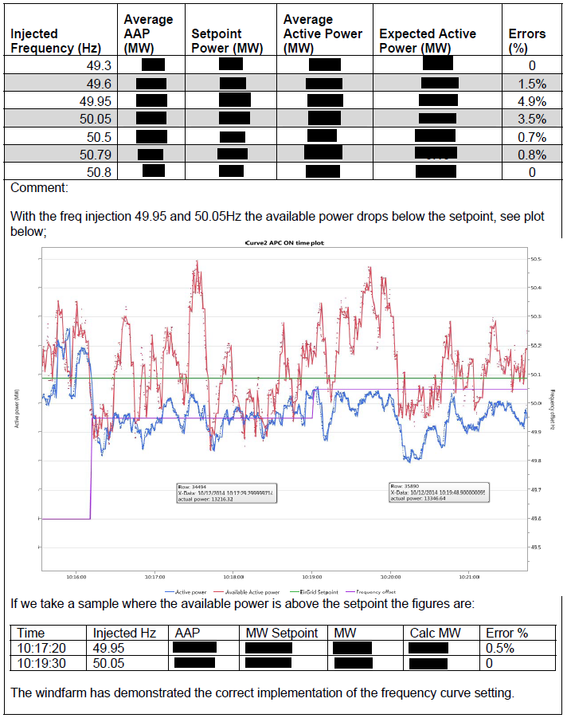

Graph X

## Frequency Response On, Curve 2, APC Off

*Graph X – Frequency Response On, Curve 2, APC Off*

Frequency Response On, Curve 2, APC Off test is included in Graph X.

*[Include any relevant test notes here, relating to how the test was carried out or any specific conditions encountered during this test].*

| **Criteria** | **Criteria Assessed** | **Criteria Passed** |
| --- | --- | --- |
| **Rate of Response** | | |
| WFPS provides ≥60% of its expected response within 5 seconds and 100% of its expected response within 15 seconds. |  |  |
| **Frequency Response Curve** | | |
| For frequency < FA, MW output ramps directly to 100% of AAP. |  |  |
| For frequency between FA and FB, MW output is based on frequency droop setting |  |  |
| For frequency ≥ FB and ≤ FC, no response shall be provided |  |  |
| For frequency between FC and FD, MW output is based on frequency droop setting. |  |  |
| For frequency > FD, MW output ramps directly to DMOL |  |  |
| For frequency > FE, MW output ramps directly to 0 MW |  |  |
| Deadband of +/-15 mHz is applied in Active Power Control Mode and in Curve 2 |  |  |
| **Latching etc.** | | |
| Any WTG which has disconnected due to frequency ≥ 50.8 Hz, shall be brought back on load when frequency falls less than 50.2 Hz. |  |  |
| WFPS regulates its active power output to within the greater of ±0.5 MW or ±3% of Registered Capacity of the Active Power Control Set-point adjusted for frequency response. |  |  |

**Criteria – For frequency < FA, MW output ramps directly to 100% of AAP**

**Criteria – For frequency between FA and FB, MW output is based on frequency droop setting**

**Criteria – For frequency ≥ FB and ≤ FC, no response shall be provided**

**Criteria – For frequency between FC and FD, MW output is based on frequency droop setting**

**Criteria – For frequency > FD, MW output ramps directly to DMOL**

**Criteria – For frequency > FE, MW output ramps directly to 0 MW**

**Criteria – Deadband of +/-15 mHz is applied in Active Power Control Mode and in Curve 2**

**Criteria – WFPS regulates its active power output to within the greater of ±0.5 MW or ±3% of Registered Capacity of the Active Power Control Set-point adjusted for frequency response**

*[Include a graph of any anomalies and any supporting plots/diagrams].*

*Analyse the performance of the WFPS in relation to the criteria.*

| **Step** | **Time** | **Simulated Frequency** | **AAP** | **Droop** | **Required MW** | **Actual MW** | **Max Deviation** |
| --- | --- | --- | --- | --- | --- | --- | --- |
| 1 |  | 49 Hz |  |  |  |  | -0.5 MW to +0.3 MW |
| 2 |  | 49.75 Hz |  |  |  |  |  |
| 3 |  | 49.984 Hz |  |  |  |  |  |
| 4 |  | 49.985 Hz |  |  |  |  |  |
| 5 |  | 49.985 Hz |  |  |  |  |  |
|  |  |  |  |  |  |  |  |
|  |  |  |  |  |  |  |  |

Table X

**Criteria – WFPS provides ≥60% of its expected response within 5 seconds and 100% of its expected response within 15 seconds**

*[Include a graph of any anomalies and any supporting plots/diagrams].*

*Analyse the performance of the WFPS in relation to the criteria.*

| **Frequency Step (Hz)** | **Time** | **Initial MW** | **Required MW** | **MW required after 5 seconds** | **MW achieved after 5 seconds** | **MW required after 15 seconds** | **MW achieved after 15 seconds** |
| --- | --- | --- | --- | --- | --- | --- | --- |
| 50 – 49 Hz |  |  |  |  |  |  |  |
| 49 – 49.75 Hz |  |  |  |  |  |  |  |
| 49.75 – 49.984 Hz |  |  |  |  |  |  |  |
|  |  |  |  |  |  |  |  |

Table X

**Criteria – Any WTG which has disconnected due to frequency ≥ 50.8 Hz, shall be brought back on load when frequency falls less than 50.2 Hz**

[Include a graph of any anomalies and any supporting plots/diagrams].

*Analyse the performance of the WFPS in relation to the criteria.*

| **Step** | **Time** | **Simulated Frequency** | **Actual MW** | **# Turbines Online** |
| --- | --- | --- | --- | --- |
|  |  |  |  |  |
|  |  |  |  |  |
|  |  |  |  |  |
|  |  |  |  |  |

Table X

**Criteria – Frequency response is achieved by altering the output of all WTGs as opposed to switching WTGs on or off, insofar as possible**

*[Include a graph of any anomalies and any supporting plots/diagrams].*

When the frequency was changed from X Hz to Y Hz, the MW output reduced from XX MW to DMOL. As shown in Table X, no turbines were stopped until the active power was reduced less than DMOL.

| **Step** | **Time** | **Simulated Frequency** | **Actual MW** | **# Turbines Online** |
| --- | --- | --- | --- | --- |
|  |  |  |  |  |
|  |  |  |  |  |
|  |  |  |  |  |
|  |  |  |  |  |

Table X

## Frequency Response Off, Curve 1, APC On

*Graph X – Frequency Response Off, Curve 1, APC On*

Frequency Response Off, Curve 1, APC On test is included in Graph X.

*[Include any relevant test notes here, relating to how the test was carried out or any specific conditions encountered during this test].*

| **Criteria** | **Criteria Assessed** | **Criteria Passed** |
| --- | --- | --- |
| **Governor Droop** | | |
| When Frequency Response is OFF, no response shall be provided. |  |  |

**Criteria – When Frequency Response is OFF, no response shall be provided**

*[Include a graph of any anomalies and any supporting plots/diagrams].*

*Analyse the performance of the WFPS in relation to the criteria.*

| **Step** | **Time** | **Simulated Frequency** | **Set-point** | **Droop** | **Required MW** | **Actual MW** |
| --- | --- | --- | --- | --- | --- | --- |
|  |  |  |  |  |  |  |
|  |  |  |  |  |  |  |
|  |  |  |  |  |  |  |
|  |  |  |  |  |  |  |

Table X

## Frequency Response Off, Curve 1, APC Off

*Graph X – Frequency Response Off, Curve 1, APC* *Off*

Frequency Response Off, Curve 1, APC Off test is included within Graph X.

[Include any relevant test notes here, relating to how the test was carried out or any specific conditions encountered during this test].

| **Criteria** | **Criteria Assessed** | **Criteria Passed** |
| --- | --- | --- |
| **Governor Droop** | | |
| When Frequency Response is OFF, no response shall be provided. |  |  |

**Criteria – When Frequency Response is OFF, no response shall be provided**

*[Include a graph of any anomalies and any supporting plots/diagrams].*

*Analyse the performance of the WFPS in relation to the criteria.*

| **Step** | **Time** | **Simulated Frequency** | **AAP** | **Droop** | **Required MW** | **Actual MW** |
| --- | --- | --- | --- | --- | --- | --- |
|  |  |  |  |  |  |  |
|  |  |  |  |  |  |  |
|  |  |  |  |  |  |  |
|  |  |  |  |  |  |  |

Table X

## Frequency Response Off, Curve 2, APC On

*Graph X – Frequency Response Off, Curve 2, APC On*

Frequency Response Off, Curve 2, APC On test is included within Graph X.

[Include any relevant test notes here, relating to how the test was carried out or any specific conditions encountered during this test].

| **Criteria** | **Criteria Assessed** | **Criteria Passed** |
| --- | --- | --- |
| **Governor Droop** | | |
| When Frequency Response is OFF, no response shall be provided. |  |  |

**Criteria – When Frequency Response is OFF, no response shall be provided**

*[Include a graph of any anomalies and any supporting plots/diagrams].*

*Analyse the performance of the WFPS in relation to the criteria.*

| **Step** | **Time** | **Simulated Frequency** | **Set-point** | **Droop** | **Required MW** | **Actual MW** |
| --- | --- | --- | --- | --- | --- | --- |
|  |  |  |  |  |  |  |
|  |  |  |  |  |  |  |
|  |  |  |  |  |  |  |
|  |  |  |  |  |  |  |

Table X

## Frequency Response Off, Curve 2, APC Off

*Graph X – Frequency Response Off, Curve 2, APC* *Off*

Frequency Response Off, Curve 2, APC Off test is included within Graph X.

*Include any relevant test notes here, relating to how the test was carried out or any specific conditions encountered during this test].*

| **Criteria** | **Criteria Assessed** | **Criteria Passed** |
| --- | --- | --- |
| **Governor Droop** | | |
| When Frequency Response is OFF, no response shall be provided. |  |  |

**Criteria – When Frequency Response is OFF, no response shall be provided**

*[Include a graph of any anomalies and any supporting plots/diagrams].*

*Analyse the performance of the WFPS in relation to the criteria.*

| **Step** | **Time** | **Simulated Frequency** | **AAP** | **Droop** | **Required MW** | **Actual MW** |
| --- | --- | --- | --- | --- | --- | --- |
|  |  |  |  |  |  |  |
|  |  |  |  |  |  |  |
|  |  |  |  |  |  |  |
|  |  |  |  |  |  |  |

Table X

## DMOL

*Graph X – DMOL*

DMOL test is included in Graph X.

*[Include any relevant test notes here, relating to how the test was carried out or any specific conditions encountered during this test].*

| **Criteria** | **Criteria Assessed** | **Criteria Passed** |
| --- | --- | --- |
| **Rate of Response** | | |
| WFPS provides ≥60% of its expected response within 5 seconds and 100% of its expected response within 15 seconds. |  |  |
| **Latching etc.** | | |
| Frequency response is achieved by altering the output of all WTGs as opposed to switching WTGs on or off, insofar as possible. |  |  |
| For active power output levels ≥ DMOL, all WTGs shall be generating electricity. |  |  |

**Criteria – WFPS provides ≥60% of its expected response within 5 seconds and 100% of its expected response within 15 seconds**

*[Include a graph of any anomalies and any supporting plots/diagrams].*

*Analyse the performance of the WFPS in relation to the criteria.*

| **Step** | **Time** | **Initial MW** | **Required MW** | **MW required after 5 seconds** | **MW achieved after 5 seconds** | **MW required after 15 seconds** | **MW achieved after 15 seconds** |
| --- | --- | --- | --- | --- | --- | --- | --- |
| 50 – 49 Hz |  |  |  |  |  |  |  |
| DMOL – Registered Capacity MW |  |  |  |  |  |  |  |

Table X

**Criteria – Frequency response is achieved by altering the output of all WTGs as opposed to switching WTGs on or off, insofar as possible**

**Criteria – For active power output levels ≥ DMOL, all WTGs shall be generating electricity**

*[Include a graph of any anomalies and any supporting plots/diagrams].*

While the WFPS was dispatched to DMOL (XX MW) all WTGs were online and generating electricity, As shown in Table X.

|  |  |  |  |  |
| --- | --- | --- | --- | --- |
| **Step** | **Time** | **Simulated Frequency** | **Actual MW** | **# Turbines Online** |
|  |  |  |  |  |

Table X

## Frequency Response Ramp Rate Priority in Curve 1

*Graph X – Frequency Response Ramp Rate Priority in Curve 1*

Frequency Response Ramp Rate Priority in Curve 1 test is included within Graph X.

[Include any relevant test notes here, relating to how the test was carried out or any specific conditions encountered during this test].

| **Criteria** | **Criteria Assessed** | **Criteria Passed** |
| --- | --- | --- |
| **Rate of Response** | | |
| WFPS provides ≥60% of its expected response within 5 seconds and 100% of its expected response within 15 seconds. |  |  |
| Ramp Rates shall be prioritised with Frequency Response Ramp Rate given the highest priority. |  |  |

**Criteria – WFPS provides ≥60% of its expected response within 5 seconds and 100% of its expected response within 15 seconds**

*[Include a graph of any anomalies and any supporting plots/diagrams].*

*Analyse the performance of the WFPS in relation to the criteria.*

| **Frequency Step (Hz)** | **Time** | **MW at time of injection** | **Required MW** | **MW required after 5 seconds** | **MW achieved after 5 seconds** | **MW required after 15 seconds** | **MW achieved after 15 seconds** |
| --- | --- | --- | --- | --- | --- | --- | --- |
| 50 – 50.79 Hz |  |  |  |  |  |  |  |
| 50 – 47 Hz |  |  |  |  |  |  |  |
| 50 – 50.79 Hz |  |  |  |  |  |  |  |

Table X

**Criteria – Ramp Rates shall be prioritised with Frequency Response Ramp Rate given the highest priority**

As shown in Table X, when the simulated frequency deviations took place during a ramp in Active Power Control mode, the ramp rate changed from Active Power Control Set-point Ramp Rate to the Frequency Response Ramp Rate.

As shown in Table X, when the simulated frequency deviations took place during a ramp in Wind Following mode, the ramp rate changed from Wind Following Ramp Rate to the Frequency Response Ramp Rate.

## Frequency Response Ramp Rate Priority in Curve 2

*Graph X – Frequency Response Ramp Rate Priority in Curve 2*

Frequency Response Ramp Rate Priority in Curve 2 test is included in Graph X.

*[Include any relevant test notes here, relating to how the test was carried out or any specific conditions encountered during this test].*

| **Criteria** | **Criteria Assessed** | **Criteria Passed** |
| --- | --- | --- |
| **Rate of Response** | | |
| WFPS provides ≥60% of its expected response within 5 seconds and 100% of its expected response within 15 seconds. |  |  |
| Ramp Rates shall be prioritised with Frequency Response Ramp Rate given the highest priority. |  |  |

**Criteria – WFPS provides ≥60% of its expected response within 5 seconds and 100% of its expected response within 15 seconds**

*[Include a graph of any anomalies and any supporting plots/diagrams].*

*Analyse the performance of the WFPS in relation to the criteria.*

| **Frequency Step (Hz)** | **Time** | **MW at time of injection** | **Required MW** | **MW required after 5 seconds** | **MW achieved after 5 seconds** | **MW required after 15 seconds** | **MW achieved after 15 seconds** |
| --- | --- | --- | --- | --- | --- | --- | --- |
| 50 – 50.79 Hz |  |  |  |  |  |  |  |
| 50 – 47 Hz |  |  |  |  |  |  |  |
| 50 – 50.79 Hz |  |  |  |  |  |  |  |

Table X

**Criteria – Ramp Rates shall be prioritised with Frequency Response Ramp Rate given the highest priority**

As shown in Table X, when the simulated frequency deviations took place during a ramp in Active Power Control mode, the ramp rate changed from Active Power Control Set-point Ramp Rate to the Frequency Response Ramp Rate.

As shown in Table X, when the simulated frequency deviations took place during a ramp in Wind Following mode, the ramp rate changed from Wind Following Ramp Rate to the Frequency Response Ramp Rate.

# Reactive Power Capability

## Purpose of the Test

The purpose of this test is to demonstrate the limits of the WFPS reactive power capability curve at the connection point. The test is undertaken at various load levels for both the export of reactive power from the WFPS and for the import of reactive power to the WFPS.

## Pass Criteria Summary

The following is the pass criteria for the test. Test data shall be assessed against each of these criteria.

| **Criteria** | **Criteria Assessed** | **Criteria Passed** |
| --- | --- | --- |
| **Reactive Power Capability** | | |
| Demonstration that the measured P-Q capability is in line with the submitted P-Q capability diagram |  |  |
| Demonstration that the measured P-Q capability meets or exceeds the minimum expected reactive power capabilities of the controllable WFPS, as defined in Grid Code *Figure WFPS1.4,* as measured at the Connection Point |  |  |

## Instrumentation and Onsite Data Trending

|  |  |  |  |
| --- | --- | --- | --- |
| **No.** | **Data Trending and Recording** | **Resolution** | **Recorded** |
| 1 | Available active power from the prevailing wind in MW, derived by algorithm in the WFCS (*Figure WFPS1.3, Point Y*) | WFPS to Specify (≥10 Hz) | Yes / No |
| 2 | Actual active power from the wind farm in MW (*Figure WFPS1.3, Point Y*) | WFPS to Specify (≥10 Hz) | Yes / No |
| 3 | Wind farm voltage measured at the lower voltage side of the grid connected transformer (*Figure WFPS1.3, Point Y*) | WFPS to Specify (≥10 Hz) | Yes / No |
| 4 | Grid voltage measured at the connection point (*Figure WFPS1.3, Point Z*) | WFPS to Specify (≥10 Hz) | Yes / No |
| 5 | Reactive power measured at the lower voltage side of the grid connected transformer, (*Figure WFPS1.3, Point Y*) | WFPS to Specify (≥10 Hz) | Yes / No |
| 6 | Reactive power measured at the connection point (*Figure WFPS1.3, Point Z*) | WFPS to Specify (≥10 Hz) | Yes / No |
| 7 | Grid transformer tap position | WFPS to Specify (≥10 Hz) | Yes / No |
| 8 | AVR (kV) set-point (*Figure WFPS1.3, Point Y*) | WFPS to Specify (≥10 Hz) | Yes / No |

## Test Analysis

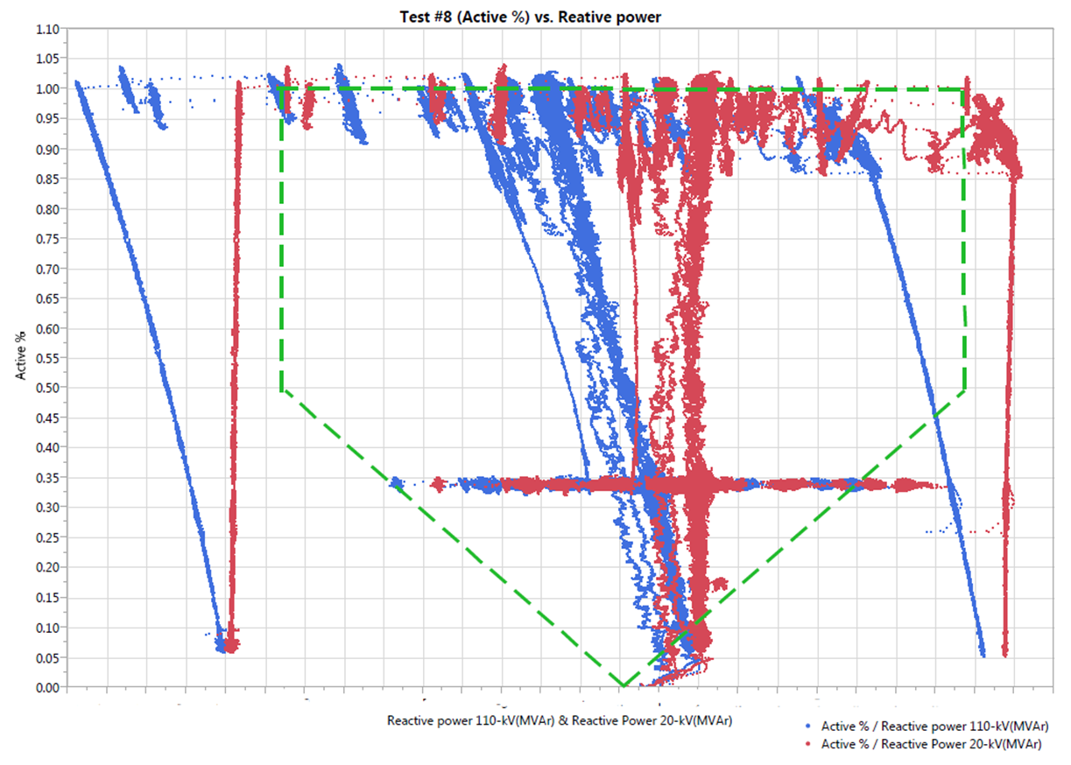

*Graph X – Reactive Power Capability*

A scatter plot of the Reactive Power Capability test is included in Graph X.

*[Include any relevant test notes here, relating to how the test was carried out or any specific conditions encountered during this test].*

| **Criteria** | **Criteria Assessed** | **Criteria Passed** |
| --- | --- | --- |
| **Reactive Power Capability** | | |
| Demonstration that the measured P-Q capability is in line with the submitted P-Q capability diagram |  |  |
| Demonstration that the measured P-Q capability meets or exceeds the minimum expected reactive power capabilities of the controllable WFPS, as defined in Grid Code *Figure WFPS1.4,* as measured at the Connection Point |  |  |

**Criteria – Demonstration that the measured P-Q capability meets or exceeds the minimum expected reactive power capabilities of the controllable WFPS, as defined in Grid Code Figure WFPS1.4, as measured at the Connection Point**

*[Include a graph of any anomalies and any supporting plots/diagrams].*

*Analyse the performance of the WFPS in relation to the criteria.*

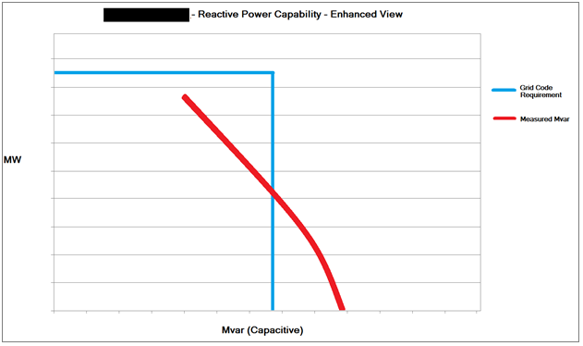

*Graph 2 – Reactive Power Capability – Enhanced View*

Graph 2 shows an enhanced view of the 1.5 Mvar issue in reactive power capability.

**Criteria – Demonstration that the measured P-Q capability is in line with the submitted P-Q capability diagram**

*[Include a graph of any anomalies and any supporting plots/diagrams].*

*Analyse the performance of the WFPS in relation to the criteria.*

Note whether or not the reactive capability of the wind farm at low MW is dependent on wind speed. *i.e.* WFPS has a greater reactive capability when curtailed to 5 MW during high wind, than it has when the WFPS is only available for 5 MW. This dependency on wind speed shall be quantified.

*[Include a graph of the relevant trends recorded during the test].*

*Graph X – Leading Reactive Power Capability Test*

*Graph X – Lagging Reactive Power Capability Test*

## Table of measured reactive power capability

| **MW** | **Leading Mvar Capability** | **Lagging Mvar Capability** |
| --- | --- | --- |
| 0 | 0 | 0 |
| 1 | -2 | 2 |
| 2 | -4 | 4 |
| 3 | -7 | 7 |
| 4 | -10 | 10 |
| 5 | -10 | 10 |
| 6 | -10 | 10 |
| . | . | . |
| . | . | . |
| . | . | . |
| Registered Capacity MW | -15 | 8 |

Table X

# Reactive Power Control Test

## Purpose of the Test

The purpose of this test is to confirm correct operation of AVR system in kV, Q and PF control modes, and changing between modes.

## Pass Criteria Summary

The following is the pass criteria for the test. Test data shall be assessed against each of these criteria.

| **Criteria** | **Criteria Assessed** | **Criteria Passed** |
| --- | --- | --- |
| **AVR Control** | | |
| WFPS receives all kV set-points, implements kV all set-points within 20 seconds of receipt of the set-point and provides the correct set-point feedback |  |  |
| WFPS regulates its reactive power at the point of connection correctly based on the voltage slope setting, system voltage and kV set-point |  |  |
| Demonstration that the Voltage Regulation System Slope Setting can be set between 1% and 10% |  |  |
| Voltage Regulation System responds to a step change in voltage at the connection point, it achieves 90% of its steady-state response within 1 second |  |  |
| **Mvar Control** | | |
| WFPS receives all Mvar set-points, implements Mvar all set-points within 20 seconds of receipt of the set-point and provides the correct set-point feedback |  |  |
| WFPS maintains the Mvar set-point at the connection point |  |  |
| **Power Factor Control** | | |
| WFPS receives all PF set-points, implements PF all set-points within 20 seconds of receipt of the set-point and provides the correct set-point feedback |  |  |
| WFPS maintains the PF per phase angle set-point at the connection point |  |  |
| **Bumpless Transfer** | | |
| Voltage Regulation System implements bumpless transfer between reactive power control modes |  |  |

## Instrumentation and Onsite Data Trending

| **No.** | **Data Trending and Recording** | **Resolution** | **Recorded** |
| --- | --- | --- | --- |
| 1 | Available active power from the prevailing wind in MW, derived by algorithm in the WFCS (*Figure WFPS1.3, Point Y*) | WFPS to Specify (≥10 Hz) | Yes / No |
| 2 | Actual active power from the wind farm in MW (*Figure WFPS1.3, Point Z*) | WFPS to Specify (≥10 Hz) | Yes / No |
| 3 | Wind farm voltage measured at the lower voltage side of the grid connected transformer (*Figure WFPS1.3, Point Y*) | WFPS to Specify (≥10 Hz) | Yes / No |
| 4 | Grid voltage measured at the connection point (*Figure WFPS1.3, Point Z*) | WFPS to Specify (≥10 Hz) | Yes / No |
| 5 | Reactive power measured at the lower voltage side of the grid connected transformer, (*Figure WFPS1.3, Point Y*) | WFPS to Specify (≥10 Hz) | Yes / No |
| 6 | Reactive power measured at the connection point (*Figure WFPS1.3, Point Z*) | WFPS to Specify (≥10 Hz) | Yes / No |
| 7 | Grid transformer tap position | WFPS to Specify (≥10 Hz) | Yes / No |
| 8 | AVR (kV) set-point (*Figure WFPS1.3, Point Y*) | WFPS to Specify (≥10 Hz) | Yes / No |
| 9 | Mvar set-point (*Figure WFPS1.3, Point Y*) | WFPS to Specify (≥10 Hz) | Yes / No |
| 9 | PF set-point (*Figure WFPS1.3, Point Y*) | WFPS to Specify (≥10 Hz) | Yes / No |

## AVR & PF Settings

|  |  |
| --- | --- |
| **Calculation** | **Value** |
| 1kV change in set-point with Voltage Regulation System slope of 4% | ____ Mvar  (WFPS to specify calculation and formula used) |
| Mvar for set-point of +8 degrees at 30% of Registered Capacity (WFPS exporting Mvar) | ____ Mvar  (WFPS to specify calculation and formula used) |
| Mvar for set-point of -12 degrees at 50% of Registered Capacity (WFPS importing Mvar) | ____ Mvar  (WFPS to specify calculation and formula used) |

## Automatic Voltage Regulation Mode

*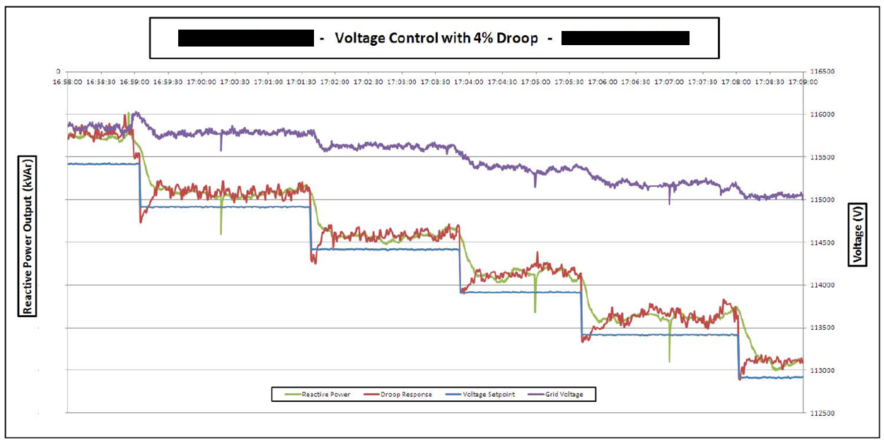Graph X – Automatic Voltage Regulation Mode*

A graph of the Automatic Voltage Regulation test is included in Graph X.

*[Include any relevant test notes here, relating to how the test was carried out or any specific conditions encountered during this test].*

Required Mvar post-settling is calculated using the following equation, where ${Mvar}_{range}$ is the Mvar range required under Grid Code, calculated as ±0.33 Q/Pmax:

| **Criteria** | **Criteria Assessed** | **Criteria Passed** |
| --- | --- | --- |
| **AVR Control** | | |
| WFPS receives all kV set-points, implements kV all set-points within 20 seconds of receipt of the set-point and provides the correct set-point feedback |  |  |
| WFPS regulates its reactive power at the point of connection correctly based on the voltage slope setting, system voltage and kV set-point |  |  |
| Demonstration that the Voltage Regulation System Slope Setting can be set between 1% and 10% |  |  |
| Voltage Regulation System responds to a step change in voltage at the connection point, it achieves 90% of its steady-state response within 1 second |  |  |

**Criteria – WFPS receives all kV set-points**

As per the signed test procedure that was scanned and submitted to [generator_testing@eirgrid.com](mailto:generator_testing@eirgrid.com), All kV set-points were received on the day of testing.

**Criteria – Set-point Implementation and Feedback within 20 seconds of receipt**

Table X demonstrates that each set-point was implemented within 20 seconds of receipt.

*[Insert a table showing the implementation times of each set-point received].*

| **Time of Set-point** | **Time of Mvar Settling** | **Implementation Time** |
| --- | --- | --- |
| 12:43:07 | 12:43:10 | 3 seconds |
| 12:49:48 | 12:49:50 | 2 seconds |
|  |  |  |

Table X

**Criteria – WFPS regulates its reactive power at the point of connection correctly based on the voltage slope setting, system voltage and kV set-point**

**Criteria – Voltage Regulation System responds to a step change in voltage at the connection point, it achieves 90% of its steady-state response within 1 second**

The criteria are assessed for each set-point change in the test procedure. A workbook is available for download at [www.eirgrid.com/operations/gridcode/compliancetesting/wfpstestprocedures](http://www.eirgrid.com/operations/gridcode/compliancetesting/wfpstestprocedures), which will assist in the calculation of data required for demonstration of Compliance with these criteria.

As shown in Table X, the WFPS response is within +/-2 Mvar of the required response (based on droop calculation) for each step. The WFPS achieved greater than 90% of the required response within 1 second of each set-point change. An overshoot of X Mvar was observed on 3 of the set-points, with a settling time of Y-Z seconds.

| **Mvar Measured Pre-Event** | **Time of Set-point Change** | **New Set-point Received (kV)** | **System Voltage Post Settling (kV)** | **Mvar Required Post Settling** | **Mvar Measured Post Settling** | **Mvar Required After 1 Second** | **Mvar Measured After 1 Second** |
| --- | --- | --- | --- | --- | --- | --- | --- |
| 4.2 | 12:43:07 | 116 | 115.1 | 13.5 | 13.51 | 12.57 | 12.89 |
| 13.5 | 12:49:48 | 116.5 | 115.3 | 18 | 17.95 | 17.55 | 17.7 |
|  |  |  |  |  |  |  |  |
|  |  |  |  |  |  |  |  |

Table X

*Required Mvar 1 second after response begins is calculated as:*

*Measured Mvar prior to set-point change + (Required Mvar change * 0.9)*

**Criteria – Demonstration that the Voltage Regulation System Slope Setting can be set between 1% and 10%**

*[Include a graph of any anomalies and any supporting plots/diagrams].*

*Analyse the performance of the WFPS in relation to the criteria.*

As demonstrated in the test steps, the Voltage Regulation System Slope was set to 2%, 4% and 10%. A sample calculation at each of those slope settings is included in Table X.

| **Time** | **Droop Setting** | **kV Set-point** | **System Voltage post settling** | **Measured Mvar post settling** | **Required Mvar post settling** |
| --- | --- | --- | --- | --- | --- |
|  | 2% |  |  |  |  |
|  | 4% |  |  |  |  |
|  | 10% |  |  |  |  |

Table X

*[Insert a graph of each individual set-point change].*

*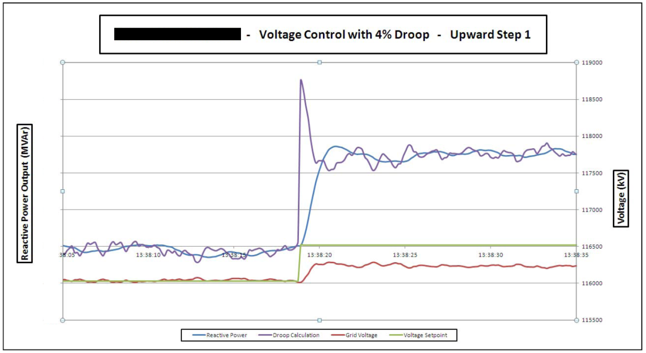Graph X – +0.5 kV step at hh:mm:ss*

*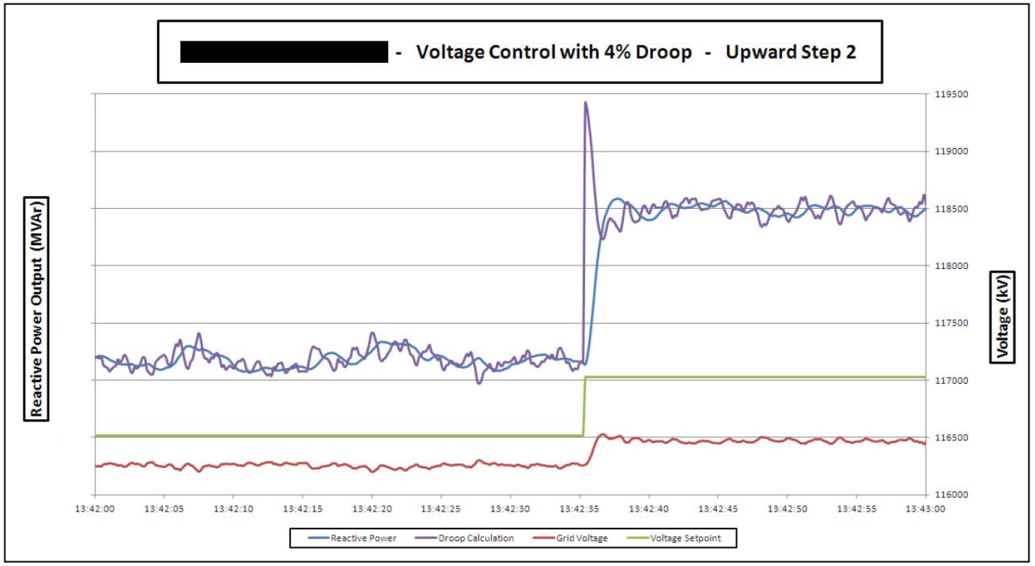Graph 2 – +0.5 kV step at hh:mm:ss*

## Automatic Voltage Regulation Response Rate

*Graph X – Automatic Voltage Regulation Response Rate*

Automatic Voltage Regulation Response Rate test is included within Graph X.

*[Include any relevant test notes here, relating to how the test was carried out or any specific conditions encountered during this test].*

| **Criteria** | **Criteria Assessed** | **Criteria Passed** |
| --- | --- | --- |
| **AVR Control** | | |
| Voltage Regulation System responds to a step change in voltage at the connection point, it achieves 90% of its steady-state response within 1 second |  |  |

**Criteria – Voltage Regulation System responds to a step change in voltage at the connection point, it achieves 90% of its steady-state response within 1 second**

*[Include a graph of any anomalies and any supporting plots/diagrams].*

*Analyse the performance of the WFPS in relation to the criteria. If there is more than one step change carried out in this test, include a table with analysis of each step change carried out.*

| **Description** | **Value** | **Unit** |
| --- | --- | --- |
| kV set-point | 116 | kV |
| System voltage post settling | 115.1 | kV |
| Required Mvar post settling (based on 4% droop) | 13.5 | Mvar |
| Measured Mvar post settling | 13.51 | Mvar |
| Measured Mvar prior to set-point change | 4.2 | Mvar |
| Required Mvar change | 9.3 | Mvar |
| Required Mvar 1 second after set-point change | 12.57 | Mvar |
| Measured Mvar 1 second after set-point change | 12.89 | Mvar |

*Required Mvar 1 second after set-point change is calculated as:   
Measured Mvar prior to set-point change + (Required Mvar change * 0.9)*

## Mvar Control Mode

*Graph X – Mvar Control Mode*

A graph of the Mvar Control Mode test is included in Graph X.

*[Include any relevant test notes here, relating to how the test was carried out or any specific conditions encountered during this test].*

| **Criteria** | **Criteria Assessed** | **Criteria Passed** |
| --- | --- | --- |
| **Mvar Control** | | |
| WFPS receives all Mvar set-points, implements Mvar all set-points within 20 seconds of receipt of the set-point and provides the correct set-point feedback |  |  |
| WFPS maintains the Mvar set-point at the connection point |  |  |

**Criteria – WFPS receives all Mvar set-points**

As per the signed test procedure that was scanned and submitted to [generator_testing@eirgrid.com](mailto:generator_testing@eirgrid.com), All Mvar set-points were received on the day of testing.

**Criteria – Set-point Implementation and Feedback within 20 seconds of receipt**

Table X demonstrates that each set-point was implemented within 20 seconds of receipt.

*[Insert a table showing the implementation times of each set-point received].*

| **Time of Set-point** | **Time of Mvar Settling** | **Implementation Time** |
| --- | --- | --- |
| 12:43:07 | 12:43:10 | 3 seconds |
| 12:49:48 | 12:49:50 | 2 seconds |
|  |  |  |

Table X

**Criteria – WFPS Maintains the Mvar set-point at the connection point**

*[Include a graph of any anomalies and any supporting plots/diagrams].*

*Analyse the performance of the WFPS in relation to the criteria. As shown in Table X, the WFPS response is within +/-2 Mvar of the required response.*

*[Include a table detailing the Minimum, Maximum and Average Mvar for each set-point tested].*

| **Time** | **Set-point** | **Minimum Mvar** | **Maximum Mvar** | **Average Mvar** |
| --- | --- | --- | --- | --- |
| hh:mm:ss | a Mvar | b Mvar | c Mvar | a Mvar |
| hh:mm:ss | d Mvar | e Mvar | f Mvar | d Mvar |
| … |  |  |  |  |

Table X

*Graph X – Change from 8 Mvar Set-point to 17 Mvar Set-point*

*Graph 2 – Change from 17 Mvar Set-point to 0 Mvar Set-point*

## Power Factor Control Mode

*Graph X – Power Factor Control Mode*

A graph of the Power Factor Control Mode test is included in Graph X.

*[Include any relevant test notes here, relating to how the test was carried out or any specific conditions encountered during this test].*

The set-point for Power Factor is sent and received as an angle and can be calculated as follows, where a +ive angle denotes a +ive PF and a –ive PF denotes a –ive PF:

$$PF=Cos(set-point)$$

For a given set-point, the required Mvar at any time is calculated as follows:

$$Mvar=MW*Tan(set-point)$$

| **Criteria** | **Criteria Assessed** | **Criteria Passed** |
| --- | --- | --- |
| **Power Factor Control** | | |
| WFPS receives all PF set-points, implements PF all set-points within 20 seconds of receipt of the set-point and provides the correct set-point feedback |  |  |
| WFPS maintains the PF per phase angle set-point at the connection point |  |  |

**Criteria – WFPS receives all PF set-points**

As per the signed test procedure that was scanned and submitted to [generator_testing@eirgrid.com](mailto:generator_testing@eirgrid.com), All Mvar set-points were received on the day of testing.

**Criteria – Set-point Implementation and Feedback within 20 seconds of receipt**

Table X demonstrates that each set-point was implemented within 20 seconds of receipt.

*[Insert a table showing the implementation times of each set-point received].*

| **Time of Set-point** | **Time of Mvar Settling** | **Implementation Time** |
| --- | --- | --- |
| 12:43:07 | 12:43:10 | 3 seconds |
| 12:49:48 | 12:49:50 | 2 seconds |
|  |  |  |

Table X

**Criteria – WFPS maintains the PF set-point at the connection point**

*[Include a graph of any anomalies and any supporting plots/diagrams].*

*Analyse the performance of the WFPS in relation to the criteria.*

As shown in Table X, the WFPS response is within +/-2 Mvar of the required response.

*[Include a table detailing the Minimum, Maximum and Average Mvar for each set-point tested].*

| **Time** | **Active Power (MW)** | **PF Set-point (degrees)** | **Required Mvar** | **Minimum Mvar** | **Maximum Mvar** | **Average Mvar** |
| --- | --- | --- | --- | --- | --- | --- |
| hh:mm:ss | a MW | b degrees | c Mvar | d Mvar | e Mvar | c Mvar |
| hh:mm:ss | f MW | g degrees | h Mvar | i Mvar | j Mvar | h Mvar |
| … |  |  |  |  |  |  |

*Table X*

*Graph X – Change from 8 degrees Set-point to 12 degrees Set-point*

*Graph 2 – Change from 12 degrees Set-point to 8 degrees Set-point*

## Functional checks and Bumpless Transfer

*Graph X – Functional Checks and Bumpless Transfer*

A graph of the Functional Checks and Bumpless Transfer test is included in Graph X.

*[Include any relevant test notes here, relating to how the test was carried out or any specific conditions encountered during this test].*

| **Criteria** | **Criteria Assessed** | **Criteria Passed** |
| --- | --- | --- |
| **Bumpless Transfer** | | |
| Voltage Regulation System implements Bumpless transfer between reactive power control modes |  |  |

**Criteria – Voltage Regulation System implements Bumpless transfer between reactive power control modes**

*[Include a graph of any anomalies and any supporting plots/diagrams].*

*Analyse the performance of the WFPS in relation to the criteria.*

| **Time** | **Mode pre-transfer** | **Mode post-transfer** | **Last received Set-point in post-transfer mode** | **Implemented Set-point in post-transfer mode** | **Mvar before mode transfer** | **Mvar after mode transfer** | **Mvar deviations during mode transfer** |
| --- | --- | --- | --- | --- | --- | --- | --- |
| 12:43:07 | kV | Q | -3 Mvar | +2 Mvar | +2 Mvar | +2 Mvar | 0.01 Mvar |
| 12:49:48 | Q | kV | 115.0 kV | 116.3 kV | +4 Mvar | +4 Mvar | 0 Mvar |
|  |  |  |  |  |  |  |  |
|  |  |  |  |  |  |  |  |

Table X

# Black Start Shutdown Test

## Purpose of the Test

The purpose of this test is to confirm correct operation of the Black Start Shutdown scheme at the controllable WFPS.

## Pass Criteria

The following is the pass criteria for the test. Any subsequent report for this test shall be assessed against each of these criteria.

1. WFPS opens the specified CB upon receipt of the Black Start Shutdown signal.
2. The specified CB is inhibited from closing while the Black Start Shutdown signal is ON.

## Instrumentation and Onsite Data Trending

No instrumentation and onsite data trending is necessary for this test. All required information is recorded manually in this test procedure.

## Black Start Shutdown Test Analysis

The Black Start Shutdown test for ___ WFPS was carried out on dd/mm/yyyy by ______ (Company) and was witnessed by _____ (EirGrid). The functionality of the Black Start Shutdown is described in the following tables.

*[Include any relevant test notes here, relating to how the test was carried out or any specific conditions encountered during this test].*

|  |  |  |
| --- | --- | --- |
| Initial Conditions | T121 110 kV cubicle Sub Remote Control Switch  EirGrid Remote Control Enable Switch | OFF  ON |
| Action | NCC enable Black Start Shutdown command | Time: |
| Outcome | T121 110 kV CB:  T121 WFPS 20 kV CB:  Blue Alert Lamp: | |
| Additional Notes |  | |

|  |  |  |
| --- | --- | --- |
| Initial Conditions | T121 110 kV cubicle Sub Remote Control Switch  EirGrid Remote Control Enable Switch | ON  OFF |
| Action | NCC enable Black Start Shutdown command | Time: |
| Outcome | T121 110 kV CB:  T121 WFPS 20 kV CB:  Blue Alert Lamp: | |
| Additional Notes |  | |

|  |  |  |
| --- | --- | --- |
| Initial Conditions | T121 110 kV cubicle Sub Remote Control Switch  EirGrid Remote Control Enable Switch  Black Start Shutdown command | ON  ON  ON |
| Action | Attempt to close WFPS 20 kV CB at mimic panel | Time: |
| Outcome | T121 110 kV CB:  T121 WFPS 20 kV CB:  Blue Alert Lamp: | |
| Additional Notes |  | |

|  |  |  |
| --- | --- | --- |
| Initial Conditions | T121 110 kV cubicle Sub Remote Control Switch  EirGrid Remote Control Enable Switch  Black Start Shutdown command | ON  ON  ON |
| Action | WFPS turn EirGrid Remote Control Enable Switch OFF | Time: |
| Outcome | T121 110 kV CB:  T121 WFPS 20 kV CB:  Blue Alert Lamp: | |
| Additional Notes |  | |

|  |  |  |
| --- | --- | --- |
| Initial Conditions | T121 110 kV cubicle Sub Remote Control Switch  EirGrid Remote Control Enable Switch  Black Start Shutdown command | ON  OFF  ON |
| Action | Attempt to close WFPS 20 kV CB at mimic panel | Time: |
| Outcome | T121 110 kV CB:  T121 WFPS 20 kV CB:  Blue Alert Lamp: | |
| Additional Notes |  | |

|  |  |  |
| --- | --- | --- |
| Initial Conditions | T121 110 kV cubicle Sub Remote Control Switch  EirGrid Remote Control Enable Switch  Black Start Shutdown command | ON  OFF  ON |
| Action | NCC remove Black Start Shutdown Command | Time: |
| Outcome | T121 110 kV CB:  T121 WFPS 20 kV CB:  Blue Alert Lamp: | |
| Additional Notes |  | |

# Appendix 1 – Frequency Response Setings



**Curve 1: Wind Following Mode**

|  |  |  |  |
| --- | --- | --- | --- |
|  | ***Transmission System Frequency*** *f (Hz)* |  | ***Required Active Power Output*** |
|  | *f < 48* |  | *100% of AAP* |
| ***FA*** | *48* | ***PA*** | *100% of AAP* |
| ***Under Frequency Response*** | *48 < f < 49.8* |  | *100% of AAP* |
| ***FB*** | *f = 49.8* | ***PB*** | *100% of AAP* |
| ***+/-0.2Hz Deadband*** | *49.8 < f < 50.2* |  | *100% of AAP* |
| ***FC*** | *f = 50.2* | ***PC*** | *100% of AAP* |
| ***Over Frequency Response*** | *50.2 < f < 50.79* |  | *AAP + ∆MW2* |
| ***FD*** | *f = 50.79* | ***PD*** | *Minimum of: AAP and DMOL* |
| ***FE*** | *f = 50.8* | ***PE*** | *0%3* |
|  | *f > 50.8* |  | *0%3* |

**Curve 1: Active Power Control Mode**

|  |  |  |  |
| --- | --- | --- | --- |
|  | ***Transmission System Frequency*** *f (Hz)* |  | ***Required Active Power Output*** |
|  | *f < 48* |  | *100% of AAP* |
| ***FA*** | *f = 48* | ***PA*** | *100% of AAP* |
| ***Under Frequency Response*** | *48 < f < 49.985* |  | *Minimum of: APC Set-point + ∆MW and AAP* |
| ***FB*** | *f = 49.985* | ***PB*** | *Minimum of: APC Set-point and AAP* |
| ***+/-0.015Hz Deadband*** | *49.985 < f < 50.015* |  | *Minimum of: APC Set-point and AAP* |
| ***FC*** | *f = 50.015* | ***PC*** | *Minimum of: APC Set-point and AAP* |
| ***Over Frequency Response*** | *50.015 < f < 50.79* |  | *Minimum of: APC Set-point + ∆MW and AAP + ∆MW1, 2* |
| ***FD*** | *f = 50.79* | ***PD*** | *Minimum of: APC Set-point and AAP and DMOL* |
| ***FE*** | *f = 50.8* | ***PE*** | *0%3* |
|  | *f > 50.8* |  | *0%3* |

**Curve 2: Wind Following Mode**

|  |  |  |  |
| --- | --- | --- | --- |
|  | ***Transmission System Frequency*** *f (Hz)* |  | ***Required Active Power Output*** |
|  | *f <49.3* |  | *100% of AAP* |
| ***FA*** | *f = 49.3* | ***PA*** | *100% of AAP* |
| ***Under Frequency Response*** | *49.3 < f < 49.985* |  | *95% of Available Active Power + ∆MW* |
| ***FB*** | *f = 49.985* | ***PB*** | *95% of Available Active Power. This is = to 5% Reserve.* |
| ***+/-0.015Hz Deadband*** | *49.985 < f < 50.015* |  | *95% of Available Active Power. This is = to 5% Reserve.* |
| ***FC*** | *f = 50.015* | ***PC*** | *95% of Available Active Power. This is = to 5% Reserve.* |
| ***Over Frequency Response*** | *50.015 < f < 50.79* |  | *95% of AAP + ∆MW2* |
| ***FD*** | *f = 50.79* | ***PD*** | *Minimum of: AAP and DMOL* |
| ***FE*** | *f = 50.8* | ***PE*** | *0%3* |
|  | *f > 50.8* |  | *0%3* |

**Curve 2: Active Power Control Mode**

|  |  |  |  |  |
| --- | --- | --- | --- | --- |
|  | | ***Transmission System Frequency*** *f (Hz)* |  | ***Required Active Power Output*** |
|  | | *f < 49.3* |  | *100% of AAP* |
| ***FA*** | | *f = 49.3* | ***PA*** | *100% of AAP* |
| ***Under Frequency Response*** | | *49.3 < f < 49.985* |  | *Minimum of: AAP and APC Set-point + ∆MW* |
| ***FB*** | | *f = 49.985* | ***PB*** | *Minimum of: APC Set-point and 95% of AAP* |
| ***+/-0.015Hz Deadband*** | | *49.985 < f < 50.015* |  | *Minimum of: APC Set-point and 95% of AAP* |
| ***FC*** | | *f = 50.015* | ***PC*** | *Minimum of: APC Set-point and 95% of AAP* |
| ***Over Frequency Response*** | | *50.015 < f < 50.79* |  | *Minimum of: APC Set-point + ∆MW and 95% of AAP + ∆MW1, 2* |
| ***FD*** | | *f = 50.79* | ***PD*** | *Minimum of: APC Set-point and AAP and DMOL* |
| ***FE*** | | *f = 50.8* | ***PE*** | *0%3* |
|  | | *f > 50.8* |  | *0%3* |
| 1 APC Set-point + ∆MW shall have a lower limit of the minimum of: APC Set-point and DMOL. | | | |
| 2 (95% of) AAP + ∆MW shall have a lower limit of the minimum of AAP and DMOL | | | |
| 3 Any WTG which has disconnected due to high frequency shall be brought back on load as fast as technically feasible, provided the Frequency has fallen less than 50.2Hz. | | | |

1. <http://www.eirgrid.com/operations/gridcode/compliancetesting/wfpstestprocedures/#d.en.17698>
2. <http://www.eirgrid.com/media/LoadProfileRequestForm.xlsx>
3. This instruction will be in the form of a Black Start Shutdown OFF command